Potomac District
Fall Camporee 2026

Camp Potomac
October 23rd-25th

Leaders Guide

Join us for an exciting weekend of Scouting, teamwork, competition, adventure, and American heritage as we celebrate America’s 250th Anniversary!
Our America 250 Camporee will bring Scouts together for a weekend packed with hands-on activities, challenges, games, skills, and opportunities to put the Scout Oath and Law into action.
Starting Friday evening, patrols and teams will begin working together, competing in challenges, earning points, and discovering the meaning behind their team identity. Saturday, Scouts will test their leadership, communication, problem-solving, outdoor skills, teamwork, and Scout spirit.
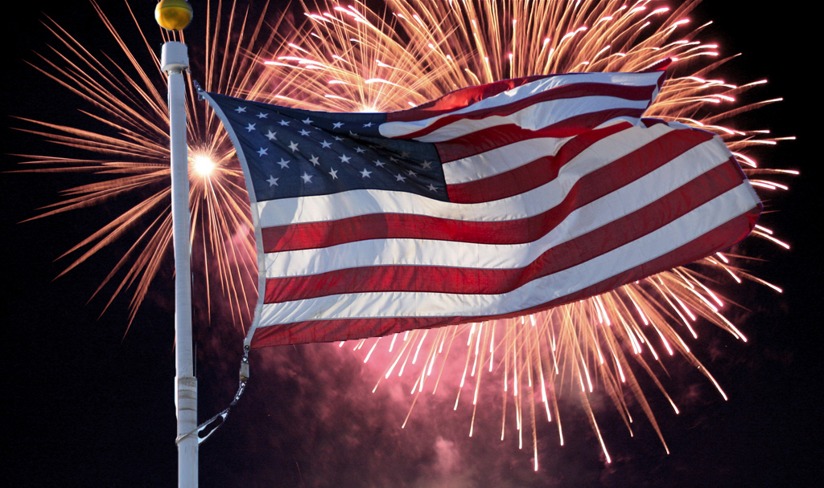
So, without further ado, let’s get the basics out of the way and let the celebration begin!

LOCATION:
Camp Potomac
18308 Scout Camp Rd. SE,
Oldtown, MD 21555

PARKING:
Units may drop their trailers and gear off at their campsites, then immediately move all vehicles to the parking lot prior to setting up camp. Please limit trailers to one per unit. Loading for departure will be conducted in a similar manner after Scouts Own Service. Please see attached new parking guidelines for camp!

CHECK-IN
Check-in will be at the Trading Post. Please have a unit Leader check in your Unit. Please let us know of ANY intention your unit or individual Scouts may have for early departure. Do Not leave camp wit out checking out.

CAMPING AREA:
Troop campsites will be assigned upon arrival Friday Evening at Check-In. Please be prepared/have your unit prepared to be in a different campsite than normal. All units should have tents ready for campsites without Adirondacks.

WATER: There is plenty of safe water at Camp Potomac Each Troop will be able to fill their jugs up at the Bath house and take back to their Campsites. Fresh water is also available at all Campsite Latrines.

FIRES:
Campfires are permitted at campsites as long as all BSA procedures are followed for starting, maintaining and extinguishing them. Bring your bow saw, there is a lot of wood and brush lying on the ground that everyone is welcome to. Wood will not be provided, because scouts find their own. Please refrain from using any
chemicals to start your fires.

SAFETY:
Normal safety precautions should be taken at this event: no throwing of rocks or other objects, no sheath knifes or machetes, no liquid fuel or open flames in tents, no unattended fires, etc. All injuries should be referred immediately to the Medical Officer or Camp Staff. The Bell is to be used only if a Camper is confirmed to be lost. If you hear the bell, everyone must report to the parade field immediately.
CONDUCT:
The Scout Law and Scout Oath are the code of conduct at the Outing.

SANITATION:
Restroom facilities are available. Please do your best to keep them all clean and in working order. Field latrines are available at most campsites.

TRASH:
Please bag all of your trash and police your campsite. All trash must be taken to the dumpster located in the parking lot outside of camp.

UNIFORMS:
Scouts look good and show respect when they wear the field uniform (Class A) when arriving at camp, during flag ceremonies, at Scouts Own Service and when departing from camp. Comfortable clothing is encouraged on Saturday during activities.

CHECK-OUT: NEW
***All Troops are not to leave before or during Scouts Own Service. Regardless of attendance to service. Gates will be open for all troops to leave once the service is over and their Campsites are clean.

TRADING POST:
Will be open the throughout the weekend and will be stocked with cold drinks and snacks

FOOD
No meals will be provided. All Units are responsible for bringing and preparing their own meals.
NEW RULE ADDITIONS!

RESTRICTED ITEMS
Smoking, Vaping, Drugs, alcoholic beverages, fireworks, personal firearms, RVs, and pop-up campers are not permitted at the camporee. Standard rules from the Guide to Safe Scouting apply with respect to prescription medications. Use of or possession of any prohibited items will result in immediate dismissal from the Camporee and may result in a call to law enforcement.

YOUTH PROTECTION
All adults (18+) must have completed Youth Protection training, and their certification has not expired.
NO ADULTS ARE PERMITTED IN CAMP WITHOUT A VAILD YPT

WEBELO Scouts-
Due to recent BSA changes, Webelos are no longer permitted at camporees.

ELECTRONIC DEVICES
Please ask your Scouts to limit electronic device usage to activities.

PATROL NEEDS
Each patrol will be given a team patriotic flag. This flag will need to be carried with them throughout the day on Saturday, so come prepared with a way to display it. Patrols should also have a compass, a flashlight, and some rope for a pioneering project

STAFF
Each troop is required to present at least 2 Leaders to help run a station during the day Saturday. Assignments will be given during the leaders meeting/ Cracker Barrel on Friday evening.

SCORING
Scoring will be based on the performance at each station, with all teams working towards the perfect score of 250! Challenges will begin Friday night and continue through Saturday evening.

DATE:
Start Date/Time:
10/23/2026 5:00 PM – 10/25/2026 11:00AM

COST:
$15.00 per Scout

$10.00 per Adult

*All payments should be submitted on 24/7 or at the Potomac Scout Office
*NO payments will be taken at camp.

REGISTRATION:
Register on: Laurel Highlands Council - (scoutingevent.com)

Registration Begins: 09/14/2026 12:00:00 AM
Register: 10/13/2026 11:59:00 PM

EVENT INFORMATION—What to Expect

This camporee will be run a bit differently than others. We will actually be starting on Friday night, so we urge Troops to arrive and be set up by 8pm so you won’t miss out on the fun. Saturday morning will have six rotations followed by a camp-wide race in the afternoon. We will finish with an awesome campfire, followed by cake and ice cream (we can’t celebrate without that).

Friday Evening—The Adventure begins
Check-in and campsite set up
Opening with Team assignments
Kickoff challenge

Saturday – The 250 Challenge
Morning - Teams rotate through six eras in the history of America
Afternoon - Teams race through checkpoints of the 13 original colonies.
Evening – Celebration Campfire, with Flag Retirement

Sunday - Scouts Own, Clean up, Camp dismissed

Stations, Skills and Supplies needed

Friday night kickoff
- -1776 challenge – this will include some trivia, pioneer building, nighttime navigation, and a bit of bartering with other teams (subject to change)
- -Supplies needed- You will need to build a pioneer item, bring rope and poles (or you can forage for the poles), flashlight, and a compass

Saturday morning will be rotations

The Six Eras Stations
- 1. The Revolution — Colonial America & the American Revolution (1607–1783) — Courage
- 2. The Balance of Power — Founding of the United States (1783–1820s) — Leadership
- 3. Go West! — Expansion & Westward Movement (1820s–1860s) — Exploration
- 4. A Nation Tested — Civil War & Reconstruction (1861–1877) — Unity
- 5. American Innovation — Industrial & Progressive America (1877–1919) — Innovation
- 6. America Today & Tomorrow — Modern America (1919–Present) — Service & Discovery
Leader note: These are a practical six-era storytelling framework for the Camporee, not an official or universally accepted six-period division of U.S. history.

Although we don’t want to spoil the surprise, here are some skills you will want to brush up on for the stations. You won’t need any additional required supplies for Saturday.

- Knots through 1st class
- Basic lashings
- Fire Building
- Plant and animal identification
- Compass and bearing basic knowledge
- Flag skills
- Semaphore messages
- Teamwork
- Trust
- Patience
- Thinking skills

Saturday Afternoon will be The 13 Colonies Race
No required supplies needed; most of the skills above will be used

Event Schedule (subject to change)

Friday:
5:30 - 8:00 Check-in at Trading Post Set up Camp
8:05 – 8:15 Opening Ceremony
8:20 – Sat am Kickoff challenge
9:30 – 10:00 Leader Cracker Barrel
11:00pm Lights out

Saturday:
7:00 am Reveille
7:00 – 8:30 Breakfast
8:35 - 8:55 Flags/ Opening
9:00 – 9:40 Station 1
9:45 - 10:25 Station 2
10:30 - 11:10 Station 3
11:15 - 11:55 Station 4
12:00 - 1:00 Lunch
1:05 - 1:45 Station 5
1:50 - 2:30 Station 6
2:35 - 2:55 Break/ Rest
3:00 - 5:15 Campwide 13 Colonies Race
5:15 - 5:25 Flags
5:30 - 8:00 Dinner
8:00 – 9:45 Campfire/ Awards/ Celebration
9:45-10:00 Leaders meeting
11:00 Lights Out

Sunday:
7:00 am Reveille
7:00 - 7:55 Breakfast
8:00- 8:30 Scouts Own Service
8:35 -11:00am Break camp/ Clean-up/ Check Out

