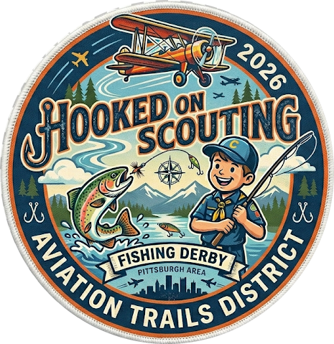
Fishing Derby &
Scout Skill Demonstrations

All Cub Scouts
September 12, 2026
Hopewell Park

Event Contacts:
Ken Smith, District Executive Kenneth.smith@scouting.org
John Pavolko, District Activity Chair jpavolko@gmail.com
Scott Hiemstra, Hooked on Scouting Chair scotthiemstra+scouting@gmail.com

Table of Contents
Registration Info 3
Scouts 3
Required Paperwork to Bring 3
Youth 3
Adults 3
Directions to Event 3
Park Rules and Information 4
Camping options for Units. 4
Packing Suggestions 4
Participants 4
First Aid 4
Other Emergency Procedures 5
Lost Person: 5
Stranger on Site: 6
Inclement Weather: 6
Other Hazards: 6
Event Schedule 6
Saturday 6
Events 6
Fishing Derby 6
Other demonstrations and activities 6
Dutch Oven 6
First Aid 7
Wildlife habitat 7
Leave No Trace 7
Casting accuracy challenge 7
A Pathway through the Ranks (Advancement Opportunities) 7
Event Map 8

Registration Info

Scouts
Youth: $5 Volunteers: Free

Required Paperwork to Bring

Youth
All youth participating will need a Part A and B medical form.

Adults
All registered scouting volunteers must bring their medical (Part A and B), a copy of their PA Required Clearances, as well as evidence of their current YPT completion.

Directions to Event
Hopewell Community Park https://maps.app.goo.gl/gi8gHbKmBBggXuFC8
From Beaver:  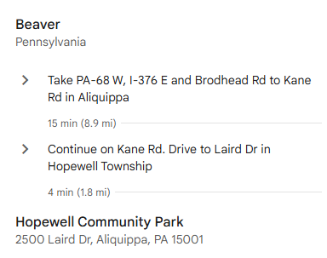 | From Robinson:  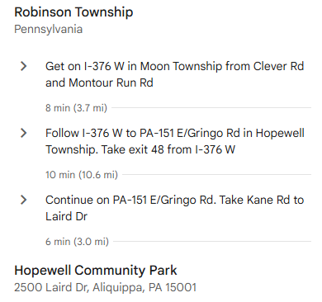

Once in the park, follow the posted signs to the event, registration will be held at pavilion 3.

This QR Code will open Google Maps to the Fishing Derby Location:
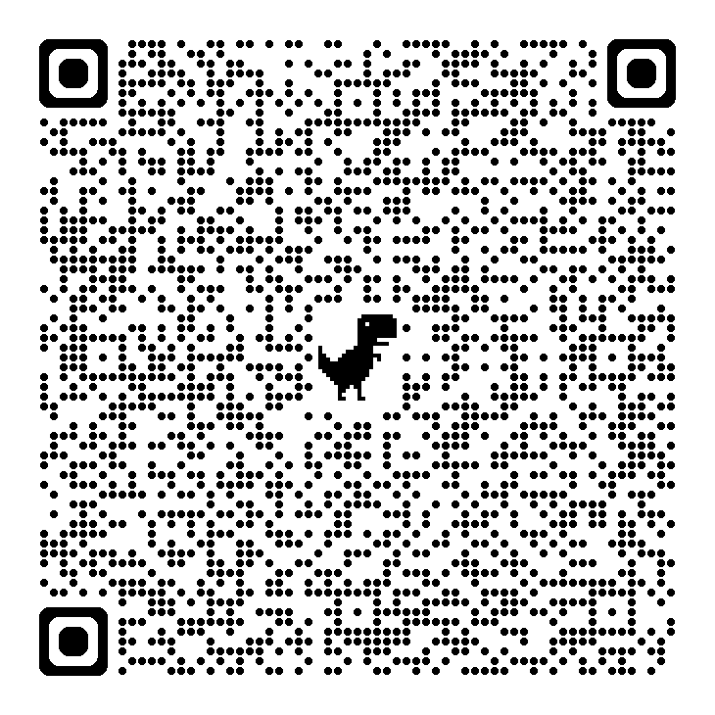

Park Rules and Information
https://hopewelltwp.com/wp-content/uploads/2021/12/Hopewell-Community-Park-Rules.pdf

Camping options for Units.
No camping options are offered for this event.

Packing Suggestions

Participants
Please bring a daypack with your scouting essentials. Please bring your own fishing equipment, there will be some equipment available to borrow, but it will be limited supply.

First Aid & Advisories
Emergency First Aid location: Heritage Valley Convenient Care – Aliquippa is the closest urgent care to the event, the nearest hospital is Heritage Valley Sewickley.
ALL FIRST AID MUST BE ADMINISTERED BY STAFF AT THE FIRST AID STATION (will be at check-in)
1. Medical treatment must be given no matter how slight the injury or illness.
2. Always use the Buddy System and 2 deep leadership.
3. All campers should drink plenty of water throughout the day.
4. Always be aware of exhaustion, fatigue and stress levels of your Scouts, other volunteers and yourself!
❖ Outdoor Hazards: In any trip to the out-of-doors a camper may encounter annoying insects and poisonous plants or animals. Each Scout leader should prepare their Scouts to recognize and protect against such outdoor hazards. The effects of poison ivy, ticks, etc., can be minimized with good personal practices. All injuries of this type should be reported at the First Aid Station for treatment and recording.

Other Emergency Procedures

Lost Person:
IF A SCOUT IS MISSING, YOU MUST FOLLOW THESE PROCEDURES:
1. Immediately notify the closest staff member. Please use the closest cell phone or radio to relay the following information to Program Coordinator:
a. Name of missing Scout
b. Their age and Unit #
c. Where the missing Scout was last seen and by whom.
d. What color shirt or jacket the Scout was wearing.
2. Staff will check to see if a medical condition may be responsible for the missing Scout and notify “finders” as appropriate.
3. Take account of all other children under your supervision. Make sure two buddies didn’t leave for the bathroom without telling a responsible adult.
4. Remain where you are (station, campsite, etc.) as this is where a wandering Scout is apt to return.
5. Maintain control of the remaining children. Have them sit where they are and give them a job to do
IF THE PERSON IS STILL MISSING:
1. A camp-wide alarm will be issued. (Three short bursts from an air horn)
2. When this alarm is heard, all campers and staff should stay where they are.
3. Adult participants need to count heads to ensure that all Scouts are present and accounted for. Further instruction will be given at that time. Everyone should remain QUIET and CALM. It is very important that everyone be able to hear instructions as they are given.

Stranger on Site:
We will be in a community park that will have other visitors. Please ensure to follow safe scouting procedures as defined in the Guide to Safe Scouting available at https://www.scouting.org/health-and-safety/gss/toc/.

Inclement Weather:
Please come prepared for the weather. The event will continue even if it is raining. If it begins to rain heavily, or if lightning is close by, Scouts and adults will be directed into the closest covered designated area and await further instructions. Scouts should be encouraged to stay with their buddy and make sure each Scout is accounted for. Campers will be notified when normal activities will resume.

Other Hazards:
The fishing area is a pond in a community park, there is a mild slope down to the water, the entire pond is surrounded by grass. Children should be discouraged from running near the water. Insects, wildlife and poisonous plants may be present.

Event Schedule

Saturday
Time | Activities
8:00 - 8:30am | Check-in
9:00 – 12:00pm | Open fishing derby, activities, and demonstrations
12:00m – 12:15pm | Admin
12:15pm – 1:00pm | Awards and door prizes

Events

Fishing Derby
All scouts can participate in the fishing derby. Scouts can win a prize for longest fish, smallest fish and most fish. Door prizes will also be awarded.
You must follow state laws regarding who is required to have a fishing license, anyone over the age of 16 is required to have a fishing license in Pennsylvania. Please see the PA Fish & Wildlife website for details on regulations.

Other demonstrations and activities
We will have some additional demonstration and activities available for scouts to go see. These stations will be dependent on having appropriate staff volunteers to run the stations and are subject to change

Dutch Oven
Showing how to use dutch ovens for camping meals. Proper care and general questions around equipment. Details TBD

First Aid
Basic first aid skills that may be needed while fishing.

Wildlife habitat
Beaver County Conservation District will go through what makes a good habitat for fish and other aquatic life. Details TBD

Leave No Trace
Talking about the importance of following the Leave No Trace principles while fishing.

Casting accuracy challenge
- Lions, Tigers & Wolves will have 2 attempts to cast at an object 20 feet away, the closest 3 casts will win a prize.
- Bears, Webelos & AOLS will have 1 attempt to cast at an object 30 feet away, the closest 3 casts will win a prize.

A Pathway through the Ranks (Advancement Opportunities)
Cub Scouts will also have an opportunity to complete rank appropriate activities in the following areas.
- 9:00-9:30 – Knot Tying
- 9:30-10:00 – Basic First Aid
- 10:00-10:30 – Camp Set Up
- 10:30-11:00 – Tree & Plant Identification
- 11:00-11:30 – Fire Building

Event Map
There is a parking lot near the pond which accommodates approximately 30 vehicles, there is another parking lot at the entrance to the park which is only about 600 feet from the pond. Restrooms are located right off the parking lot near pavilion 3, there is a playground at the park which is not part of this event.
