Scouting Fair

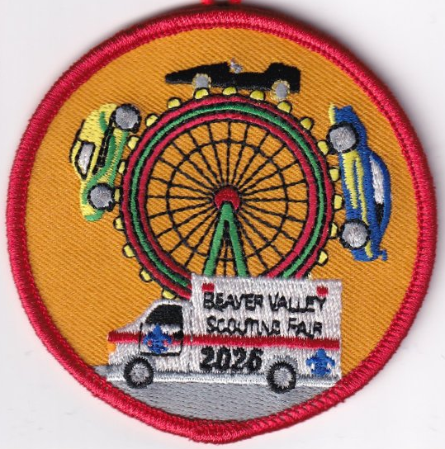

Beaver Valley District Cub Scout and ScoutBSA event:
February 7, 2026
Event Contacts:
John Pavolko, District Activity Chair jpavolko@gmail.com
Ken Smith, District Executive Kenneth.smith@scouting.org

Table of Contents
Registration Info 3
Cub Scout Pinewood Derby Racers 3
Troop participants 3
Staff Registration 3
Required Paperwork to Bring 3
Youth 3
Adults 3
Location 4
First Aid 4
Other Emergency Procedures 4
Lost Person: 4
Fire Plan: 4
Event Schedule 5
Pinewood Derby 5
First Aid Meet 5

Registration Info

Cub Scout Pinewood Derby Racers
Costs: $5/scout
Units will pre-register their racers online before the event. This will be done through the council calendar.

Troop participants
Costs: $5/scout
Patrols will be competing in the First Aid Meet. Please confirm with John about number of patrols and the time slot your patrol(s) will be competing.

Staff Registration
Costs: $0
If you would be willing to help with the following events please signup up at this link.

Required Paperwork to Bring

Youth
All youth participating will need a Part A and B medical form.

Adults
All Adults in camp must bring a copy of PA Required Clearances, as well as evidence of their current YPT completion.

Location
We will be holding this event in the Beaver Valley Mall.

First Aid
ALL FIRST AID MUST BE ADMINISTERED BY THE MEDICAL STAFF.
1. Medical treatment must be given no matter how slight the injury or illness.
2. Always use the Buddy System and 2 deep leadership.

Other Emergency Procedures

Lost Person:
IF A SCOUT IS MISSING, YOU MUST FOLLOW THESE PROCEDURES:
1. Immediately notify the closest staff member with this information
a. Name of missing Scout
b. Their age and unit #
c. Where the missing Scout was last seen and by whom
d. What color shirt or jacket the Scout was wearing
2. Staff will check to see if a medical condition may be responsible for the missing Scout and notify “finders” as appropriate.
3. Take account of all other children under your supervision. Make sure two buddies didn’t leave for the bathroom without telling a responsible adult.
4. Remain where you are (station, campsite, etc.) as this is where a wandering Scout is apt to return.
5. Maintain control of the remaining children. Have them sit where they are and give them a job to do
IF THE PERSON IS STILL MISSING:
1. A camp-wide alarm will be issued. (Three short bursts from an air horn)
2. When this alarm is heard, all campers and staff should stay where they are.
3. Adult participants need to count heads to ensure that all Scouts are present and accounted for. Further instruction will be given at that time. Everyone should remain QUIET and CALM. It is very important that everyone be able to hear instructions as they are given.

Fire Plan:
If a fire has been spotted, we will follow the mall’s fire protocol.

Event Schedule

Time | Pinewood Derby (Registration starts at the start of the hour and racing begins at the bottom of the hour)
10:00 – 11:20 | AOL Races
11:00 – 12:20 | Webelos Races
12:00 – 1:20 | Bears Races
1:00 – 2:20 | Wolves Races
2:00 – 3:20 | Tigers Races
3:00 – 4:20 | Lion Races
4:45 - 5:00 | Final Award

Time | First Aid Meet
10:00 – 10:30 | Registration
10:30 - 11:30 | First Aid Heat
11:30 – 12:30 | First Aid Heat
1:00 – 2:00 | First Aid Heat
2:00 – 3:00 | First Aid Heat
3:00 – 4:00 | Final Heat
4:00 - 4:30 | Final Award

Event Descriptions

Pinewood Derby
2 Volunteers are needed per race. Each Pack is asked to have volunteers. Please utilize the signup above. On the calendar there will be the rules for the race also posted. Any other specific rules or guidelines for this portion will also be posted as a separate document

First Aid Meet
The ScoutBSA patrols will be competing in the annual first aid meet. The specific details for this will be located on the council calendar signup. We will need 2 additional adult volunteers to help score all of the patrols.

