Wilderness Wander
Webelos/AOL Outdoor Tech on the Trail
Webelos: Math on the Trail & Tech on the Trail Adventures
Arrows of Light: High Tech Outdoors & Estimations Adventures
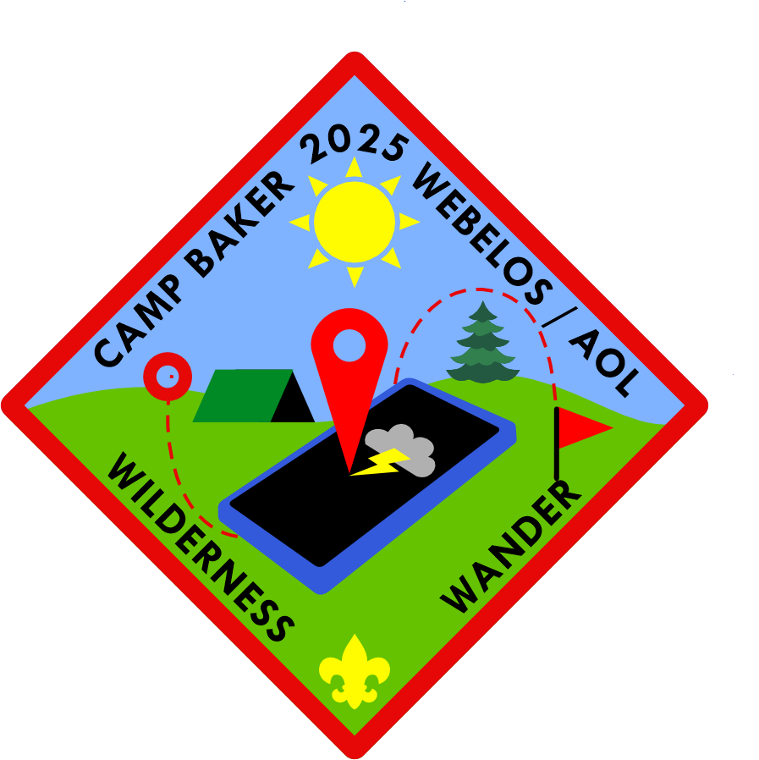

June 7, 2025
Event Contacts:
John Pavolko, District Activity Chair jpavolko@gmail.com
Ken Smith, District Executive Kenneth.smith@scouting.org
Table of Contents
Registration Info 3
Cub Units 3
Troop Units 3
Staff Registration 3
Required Paperwork to Bring 3
Youth 3
Adults 3
Directions to Camp 4
Camp Rules and Information 4
Camping options for Units. 5
Packing Suggestions 5
For Adults 5
For Youth 5
First Aide 5
Other Emergency Procedures 6
Lost Person: 6
Stranger on Site: 6
Inclement Weather: 6
Fire Plan: 7
Event Schedule 7
Event Descriptions 8
Lunch 8
Parent Crossover Information 8
Stations: 8
Plan the Hike – Orienteering with GPS or Map and Compass 8
Plan the Hike – Weather and Food 8
Plan the Hike – Estimation 8
Plan the Hike – Picking a hike 8
Wilderness Wander 8
Field Sports 8

Registration Info

Cub Units
Cub Scouts: $25
Adult Leaders: $15
This event is limited in registration to Scouts that are in either Webelos or Arrow of Light Dens. (Scouts entering 4th or 5th Grade). The Event occurs in June so that it is after the close of school and after rank-ups so that 2024/2025 Bears would be Webelos at the time of this event. For this year we are not running the event as an overnight event, however if a Den wishes to camp we are not reserving the camp outright, only the sites we need, the remaining sites are available through the council registration system for any unit to reserve if they wish.

Troop Units
Troops wishing to assist with the event can register so that we can have an accurate count of youth and adults in camp. Just as with the cubs, we are not coordinating an overnight experience this year. Available sites not needed for the event will be available to units to reserve on a first come first served basis.

Staff Registration
Adult Staff: $5
Youth and OA Youth Staff: NO COST
All Staff are required to register. Adult staff fee covers the cost of snacks, lunch, and patches for staff.

Required Paperwork to Bring

Youth
All youth participating will need a Part A and B medical form. Because of the shooting sports focus, on the front of the Part A form, please note the permission area about using BB guns being approved. Youth without the check noting no restrictions will not be able to participate without a parent’s written permission.

Adults
All Adults in camp must bring a copy of PA Required Clearances, as well as evidence of their current YPT completion.

Check-In procedures
Please check-in at the Headquarters Tent upon your arrival. We will need the following when you arrive: Full roster of your troop, copy of medical forms for all participants, and copies of clearances for all adults present. These will be kept on file at HQ until your departure.

Directions to Camp

Camp Address: 371 Winterburn Road, Beaver Falls, PA 15010
Camp is located 32 miles north of the Pittsburgh Airport. From Pittsburgh take Rt 376 to Brighton Exit 36. Turn right onto service road 7/10 of mile. Turn right on Dutch Ridge Road for 7/10 mile. Then turn carefully to Park Road for 2 miles. Turn left onto Achortown Road for 1.5 miles. Turn onto Winterburn Road for 5/10 mile. Camp is on right.
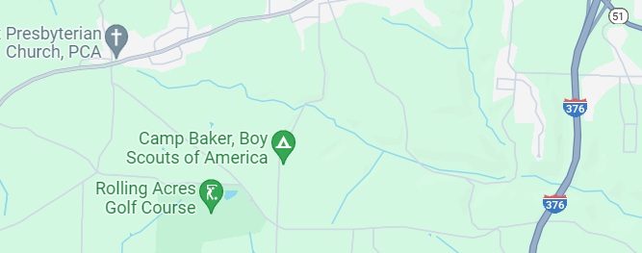

Camp Rules and Information

Parking is permitted in designated areas only.
Speed Limit of 5 mph must be adhered to.
All Vehicles must remain on camp roads at all times, except as allowed by the ranger staff.
No Running in camp outside of the designated activity areas.
As Scouts we follow Leave No Trace standards; leave camp better than you found it.

Camping options for Units.

This year’s event does not have camping coordinated by the district. We will be putting camping back into the standard program next year. However, this does not mean your unit cannot camp over this weekend. If you and your youth would like to camp, available sites will be first come first serve though the LHC reservation system. This camping experience would then be a DEN Camp for the Webelos and AOL dens. Your den would be responsible for all meals, and evening planning.

Packing Suggestions

For Adults
A lightweight Camp Chair to use while the kids are on stations
Snacks, Water, Lunch food
Sunscreen, Hat, other sun protection

For Youth
A daypack with your essentials
Water bottle
Lunch

First Aid
ALL FIRST AID MUST BE ADMINISTERED BY THE MEDICAL STAFF AT THE FIRST AID STATION (Rear Shelter)
1. Medical treatment must be given no matter how slight the injury or illness.
2. Always use the Buddy System and 2-deep leadership.
3. All campers should drink plenty of water throughout the day.
4. Always be aware of exhaustion, fatigue and stress levels of your Scouts, other volunteers, and yourself!
5. Medications must be discussed with the Medical Staff upon arrival in camp. Arrangements for the safe handling and storage of the medication will be made between a unit adult and the camp medical staff to ensure that medications are properly available to the patient, and also safely stored.
❖ Outdoor Hazards: In any trip to the out-of-doors a camper may encounter annoying insects and poisonous plants or animals. Each Scout leader should prepare their Scouts to recognize and protect against such outdoor hazards. The effects of poison ivy, ticks, etc., can be minimized with good personal practices. All injuries of this type should be reported at the First Aid Station for treatment and recording.

Other Emergency Procedures

Lost Person:
IF A SCOUT IS MISSING, YOU MUST FOLLOW THESE PROCEDURES:
1. Immediately notify the closest staff member. Please use the closest cell phone or radio to relay the following information to the medic.
a. Name of missing Cub Scout
b. Their age and Pack #
c. Where the missing Scout was last seen and by whom.
d. What color shirt or jacket the Cub Scout was wearing.
2. Staff will check to see if a medical condition may be responsible for the missing Scout and notify “finders” as appropriate.
3. Take account of all other children under your supervision. Make sure two buddies didn’t leave for the bathroom without telling a responsible adult.
4. Remain where you are (station, campsite, etc.) as this is where a wandering Scout is apt to return.
5. Maintain control of the remaining children. Have them sit where they are and give them a job to do.
IF THE PERSON IS STILL MISSING:
1. A camp-wide alarm will be issued. (Three short bursts from an air horn)
2. When this alarm is heard, all campers and staff should stay where they are.
3. Adult participants need to count heads to ensure that all Scouts are present and accounted for. Further instruction will be given at that time. Everyone should remain QUIET and CALM. It is very important that everyone be able to hear instructions as they are given.

Stranger on Site:
All participants at Camp MUST BE IDENTIFIABLE – Camp Staff cannot be everywhere on site at one time, so we need every volunteer to be our “eyes and ears.” Participants at Camp can be identified as follows:
*ALL VISITORS MUST SIGN IN WITH ADMIN AT THE HEADQUARTERS TENT.
*If you suspect that there is a stranger on site, immediately contact the nearest member of staff

Inclement Weather:
Please come prepared for the weather. The event will continue even if it is raining.
If it begins to rain heavily, or if lightning is close by, Scouts and adults will be directed into the closest covered designated area and await further instructions. Scouts should be encouraged to stay with their buddy and make sure each Scout is accounted for. Campers will be notified when normal activities will resume.

Fire Plan:
If a fire has been spotted, Camp Staff should be notified immediately. Staff and Campers are to gather the Scouts at their station together quickly and head to their designated area (as directed by staff). If the fire is in the designated area, lead the Scouts you are responsible for away from the area as directed by staff. Scouts should be lined up in the buddy system so that all can be accounted for.
Should fire trucks come, continue to keep the Scouts together in this designated area. Participants will be notified when programing can be resumed.

Event Schedule

Time | Activities
8:00-9:15 | Check-in @ HQ Tent
9:15-9:30 | Opening Ceremony
9:30-12:00 | Morning Sessions
12:00-1:30 | Lunch Break
1:45-3:45 | Afternoon Hikes
4:00-5:00 | GaGa Ball/Field Sports / Parents Webelos & AOL Transition Meeting
5:00-6:00 | Camp Cleanup

Event Descriptions

Lunch
Lunch will be on your own for units. Units will have the option if they elected to camp to take their meal in their campsite, or to eat as a larger group at the Wildman shelter. Any food preparation can take place at camp so long as it is camp appropriate and is cleaned to BSA Camp standards.

Parent Crossover Information
Parents, join us as we come to the end of the day to start getting an idea about what crossing over to a BSA Troop means for you and your scout. We will talk a bit about the differences in the programs, and try to demystify some of the terms troops use all the time for you. This meeting will be at Headquarters Tent.

Stations:

Plan the Hike – Orienteering with GPS or Map and Compass
Learning how to read a map and use a GPS unit along with map and compass skills. Scouts should bring their own compass and have a map of Camp Baker with them.

Plan the Hike – Weather and Food
We will utilize smart phone technology for looking at weather conditions for a few various locations to plan a hike. In addition, we will look at the food requirements for a 2 day 20 mile hike plan and see how well we get to estimated our needed food supply.

Plan the Hike – Estimation
We are going to look at our walk speed and pace length to see if we can estimate how long a two-mile hike will take us. And then in the afternoon we are going on a two-mile hike to see how well our estimation works out.

Plan the Hike – Picking a hike
During lunch as a small patrol, you will look at your map and plan out a two mile hike around Camp Baker. We will utilize some of the skills we learned in the morning to put together a hike plan.

Wilderness Wander
Taking our hike plan, we will go on a two-mile hike. We have our estimations of length of time, how to measure our distance, and a hiking plan that we will attempt to follow.

Field Sports
At field sports we will have a few games including GaGa Ball to keep the kids moving and having fun. This station will be run during the parent meeting in the main activity field. Other games will be determined by the team running the station closer to the event date.

