Beaver Valley District
Advancement Day @ the Scouting Fair
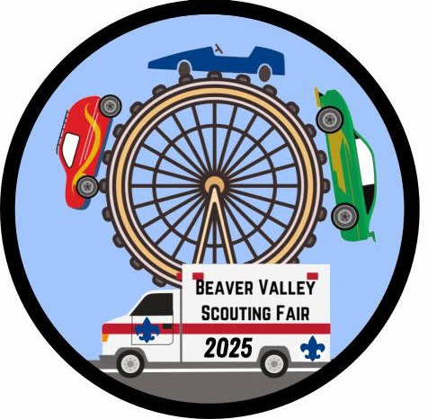

Scouts BSA Units
February 01, 2025
10am to 5pm
Beaver Valley Mall
Monaca, PA

Event Contacts:
Jessica Spitcaufsky, BVD Advancement Chair – BVDAdvancmentChair@gmail.com
Ken Smith, District Executive – Kenneth.Smith@scout.org
John Pavolko, District Activity Chair – jpavolko@gmail.com

Merit Badge Day
The Scouting Fair
Event Details:
Beaver Valley Mall
570 Beaver Valley Mall Rt. 18
Monaca, PA 15061
Date and Time:
February 01, 2025
09:00am to 05:00pm
Schedule:
9am to 10am – Check In
10am to 1pm – AM Sessions
1pm to 2pm – Lunch/Break
2pm to 5pm – PM Sessions
Registration Info:
Troop Youth: FREE
Volunteer Staff: FREE
Required Paperwork to Bring
Youth
All youth participating will need an up-to-date Part A/B medical form.
All youth participating will need to bring a filled out and signed prerequisites form for EACH merit badge they are attending.
Adults
All adults participating will need an up-to-date Part A/B medical form. If an adult is NOT registered, but is volunteering, they must bring a copy of their current YPT and as well as copies of the PA required clearances.
Preparations and Prerequisites:
- Scouts are encouraged to obtain and read the current merit badge book, or use All Merit Badges A-Z | Boy Scouts of America (scouting.org).
- Scout may print the corresponding worksheets to use as a tool to organize notes and document their work. Merit Badge Worksheets (usscouts.org)
- To earn the merit badge(s), Scouts need to complete all prerequisites and show proof of completion.
- Prerequisites and proof required will be listed in the class schedule and sign up.
- Scouts should bring the following items to the Merit Badge Day:
  - A Scoutmaster signed MBC Prerequisites Form for each merit badge.
  - A Scoutmaster signed and filled out blue card for each merit badge.
  - Any merit badge worksheets, prerequisites work and proof. Pen/pencil(s) and spare paper.
  - A packed lunch OR money for lunch, and refillable water bottle Up-to-date health forms.
- Scouts must be prepared to discuss and demonstrate all requirements. Scouts are encouraged to wear their official BSA uniform along with appropriate footwear.

Merit Badges
Photography
10am to 1pm – AM Session, 10 Scouts Max
Merit Badge Counselor – Jeffery Jones, BSA# 1871999, jeffjones.nev64@gmail.com, Beaver, PA
Prerequisites – 4 and 5 – Come prepared to discuss.

Citizenship in Society
2pm to 5pm – PM Session, 5 Scouts MAX
Merit Badge Counselor – Jessica Spitcaufsky, BSA# 133142548, BVDAdvancmentChair@gmail.com, Rochester, PA
Prerequisites – 1, 2, 3, 4, 5, 6, 7, 8, 9, 10, and 11
Scouts must have ALL requirements completed and written down, and must be ready to discuss.

Electricity
10am to 11:30am – AM Session, 10 Scouts MAX
Merit Badge Counselor – Jonn Pavolko, BSA# 132775399, jpavolko@gmail.com, Beaver, PA
Prerequisites – None
Take Home - Will be discussed during the session.

Game Design

10am to 1pm – AM Session, 10 Scouts MAX

Merit Badge Counselor – Nathan Bradley, BSA# 136190425, neb139@gmail.com, Beaver, PA

Prerequisites – None; however, if a Scout has designed a game recently please have them bring it in to show.

Take Home - Will be discussed during the session.

*More Merit Badges to Come*
Advancement Opportunities
Troop 766 - Knots and Lashings
Troop 436 – Camping How-To's
*More Opportunities to Come*

