Patch and Chenille Design for Section E14 2023 Conclave
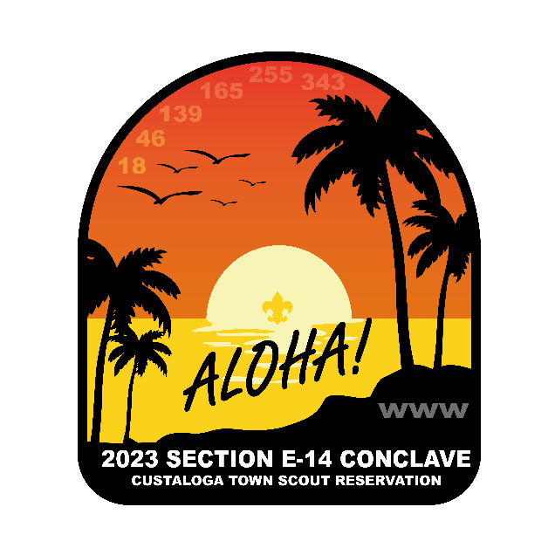

Neckerchief for Section E14 2023 Conclave
