Oneida District Fall Camporee 2026

The Prepared Chef
November 13-15, 2026
Camp Sinoquipe
677 Boy Scout Rd
Fort Littleton, Pennsylvania 17223
The Vibe: Culinary competition meets wilderness survival. Three stages of culinary competition throughout the day on Saturday with opportunities to win advantages for each stage.

Camping/Cabin Reservations
Each unit attending the camporee is responsible for securing their own campsite or cabin at Camp Sinoquipe. Cabin prices range from $100-$250 for the weekend, depending on size and amenities. Cub Scout Packs are especially encouraged to use cabins, and may partner with a Scouts BSA Troop to share a larger cabin. Tent camping sites range from $50-60 for the weekend. The hub for Camporee activities will be the LeBleu Pavilion, please consider this when choosing your cabin or campsite (See map below).
Reserve a campsite or cabin for your unit at: https://campreservation.com/598/Camps/1038
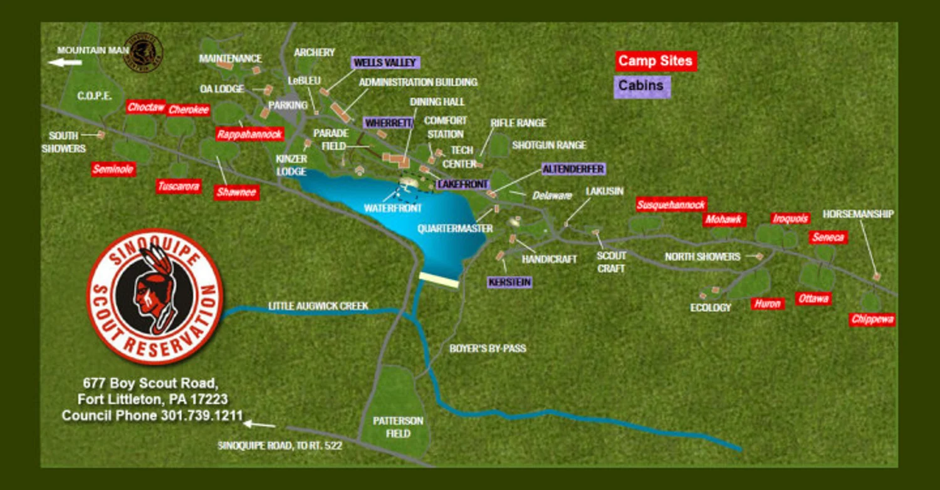

Camporee Registration
Because we are using an out-of-council BSA facility, camporee registration is separate from the campsite or cabin rental. Camporee registration includes a commemorative patch, and helps pay for program materials. Register your unit for the camporee at https://scoutingevent.com/497

Program Schedule

Friday evening
5-8 p.m. Units arrive, set-up camp or move into cabins

8 p.m. Patrol Leader, SPL, Scoutmaster, Den Leader, Cubmaster meeting to go over camp rules, competition format and any other housekeeping notes

8:30 p.m. Camp-wide cracker barrel/opening campfire at LeBleu Pavilion

Saturday
All Day Leader Challenge: Whittle a useful wooden spoon from a block of wood issued at Breakfast turn-in.
Scouts BSA & Venturing Breakfast Challenge: Prepare a simple breakfast over an open fire for each patrol member + 1 judge without using any metal (aluminum foil counts as a prohibited metal), ceramic, glass or silicone cookware. The meal must include the following items prepared in the presence of a judge:
- a baked item made from dough or batter (dough or batter may be ready made, like canned biscuit dough, or mixed ahead of time, but cannot be pre-baked)
- a fruit
- a cooked protein (protein may be cured, but cannot be pre-cooked)
Cub Scout Breakfast Challenge: Prepare a simple breakfast over an open fire for each den member + 1 judge. The meal must include the following items prepared in the presence of a judge:
- a baked item made from dough or batter (dough or batter may be ready made, like canned biscuit dough, or mixed ahead of time, but cannot be pre-baked)
- a fruit
- a cooked protein (protein may be cured, but cannot be pre-cooked)
8:30 a.m. Breakfast challenge turn-in/judging
Judging will be based on the following points of the Scout Law:
- A Scout is Helpful (teamwork)
- A Scout is Obedient (adherence to challenge requirements and turn-in time)
- A Scout is Thrifty (resourcefulness in cooking vessels)
- A Scout is Clean (sanitation)
- A Scout is Reverent (service)

9:30 a.m-10:30 a.m. Scouts BSA & Venturing Campfire building/hard boiled egg race: As a patrol, scouts race to gather appropriate campfire tinder, kindling and wood fuel, ignite a fire using flint & steel and use the fire to boil enough water to cook a hard-boiled egg for a judge. Patrols are responsible for providing their own metal pot and water. Patrols may bring dry tinder (no waxy firestarters). Kindling should be scavenged on-site during the challenge time. Split firewood and eggs will be supplied.

Selection of secret ingredients for the lunch challenge will be based on finishing order for the hard-boiled egg challenge.

9:30-11:30 a.m. Cub Scout Knife Safety:
Arrow of Light Knife Safety elective adventure: https://www.scouting.org/cub-scout-adventures/knife-safety/, Webelos Chef’s Knife elective adventure: https://www.scouting.org/cub-scout-adventures/chefs-knife/,
Bear Whittling elective adventure: https://www.scouting.org/cub-scout-adventures/whittling/
Scouts BSA & Venturing Lunch Challenge: Each patrol must prepare a packable meal for the trail for each patrol member + 1 judge. The meal must:
- Include the secret ingredient selected after the hard-boiled egg challenge.
- Include a dish cooked on a backpack stove
- Include gorp made in camp with at least a protein, a high-carbohydrate ingredient and a dried fruit.
12:30 p.m. Lunch challenge turn-in/judging
Judging will be based on the following points of the Scout Law:
- A Scout is Helpful (teamwork)
- A Scout is Obedient (adherence to challenge requirements and turn-in time)
- A Scout is Cheerful (creativity in incorporating the secret ingredient)
- A Scout is Clean (sanitation)
- A Scout is Reverent (service)

1:30-2:30 p.m. Siesta

2:30-3:15 p.m. (Tentative) Learning to Forage: Learn from an expert how to identify wild edibles while avoiding wild plants and fungi that can make you sick or worse.

3:30-4 p.m. Advantage Challenge: This challenge will test Scouts’ knowledge of cooking measurements, techniques and tools. So study up!
The patrols will be released to their campsite or cabin to begin dinner preparations in five minute increments based on the challenge scoring order. Patrols that tie will be released at the same time.

Dinner Challenge: Each patrol must prepare a three-course meal for the patrol in their cabin or campsite, and present single bite tastes of each course to three judges. The courses are: Appetizer, Soup or Salad, and Entree. Side dishes may be prepared for the meal, but will not be judged.
5:30 p.m. Appetizer Turn-In
5:45 p.m. Soup or Salad Turn-In
6 p.m. Entree Turn-In
Judging will be based on three factors with points deducted for each minute late for turn-ins:
- Presentation
- Taste
- Creativity
6:30 p.m. Leader Challenge Turn-In & Judging

8 p.m. Dessert Pot Luck & Awards Presentation

Sunday
7 a.m. Scout’s Own Worship Service
7:30-11 a.m. Breakfast and pack for home

