Get ready for NYLT 2026!
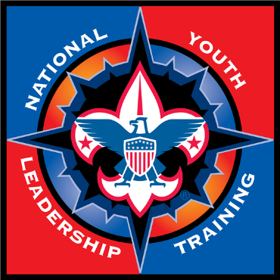
Who Can Attend
Scouts BSA participants must be 13 years of age and fall within the maximum age allowance for their program registration. They must be ranked a First Class Scout or higher and have completed Introduction to Leadership Skills for Troops.
Venturers and Sea Scouts participants must be at least 14, or 13 and have completed eighth grade, and fall within the maximum age allowance for their program. They must have completed Introduction to Leadership Skills for Crews or Ships.
This action-packed, council-level leadership adventure runs from April 24-26 and May 1-3 at Camp Seven Mountains. Don’t miss your chance to experience an incredible week of growth, challenge, and unforgettable memories!
National Youth Leadership Training (NYLT) is Scouting’s premier youth leadership course, offering a dynamic, week-long experience where scouts learn by being part of a model troop. Through peer-led instruction, hands-on challenges, and engaging activities, scouts develop essential skills in communication, teamwork, planning, conflict resolution, and problem-solving. They also explore leadership styles, the EDGE Method (Explain, Demonstrate, Guide, Enable), and create personal and team visions. By the end of the course, scouts gain confidence, set personal goals, and strengthen their ability to lead and make a positive impact in their home units and communities.

Logistics
Course will run 2 Weekends: April 24-26 and May 1-3 at Camp Seven Mountains.
(FRI [start 4:15PM] to SUN each [end 5:30PM])
Attendance and participation for all days is mandatory.

Attendance Eligibility
Scouts who wish to attend must* be:
- For troops - 13 years old
- For Crews or Ships - 14 years old (or 13 and completed 8th grade)
- Be at least First Class (there is no rank requirement for Venturers and Sea Scouts)
- Have completed Introduction to Leadership Skill for Troops, Crews, or Ships (ILST, ILSC, ILSS)
- Be recommended by their unit leader
These requirements must be met by the beginning of course. You may register without all requirements met, but the requirements must be completed by April 23, 2026: the beginning of course.

Costs
Early Bird Registration of $300 is due by January 15, 2026.
Regular Registration of $325 is due by March 24, 2026.
A non-refundable deposit of $50 per participant needs to accompany each registration.

FAQ
- Youth will be inside and outside during course (rain or shine).
- A gear list will be provided but note that youth will be camping in their own tent each weekend.
- Youth will need their sleep-system (sleeping bag, air mattress, pillow), backpack for the Outpost hike, water bottles, headlamp, and have access to bathrooms and a shower.
- Youth will receive a hat and 2 T-shirts for the course and will need their respective unit uniform (Class A, also called Field uniform…not class B like a unit T-shirt or sweatshirt).
- Youth will need to bring a standard mess kit and all gear/outdoor clothing for a camping outing.
- Each participant must submit a completed Annual Health and Medical Record form (Parts A, B and C). All forms must have been completed within one (1) year prior to May 3, 2026, (course completion date) and are due by Mar 1 for staff and Mar 24 for participants.
If you have questions about the course, please reach out to our SPLs and CDs.
- Keira Drohan, Senior Patrol Leader, keiradrohan@gmail.com
- Zach Martin, Senior Patrol Leader, zacharymartin07@yahoo.com
- Patrick Drohan, Course Director, drohanp@gmail.com
- Marissa Crames, Course Director, Mjcrames@outlook.com

