

**Wilderness First Aid**

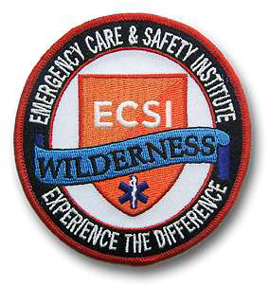

Council Event Registration page: <https://scoutingevent.com/497/Calendar>

All payments need to be submitted in full to be considered registered for WFA.

Headed to Philmont, Sea Base, or taking your troop or crew on a wilderness experience?

WFA courses contain medical information and teach skills to respond to medical emergencies in the wilderness. A BSA-led task force developed a WFA training curriculum for Scouts and Scouters to help them provide assessment and treatment miles from advanced care. Treatment skills are important, but so are educating Scouts and adult leaders to recognize illnesses early and minimize the potential for injury. The skills learned in a BSA-approved WFA course can save lives. WFA is not just for the backcountry. It is just as relevant in urban areas during hurricanes, floods, fires, or mass casualty events when emergency services might be strained. WFA knowledge can be lifesaving.

Course topics are: Patient Assessment System; CPR; Circulatory System; Nervous System; Respiratory System; Fractures, Stable Injuries; Splinting Extremities; Hypothermia; Hyperthermia and Heat Illness; Near Drowning; Lightning Injuries; Wounds and Burns; Anaphylaxis; Lifting, Moving Extrication; Patient Carries; Backcountry Medicine.

Please dress for the weather as most of the class will be held outdoors.

Please bring a bagged lunch for both days. Some snacks and drinks will be provided.

The course is limited to 20 participants.

NOTE: Overnight lodging is not provided as part of the event. Participants are free to reserve a facility at Seven Mountains Scout camp if desired. Reservations can be made at this link:

<https://campreservation.com/497/Camps/402>