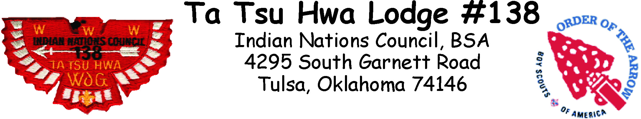
VIGIL WEEKEND
March 30 @ 8:00 AM
until Noon March 31, 2019
Mabee Scout Reservation

(Vigil Members & Vigil Candidates Only)
=========================================================================================================
VIGIL CANDIDATE - NO FEE

❒ Vigil Candidate No Fee

VIGIL MEMBER (Saturday: Lunch & Dinner and Sunday: Breakfast)

 Early Bird $25.00 (if paid prior to March 15, 2019)
 Event Fee $35.00 (March 16 to March 22, 2019)

The Trading Post will be open! So bring extra money to buy new items and to build up your trading stock.

You must have a BSA Annual Health and Medical Record
http://www.scouting.org/filestore/HealthSafety/pdf/680-001_AB.pdf

BSA ID #: |  |  |  |  |  |  | Name:
Address:
City: |  |  |  |  |  |  |  |  | State: |  |  |  | Zip:
Phone: |  |  |  |  | Chapter: |  |  |  |  |  | Unit:
If under age 18, what Adult OA Member at this event will be responsible for you:
Make checks payable to: INDIAN NATIONS COUNCIL, BSA
Event Code 6015
Donald W. Reynolds Scout Resource Center
4295 S. Garnett Road
Tulsa, Oklahoma 74146
918.743.6125
www.okscouts.org

