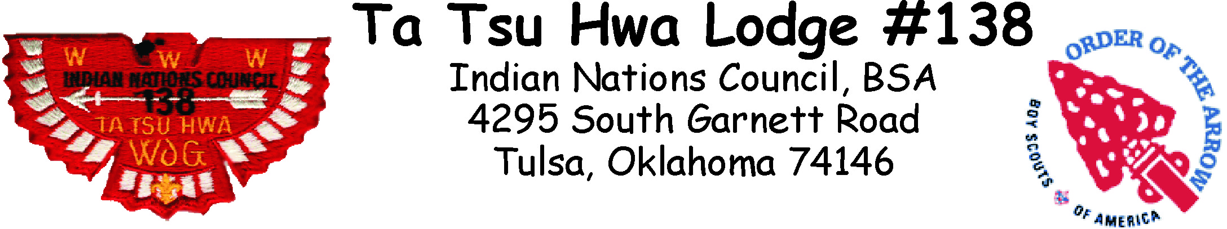

Dear Scoutmasters,

I would like to invite you and your troop to the annual Order of the Arrow Service Weekend, on May 17-19 at the Hale Scout Reservation.

The OA Service Weekend is a weekend camping opportunity for your Troop which is sponsored by our Lodge. Your meals will be provided for you in the dining hall. There will be a special patch to all Scouts and Scouters, Arrowmen and non-Arrowmen. This is an excellent opportunity for those new Scouts who have joined your Troop to experience Hale before their first year at summer camp.

All we are asking is some help finalizing the preparation of the camp for the summer camp program. Most of the camp has been set up already by our Lodge and there are just a few things that need to be done. They all can usually be completed by lunch time so the rest of the day you’ll be free to enjoy some activities at the camp.

We are going to have a great time. The pool should be open so bring you trunks, if the pool is unavailable then we will have free use of the lakefront area. Also remember to bring a sleeping bag, cot and anything else you may need for a weekend at Hale. We have a lot of great activities planned. The event is **free** all you need to do is sign up so we know how much food to order. Enclosed is a copy of OA Service Weekend sign up form.

I am looking forward to a great weekend and hope to see everyone there.

Yours in Scouting,

Jacob Rampy

Lodge Chief

Ta Tsu Hwa Lodge

C:\Users\tatsuhwa\Desktop\image002.png