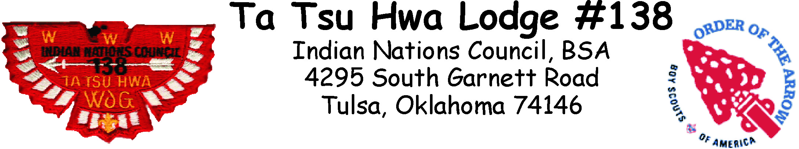
Registration Form

Lodge Awards & Recognition Banquet
Saturday, January 5, 2019
Spirit Bank Event Center
10441 S Regal Blvd., Tulsa, OK

5:30 pm – Gathering Period
6:00 pm – Dinner & Awards

Name |  |  |  |  |  |  |  | Phone
Address |  |  |  |  | City |  |  |  |  | Zip

Email
OA Chapter |  |  |  |  |  | Unit Type and Number

Payments for Banquet must be made by Friday, Dec. 21, 2018
Payments will not be accepted after this date.

________ Tickets @ $25 ea. = $ ___________

Make checks payable to: Indian Nations Council, BSA
Donald W. Reynolds Scout Resource Center
4295 S. Garnett Road
Tulsa, Oklahoma 74146
918.743.6125
www.okscouts.org
www.okscouts.org

Event #6010

