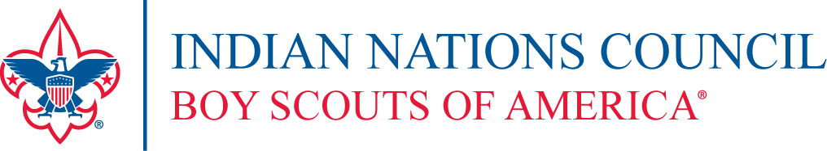

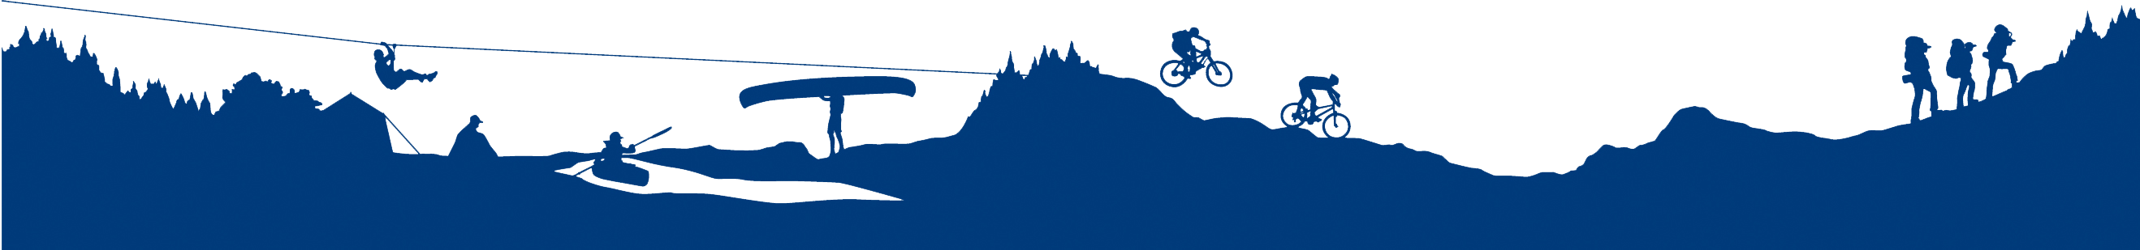

**Register online at:** <https://scoutingevent.com/calendar.php?OrgKey=BSA488>

**Event #6601**

Donald W. Reynolds Scout Resource Center

4295 S. Garnett Road

Tulsa, Oklahoma 74146

918.743.6125 www.okscouts.org

--------------------------------------------------------------------------------------- --------------------------------

**Vertical Reality Event – Climbing – Cherokee Nation Scout Ranch** May 12th, 2018

|  |  |  |  |  |  |  |  |  |  |  |  |  |  |  |  |  |  |  |  |  |  |  |
| --- | --- | --- | --- | --- | --- | --- | --- | --- | --- | --- | --- | --- | --- | --- | --- | --- | --- | --- | --- | --- | --- | --- |
| Name | | |  | | | | | | | | | | | | Phone | |  | | | | | |
| Address | | | |  | | | City | |  | | | | | | | | | | | Zip | |  | |
| Email | |  | | | | | | | | | District | | | | |  | | | | | | |
| Registered Scouting Position | | | | | |  | | | | Unit Type | | |  | | | | | | Unit # | |  | |
| BSA ID # | | | | |  | | | Age: | | | |  | | | | | | | | | | |
| ❑ | $ 15.00 Fee for Vertical Reality Event | | | | | | | | | | | | | Receipt # | | | |  | | | | |
|  | **Fees payable to “BSA”** | | | | | | | | | | | | Receipt Date | | | | |  | | | | |
|  |  | | | | | | | | | | | | |
|  |  | | | | | | | | | | | |

**Vertical Reality Tour – Climbing**

**At Cherokee Nation Scout Ranch, on May 12th, 2018**

Come join us for the day to experience the climbing activities at Cherokee Nation Scout Ranch, with Council Instructors. This is your opportunity to join in the fun, see what our Council facilities have available to you and your Troop or Crew and for adult leaders to learn more about Instructor Training prospects.

* Does your Unit not have trained Climbing Instructors? Then this is the event for you!
* Come enjoy a day on the rocks, without planning an event.
* We encourage Units to incorporate this programing into your Units Campout.
* This is a unit based event so two deep leadership applies. If a unit only has a single participant attending and two leaders are not available, a legal guardian or parent must be present for the entire day

**Important Event Information (please read):**

* Each participant must be currently registered as a Boy Scout or Venturer to participate – this is not an open session to individuals interested in joining BSA
* Because this is a three-part event, which includes the COPE Course, Natural Rock Climbing and the Mega Zip. These events are closed to Cub Scouts.
* You must provide a current health form (part C optional) at check in where a wristband will be provided by staff for clearance during the day.
* Units are encouraged to make this a campout weekend but they must make their own, separate, arrangements for campsite reservation as per normal council process.
* All participants shall provide their own food and drink as desired for the day.
* You may bring your own personal helmet and harness for use after being inspected and approved by event staff.

**Dates:**

May 12th, 2018 - Saturday – Cherokee Nation Scout Ranch, Welling, OK – 8:30am - 5:30pm

**Fee:** $ 15.00 includes Patch, Snack, and Equipment.

Registration Deadline: Thursday, May 10th, 2018

COPE & Climbing Program Manager:Kyle Driscoll (918) 392-1228 or [KDriscoll@okscouts.org](mailto:KDriscoll@okscouting.org)

Climbing Chair: Chris Falkensten (918) 645-7494 or [INClimbing@gmail.com](mailto:INClimbing@gmail.com)