
CAMP LOCAL

Did you know Last Frontier Council has 6 Council Camps?
Kerr Scout Ranch John Nichols Scout Ranch Diamond H Camp George Thomas Camp Sasakwa Dripping Springs
CAMP LOCAL…Make connections with other local scouts. Support your local council. Be part of the scouting legacy at one of the camps. Show your Pride for your camps, do a service project for your local camp. We are Oklahoma Strong. We are Scout Strong.

Dripping Springs
This is one of our primitive camps. This camp has 5 campsites. It is located between Clinton and Weatherford. Some of the program areas are as follows:

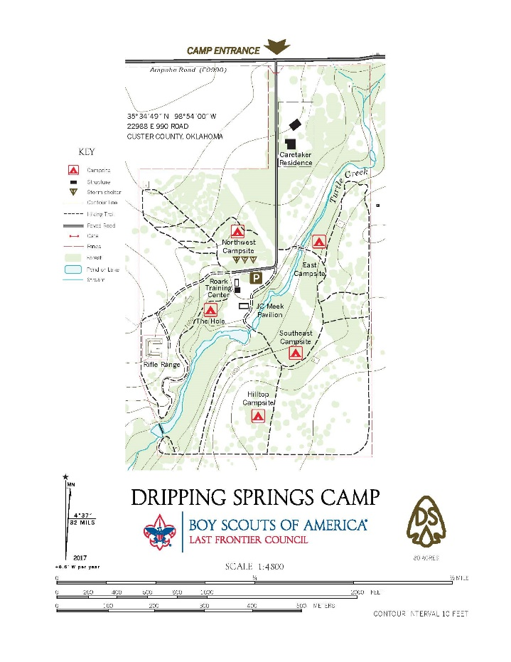
- Roark Training Center
- JC Meeks Pavilion
- Council Ring
- Chapel
- BB Range
- Archery Range

