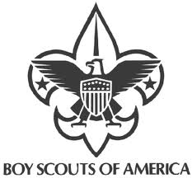
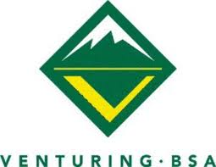
LAST FRONTIER COUNCIL
KLONDIKE DERBY
January 29-31, 2027

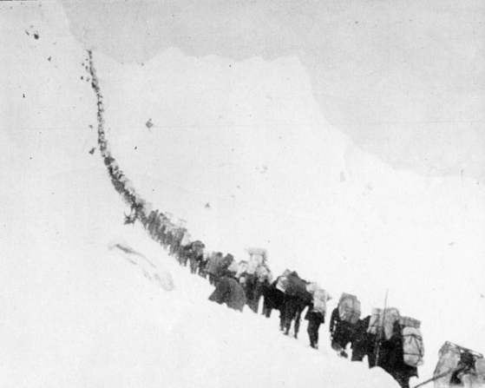

Where is everyone going?

Williams Scouts Reservation
Hwy 412
Cleo Springs, OK
Klondike Derby Setting
In August 1896, prospectors George Washington Carmack, Skookum Jim, and Dawson Charley discovered gold on Rabbit Creek (renamed Bonanza Creek) in the remote Klondike region of Canada's Yukon Territory. News of the Klondike discovery spread slowly over the next year until miners began to return with their fortunes. In July 1897, the S.S. Portland arrived in Seattle, Washington, with more than a ton of Klondike gold on board. This event touched off the great Klondike Gold Rush as thousands of people who dreamed of becoming wealthy began booking passage on steamers heading north from Seattle and other West Coast ports. Upon arriving at the northern end of the Inside Passage, however, these adventure-bound stampeders found no easy route leading to the still distant Klondike region. The most direct route involved climbing over either the White Pass Trail from Skagway, Alaska, or the Chilkoot Pass Trail from Dyea (pronounced Die-ee) to Bennett Lake, the headwaters of the Yukon River. Stampeders then had to build a boat to navigate five hundred miles down the Yukon River. Their destination was Dawson City, a town that developed near the gold fields. So, load up your sleds with supplies, harness up your huskies and make your way to Dawson City for” Thars gold in them thar hills! ”

BSA Requirements
Youth must be a registered Scout, Venturer, or AOL to participate in the Klondike for insurance purposes. Two Klondike Unit Leaders (adults) are required to be responsible for all youth accompanying a unit. All leaders are required to be trained in youth protection. One leader must be at least 21.

GENERAL KLONDIKE INFORMATION:
Each "Dog Team" (so-called because Scouts function as Huskies), will follow a course along an outline on a map given to the acting dog team leader (Handed out at the flag ceremony on Saturday). The maps guide the teams over a field course from start to finish.
To survive this arduous journey, you will need to be on top of your Scouting skills. The trail is a brutal one, you will need your entire team involved to quickly assess the challenges along the way, devise a plan, and execute it to survive. Depending on how well the team works out this challenge, it will be awarded a number of "gold nuggets". Each stop MUST be visited in the correct order for the patrol to participate. All patrols must follow the entire trail. Demonstrating proper mushing commands and the use of patrol cheers may result in additional rewards.
After completing the trail, report to the Canadian Imperial Bank in Dawson Dining Hall to register your gold.

Sled Operation
Driving a Klondike sled is called mushing and requires the huskies to work together as a coordinated team. One Scout out of the patrol is called the musher. This position should rotate among the Scouts during the day. The musher is the Scout at the back of the sled and usually helps to push. When travelling fast, it may work better for the musher to stand on a ski with one foot and push with the other. This is called kicking.
The rest of the Scouts are called huskies. Each team has a harness (usually a loop of nylon webbing) which is attached to the front of the sled by a rope. Each husky should have their own rope, rather than branching a single rope to more than one harness. The sled should also be equipped with a brake on the back. The musher oversees the team. They use the commands below to direct the team. To give a command to the entire team, they just say it. To give it to one person or a few people, they say the name of the person followed by the command.

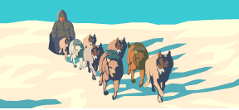

Hike- Start moving.
Haw- Turn left ("Haw, like southpaw").
Gee- Turn right ("Gee, that's right"). Pronounced "jee"
Good- Keep doing what you are doing.
Easy- Slow down but keep moving. Do not let the rope go slack.
Pick it up- Go faster.
Gee over- Move to the right side of the trail.
Haw over- Move to the left side of the trail.
On By- Keep going straight, passing other teams.
Whoa- Stop.

It is important to remember that the musher is not the boss, but the leader of the team. The musher cannot just decide that they want to go fast and expect the team to do so. Rather, the team must decide together how fast they want to go, that is, what their objectives are. Once the decision is made, the musher is responsible for coordinating the team to carry out what they have all decided to do. Teams should consider how they will work together to control descents, hill climb and maneuvering side of hills.
Klondike Derby 2027 Schedule
Friday, 29 Jan.
6:00 pm Check-in registration begins @ Dining hall.

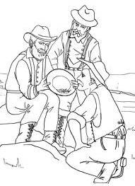
Saturday, 30 Jan.
7:00- Reveille
8:00- Flag raising @ Parade grounds.
9:00- Klondike derby begins.
11:30- Stations closed for lunch
Teams need to take lunch on the sleds with them.
1:00- Stations reopen.
3:00- Finish Race
3:30- Scavenger hunt over
5:00- Flags
5:30- Dinner at campsites
7:00- Campfire, Skits and Cracker Barrel
Sunday, 31 Jan.
7:00 - Reveille
8:00 - Chapel

BE PREPARED
CLOTHING: One of the most important requirements is to know how to keep warm and dry. Each scout must know what to wear. Winter weather is very changeable, requiring preparedness for almost any condition. A nice day can turn into a raging blizzard. Just before the turn of our century, men raced by means of dogs and sleds across the frozen wastes of Alaska in search of gold. They camped out in all kinds of winter weather. They had to be prepared with adequate survival knowledge. Utilizing the knowledge of the native Eskimos, the "gold rushers" survived. Scouting has capitalized on this theme and has developed the Klondike Derby as an activity for Boy Scouts and Ventures. Traditionally the purpose of which has been a test of how well Scouts are prepared for cold weather and possible adverse conditions. Your best piece of cold weather clothing is your mind! Dress to be dry, don't do any activity fast enough to sweat, remove layers, or add layers to accomplish this. Cold weather camping requires adequate clothing and waterproof boots to protect the camper and yet be versatile enough to prevent sweating during activity and keep the boy warm during idle periods. Layered clothing meets this requirement. A second and third change of inner clothing will be required for your boy's personal safety and comfort. A wool stocking cap or similar head covering is necessary both during the day and at night in the sleeping bag to retain warmth.

SLEDS: Klondike style sleds or sledges must be built or put back in shape (don't forget to wax the runners). If a patrol does not have a sled, build one (many plans available on the web). Toboggans and store-bought sleds will not be allowed to participate. Incidentally, don't let the idea of sleds scare you. It is not essential to have snow for this event. In the event there is no snow, ensure you build a sled that you can add wheels to. If there is snow the wheels will have to come off. The decision for wheels during the derby will be made on the day of the derby.
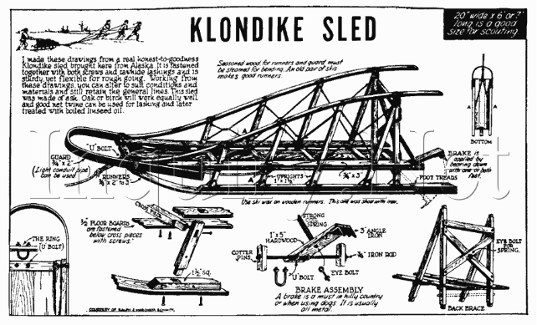
KLONDIKE RULES, EVENTS AND SCORE KEEPING
1. CLOTHING INSPECTION
Each scout will be inspected BY YOU (Scoutmaster or adult leader present) before he takes off on the trail. (Check list is later in this leader’s guide) If any boy is not adequately dressed, he will not be allowed on the trail. This ruling will be rigidly enforced. Please save the hard feelings and see that your Troop is prepared.
a) Clothing - proper and warm for existing conditions. Dress in layers of clothing.
b) Footwear - proper for existing conditions, no tennis. Wear wool socks over a pair of cotton or even better wicking ones. Do not wear low-cut shoes (no tennis shoes) unless covered by a pair of galoshes.
c) Headgear - to cover head and ears (scarves recommended). Wear a head protector which has ear covering. An added scarf will protect the face from the cold and biting wind.
d) Hand gear - to protect a vulnerable part of the body. Hands should be protected with wool mittens covered with a water repellent shell. Gloves may be worn but are not as warm as mittens.
2. FIRST AID STATION
Located in the Admin Building, this area is manned throughout the derby. Also, there is a warming area for your "EMERGENCY" that is NOT to be used for other purposes. The whole idea of the Klondike is to train boys for OUTDOOR WINTER ACTIVITY. Hot Chocolate is available OUTSIDE at this location as well as along the trail.

3. WEATHER
Traditionally the purpose of the Klondike Derbies over the years has been a test of how well Scouts are prepared for cold weather and possible adverse conditions. Therefore, unless the weather reaches dangerous conditions -- the DERBY WILL GO ON! (This will be determined at the site).

4. PRE-REGISTRATION
Send in the pre-registration form to the Council Office with your unit's $10/scout fee so it will be delivered prior to the "Early Bird" date of 01/08/2027.
􀂾 Included in the fee:
o Patches
o Awards
o Hot Cocoa

5. COMPLETED REGISTRATION
Bring a copy of the completed Klondike Registration Form with you to the Derby. Scout Troops and Venture Crews check in on FRIDAY after 6 p.m. then proceed to their campsites to set up their REGULAR TENT camps. Troops start Klondike competition at 9 am.

6. PATROLS
This year's Klondike will be a traditional Scout patrol-based event. Let the patrol succeed or fail on the strength of its members. Scout leaders DO NOT accompany their scouts. Patrol members must work together to navigate the course and complete the events. The team size is preferably 5; 1 musher and 4 huskies which will rotate during the competition.
7. PATROL EQUIPMENT (must be on your sled throughout the day)
􀀀 Klondike sled
􀀀 Compass
􀀀 Patrol Flag
􀀀 6 ft. length of knot tying rope per scout
􀀀 Poles and lashing twine (4 – 5 ft lengths, 4 – 3 ft lengths, and approx. 70 ft of twine)
􀀀 One 20 ft. rope per sled
􀀀 Flint and Steel preferred or matches (More points for using flint and steel)
􀀀 First Aid Kit, triangular bandages, and Splints
􀀀 One Blanket
􀀀 Scout Handbook
􀀀 At least 2 gallons of drinking water, contained in a 2 or 2.5 gal. jug.
􀀀 Tarp
􀀀 Every participant will need his own mess kit (cup, bowl, and spoon) for meals.
􀀀 One 1 qt. pot to boil water over an open fire
􀀀 Sack to hold your gold.
􀀀 Spare coat, hat, gloves and boots

ADDITIONAL EQUIPMENT NEEDED
PERSONAL: Recommended – TWO (2) Sleeping Bags & Ground insulation pad (if sleeping overnight) Pocket Knife, Compass, 2 Flashlights, Spoon, Bowl, & Drinking Cup (no paper products supplied), Scout Handbook, Adequate layers of clothing, Adequate footgear, headgear, and hand gear.
TROOP: Saw, axe, Propane stove and lantern, cooking gear…
EQUIPMENT: All meals will be cooked in your troop/crew camp site. Bring your own food, cooking gear, tents, rope, twine, waterproof ground covers, adequate tarps for shelters, lanterns, and other troop gear needed for winter camping. Consider erecting a warming tent or shelter for your site.
8. Miscellaneous
There will be no water available in the campsites. Plan accordingly. (5 gallons of water per person per day)

9. EVENT SPECIFICATIONS
Teams will be rewarded with gold for each skill event. "GOLD" will be awarded for participation in these activities. Here's how to earn "GOLD" at the Klondike:
The Events | Description
Obstacle Course | Lead your sled team through a course.
Fire building. | Build a fire, boil water.
Trail Trauma | Build a stretcher and carry your injured scout
Tie up your dogs. | Demonstrate your ability to tie scout knots to secure your load of gold and provisions for transport.
Hatchet Match | Use your hatchet to light the match.
Bear bag | Secure your gear from grizzly bears for the night.
Get the gold. | Recover a bucket of gold from the middle of a dangerous sinking bog.
Trail navigation | Use a compass to safely navigate the trail.
Spend the night. | One nugget per team member/night.
Sing and act. | Gold nuggets for song or skit performed at Saturday night’s campfire. You must file a claim at the Dining hall by 3:30 PM Saturday.

