December 12, 2024

Dear Scouts and Scouters,

As unit leaders, you have first-hand knowledge of the tremendous positive impact Scouting has on Scouts, their families and their leaders. Each week, volunteer leaders like you provide educational, values-driven, family fun! Your efforts help youth gain knowledge and confidence, strengthen families, and build future leaders. That’s something to celebrate!

On Saturday, February 1st, 2025, the Muskingum Valley Council will gather as a family to celebrate Scouting, recognize our Council Youth, Unit Key 3, District Key 3, and Council Volunteers. We will recognize our volunteer leaders and highlight your achievements over the last year. Every unit is invited to join the celebration, the camaraderie, and the accolades!

The event will again be at the Deerassic Park Education Center and the cost will be just $10 per person (youth or adult).

Please put this event in your unit calendar and invite your Scouts and their families.

The Unit Planning Guide is attached, and can be found online via the link, sponsorship form for units, parents, family, friends, businesses, and individuals, as well a program example for potential sponsors is included. The planning guide includes all the details for the fun and excitement to be had by all, to include a Unit Flag Parade, a Unit centerpiece contest, and door prizes!
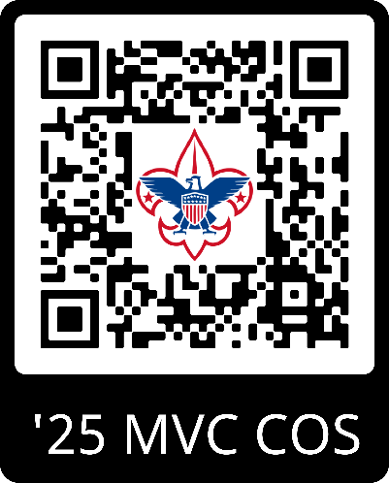
https://www.scoutingevent.com/467-25CelebrationOfScouting

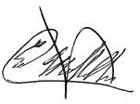
Yours in Scouting,

Ed Mulholland | MVC Retired Scout Executive/CEO
Chair of the Celebration of Scouting
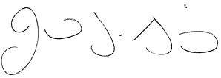

Jared F. Smith | Scout Executive/CEO
Muskingum Valley Council, Scouting America
734 Moorehead Ave, Zanesville, OH 740.453.4709 | jared.smith@scouting.org

