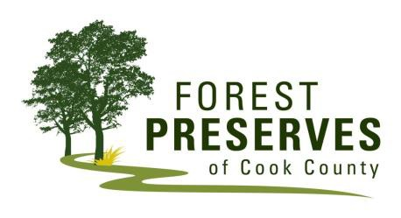
STUDENT RESTORATION FIELD TRIP AGREEMENT & WAIVER

The Forest Preserves of Cook County offers a variety of volunteer and service-learning field trips in about 69,000 acres of nature in Cook County.

During a field trip, activities may include, but are not limited to: brush cutting, seed collecting, weeding and other outdoor activities. During brush cutting activities, participants may learn to use hand tools, such as bow saws and loppers, and may be near a “working” brush pile fire.

Participants should come prepared by dressing to be outdoors in old clothes and shoes that can get dirty. Long pants and sturdy shoes (no flip-slops, sandals or dress shoes) are required. Wearing non-synthetic clothing, like cotton, is highly recommended. Dressing in layers and using sun protection (hat, sunscreen) is also recommended.

Parent/Guardian Agreement & Waiver
I give my child permission to participate in a Restoration Field Trip. I understand that there are certain risks of injury on any field trip. My child will make reasonable efforts to ensure his/her own safety and the safety of other Preserve visitors, other participants, and District staff.

I understand that any damage or injury which my child may cause to a third party is my responsibility, and liability and insurance for such damages or injuries is my own responsibility. This includes transportation and travel to and from the Forest Preserves. The undersigned releases and discharges the Forest Preserves of Cook County and its Commissioners, officers, employees and other volunteers from any claims which my child or I may have against them arising in connection with this field trip.

I have read and agree to the Restoration Field Trip Agreement & Waiver.

Participant Name
(print child’s first and last name)

Parent/Guardian Name
(print first and last name)

Parent/Guardian Signature Date

Optional Photo Release – I hereby grant and convey to the Forest Preserves all rights, title and interest in any and all photographic images and video or audio recordings made by or on behalf of the Forest Preserves during my volunteer work for the Forest Preserves, including, but not limited to, any royalties, proceeds, or other benefits derived from such photographs or recordings. I further agree that the Forest Preserves may photograph and/or videotape me while I am engaged in volunteer work at the Forest Preserves and that the Forest Preserves retain the rights to use these visual images and recordings in any manner without compensation to or prior authorization by me.

Please check one box. I agree to the photo release. [ ] YES [ ] NO

Workday Site Date

10-1-13 edition date

Matthew Bieszczat Volunteer Resource Center 6100a North Central Ave / Chicago, IL 60646 / p 773.631.1790 / f 773.792.0539

