
Checaugau District

SATURDAY, MARCH 14, 2026
8:00 am to 1:00 pm
Saint Andrew Parish Gymnasium
1658 W. Addison Street
NE corner of Addison and Paulina
Limited parking in the parish lot east of the building; street parking is available and free

$15 per scout - Advance registration required
Please register and pay on the PTAC website at:
https://scoutingevent.com/456-112161

OVERVIEW OF THE EVENT
Please arrive at 8:00 am (or earlier, but not too early) to check in. Registration and payment should be completed before the event. Be sure to bring the required equipment listed on the next page. All participating patrols must provide at least one adult leader to act as a scenario judge.
Patrols entered in the event should be no smaller than five (5) scouts and no larger than nine (9) scouts. Smaller patrols may be combined at registration. Webelos dens are encouraged to participate as well! (But with an extra adult to help with the group).
Patrols will compete in at least five different first aid scenarios. The judges will describe each scenario and will provide relevant background and information that the patrol must consider. Patrols will select a patrol member to act as a victim in each scenario, while the other patrol members will assess the situation, describe their approach to the situation, and apply the appropriate aid to the victim.
All scenarios will be judged according to the information in the most current edition of the Boy Scout Handbook or the current edition(s) of the First Aid Merit Badge.
Lunch will be provided at 12:00 Noon. After lunch, awards will be presented to the highest scoring patrols, and each scout will receive a commemorative patch. The event will end at 1:00 PM.

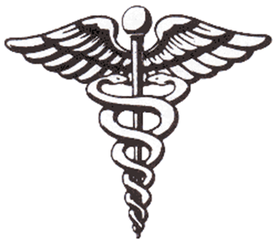

+ CHECAUGAU DISTRICT + FIRST AID MEET + MARCH 14, 2026 +

REQUIRED EQUIPMENT
Each patrol must bring the following equipment for use during the event.

- Two (2) sturdy poles, at least six feet long, capable of performing safely as stretcher supports.
- Sturdy blanket at least 6 feet by 6 feet
- Four (4) triangular bandages and 4 cravat bandages
- Splint material for arm and leg injuries
- Antiseptic (will not actually be applied) or realistic antiseptic simulator
- Four (4) 3” by 3” pads (can be utilized in packaging or simulators may be used)
- Tweezers
- Scissors
- First aid kit container, cardboard box, case, or other method for holding all small items yet allowing immediate access
- Notepad and pens and pencils for each patrol member
- A sense of humor and scout spirit
- A water bottle for each participant (beverages will not be provided)

