2025 Checaugau Mountaineer Challenge and Arctic Games

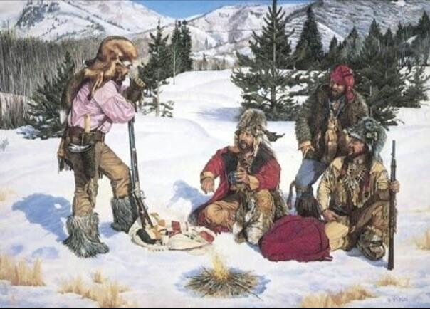

Saturday, January 25th, 2025
Camp Reinberg, Palatine IL
Check In begins @ 9:00 AM

Welcome to the 2025 Mountaineer Rendezvous and Arctic Games Challenge

Mountaineer Rendezvous and Arctic Games Challenge will be an opportunity for the Scouts and Scouters to get together for food, games and competition. It is a chance for the Scouts to get outside and utilize some of their scout skills as well as some physical challenges. It is also a chance for Scouters to come out and do what they do best, mentor youth, eat food and drink coffee. The event will be held at Camp Reinberg in Palatine, this camp has some great facilities. We will also have a concessions area for hot food, drinks and snacks. It should be an outstanding day. There are a few Cabins and Campsites that are available for rental, this can be done through the Cook County Forest Preserves Camping Program. This year we are trying to keep the equipment list to a minimum.

We will have Boys, Girls and Mixed Divisions
We also have a Webelos Division

Recommended Patrol Size is 6 - 8, We will allow patrols of 4 - 10 (More or less make it difficult to perform some of the events).
Our Arctic Games event will feature Games of Strength, Agility and Endurance.
Mountaineer Team Challenge : The team event will comprise 10 stations over two courses. Each course will have 5 stations. Once the patrol completes the course, it will be given an hour break before starting the second course. Both course times will be added together. The goal is to have the fastest time at the end of the day. Note: “Times may be modified due to factors that include, waiting for a station to open up, unscoutlike conduct, cheating and receiving help from leaders”. Teams will also be able to modify their overall times by competing and scoring in the top 5 of the Arctic Games Challenge.

The Stations will be as follows:

1. The Electric Fence : An old scout favorite, get your team and all of its gear over the top of a suspended rope - Fun, balance, agility and danger in one package.

2. Balance Beams: Scouts and their gear will need to cross multiple 4” x 4” beams

3. Sled Rescue: Sled will be placed 30’ away from the patrol. One member of the patrol will remain on the sled. The patrol will throw a rescue line to the sled. The Scout on the sled will tie a bowline around their waist. Once tied the sled and scout will be pulled to the rest of the patrol.

4. Fire Building : Patrols need to build a fire and boil a cup of water. Patrols are not allowed the use of accelerants or matches. (Tinder, kindling and fuel will be provided) Scouts will need to use only the provided materials to build their fires.

5. Rope Crossing : Another crowd favorite, balance, agility and teamwork are needed to complete this event.

6. Shelter Building: Teams will need to build a shelter that replicates the example at the station. Taut-Line Hitch, Half Hitch and Square knot will be primarily used.

7. The “Knot cube” : Scouts will need to replicate a knot puzzle. Knots that will be used are Half-hitch, two half-hitches, taut-line hitch, sheet bend, sheep shank, square knot, timber hitch, bowline, clove hitch, round lashing, square lashing and diagonal lashing

8. Improvised stretcher race : Scouts will use two 6’ poles and a tarp to create a stretcher and transport their victims over a course to safety.
9. Load and Go : Scouts will load their sled with sandbags and complete a set distance course.

10. Tripod Lash : Scouts will lash their 3 poles together to form a tripod, and then balance their sled (loaded with gear) on top of the tripod. The sled must stay there for 60 seconds without falling over.

Complete details of each event will be secret until the day of the event. Only the volunteers running the stations will have the complete details given to them, the day of the race. This will give the Scouts the challenge of planning on the fly.

Patrol Equipment List:
Sled
(3) 6 foot wooden poles
Fire Starter Kit (Striker, Flint and Steel, Battery and Steel wool)
Small Tarp
Blanket
First Aid Kit
50’ Rope (For throwing to rescue someone)
Enough rope for a tripod lashing

Each Scout:
Pocket Knife
Water Bottle (with water)
Boots (No Gym Shoes)
Proper Clothing for Conditions (Hat, Gloves and Jacket)
Can of Soup (To be turned in at registration)
Pocket Money for Additional Food (If wanted)

Patrols are not limited in the equipment that they bring, Listed above are the items needed to complete the race, as well as a couple things to have on hand to Be Prepared.

Adult Leaders can follow their scouts around the course, but are prohibited from helping. It is a great time to observe the strengths and weaknesses of each Scout. The Scouts will learn more from figuring out how to do something, rather than having it done for them. If Adult leaders are interfering, time will be added to the Patrol’s overall time.

SCOUTMASTERS: I will need Adult Volunteers to help run the Stations, I am hoping that each Troop can provide one or two adults to help with the program.

Arctic Games Competition : Skill, Strength, Agility & Perseverance will be tested. This event will not be easy. Each Patrol may enter ONE Scout per each of the 2 games. If you finish in the top 5 of any of the Arctic Games, you will have time shaved off of your patrol’s overall course time for the day. Please take the time to view these events on Youtube so the scouts can practice before the event.

The Events are as Follows:

1. Inuit Kneel Jump - From a kneeling position, jump up and lunge forward - landing on your feet. Must keep your balance or it doesn’t count. Everyone will get 3 tries, the furthest distance wins.
https://www.youtube.com/watch?v=NW4GBq82cX4

2. Inuit One Footed Jump - Jump up into the air and kick a suspended “target” with one foot and then land only on the foot that you struck the target with. Scouts will take turns hitting a height, If a scout has 3 unsuccessful attempts at a set height, they will be eliminated from the game. Last Scout left will be the winner.
https://www.youtube.com/watch?v=zcyEDFw-S9U

The Arctic Games events will be held indoors. Contestants can wear gym shoes for these events only.

Everyone, I am looking forward to a great event. If I missed something or you have any questions or Concerns, Please feel free to contact me at stevenpdelacruz@gmail.com
2025 Mountain Man and Arctic Games Challenge
Registration

Troop : ___________ Boys or Girls

Team Competition (Number of Scouts) : ______________ @ $10.00

Team Competition (Number of Patrols) : ______________ @ $10.00

Fees: $10.00 per Patrol

$10.00 per Scout per Event (Team or Patrol)

- Each Scout will also receive a Hot Dog, Bag of Chips and Bottle of water for lunch.

- Free soup and hot chocolate will be provided for All

- Additional Food for Scouts and Food for Adults will be available at a minimal cost

