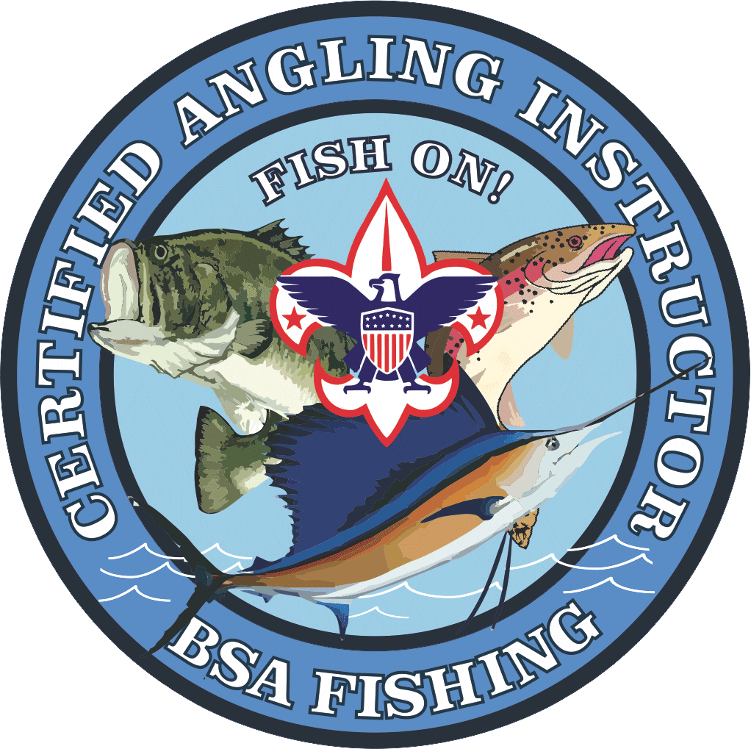

Paid by: Cash_________ Check (Enclosed)_________ Money Order (Enclosed)____________

Register online at <https://scoutingevent.com/444-CAIC>

Or Make check or money order out to Troy Fish and Game.

And mail this to:

Troy Fish and Game C/O Nick Gwin, 2618 Lefevre Rd, Troy OH 45373

**Acct. 6871**

Name___________________________________Unit#__________District__________________________

No. of years in Scouting ____________ Outdoor Camping Experience? Y N

Current Leadership Position ________________________

Trained Date ____________ Youth Protection Trained Date _______________

Address __________________________________ Email _____________________________________

City _______________________ St _____Zip____________ Phone_____________________________

**Emergency Contact:** Name_________________________________________Phone_________________________________

Any Dietary or Medical Needs:____________________________________________________________

This conference is facilitated by the BSA National Fishing Task Force, with a focus on providing enhancements to your BSA Fishing Programs. Course will cover Cub Scout, Boy Scout, and Venturing Fishing Programs held at the Unit, District, and Council Level.

Course delivers an understanding of the Mission and Vision of Outdoor Programs-Fishing, assisting in your efforts to Deliver the Promise. You will learn age based and skill appropriate fishing tools and techniques for your Scouts, ranging from the Cane Pole to Fly Fishing. The course highlights best practices on content delivery, in both the classroom and the field.

Email questions to [james.ridgeway@aes.com](mailto:james.ridgeway@aes.com) or call Jim Ridgeway 513-582-8469

* *Fee includes meals, course materials, CAI Patch & Certificate.*
* Course Graduates will become BSA Certified Angling Instructors (Training Code CS61). ***FISH ON!***
* CAI Resources: <http://bsafishing.com/>
* BSA Fishing Programs: <http://www.scouting.org/Home/OutdoorProgram/Fishing.aspx>

**Certified Angling Instructor Course**

Troy Fish and Game

2618 Lefevre Rd, Troy OH 45373

**July 17-19th, 2020**

**Course Fee:** $45/per person

**Registration closes** July 6th, 2020

Maximum Attendees: 24 Minimum Age: 15