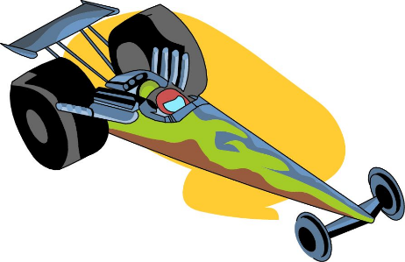
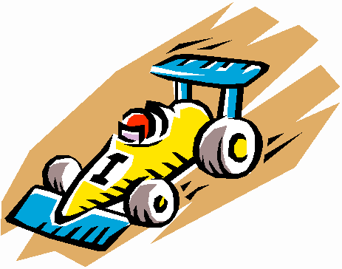
2023 Sunwatch District Pinewood Derby
Saturday, March 4th, 2023
200 West National Rd., Englewood, Ohio
Registration starts at 1:30pm, Race starts at 2pm

Once your Pack's race is run, you may register your "Overall Top Three" and your First Place Finisher in each Rank (Lion, Tiger, Wolf, Bear, Webelos and Arrow of Light - even if they have recently crossed over to a Troop) in the Sunwatch District Pinewood Derby. The Overall Top 3 are separate from First Place Finishers. Whichever Rank your Top 3 are from, the 2nd Place Finisher in that Rank would then move up to First Place. So, you may register a total of 9 Scouts to represent your Pack at the District Pinewood Derby. The pack may also include one car for Best in Show. This car does not race and will be judged solely on appearance.
Please let the youth do as much work on the car as possible. All cars must pass inspection to qualify for the race. The inspection points are as follows:
A. The car must have been made during the current school year (the year in which the District Derby is held).
B. Width - overall width shall not exceed 2.75” (2-3/4 inches). Minimum track width (space between insides of wheels) must be at least 1.875” (1-7/8 inches)
C. Length - overall length shall not exceed 7 inches. (Note: check your length, cars out of the box are sometimes over 7 inches.)
D. Height - overall height shall not exceed 3 inches.
E. Weight - Shall not exceed 5 ounces on our scale.
F. Wheel bearings, washers, bushings or hubcaps are prohibited.
G. No solid axles, only the official Grand Prix Pinewood Derby kits with nails for axles can be used. Wheel base cannot exceed 4.375” (4-3/8 inches) Center to Center of axle.
H. The car shall not ride on any kind of springs.
I. Dry Lubricant only. No Liquid Lubricant allowed.
J. Wheels can be sanded to remove surface imperfections, but the treads must be left flat. Wheels cannot be any smaller than 1.170” diameter. You cannot remove any significant amount of plastic - inside or outside of wheel. Only the Official BSA Pinewood Derby Wheels are acceptable. Cars with modified wheels will be disqualified.
K. Must have a .375” (3/8 inch) clearance under the car body. Any low hanging weights must be moved to another part of the car or recess into the bottom of the car to pass the .375” clearance.
L. Any details added must be within length, width, and weight limits.
M. No loose materials of any kind are allowed on the car. If anything falls off during or after a race, it stays off.
If you have any questions regarding these rules, please email Jon Wells at jswellsjr@gmail.com.
