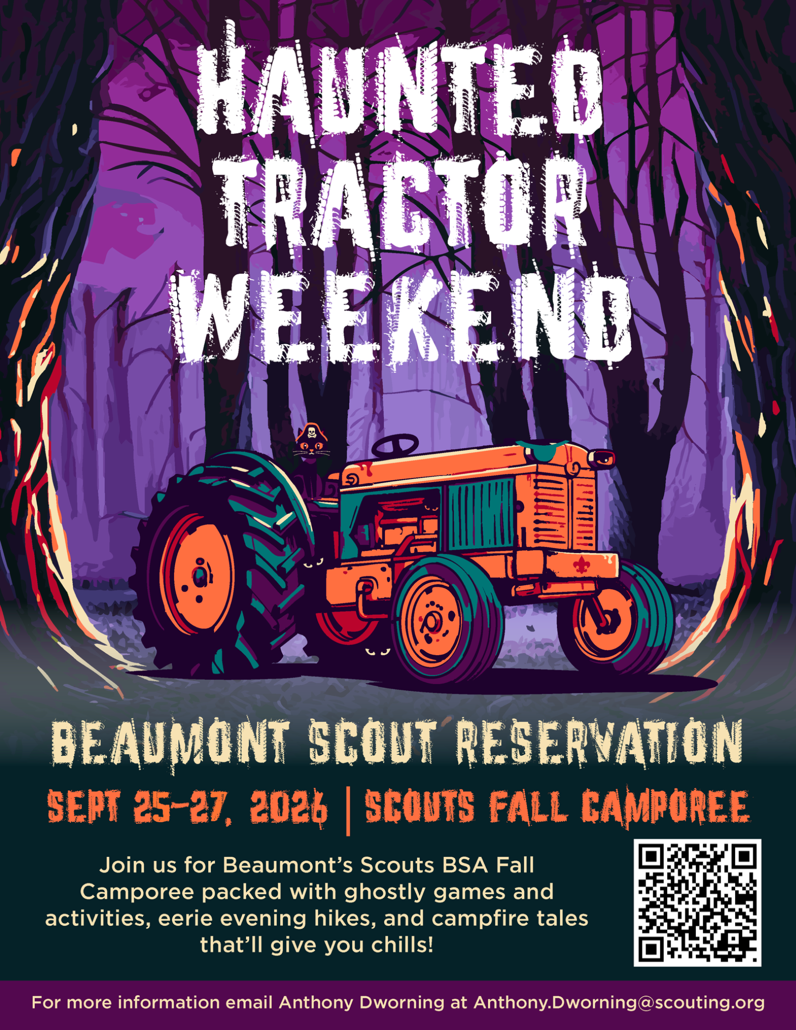

Haunted Tractor Weekend Leaders Guide
September 25–27, 2026 | Beaumont Scout Reservation
Haunted Tractor Weekend is Beaumont Scout Reservation’s Scouts BSA fall camporee. This guide gives unit leaders the information needed to register, prepare participants, enjoy the weekend program, meet health and safety requirements, and complete checkout.

Weekend at a Glance
Item | Details
Event | Haunted Tractor Weekend, Scouts BSA Fall Camporee
Dates | Friday, September 25 through Sunday, September 27, 2026
Location | Beaumont Scout Reservation
Saturday check-in | Begins at 11:00 AM
Friday camping | Available by advance reservation with Drew Denger
Youth pricing | $50 Early Bird | $60 Regular
Adult pricing | $30
Program focus | Daytime activities, evening Range and Target Activities and climbing, Glow Party, Haunted Woods, and the hike to the Haunted Tractor

Registration and Preparation
Units wishing to camp Friday night must contact Drew Denger in advance so he can reserve a campsite. The scheduled weekend begins Saturday, with check-in opening at 11:00 AM and lunch at Noon.
- Register every youth and adult participant and keep payments current under the published event fee schedule.
- Bring a fully typed unit roster for Jan Jury at check-in. Roster forms are available on the Council website.
- Bring a completed Annual Health and Medical Record.
- Review two-deep leadership, transportation, medication, dietary, and program needs with your unit before arrival.
- Plan for changing fall weather. Bring layered clothing, rain gear, a flashlight or headlamp, a refillable water bottle, and sturdy closed-toe footwear.

Program and Activities
Activities are offered throughout Saturday unless a specific time is listed. Final station locations and any program adjustments will be shared at check-in. Participation is subject to age, safety, staffing, weather, and capacity requirements.
Afternoon Program | Evening Program
• Cider Making | • Rifle, evening
• Pumpkin Smashing | • Saturday Night Glow Party
• Muzzleloader | • Saturday Night Hike to the Haunted Tractor
• Archery | • Haunted Woods
• Zip Line | • Night Climb
• Boating | Glow Shotgun
• Two-Man Saw | Archery
• Apple Smashing
• Nail Forging

Saturday Program Schedule
Time | Program
11:00 AM | Check-in opens
12:00 PM | Weekend begins with lunch: meatball subs, chips, cookie, and fruit cup
1:30–5:45 PM | Saturday afternoon program
6:00 PM | Flags
6:10 PM | Dinner: Salisbury steak, mashed potatoes, corn, and cobbler
7:30–11:30 PM | Evening program: rifle, Night Climb, Haunted Woods, Glow Party, and hike to the Haunted Tractor
11:45 pm | S’mores and nacho bar @ Augustus

Dining Services
The following meals are included in the event menu. Units should report allergies, dietary restrictions, and other food-service needs through the event’s established registration or communication process before arrival.
Meal | Menu
Saturday Lunch | Meatball subs, chips, cookie, and fruit cup
Saturday Dinner | Salisbury steak, mashed potatoes, corn, and cobbler
Saturday Glow Party Snack | S’mores and nacho bar
Sunday Breakfast | Eggs, cinnamon rolls, sausage, and pancakes

BeauMart Trading Post
Location: Camp Broadbent
Hours: Saturday 1:00 pm – 6:00 pm & 7:00 pm – 10:00 pm PLUS Midnight to 12:30

Volunteer Opportunities
We need volunteers to run activity stations. To volunteer, email Dan Goerndt and Anthony Dworning with the station you would like to lead. All standard materials will be placed at the assigned station. If you believe additional supplies are needed, notify Anthony, Dan, or Drew before the event.
Station mayors must check in at the Dining Hall before the program opens and then report to their assigned station. Station mayors are expected to staff their station from 1:30 to 5:45 PM. Please contact Dan and Anthony as soon as possible to reserve a station.

Medical and Health Services
- Every participant must have a completed Annual Health and Medical Record. This is especially important when a Scout attends without a parent or guardian.
- The Health Lodge is next to the Augustus Training Center and will be staffed 24 hours a day.
- Unit leaders remain responsible for participant medications and unit-level health supervision consistent with Scouting America requirements and event procedures.
- Drink plenty of water throughout the weekend.

Leadership and Participant Safety
- Two-deep leadership is required at all times.
- All adult leaders must be registered with Scouting America, be at least 21 years old, and have current Safeguarding Youth Training.
- Follow all instructions from range, aquatics, climbing, and event staff. Do not enter closed program areas.
- Wear sturdy closed-toe shoes for activities and travel around camp. Bring a flashlight or headlamp for evening programs.
- Use the buddy system and maintain appropriate unit supervision throughout the event.

Alcohol and Drugs
Possession or use of alcohol or illegal drugs is strictly prohibited. Violators will be removed from the event and may be prosecuted.

Parking Driving and Trailers
- Limit vehicles at the campsite to one vehicle per unit.
- Keep all vehicles on established roads. Driving off established roads can damage camp property and may leave vehicles stuck.
- Follow all posted signs and directions from staff regarding parking, trailer placement, and restricted roads.

Trash and Campsite Care
Dispose of all trash in the dumpsters at the McIntosh Parking Lot near the BeauMart, behind the Augustus Training Center, or at the McCahill Parking Lot. Units are responsible for keeping campsites clean and leaving them ready for the next group.

Check In
- Check in every participant without exception.
- Provide a fully typed roster to Jan Jury.
- Have medical records organized and available for review.
- Report participant changes and outstanding event needs during check-in.

Check Out
- Schedule a checkout time with Jan at the office.
- Fully pack and police the campsite before inspection.
- Event staff will inspect the site.
- Patches will be distributed after the site passes inspection. Once patches are received, the unit is cleared to depart.

Event Contacts
Name | Role | Phone | Email
Anthony Dworning | General Manager | 440-251-9368 | Anthony.Dworning@scouting.org
Dan Goerndt | Director of Programs | 440-376-9010 | Daniel.Goerndt@scouting.org
Drew Denger | Business Manager | 440-309-8740 | drew.denger@lecscouting.org
Caleb Molseed | Food Operations Director | 216-246-5880 | Caleb.molseed@lecscouting.org
David Metzger | Weekend Ranger | 246-469-2514

Unit Leader Final Checklist
☐ Registration and payments are current
☐ Typed roster is ready for check-in
☐ Medical form is complete for every participant
☐ Two-deep leadership and trained adult coverage are confirmed
☐ Dietary and medical needs have been communicated
☐ Unit has weather gear, flashlights, water bottles, and closed-toe footwear
☐ Checkout time is scheduled before departure

Important Reminder
DRINK PLENTY OF WATER
Event information and schedules may be adjusted for weather, safety, staffing, or operational needs. Unit leaders should review all updates provided at check-in and during the weekend.

