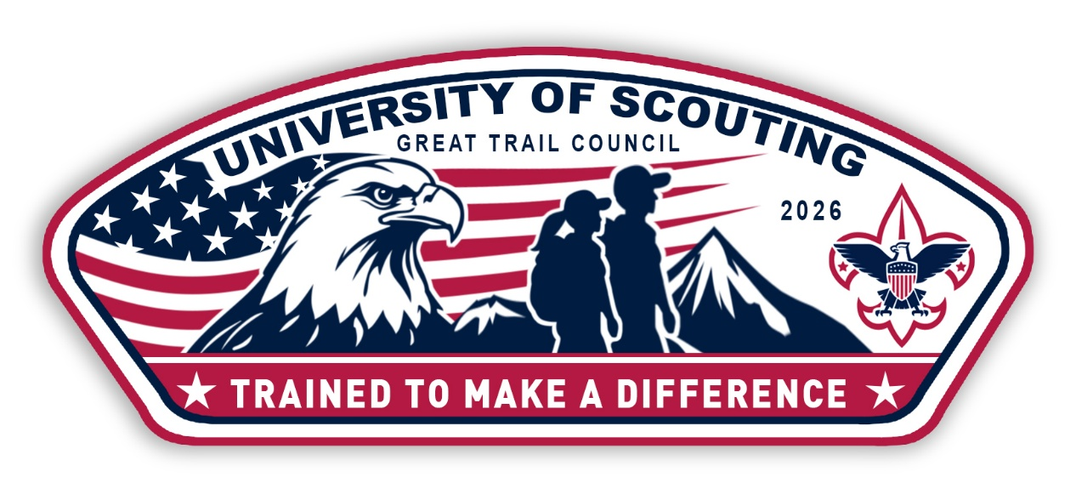
University of Scouting
Saturday, November 7th, 2026
Walsh Jesuit High School
Program Begins promptly at 8:30 am
Adult Scouters—program help is here!
NEW THIS YEAR
The College of Scouting Knowledge
and
The College of High Adventures
Join with
Cub College, Scouts BSA College, Universal Scouting College, General College
REGISTER HERE:
https://scoutingevent.com/433-uos
$10 registration includes: classes and patch
Lunch is available a la carte


