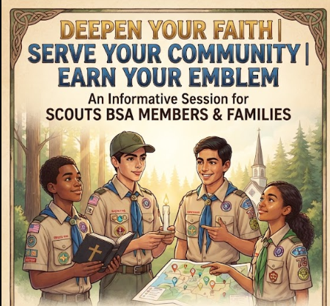

Discover Christian Religious Emblem Programs for Scouts BSA Members!
Join us for an informative session to learn how your Scouts can deepen their faith, serve their community, and earn their Christian religious emblem.
Why Attend?
- Explore available Christian religious emblem programs tailored for Scouts BSA.
- Understand the requirements, program materials, and timeline.
- Learn how parent, unit leader and counselor support helps Scouts grow in their duty to God.
- Get all your questions answered directly by experienced program counselors.

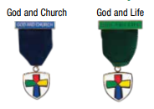
Event Details
- Date: Sunday, September 20, 2026
- Time: 7:00 PM – 8:00 PM
- Location: Camp Manatoc Conference Room
- Who Should Attend: Scouts BSA members (ages 12-17), their parents/guardians, and/or unit leaders
- Register here:
- Questions: Ed Martin (martinedp@outlook.com/330-350-1290)

