**2026 Canal District Chariot Race Rules**

**Our objectives include fostering creativity and providing a day of indoor family fun during the cold Ohio winter. Please display your Scout Spirit and help everyone have a fun day.**

The Chariot Race Rules Committee will make any rule change

and/or interpretation that they may deem necessary and appropriate.

1. Every racer must bring and wear a helmet when racing. The racers must wear tennis shoes/sneakers appropriate to a gymnasium. No loose shoelaces!
2. Scout Spirit is the overriding rule of the day. Good sportsmanship and Scout-like behavior are required. We are here to have fun.
3. Register your Pack by the announced deadline. See the calendar on [www.gtcscouting.org](http://www.gtcscouting.org).
4. A race team will consist of 3 Cub Scouts of the same or roughly same rank. Packs and Dens may enter more than one chariot/team. Each Cub Scout may participate on only one Chariot team. During the race a chariot will have 1 rider and 2 horses (cub scout pullers). If a team has more than 3 Cub Scouts, the cub scouts may rotate positions between races. If a team has cub scouts of different ranks, the team will race with the group of the highest ranked Cub Scout.
5. Chariots will be inspected on race day and those not complying with the construction rules must be corrected and may be disqualified at the sole discretion of the Race Committee.
6. Chariots may include detachable decorations for the judging of themes/costumes. If decorations exceed the dimensions of a race-ready chariot they must be removed before the start of the race.
7. The rider must remain inside the chariot, holding onto the ropes and on their knees throughout the race.
8. A team’s race is considered completed:
   1. All three team members are in their assigned position (runners and rider)
   2. Any portion of the Chariot crosses the finish line.
9. No lubricating substances of any type are permitted; they make the floor slippery and unsafe, and we would then need to wash the floor before the event may continue.
10. Chariots will race through a course, marked by cones. Time penalties may be assessed for knocking over, moving or missing cones.
11. Keep teams together to help the event run quickly. Volunteers will try to provide advance notice of an upcoming race, but it is the Cub Scout leaders responsibility to have their team ready.
12. The entire event including all preparation, execution and cleanup is conducted by Scouting volunteers. A post-race survey will offer participants an opportunity to provide feedback. For complaints, please see our volunteer coordinator with your offer to volunteer next year.

**Additional Race Day Information**

* **EVERYONE MUST WEAR A HELMET! NO EXCEPTIONS!**
* Gym-appropriate shoes are required. Shoes must be tied.
* Please know where your cub scouts are at all times and be ready to race on short notice.
* Pack leaders are responsible for their Cub’s conduct. Scout-like behavior is expected.
* Each Chariot leader (the adult responsible for each chariot) must check-in with the chariot. Pack/Den members need not come to the registration table. The racers and family should check in with their leaders in the stands.
  + We’re going to try (honestly, try) to start the program at 9:00 AM. Having your families check in with you in the stands will help speed things along.
* Chariots arriving late will be accommodated as best as possible without disrupting other racer’s experiences.
* Teams will race multiple times and may race back-to-back.
* Chariots will be stored in a pit area for the event.
* Each race is for time within your bracket. Any given heat may include teams from different brackets. You are racing for time, not against the other team in your heat.
* Each team’s time is based upon when a designated “part” of the team/chariot crosses the finish line. That “part” will vary from year to year as the event matures and based upon volunteer availability.
* Awards will be given for 1st, 2nd, 3rd place within each bracket. Brackets will include Cub Scouts of roughly the same rank.
* Additional awards will be given for various categories (design, decorations, Scout Spirit…) as determined on race day by the Senior Patrol Leader(s) of the Scout Troops operating the event. Such categories will be determined on race day and will not be announced in advance.

**Chariot Race Team Form**

**Please complete and submit to poormansw@gmail.com by January 24, 2026**

|  |  |  |  |  |
| --- | --- | --- | --- | --- |
| **Pack** | **Leader Name** | **Number of Cubs Participating** | **Chariot Team Names** | **Cub Scout Rank(s)** |
|  |  |  |  |  |
|  |  |
|  |  |
|  |  |
|  |  |
|  |  |
|  |  |
|  |  |
|  |  |
|  |  |

**Canal District Chariot**

**Construction Rules**

1. The chariot must be constructed from a cardboard/corrugated box that is:
   1. A minimum of 18 inches wide and a maximum of 24 inches wide,
   2. Up to 36 inches long, and
   3. Up to 20 inches high.
2. Over the years we have determined that there are no pro’s and con’s of having a box with four sides vs. three sides and either way is acceptable. (***see illustration A***).
3. Two 1x4 boards will be placed (one on the outside and one on the inside) 1/2 inch to 3/4 inch from the bottom of the box (***see illustration B***). This prevents the boards from damaging any floor surfaces.
4. The 1x4 will be held together with three bolts which must be countersunk in the front to prevent damage to the floor or injury to the horses in case of a rollover. The ends of the bolts on the inside must be covered, cut off flush with the nuts or countersunk to prevent injury to the rider. (***see illustration D***).
5. A terry cloth (bath towel) will be installed to cover the front board and the entire bottom of the box. Only terry cloth material will be accepted (***see illustration C***).
   1. No lubricating substances of any type are permitted; they make the floor slippery and unsafe, and we would then need to wash the floor before the event may continue.
6. Ropes - (***see illustration E***)
   1. Two ropes will be used for the outside pullers.
   2. Each rope must measure between 4 and 5 feet in length from the front of the box.
   3. There should be approximately 6 inches of rope on the inside of the box to install handles for rider.
   4. Place knots on the puller’s rope as shown in illustration ***(see illustration F)***.
7. Handles for the pullers and the rider must not exceed 4 inches in length. PVC pipe make good handles. Remove any sharp edges or burrs. For easy installation drill holes through the center of the PVC pipe. Place handles on rope and secure with more knots. (***see illustration G***).

**Canal District Chariot Race Construction Rules**

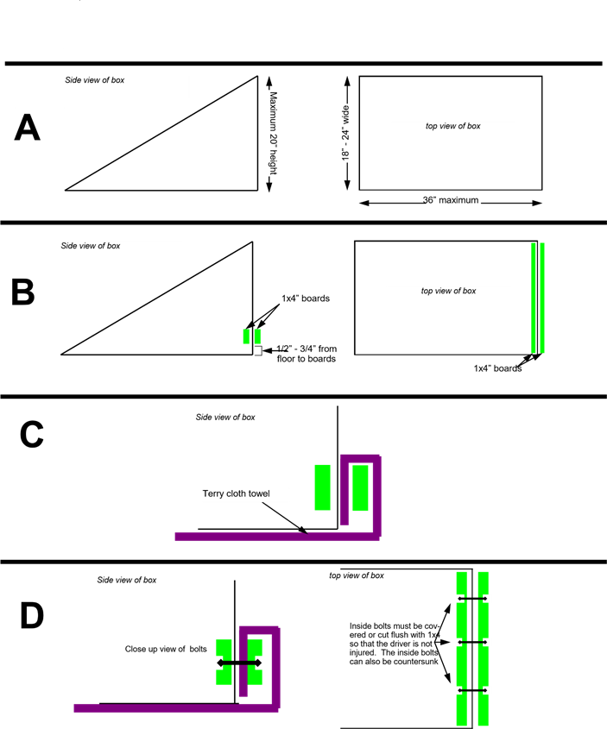

**Canal District Chariot Race Construction Rules**

