**2025 Canal District Chariot Race Rules**

**Please display your Scout Spirit and help everyone enjoy this fun event. To keep things moving, the Chariot Race Rules Committee will make any rule interpretation that may be necessary.**

1. The overriding objective is for everyone to have a great time. Talk with the Race Committee if you have questions or need to request an accommodation.
2. A registration date will be set. Registrations after that date may impact participation. Check-in, judging and race time will be announced separately. Chariots arriving late to check-in may be disqualified from judging and may be allowed to race as time permits.
3. A race team will consist of 3 cub scouts, preferably of the same rank. Any Den, combination of Dens or parts of a Pack, may enter more than one chariot and team. However, no cub scout may participate on more than one team without Rule Committee approval. During the race a chariot will have 1 rider and 2 horses (cub scout pullers). If a team has more than 3 cub scouts, the cub scouts may rotate positions between races. If a team has cub scouts of different ranks, the team will race with the group deemed appropriate.
4. **Everyone must wear a helmet when racing**. Bring your own helmets. **The horses must wear tennis shoes.** No loose shoelaces please!
5. Each team will make a chariot that meets the construction rules. Chariots will be inspected during the check-in process on race day. Each chariot must be in compliance with the construction rules prior to race start, or the chariot will not race. **Chariots may include detachable decorations for theme/costumes judging. If these decorations exceed the dimensions of a race-ready chariot they must be removed before the start of the race or the team will not be allowed to race.** If a chariot does not meet the requirements, the chariot can be changed to do so, if time allows. (Tools not be provided.)
6. The rider must remain inside the chariot, holding onto the ropes and on their knees throughout the race. If a chariot crosses the finish line without it’s rider, the chariot automatically loses the race.
7. For the safety of the horses, and so that we do not need to wash the gym floor, towels must not be treated with any substance (Pledge, Silicon Spray, etc.). These substances would make the floor slippery and would be a safety hazard.
8. Chariots will race through a course, marked by road cones. Chariots must go around the cones. Time penalties may be assessed for knocking over, moving or missing cones. Fewer knocked over cones means a faster lap. The winner of each race will be the chariot that crosses the finish line first (not the cub scout) and/or has the least amount of penalties. Fast and careful wins the race. Racers will have an opportunity to walk the course before racing.
9. To keep the race running smoothly, it is important that the scouts stay with their team. Teams will be called to be on-deck. If the team is not complete prior to their race start, the team’s race will be delayed and may be forfeited.
10. Good sportsmanship and behavior are required! Anyone not following the rules may be asked to leave the race. - HAVE FUN!

**Canal District Chariot Construction Rules**

1. The cardboard or corrugated box must be a minimum of 18 inches wide or a maximum of 24 inches wide. It can be any length up to 36 inches long. The height must not exceed 20”. There are pro’s and con’s of having a box with four sides or three sides—either way is acceptable. (***see illustration A***).
2. Two 1x4 boards will be placed (one on the outside and one on the inside) 1/2 inches to 3/4 inches from the bottom of the box (***see illustration B***). This prevents the boards from damaging any floor surfaces.
3. A terry cloth (bath towel) will be installed to cover the front board and the entire bottom of the box. Only terry cloth material will be accepted (***see illustration C***).
4. The 1x4 will be held together with three bolts which must be countersunk in the front to prevent damage to the floor or injury to the horses in case of a rollover. The ends of the bolts on the inside must be covered, cut off flush with the nuts or countersunk to prevent injury to the rider. (***see illustration D***).
5. Ropes - (***see illustration E***)

Two ropes will be used for the outside horses. Each rope must measure 4 feet to 5 feet from teh chariot. There should be approximately 6 inches of rope on the inside of the box to install handles for rider.

Place knots on the rope as shown in illustration ***(see illustration F)***.

1. Handles for the horses and the rider must not exceed 4 inches in length. PVC pipe make good handles. Remove any sharp edges or burrs. For easy installation drill holes through the center of the PVC pipe. Place handles on rope and secure with more knots. (***see illustration G***).

**Race Day Information**

* Teams will await thier turn in the gymn bleachers. Parents and spectators will also sit in the bleachers, so please try to keep the teams together to speed racing.
* Some teams may race back to back.
* **EVERYONE MUST WEAR A HELMET! NO EXCEPTIONS!**
* Make sure tennis shoes are tied tightly.
* Chariots will be stored in the pit area and brought to the starting line wither the Cubs will take possession for the duration of the race.
* If a horse drops a rope they can attempt to rejoin group or sprint to the finish line. If they trip or fall please instruct them to let go of the rope so they are not dragged along the gym floor.
* The heat winner is determined by which chariot crosses the finish line first—not the cub scouts.
* Winners are based upon time.
* ***Please visit the concession stand.***

**Canal District Chariot Race Construction Rules**

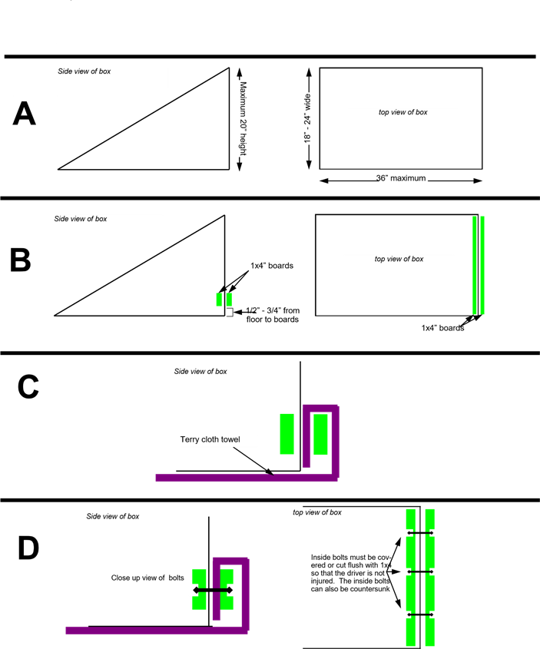

**Canal District Chariot Race Construction Rules**

