Camp Wilderness

Winter Camp

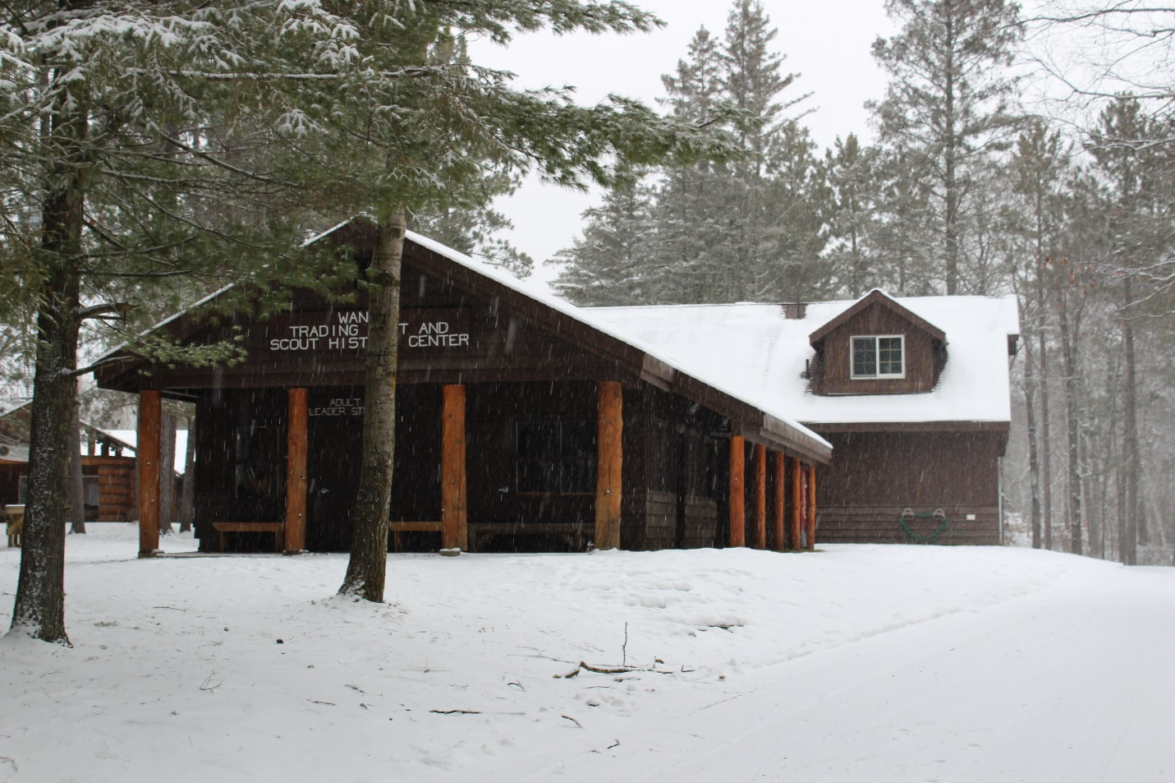

**2019-2020**

Camp Phone: 218-732-4674

**Dates:**

Winter Camp begins January 3rd, 2020 and runs every weekend through March 7th, 2020. Groups are encouraged to spend the night at camp, but day trips are always welcome!

The Wilderness ROMP is on February 8th. Every unit signed up for the weekend of the ROMP must pay the ROMP fees as well.

The Polar Cub Camp is March 7th and is open to Cub Scout families only. Every Pack that signs up for the weekend must pay the Polar Cub fees as well.

If your unit would like to make other arrangements,

please contact the Center for Scouting toll free at 877-293-5011.

**Location:**

Camp Wilderness is located 17 miles north of Park Rapids, Minnesota. It is nearly 2400 acres of largely underdeveloped forest area with many pine and birch trees. Camp Wilderness borders two lakes and has six more within its boundaries. The camp is home to abundant wildlife such as ospreys, loons, bears, wolves, deer, and bald eagles.

**Changes and Reminders to Winter Camp:**

Decisions to cancel winter camp will be made no later than noon on the Friday camp is supposed to start. We want to make sure we have all the accurate weather information available to make sure your Scouts are safe! If camp is cancelled you will be able to switch to a different weekend with no penalties.

Check in is from 7:00 pm to 9:00 pm on Friday night. Check-in will be at the Silver Beaver Lodge or the lower level of the Cub Scout Jones Tower depending on which camp you are staying at.

If you are not able to make it to camp for any reason Friday evening, please contact Camp at 218-732-4674 to let them know so they are not waiting for your group to show up.

**Reservations:**



Reservations for the upcoming winter camping season are open online at www.nlcbsa.org. A $50.00 deposit is required for each cabin reserved, the remaining balance can be paid online or when leaving camp. Please note, participant fees and outstanding lodging fees will be paid before leaving camp with your Campmaster. Please be prepared with a check or credit card.

**Cancellation Policy:**

Cancellation of winter camp must be made 30 days prior to your reservation date or the unit will be charged the full rental fee for the cabin. Fees are nontransferable to another weekend. In the event of a cancellation by the Council Program Director or the Scout Executive, fees will be refunded or transferable. Special circumstances may be reviewed by the Council Camping Committee. ***Payment in full is due at the time your Unit checks out of camp!***

**Food Service:**

We will be offering Food Service in the Dining Hall for the following weekends:

Jan 10-12, 2020 Jan 17-19, 2020 Feb 7-9, 2020

Feb 14-16, 2020 Mar 6-8, 2020

The cost is $22 per person for regular weekends and includes 3 meals on Saturday, and 1 meal on Sunday. ROMP and Polar Cub Weekend fee is $35.

You will need to have an exact count, along with any special dietary needs (peanut allergy, gluten free, etc.) called or emailed into the Fargo Center for Scouting two weeks prior to your arrival to make sure we have enough food available for all. Please make sure you let us know even if you are not wanting food service for the weekend.

MCj03965060000[1]**Facilities:**

All cabins have electric heat. The Fox Building sleeps 20 people. Cabins #1-8 sleep 9; Cabin #9 sleeps 7; Cabins #10-12 sleep 10, and Cabin #16 sleeps 11. The Nature Lodge has an upper and a lower level, each sleeping 20-25 people.

The Butler Wilderness Outpost has 4 corner tower buildings that are two stories each. The Setter, Scheels, Starion, and Jones Tower sleep 20 per level. The Towers have electric heat.

Camp and BSA regulations require separate accommodations for male and female participants. The following cabins help accommodate those needs without needing to rent multiple cabins:

* Cabin 9: One bunk is separated by a dividing wall from the others
* Cabins 10 – 12: There are five bunks on either side of a dividing wall
* Cabin 16: Two bunks are located in a separate room in the back corner
* Fox: Has two separate rooms from the main living area, each containing two bunk beds
* Nature Lodge: Each floor has a separate room that can easily accommodate multiple people
* Cub Scout Towers: Each tower consists of a general living area and two bunk rooms. Each bunk room is host to six bunk beds.

Water is provided at the Dining Hall of the Butler Wilderness Outpost, Nature Lodge, and both Youth and Adult Shower Buildings. Mattresses or cots are provided. Firewood is not provided, but can be gathered from the surrounding woods. Plan to bag your garbage and leave it in the dumpster prior to leaving camp. **Dishwashing is not allowed in the sinks in any of the Buildings!** This does not apply to the Nature Lodge which has a full kitchen on each level.

There is an electric 4 burner stove with an oven in the Fox Building and each level of the Nature Lodge. The Nature Lodge also has a fridge on each level. You need to bring your own cooking stoves if you are using a cabin that does not have a stove. Electricity is available in all cabins for electric stoves, crock pots, etc. If you are using a propane stove, you need to cook outside the cabin!

We will try our best to have the heat on before your arrival, however, depending on the amount of snow that may need to be removed to clear roads and parking lots the staff may not have time to turn on all the cabin heat.

**Camp Full Time Staff:**

The Northern Lights Council employs ***Andy Kietzman*** as a full time Camp Ranger, and ***Tom Barry*** as the Council Program Director. They keep the roads and parking lot clear of snow in the winter, run programming, and provide meal service. They have the responsibility and authority to enforce and carry out all Council policies pertaining to camp!

**Volunteer Opportunities**

Camp Wilderness has numerous volunteer opportunities to help our campers have a fun and enjoyable time! Those positions include being a Campmaster, helping in the kitchen, running program area, being medical staff or helping to plan and coordinate event weekends. Those who volunteer are not charged for their weekend at camp. If interested, contact Tom Barry at 701-499-0643 or [tom.barry@scouting.org](mailto:tom.barry@scouting.org) to learn more.

**Check-In:**

Check-in starts at 7:00pm on Friday night and goes until 9:00pm. If you are arriving at a different time, please call the camp to let us know when you will be arriving. Check-in and check-out will be handled by a volunteer Campmaster, Camp Ranger, or the Camp Director. When you arrive in camp, proceed to the Silver Beaver Lodge if you are staying on the Scouts BSA side (directional signs are posted) or Lower Jones Tower if you are staying on the Cub Scout side to check-in with the Campmaster. ALL cabins will be locked when you arrive. If the Campmaster is not present, he or she is checking in another group. Please wait for them to return to assist with your check-in. The Campmaster will open your cabin and will complete a checklist with you that indicates the condition of the cabin and the equipment in it. You will need to sign this checklist upon check-in. The Campmaster will go through the same checklist when you check-out. Your group will be charged for leaving the cabin dirty and for any damage. ***Graffiti will result in a minimum charge of $75!*** Failure to check-out with the Campmaster will make your Unit liable for any damage found in your cabin. The Campmaster must inspect your cabin and complete the checklist before you leave camp. Check-out of equipment will be done by the Campmaster.

**Possible Things to Bring:**

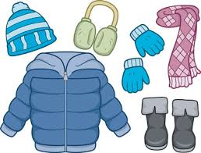Coolers for food, camp stove, Dutch Ovens, dish pan for washing dishes, extra sleeping bag for each Scout, sleds, skis, snow shoes, small pack for day hikes, winter fishing equipment, canteens or water bottles, extra mittens/gloves, extra boots/shoes and extra socks.

**Fees**

|  |  |  |
| --- | --- | --- |
| **Program Fees** (does not include lodging) | | |
|  |  | Cost |
| *All* Winter Camp Weekend Participants  (includes building heat, plowing, trail grooming, use of tubes/sleds, and Winter Camp patch) |  | $4.00 / person |
| Winter Camp Weekend Food Service *Optional* |  | $22.00 / person |
| Event Day Only  (ROMP, Polar Cub)  (includes program, lunch & dinner, and event patch) |  | $20.00 / person |
| Event Weekend  (ROMP, Polar Cub)  (includes event day fee, winter camp weekend participant fee, and weekend meals) |  | $35.00 / person |
|  | | |



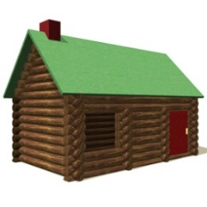

|  |  |  |  |  |
| --- | --- | --- | --- | --- |
| **Lodging Fees** | | | |  |
| Building | Capacity | Cost / weekend  Friday - Sunday | Extra Night | Co-ed Accommodations* |
| Cabins 1,2,3,4,5,6,7,8 | 9 | $85.00 | $42.00 | Single Gender |
| Cabin 9 | 7 | $85.00 | $42.00 | Co-ed |
| Cabins 10, 11, 12 | 10 | $85.00 | $42.00 | Co-ed |
| Cabin 16 | 11 | $85.00 | $42.00 | Co-ed |
| Fox Building | 18 | $141.00 | $68.00 | Co-ed |
| Nature Lodge Upstairs | 20 | $205.00 | $103.00 | Co-ed |
| Nature Lodge Downstairs | 20 | $191.00 | $96.00 | Co-ed |
| Scheels Tower Upstairs | 20 | $171.00 | $86.00 | Co-ed |
| Scheels Tower Downstairs | 20 | $171.00 | $86.00 | Co-ed |
| Starion Tower Upstairs | 20 | $171.00 | $86.00 | Co-ed |
| Starion Tower Downstairs | 20 | $171.00 | $86.00 | Co-ed |
| Jones Tower Upstairs | 20 | $171.00 | $86.00 | Co-ed |
| Setter Tower Upstairs | 20 | $171.00 | $86.00 | Co-ed |
| Setter Tower Downstairs | 20 | $171.00 | $86.00 | Co-ed |

**\**Please see page 3 for more details on cabin arrangements***

***Payment in full is due at the time your unit checks out of camp!***

**Equipment:**

The camp has a limited supply of equipment for rent.

• Snow Shoes $5.00 per weekend

• Cross Country Skis $8.00 per weekend

This equipment is on a first-come basis. If your Unit has access to their own equipment, feel free to bring it along. Damage, other than normal wear; to rented equipment, will be charged to your Unit.

**Build an Igloo:** A Polar Dome is like an igloo and it can be used to sleep in. It holds 2 to 3 Scouts.

**Yurt:** A Yurt will be available on a first come, first serve basis. The Yurt will be setup in the Trailblazer’s area and is a steel framed structure covered in a canvas tarp. Once snow is on top of the canvas this becomes a well-insulated structure to winter camp in!

Scouts can earn their “Zero Hero, 100 Below, or 200 Below” patch by staying overnight outside when the thermometer is below zero. These patches are available for purchase at camp for $2.75 a piece in the Trading Post.

**Equipment Damage Charges**

Use of Fire Extinguisher without cause Actual Cost

Ski Damage (per ski) $25

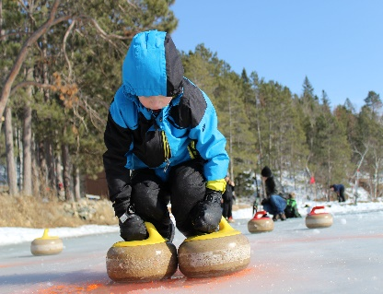Broken Bindings (per binding) $5

Ski Poles (per pole) $5

**Failure to Leave a Facility Clean**

Fox Building $45

Dining Hall/Kitchen & Lavold Nature Canter $150

Butler Wilderness Outpost Buildings $100

Other Buildings $45

Graffiti Minimum $75

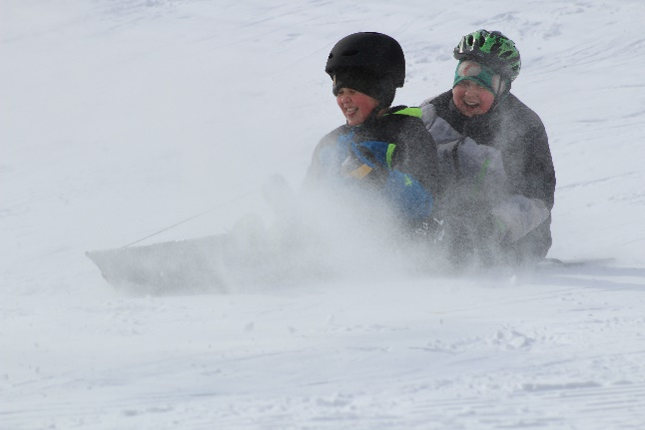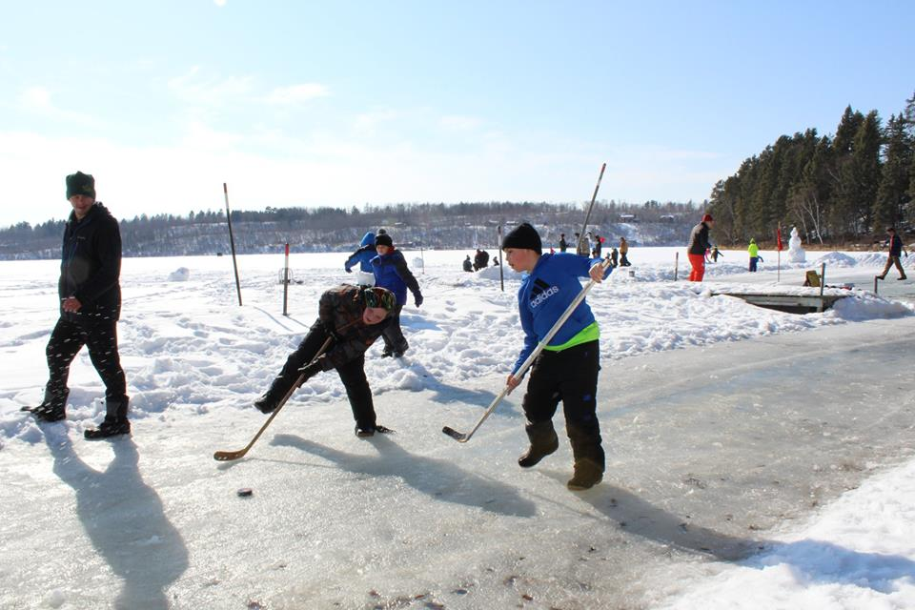

**Trading Post:**

The Wanzek Trading Post will be open on Friday, Saturday and Sunday for you to buy clothing, snacks, and pop for your hungry Scouts. This is a great place to meet new friends and warm up!

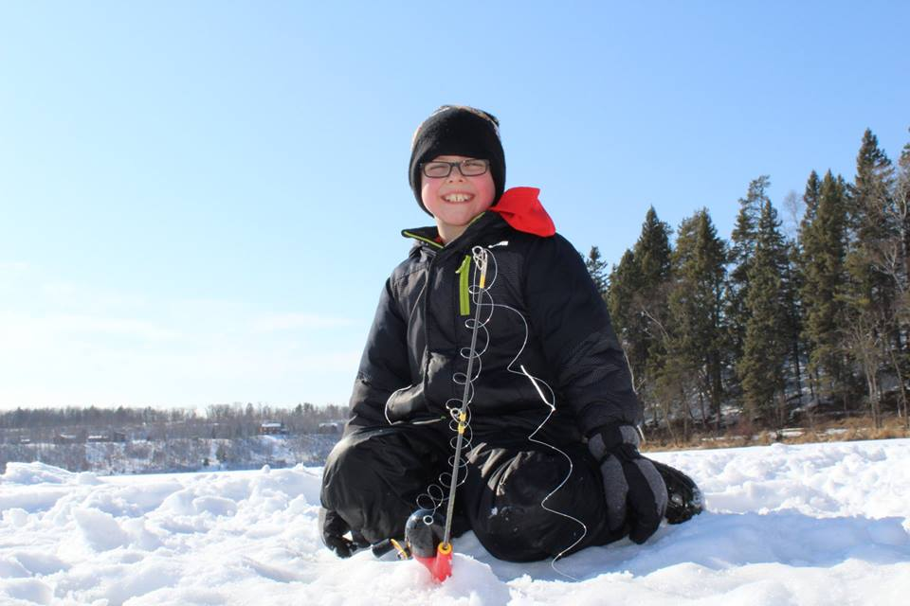

**Trading Post Hours**

**Friday:** 7:00 pm - 9:00 pm

**Saturday:** 10:00 am - 11:00 am

2:00 pm - 5:00 pm

7:00 pm - 9:00 pm

**Sunday:** 8:00 am - 9:00 am

**Camp Rules:**

1. The Campmaster or Camp Director will check your Unit in and out.

2. Equipment check-out will be Saturday morning at 9:00 am at the Adult Leader Study.

3. Sleds are available on the sledding hills for you all weekend. Please help to put them away at the end of the weekend.

4. The Campmaster will check out cabins on Sunday. Please arrange a time to check-out with your Campmaster either Friday or Saturday.

5. Your Unit will be charged for any new carvings, graffiti or damage. The charge will be based on a replacement cost basis established by the Northern Lights Council and is a minimum $75.

6. All garbage is to be bagged and put inside the garbage dumpsters located behind the Scouts BSA Dining Hall, Cabin 5, or in the Cub Scout Parking Lot.

7. **NO** pets allowed in camp!

8. **NO** snowmobiles can be driven on camp property!

9. If someone in your group gets hurt and needs to go to the hospital, you need to inform the Campmaster or Camp Director prior to leaving and upon safe arrival back into camp.

10. Before you leave your camping area, send someone to summon the Campmaster or Camp Director so they can do a final check-out. Final check-out consists of the following:

• **Inside & Outside Cleanliness**

• **Wall Graffiti**

• **Fire Alarm & Extinguishers OK**

• **Anything Broken (Glass Windows, etc.)**

• **Equipment Returned**

**Programs:**

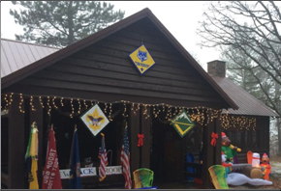**Wilderness ROMP**—open to Cub Scouts, Scouts BSA, and Venture Scouts

This program is on Saturday, February 8th and is $20 per person. This program runs from 10:00am-6:00pm and includes lunch, dinner, equipment usage, and a patch. Cabins are available for the weekend and run for the normal charge of winter camp. Program consists of Cross Country Skiing, Snow Shoeing, GPS demonstration, Ice Fishing, Snow Shelter Building, and much more. Sign-up for this event online at www.nlcbsa.org.

**Polar Cub**-open to Cub Scouts

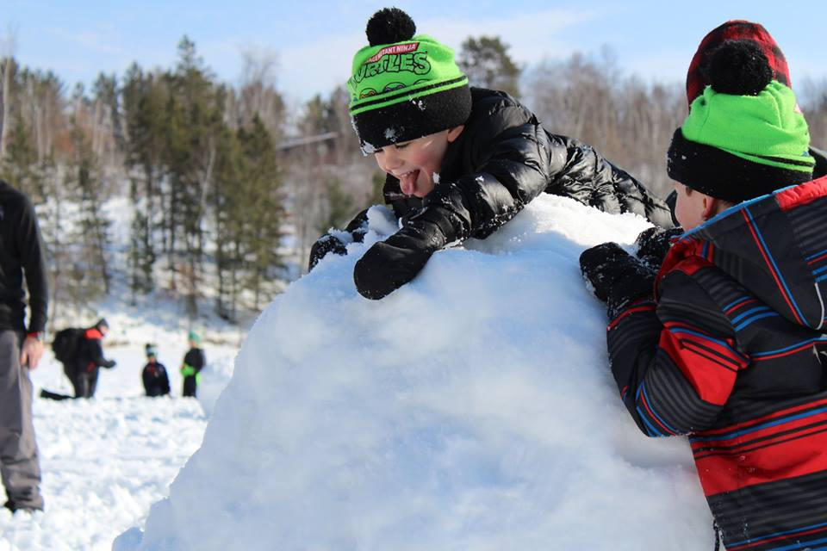This program is on March 7th runs from 10:00am to 6:00pm. The cost is $20 per person and includes lunch, dinner, equipment usage, and a patch. Cabins are available for the weekend and run for the normal charge of winter camp. This weekend programs consist of Cross Country Skiing, Snow Shoeing, Sledding Hill Races, Ice Fishing, Broomball, and much more. Sign-up for this event online at www.nlcbsa.org.

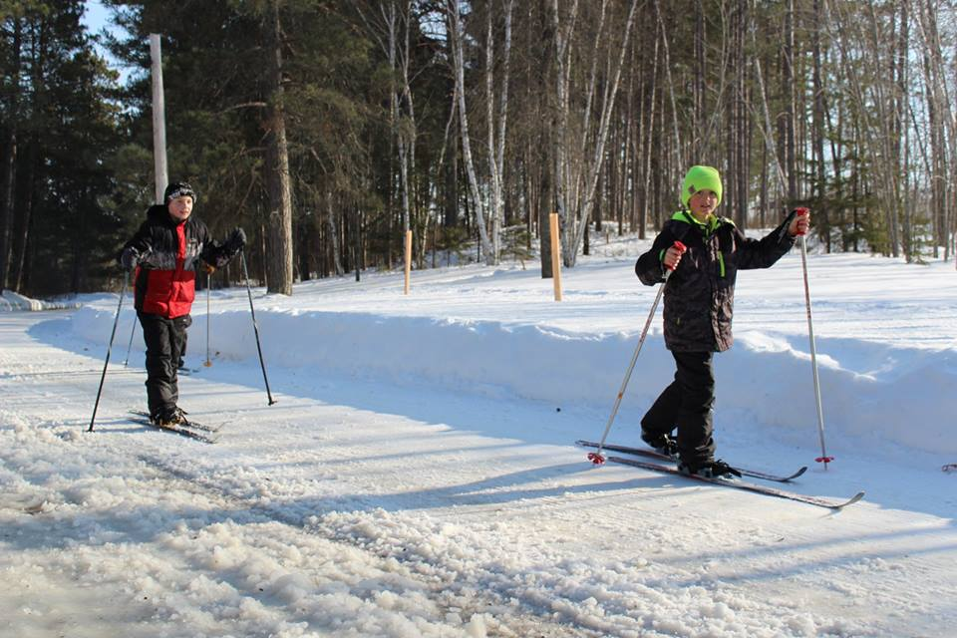

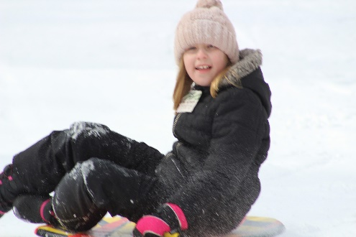

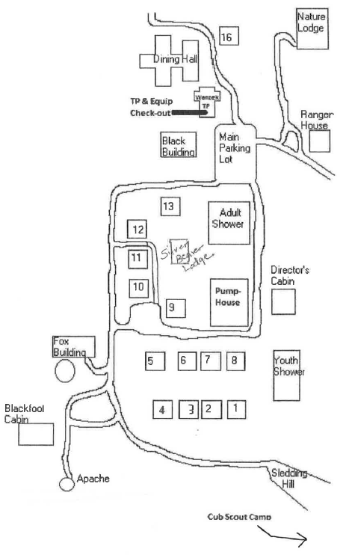

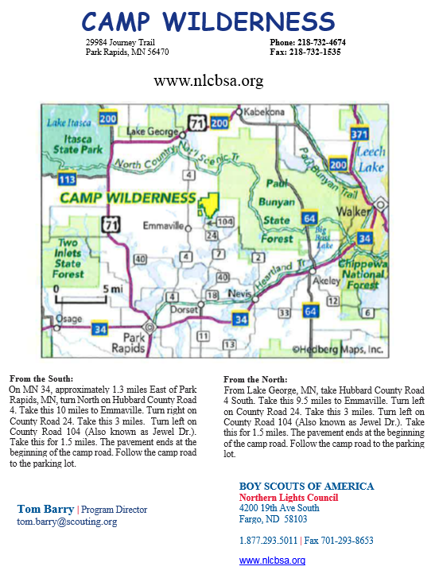

**Emilie Frenzel**| Program Assistant

[emilie.frenzel@scouting.org](mailto:emilie.frenzel@scouting.org)