2019 Camp Wilderness Webelos Weekend
7:00 PM Friday, October 10th – 9:00 AM Sunday, October 13th
Registration Fees Scouts: $50 Adults: $35 Siblings: $35
*Scouts, Adults and Siblings who register prior to September 27, 2019 qualify for our Early Bird Discount!

Scouts will work on the following Webelos and Arrow of Light Achievements:
Webelos Adventure: Webelos Walkabout
Do all of these:
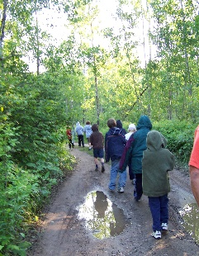
- Create a hike plan
- Assemble a hiking first-aid kit
- Describe and identify from photos any poisonous plants and dangerous animals or insects you might encounter on your hike.
- Before your hike, plan and prepare a nutritious lunch. Enjoy it on your hike and clean up afterward.
- Recite the Outdoor Code and the Leave No Trace Principles for Kids from memory. Talk about how you can demonstrate them on your Webelos adventures.
- With your Webelos den or with a family member, hike 3 miles (in the country if possible).
- Complete a service project on or near the hike location.
- Perform one of the following leadership roles during your hike: trail leader, first-aid leader, lunch leader, or service project leader.

Arrow of Light Adventure: Building a Better World
Do all of these:
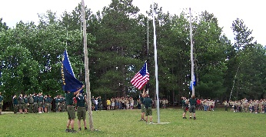
- Explain the history of the United States flag. Show how to properly display the flag in public and help lead a flag ceremony.
- Learn about and describe your rights and duties as a citizen and explain what it means to be loyal to your country. 3. Discuss in your Webelos den the term "rule of law," and talk about how it applies to you in your everyday life.
- Meet with a government leader and learn about his or her role in your community. Discuss with the leader an important issue facing your community.
- Learn about your family's expenses and help brainstorm ways to save money. Plan and manage a budget.
- Learn about energy use in your community and in other parts of our world.
- Identify one energy problem in your community and find out what has caused it.
- With the assistance of your den leader or parent, participate in an event that would help lead others in recycling and conserving resources.
- Show that you are an active leader by planning an activity without your den leader's help.
- Do one of these:
  - Learn about Scouting in another part of the world. With the help of your parent or your den leader, pick one country where Scouting exists, and research its Scouting program.
  - Set up an exhibit at a pack meeting to share information about the World Friendship Fund.
  - Find a brother Scout unit in another country.
  - Under the supervision of your parent, guardian, or den leader, connect with a Scout in another country during an event such as Jamboree on the Air or Jamboree on the Internet or by other means.

Webelos/AOL Elective Adventure: Sports
Complete the following requirements.

- Show the signals used by officials in one of these sports: football, basketball, baseball, soccer, or hockey.
- Participate in two sports, either as an individual or part of a team.
- Complete the following requirements:
  - Explain what good sportsmanship means.
  - Role-play a situation that demonstrates good sportsmanship.
  - Give an example of a time when you experienced or saw someone showing good sportsmanship.

The weekend’s programs, housing on Friday & Saturday nights, and four meals will all be covered by your registration fee! Meals provided include breakfast, lunch, and dinner on Saturday, & breakfast on Sunday.
Any registrants who have needs for which accommodations must be made are asked to notify our staff as soon as possible. Such needs may include: food allergies, immobility requiring reservation of the Action Trak, abstention of foods per religious views, etc.
Please send all requests and questions to Emilie Frenzel emilie.frenzel@scouting.org or Tom Barry tom.barry@scouting.org

