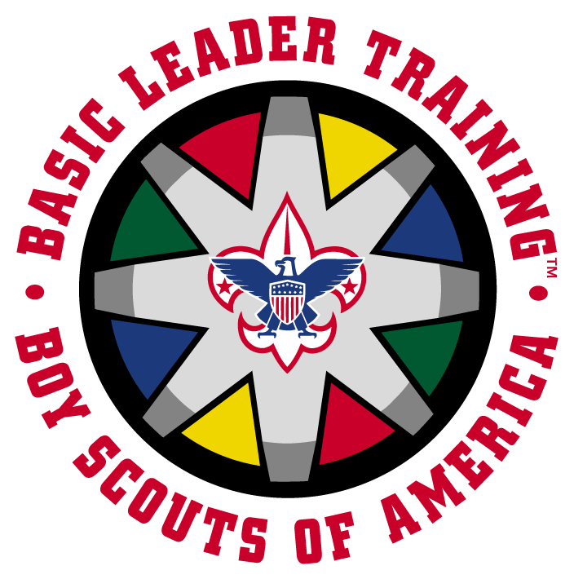
COMPLETE YOUR LEADER OUTDOOR SKILLS TRAINING AT THE SPRING Civil War Days.

You are invited to participant in the Combined Outdoor Leader Skills Training course, a fun-filled program of hands-on skills training in the outdoors, designed to help you master basic camp skills required for pacts to go camping and to meet the fully qualified requirements for Scoutmasters and their assistants.
This training combines the Basic Adult Leader Outdoor Orientation (BALOO), Outdoor Leader Skills for Webelos Leaders (OWL) training, and the Outdoor Leadership Skills training. Upon completion of this training, you will have met the requirements for all three courses.

WHERE: Heritage Village, EGF
DATE: May 17-19, 2019
TIME 7:00 pm Friday – Noon Sunday
Run in conjunction with the Spring Camporee
COST $20.00 (If participant is eating all meals with the course).
$10.00 (If participant is eating meals with their unit).
Completion of the course will take the entire weekend, and participants will not be able to take part in their unit’s activities.

Outdoor Cooking (Not just Hot Dogs and beans), Safety and Sanitation, Basic Wilderness First Aid. How to Rough it in Comfort. Outdoor Games. Maps Compasses and GPS. How not to turn your propane stove into a rocket. Choosing the right tent. Sleeping at +90 to -40. Wildlife and plants. Campfires and planning a campout. How to have fun if it rains.

FOR MORE INFORMATION CONTACT DAVE COOK
701-740-2780 n0vsh@gra.midco.net

