Training for All Scout Leaders,

OPEN TO ALL

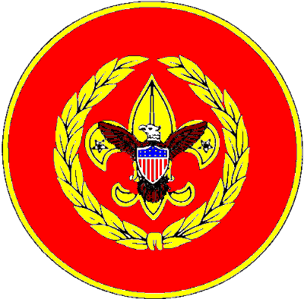
Northern Lights Council, BSA


College of Commissioner Science

Saturday, October 4, 2025

Bismarck Baptist Church

2211 LaForest Ave

Bismarck ND, 58501

For the most current information please check the
Northern Lights Council Website for

registration details at
To be inserted
Version 12-03-18

NORTHERN LIGHTS COUNCIL,

College Commissioner of Science
Tim Tello, DCS, Co-Dean of the College, Doctoral Dean of College | tim.tello123@gmail.com
Tom Henderson, MCS, Council Commissioner, Co-Dean of College | tahenderson2021@gmail.com
The Dean’s Cabinet
James Walker MCS, Continuing Education | lucerian2006@gmail.com
Toni Gumeringer MCS, Dean of Masters of College | toni_gumeringer@hotmail.com
Tina Anderson MCS, Dean of Bachelors of College | Tina.Anderson@scouting.org
Tom Henderson MCS Registrar | tahenderson2021@gmail.com
Thomas Huether Professional Advisor | Thomas.Huether@scouting.org

Letter from the Co-Deans of the College
We invite every commissioner, scout leader, volunteer and parent to attend the Northern Lights Council’s College of Commissioner Science. These courses provide information about, and ways to solve, many of the issues that face scouting units and volunteers every day. National has been continuously updating all of the college courses with new material and focused on increasing student participation. Many of the courses are completely new so even if you have attended before, come to get the current information. The Dean’s Council and the instructors look forward to your attendance, the contributions of each attendee, and this opportunity for learning and fellowship.
The bachelor program is offered for commissioners and interested individuals who have completed online specific commissioner position training and will increase your knowledge of scouting while providing useful skills.
The Masters and Doctoral program offer more advanced skills and problem-solving experiences. The Doctoral program challenges the candidate to develop, organize, research and conduct an approved project that will impact the quality of unit service. All courses are open to every volunteer and interested parent without pursuing a specific degree. Attending the complete college is not required. Degrees will be awarded to Registered Scouters and Commissioners. The registration fee covers course materials, certificate, patch, and meals. Attending the college provides an invaluable opportunity to not only learn what it is to be a commissioner, but also to network with and learn from commissioners with years of experience.
Tim Tello, DCS and Thomas Henderson, MSC
Co-Deans of the College
Table of Contents

Letter from the Co-Deans of the College 2

Schedule of Events and Room Assignments 3

Location BISMARCK BAPTIST CHURCH, 2211 LaFOREST AVE, BISMARCK, ND 58501 3

Bachelor of Commissioner Science Requirements 4
TINA ANDERSON, Dean 4

Master of Commissioner Science Requirements 5
TONI DUMERINGER, Dean 5

Doctor of Commissioner Science 5
TIM TELLO, Dean of Doctoral College 5

Required 2025 College Courses 6

Continued Education of Commissioner Science 6
JAMES WALKER, Dean of Continued Education 6

Elective Courses 6

Appendix – Commissioners Awards and Recognition 8

Schedule of Events and Room Assignments

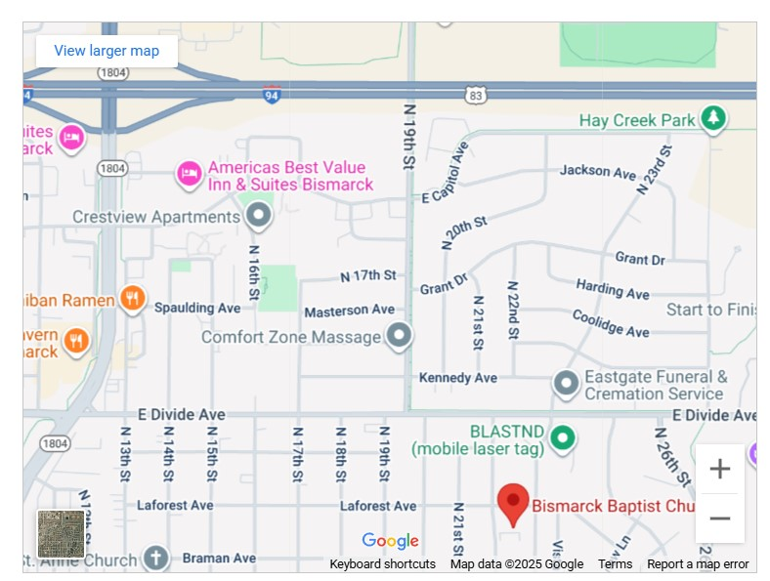
Location
Bismarck Baptist Church

2211 LaForest Ave

Bismarck ND, 58501

Bachelor of Commissioner Science Requirements

Tina Anderson, Dean
Submission of an application as a candidate for the Bachelors Degree, indicating the following:
- Current registration as a Commissioner
- Completion of Online Position Specific CommissionerTraining found in My.Scouting.org
https://my.scouting.org/tools/my-training/requirements
- Complete seven (7) hours of instruction from the list below, composing of, five (5) Bachelor’s program level courses and two (2) elective courses, listed at the end of the document (electives include higher level courses)
- Approval by the Council Commissioner, Scout executive or staff adviser for commissioner service:
BCS 101 Core Concepts of Commissioner Service
The position of commissioner is one of the oldest in Scouting. This course reviews and reinforces the commissioner core concepts and identifies the key skills needed for commissioner to be able to assess the units they serve
BCS 103 The Essential element “A servant’s heart
BCS 105 Resolving Common Unit issues
A Commissioner’s primary purpose is to help units succeed, develop a better program, and operate effectively. Frequently Commissioners are called upon to assist units with concerns that could hinder the unit’s success
BCS 113 Building relationships .
BCS 117 The Commissioner & Unit Key 3 (Required for All)
a general session course that explores the interaction of Commissioners with the unit’s Key 3, Committee Chair, Unit leader and Charter Organization Representative. This course reviews common interactions with the Unit Core leadership and provides tools to address or minimize issues that occur within units.
BCS 150 roundtables in unit service
An effective roundtable is vital to the success of all commissioner service. This course reviews and reinforces how roundtables fit into the commissioner service structure by providing roundtable services to unit leaders
MCS 310 Keynote speaker - Succession Planning (required for ALL)
Our Keynote speaker the CST Council Commissioner will address an issue near and dear to his heart, how to effectively plan for your successor, Adult leadership changes. To support the orderly change of leadership it is important to encourage each unit to create a long term succession plan. Commissioners need to understand the process to assist the units they support.
ECS # _______________________________________ Elective
ECS # _______________________________________ Elective

Master of Commissioner Science Requirements

Toni Gumeringer, Dean
Submission of an application as a candidate for the Masters Degree, indicating the following:
- Current registration as a Commissioner
- Previously earned Bachelors Degree in Commissioner Science
- Completion of seven (7) additional courses of instruction (total of 14), at least five of the courses at the Master's level courses, listed at the end of the document (electives include higher level courses)
- Approval by the Council Commissioner, Scout executive or staff adviser for commissioner service:
MCS 302 Supporting Unit Membership Renewal –
The course will discuss how administrative commissioners, in particular unit commissioners, also support on-time unit and membership renewal
MCS 304 Service To Units at Risk
Early detection and systematic problem solving is critical to support units when they encounter problems which may prevent them from functioning effectively. Learn how to identify these units and discuss the processes needed to support them..
MCS 307 Serving Newly Formed Units
An engaged commissioner is critical for the success and retention of new units. Commissioners designated as a new unit commissioner focus on only new units, preferably a single unit to which they have been assigned.
MCS 310 Keynote speaker - Succession Planning (required for ALL)
Our Keynote speaker the CST Council Commissioner will address an issue near and dear to his heart, how to effectively plan for your successor, To support the orderly change of leadership it is important to encourage each unit to create a long term succession plan. Commissioners need to understand the process to assist the units they support
MCS 312 Recruiting the 21st Century Volunteer –
All commissioners are responsible for recruiting other commissioners. This course familiarizes commissioners on the considerations and techniques that support recruiting volunteers who represent the generations of the 21st century.
MCS 314 The Commissioner and the Professional –
In this course, learn more about the relationship between the commissioner and the professional. How can they work closely together to reach a common goal of providing quality service to units? What can the professional do to help the volunteer accomplish their goals and what can the commissioners do to help the professional accomplish their goals and fulfil their critical achievements?
MCS 315 Effective Unit Service to Rural Communities
In this course, the participants will learn about the characteristics of a rural community
nd how to work with a rural community to maintain an effective unit. While this course
discusses rural and small towns in general, there are useful tips for every commissioner
when developing relationships in the community they serve whether rural, urban or
suburb.
BCS 117 The Commissioner & Unit Key 3 (Required for All)
a general session course that explores the interaction of Commissioners with the unit’s Key 3, Committee Chair, Unit leader and Charter Organization Representative. This course reviews common interactions with the Unit Core leadership and provides tools to address or minimize issues that occur within units.
ECS # _______________________________________ Elective
ECS # _______________________________________ Elective

Doctor of Commissioner Science

Tim Tello, Dean of Doctoral College
Submit an application as a candidate for the Doctors Degree, indicating the following:
- Current registration as a Commissioner
- Previously earned a Masters Degree in Commissioner Science,
- Completed the Commissioner’s Key (see page 13)
- Complete a project that has been pre-approved by the Dean.
- Complete ten (10) hours of instruction from Doctorate or Continuing Education curriculum, composing of, five (5) Doctoral courses plus five (5) elective courses, listed at the end of the document (electives include higher level courses)
- Serve for at least one year on the College of Commissioner Science Staff (instructor or support staff while at the Masters level)
- Approval by the Council Commissioner, Scout executive or staff adviser for commissioner service:
DCS 501 Selecting and Limiting the scope of your Thesis/Project
This session assists doctoral candidates in selecting their project/thesis concept. Participants receive help in reducing the Doctoral candidates explore various procedures to reduce their topic to a workable size. A suggested approval process will also be shared.
DSC 503 Developing the Thesis/Project Outline and Writing the Report
This session covers the project/thesis outline and a variety of suggestions for writing and revising the report.
DCS 509 Legacy of Servant Leadership –
This course will provide an opportunity to see how
DCS 512 Recruiting for Diversity
This course will provide an opportunity to see how.
DCS 519 Turning Relationships into Partnerships
This course will provide an opportunity to see how
DCS 550 Leveraging Roundtable in unit service
This course will provide an opportunity to see how
DCS 551 Roundtable today
This course will provide an opportunity to see how
BCS 117 The Commissioner & Unit Key 3 (Required for All)
a general session course that explores the interaction of Commissioners with the unit’s Key 3, Committee Chair, Unit leader and Charter Organization Representative. This course reviews common interactions with the Unit Core leadership and provides tools to address or minimize issues that occur within units.
MCS 310 Keynote speaker - Succession Planning (required for ALL)
Our Keynote speaker the CST Council Commissioner will address an issue near and dear to his heart, how to effectively plan for your successor, Adult leadership changes. To support the orderly change of leadership it is important to encourage each unit to create a long term succession plan. Commissioners need to understand the process to assist the units they support.

ECS # _______________________________________ Elective
ECS # _______________________________________ Elective
ECS # _______________________________________ Elective
ECS # _______________________________________ Elective
ECS # _______________________________________ Elective
All candidates for the Doctors Degree must contact Dean no later than ten (10) months prior to the Doctoral Review Board to discuss their growth project.

Continued Education of Commissioner Science

James Walker, Dean of Continued Education
[These courses are considered elective courses]
CED 701 Combatting Commissioner Stress and Burnout
WE’VE ALL HAD OUR MOMENTS WHEN WE ASK OURSELVES, “WHY ARE WE INVOLVED IN SCOUTING? WHY ARE WE DOING THIS?” THIS COURSE WILL LOOK AT SOME WAYS WE CAN HELP OVERCOME THOSE BURNOUT AND STRESSFUL SITUATIONS AND MOTIVATE OURSELVES AND OTHERS TOWARD BETTER TENURE IN SCOUTING AMERICA.
CED 716 Navigating Difficult Conversations
SCOUTING IS FULL OF CONVERSATIONS. MOST ARE PLEASANT AND PRODUCTIVE- BUT AT TIMES, DIFFERENCES CAN ARISE. IT OCCURS WHENEVER PEOPLE DISAGREE OVER THEIR VALUES, MOTIVATIONS, PERCEPTIONS, IDEAS, OR DESIRES. SOMETIMES THESE DIFFERENCES APPEAR TRIVIAL, BUT THEY CAN TRIGGER STRONG EMOTIONS. AS COMMISSIONERS, WE NEED TO BE ABLE TO NAVIGATE THESE DIFFICULT CONVERSATIONS IN A WAY THAT LEAVES EVERYONE
FEELING HEARD, UNDERSTOOD AND VALUED.Elective Courses
Bachelors, Masters, and Doctoral students will be able to choose two of the following courses or other course to fulfill their elective courses.
BCS 117 The Commissioner & Unit Key 3 (Required for All)
a general session course that explores the interaction of Commissioners with the unit’s Key 3, Committee Chair, Unit leader and Charter Organization Representative. This course reviews common interactions with the Unit Core leadership and provides tools to address or minimize issues that occur within units.
MCS 315 Effective Unit Service to Rural Communities
In this course, the participants will learn about the characteristics of a rural community
nd how to work with a rural community to maintain an effective unit. While this course
discusses rural and small towns in general, there are useful tips for every commissioner
when developing relationships in the community they serve whether rural, urban or
suburb.
MCS 314 The Commissioner and the Professional
In this course, learn more about the relationship between the commissioner and the professional. How can they work closely together to reach a common goal of providing quality service to units? What can the professional do to help the volunteer accomplish their goals and what can the commissioners do to help the professional accomplish their goals and fulfil their critical achievements?
DCS 509 Legacy of Servant Leadership –
Continuing the conversation from BCS103- The Essential Element (A Servant’s Heart).
That Bachelor’s level class introduced the concept of servant leadership and established
the expectation that commissioners served units and other volunteers. The course
objectives for A Legacy of Servant Leadership are to • Explore characteristics of servant
leaders, • Understand servant leadership in Scouting, and • Recognize the legacy of
servant leadership
DCS 519 Turning Relationships into Partnerships
As commissioners, building relationships with our units is at the core of what we do.
Turning that relationship into a partnership develops trust and shared success, which
impacts unit service with our unit leaders. This course prepares and helps commissioners
build partnerships with unit leaders, strengthening the decision-making possibilities.

For the most current information and registration details please check the Northern Lights Council Website at http://www.nlcbsa.org/commissioner

Appendix – Commissioner Awards and Recognition
Information obtained: https://www.scouting.org/commissioners/recognition/
Available Commissioner Awards and Recognitions
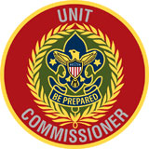
- Badge of Office

A. Appointment and Approval
The volunteer’s application for a commissioner position had been submitted and approved,
including a background check. The appointment and approval requirements are as follows:
1. Unit commissioners, Roundtable commissioners, and assistant district commissioners are
appointed by the district commissioner with the approval of the designated professional
liaison.
2. District commissioners are appointed and approved by the council executive board, with
the concurrence of the scout executive, on the recommendation of the district
nominating committee.
3. Assistant council commissioners are appointed by the council commissioner with the
approval of the designated professional liaison.
4. A council commissioner is elected at the annual meeting of the local council after
selection by the council nominating committee.
B. Training Requirements
1. Youth protection training
C. Orientation Requirements
All commissioners shall have received prescribed orientation for their position.
D. Recognition Items
1. Commissioner Badges of Office are available from local Scout shops and Scoutstuff.org.

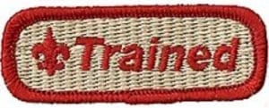
2. Commissioner Training
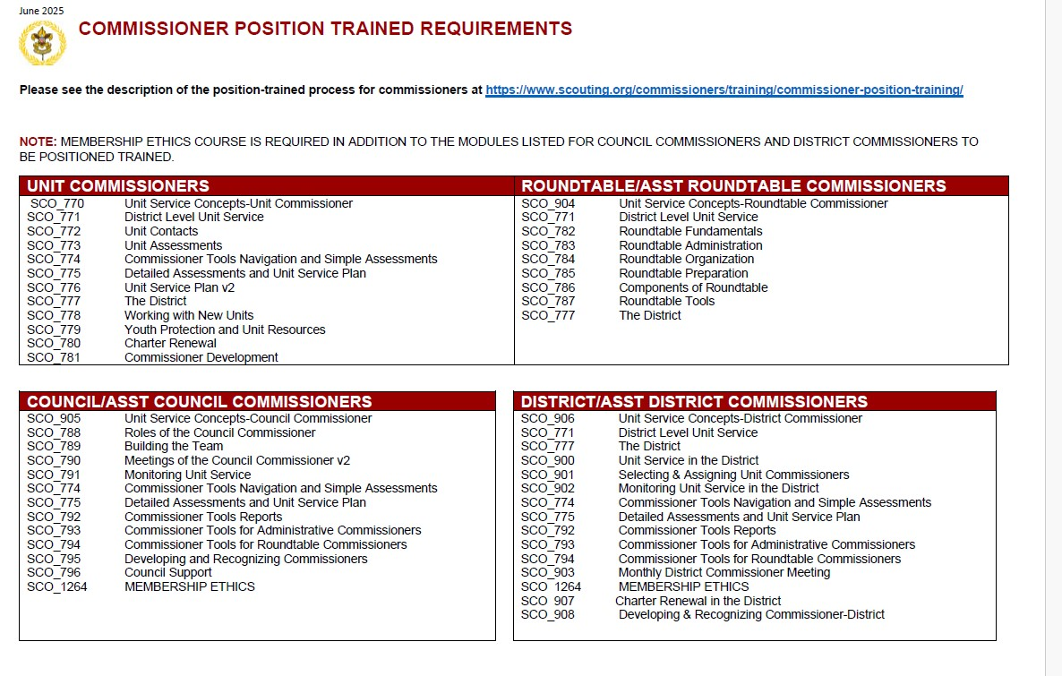
3. Commissioning
Requirements for Commissioning:
A. Appointment and Approval
The Scouter be duly appointed and approved (including background check) as a commissioner.
The appointment and approval requirements are as follows:
1. Unit commissioners, Roundtable commissioners, and assistant district commissioners are
appointed by the district commissioner with the approval of the designated professional
liaison.
2. District commissioners are appointed and approved by the council executive board, with
the concurrence of the scout executive, on the recommendation of the district
nominating committee.
3. Assistant council commissioners are appointed by the council commissioner with the
approval of the designated professional liaison.
4. A council commissioner is elected at the annual meeting of the local council after
selection by the council nominating committee.
B. Training Requirements
1. Youth protection training
2. Position‐specific training
Commissioning P.2
Requirements Edition Date: 05.01.2016
C. Orientation Requirements
All commissioners shall have received prescribed orientation for their position.
D. Recognition Items
1. Commissioning certificate template available on the Awards and Recognition page of the
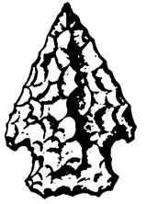
Commissioner’s website at Scouting.org.
4. Arrowhead Honor

The Arrowhead Honor recognizes proficiency in the contemporary tools and techniques commissioners use to provide effective unit service. Once the Arrowhead is earned, a commissioner can continue to wear it on the uniform.
When moving to another commissioner position, commissioners should review the Arrowhead requirements for that position and perform at that level.
Fillable pdf’s for each Commissioner Level found at https://www.scouting.org/commissioners/recognition/arrowhead-honor/
Requirements are as follows:
- Council commissioner and assistant council commissioners:
Prerequisites for the Arrowhead Honor include:
• A current Youth Protection Training certificate
• Council Commissioner position specific training
The commissioner must complete the following to demonstrate a focus on unit service and participation in continuing commissioner education:
Improve the quality of unit service within assigned districts:
1. Chair a minimum of 6 council commissioner meetings (staff or Cabinet meetings) within a 12-month period. For ACCs: Regularly attend staff meetings scheduled by the council commissioner and actively participate by developing a presentation or training segment for 1 of those meetings.
2. For council commissioners: Seek and invite enough assistant council commissioners to support the council's needs. Create position descriptions as needed.
For ACCs: Develop SMART goals for your role that address the council's needs.
3. Provide training and support to district commissioners so they can effectively seek and invite new commissioners.
4. Encourage district commissioners to organize and assign unit commissioners to support units with unmet needs that would benefit from an assigned commissioner.
5. Utilize My.Scouting tools to monitor the commissioner's organization, unit connections, unit goals1, and other information to ensure effective unit service.
6. Ensure that commissioner recognition programs are used in the council.
7. During Cabinet and staff meetings, encourage district commissioners to share best practices for seeking and engaging new commissioners, retaining current commissioners, and mentoring.
Support unit growth:
1. Support council’s plans for membership growth.
Link unit needs to council operating committees:
1. Provide district commissioners with a list of council committee chairs, including but not limited to advancement, program, training, camping, finance, and membership.
Support timely unit renewal:
1. Work collaboratively with professional staff to ensure the council has a plan to achieve on-time unit renewal. :
Continuing Education:
1. Complete the onboarding process with an assigned coach.
- Ensure that training opportunities exist for commissioners in your council, including basic training, College of Commissioner Science2, Commissioner Conference3, Commissioner Workshop4, Commissioner Retreat5, or another advanced training specifically designed for commissioners. Promote national training conferences for commissioners.

District commissioner and assistants:
Prerequisites for the Arrowhead Honor include:
• A current Youth Protection Training certificate
• District Commissioner/Asst. District Commissioner position specific training
The commissioner must complete the following to demonstrate a focus on unit service and participation in continuing commissioner education:
Improve the quality of unit service within the district:
1. Chair, provide leadership, or help plan at least 6 commissioner staff meetings within a 12-month period.
2. Review unit metrics of new units and units with unmet needs at staff meetings.
3. Work collaboratively to develop and implement a plan to track and hold unit commissioners accountable for logging meaningful unit connections in Commissioner Tools.
4. Develop goals that address district needs and coach another commissioner. Review those goals with the administrative commissioner assigned to you.
5. Using the commissioner recognition program, ensure that commissioners eligible for awards are recognized within your district.
6. District commissioners: Attend the majority of scheduled cabinet or council-level commissioner staff meetings. Ensure a representative is sent to meetings you cannot personally attend.
Support unit growth:
1. Work collaboratively to ensure units with unmet needs have an assigned commissioner who is actively engaged with the unit.
2. Develop and implement a plan to seek and invite new commissioners to increase the total number of unit commissioners in the district. Train and onboard new commissioners and determine how unit service teams are organized.
3. Demonstrate proficiency in Commissioner Tools by using available reports during staff meetings. Encourage unit commissioners to include meaningful comments in their connections.
Link unit needs to district operating committees:
1. Attend most district committee meetings during a 12-month period and report on unit service issues. ADCs should attend district committee meetings when requested.
2. District commissioners should actively participate in district Key 3 meetings and ensure unit service issues are on the agenda.
3. Ensure every unit commissioner has a list of the district’s committee chairs and contact information.
Support on-time unit renewal:
1. Provide unit renewal training when needed and assist unit commissioners to ensure all units complete unit renewal on time.
Continuing Education:
1. Complete the onboarding process with an assigned coach.
2. Attend at least one College of Commissioner Science1, Commissioner Conference2, Commissioner Workshop3, Commissioner Retreat4, national training conference5, or another advanced training specifically designed for commissioners.

- Unit commissioner:
Prerequisites for the Arrowhead Honor include:
• A current Youth Protection Training certificate
• Unit Commissioner position specific training
The commissioner must complete the following to demonstrate a focus on unit service and participation in continuing commissioner education:
Connect with units and capture their strengths and unmet needs in Commissioner Tools:
1 Complete at least one unit connection and support the development of unit goals1 over a 12-month period.
2. Work with your district commissioner or ADC to identify the frequency of contacts, focusing on new units or units with unmet needs as determined by the DC/ADC.
3. Use Commissioner Tools to log connections that include meaningful comments.
Support unit growth:
1. Complete at least one unit connection for each assigned unit.
2. Encourage the development of unit goals specific to their needs. IF a unit decides to create goals, document the unit goals in Commissioner Tools1.
3. Demonstrate and maintain proficiency in utilizing My.Scouting tools through regular unit connections.
Linking unit needs to District Operating Committee resources:
1. As needed, assist a unit by linking them to the District Operating Committee, either to fill a unit need or to introduce them to some segment of the committee as a possible resource.
2. Attend at least 50% of your district commissioner’s monthly staff meetings.
3. Review unit metrics of your units at commissioner staff meetings.
Support timely unit renewal:
1. Deliver assistance to a unit to ensure an accurate, on‐time unit renewal.
Continuing Education:
1. Complete the onboarding process with an assigned coach.
2. Attend at least one College of Commissioner Science2, Commissioner Conference3, Commissioner Workshop4, Commissioner Retreat5, national training conference6, or another advanced training specifically designed for commissioners.
- Roundtable commissioner:

Prerequisites for the Arrowhead Honor include:
• A current Youth Protection Training certificate
• Roundtable Commissioner position specific training
The commissioner must complete the following to demonstrate a focus on unit service and participation in continuing commissioner education:
1. Attend most district commissioner staff meetings during a 12-month. Participate by sharing meeting plans, attendance goals, and other strategies to improve roundtable attendance.
2. Utilize the Roundtable Support webpage to ensure best practices for delivering a quality roundtable specific to each program audience.
3. Maintain a working knowledge of current Scouting America program materials and manuals to ensure roundtables are a resource for all units.
4. Invite an adequate number of commissioners to join the roundtable team to ensure strong program delivery. Actively assist in conducting two activities during the roundtable (such as a hot topic, membership moment, or safety moment).
5. Engage in quarterly planning that is reviewed and evaluated frequently and follow through to ensure the plan is implemented.
6. Ensure roundtable attendance is recorded monthly in Commissioner Tools.
7. Work collaboratively to develop and implement a plan to improve attendance using SMART goals.
8. Conduct or be responsible for a major project, presentation, or demonstration at a roundtable.
9. Recruit subject matter experts to give special presentations that interest Scouting volunteers and include a broad, diverse range of topics for the roundtable.
Continuing Education:
1. Complete the onboarding process with an assigned coach.
2. Attend at least one College of Commissioner Science1, Commissioner Conference2, Commissioner Workshop3, Commissioner Retreat4, national training conference5, or another advanced training specifically designed for commissioners.


5. Commissioner’s Key

The Commissioner’s Key encourages and recognizes continuing training, performance, and tenure by commissioners.
Prerequisites:
• A current Youth Protection Training certificate
• Current registration as a commissioner
Tenure:
• Within a 5-year period, complete 3 years as a registered commissioner.
Training:
Participate in at least two of the following continuing education/supplemental training events:
• College of Commissioner Science1
• Commissioner Conference2
• Commissioner Workshop3
• Commissioner Retreat4
• National training conference for commissionersRev. 12-24
Performance:
1. Earn the Commissioner Arrowhead Honor for your current commissioner position.
2. Provide the level of unit service outlined in the Arrowhead Honor Award throughout the entire tenure required to earn the Commissioner’s Key.

6. Doctorate of Commissioner Science Knot Award
The Doctorate of Commissioner Science Knot Award recognizes the completion of a standardized training program including a thesis or project, the awarding of the Doctorate of Commissioner Science from a College of Commissioner Science, and the achievement of performance objectives to improve Unit Service.

Doctorate of Commissioner Science Knot Award:
- Current registration as a commissioner
- Current BSA Youth Protection Training Certificate
- Completion of Doctorate of Commissioner Science degree
- Completion of 5 years of service in one or more positions (does not need to be consecutive) as a commissioner
- Recruit or assist in recruiting at least 3 new commissioners
7. Commissioner Award of Excellence in Unit Service

The Commissioner Award of Excellence in Unit Service is awarded to a commissioner who provides exemplary unit service to a unit assigned by the district commissioner and collaborates with units using the current Scouting America Commissioner Tools.
Prerequisites for the Commissioner Award of Excellence in Unit Service include:
• Current Youth Protection Training certificate
• Current registration as a commissioner
• Arrowhead Honor is earned (for any commissioner position)
• Develop connections with one or more units
Award Criteria:
I. General Requirements
A. Any registered commissioner who builds meaningful relationships with units as set forth by the award criteria over a minimum period of one year is eligible. A commissioner may earn this award multiple times. Each subsequent award shall be earned independently of the previous award, and no criteria from a previous award may be used to satisfy the criteria for a new award.
B. The commissioner consistently exemplifies the commissioner culture statement, Be the Heart-Build Relationships-Change Lives in their work with units, recognizing that creating partnerships is fundamental to unit success.
II. Unit Service Criteria
A. Complete a unit connection and assist a unit in developing their unit goals, IF the unit chooses to set goals. A collaborative discussion with unit leaders is foundational for building a supportive relationship with unit leaders and identifying unit strengths and unmet needs.
Unit Type: __________________ Unit Number: __________________
• In collaboration with unit leaders, complete a unit connection in Commissioner Tools.
• Encourage unit leaders to develop their unit goals and IF the unit sets goals, document them in Commissioner Tools1. Encourage the unit to address one or more areas of improvement that strengthen the unit in membership, program, volunteer leadership, or planning and budgeting. Goals should be specific and measurable; however, a unit is not required to set goals.
• Support the unit regularly, documenting at least 5 additional connections in Commissioner Tools (ideally 3 in-person) that include any progress the unit has made toward its goals or revisions to its goals. Unit connections must be made in different months and should be varied in scope to include unit meetings, unit activities, district campouts, summer camps, or leader/parent meetings.
B. Commissioner Service to Unit
• Link the unit to district/council resources by obtaining the resources and assistance necessary to support the written unit goals OR by discussing unit metrics/progress with the district commissioner staff during a monthly commissioner meeting.
• Support the annual unit renewal process by connecting with unit leaders to answer any questions.
III. Personal Development Criteria
• Routinely attend commissioner staff meetings and have your attendance verified by the district commissioner or another administrative commissioner.
• Attend one or more continuing education events specifically designed for commissioners while working toward this award. The continuing education events can include:
o College of Commissioner Science2
o Commissioner Conference3
o Commissioner Workshop4
o Commissioner Retreat5
o National training conference for commissioners6

8. Commissioner Certificate of Commendation
The Certificate of Commendation is for use by a local council to recognize a commissioner who has performed in a commendable manner.
A. Overview
1. The Commissioner Certificate of Commendation is for use by the local
council to recognize a commissioner who has performed in a
commendable manner, but such performance in itself does not rise to
the level expected for the Distinguished Commissioner Service Award.
2. Any registered commissioner who has earned the Arrowhead Honor
and has contributed to the improvement of service to his/her unit(s)
and/or within his/her district or the council is eligible to receive the
Commissioner Certificate of Commendation.
3. A commissioner may receive the recognition multiple times.
4. Approval is by the administrative commissioner with the best
knowledge of the nominee’s work with the concurrence of the council
commissioner.
B. Method of recognition:
The method of recognition shall be by a specially designed certificate. The
template for the certificate will be found in the Awards and Recognition
section on the Commissioners Website
9. Distinguished Commissioner Service Award
- Overview
  - The Distinguished Commissioner Service Award is the highest recognition that can be given to a commissioner. It recognizes an individual who has consistently engaged in distinguished and exceptional commissioner service resulting in significant, positive impact on youth, units, and a district and/or council. In determining the value of such service, consideration must be given to the candidate recipient’s commissioner position and the corresponding opportunity to render outstanding and exceptional service beyond the expectations for that commissioner position.
  - In order to be considered for the Distinguished Commissioner Service Award, a candidate recipient must be nominated by a currently registered adult member of the Boy Scouts of America. Commissioners may not nominate themselves.
  - The Distinguished Commissioner Service Award may be awarded once to a commissioner.
  - There is no restriction on the number of Distinguished Commissioner Service Awards that may be awarded by a local council during a calendar year.
- Prerequisites
In order to be considered for the Distinguished Commissioner Service Award, a candidate recipient shall:
  - Be currently registered as a commissioner or have served as a commissioner within the last five years. When nominating a former commissioner, the nomination must be based on the nominee’s performance while a registered commissioner.
  - Possess the Commissioner Key (possession of the Commissioner Key automatically includes possession of the Arrowhead Honor).
- C. Procedure
  - 1. The Distinguished Commissioner Service Award nomination form will be available on the Awards and Recognition section of the Commissioners website. The nomination form will be similar to the District Award of Merit nomination form, and will contain the following:
    - A record of the nominee’s tenure as a commissioner and as a Scouter in general,
    - A listing of previous Scouting awards and recognitions received by the nominee.
    - A statement by the nominator as to the nominee’s distinguished and exceptional service as a commissioner which qualifies the nominee to receive the Distinguished Commissioner Service Award, and
    - The nominator’s signatory section on the nomination form will include the following statement:
“I confirm that the nominee lives by the principles of the Scout Oath and Scout Law in word and deed, and is exemplary in his/her personal, family, and professional activities”.
  - The completed nomination form will be returned to the council commissioner.
  - The council commissioner may annually appoint a temporary Distinguished Commissioner Service Award Selection Committee of registered commissioners which will review all nominations and make recommendations of those nominees to receive the award to the council commissioner. The council commissioner will make the final determination regarding the granting of the award(s). If the council commissioner is an intended recipient, the issuance of the award will be approved by the council president or his/her designee. Whenever possible, the members of the committee should possess the Distinguished Commissioner Service Award.
  - The council commissioner in conjunction with his/her professional liaison shall obtain the appropriate recognition items (see D below).
  - The Distinguished Commissioner Service Award should be presented at an appropriate council or district event.
- Recognition Items:
  - Certificate: A certificate specifically designed for the Distinguished Commissioner Service Award. The template for the certificate will be found in the Awards and Recognition Section of the Commissioners website.
  - Recognition items:
    - Plaque: item # 17610 (Silver)
    - Bolo tie: item # 747 (Silver)
    - Uniform Knot: #5019

