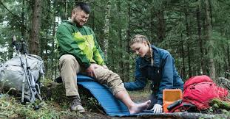
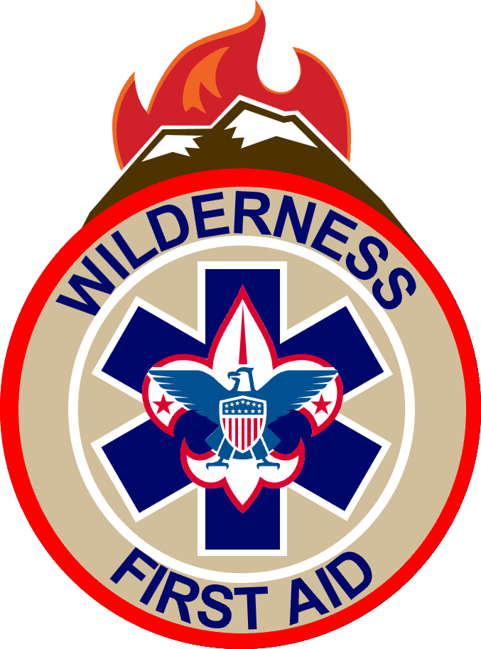

Wilderness First Aid (WFA)  When:  Friday-Sunday, September 18, 19, 20 2026  Check-In: Friday between 6:00 pm and 6:45 pm. Check-Out: Sunday 11:00am (After Graduation) Class will begin promptly at 7:00pm on September 18th.  Where:  Camp Boddie  Blounts Creek, NC  Event Details:  The focus of this course is common injury and illness recognition, treatment, management, and prevention all geared toward remote environments where definitive care from a physician and/or rapid transport is not readily available. In this class, participants will learn how to assess, treat, and, when possible, prevent medical and traumatic emergencies within the scope of their training.  Wilderness First Aid combines lectures with skills practice and role-playing to teach the response to various medical and trauma situations in locations 60 minutes or more from definitive care. Time is the essential element distinguishing wilderness first aid from standard first aid. Students will learn to prioritize care, treat injuries, improvise equipment, and create an evacuation plan. |  |  | Eligibility:  Participants must be registered Scouts or Scouters. Must be at least 14 years of age and is currently certified in CPR/AED. Cards will be checked prior to the course from one of the nationally recognized organizations (ARC, AHA, NCS, HIS & ECSI). There are only 10 class seats available so do not wait to register.  Cost:  $95.00  Registration:  All participants must register for this event and pay online using Black Pug.  Meals:  Meals will be provided Saturday (Breakfast Lunch and Dinner) and Sunday Breakfast.  Gear List:  Personal Camping Gear, Tent or Hammock, Scouts 10 Essentials, Mess Kit, Camp Chair, Notebook/Pad, Pen/Pencil and BSA Heath Forms A&B.  Point of Contact:  Kristin Mastranunzio  Council American Red Cross Training Chair  949-500-7104  kmastranunzio@gmail.com

