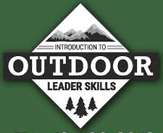

East Carolina Council
SCOUTMASTER SPECIFIC &
INTRODUCTION TO OUTDOOR LEADERSHIP SKILLS TRAINING (IOLS)

18th to 20th of September 2026 Camp Boddie, NC

The training is free for all registered Scouters that are part of East Carolina Council. If a parent or someone is not registered as a leader, the fee will be $32 for early registration and $42 for late registration. This will covers insurance, handouts, course material and meals. Registration required no later than
16th September2026 by using Black Pug on the council website.

Every Youth Deserves Trained Adult Leaders

Course pre-requisites include proof of current Youth Protection, Hazardous Weather, Safety Afloat, Safe Swim Defense, Drive Safe and Annual Health & Medical Record Parts A & B.
All Scouters and Volunteers are Welcome

For questions contact Scott Mastranunzio at slmastranunzio@gmail.com or by calling (910) 381-4043

