Webelos Resident Camp

Camp Bowers



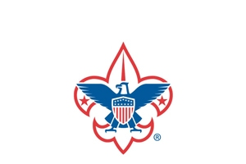

Cape Fear Council

White Oak, North Carolina



Camp Bowers

Cape Fear Council

Wilmington, NC 28406

(910) 395-1100 / FAX (910) 395-0894

Thank you for choosing to participate in the exciting, fun summer camping opportunities for Webelos Scouts in the Cape Fear Council. We can guarantee that your scout will have a great summer outdoor experience with us.

Our camp leadership have been hard at work recruiting and training a quality staff to deliver an outstanding and memorable program. Participating in our outdoor programs is a great place where your scout will have fun, meet new people, and discover new things all at once. You and your scout will have a great experience, and you can join them as well to help build those memories.

This Camp Guide gives you all the information you will need to know (and then some) to have a good time and be prepared for your camping experience. If we can be of any assistance before camp starts, please do not hesitate to contact the Cape Fear Council office at 910-395-1100 ext. 107.

I look forward to a fun-filled session with you this summer at Camp Bowers. On behalf of the entire Camp Staff, we can’t wait to see you this summer!

Yours in Scouting,

Michael DeRuyter

Program Executive

**Table of Contents**

Camp Registration and Fees 4

General Information 5

Rules and Safety Information 8

Emergency Procedures 10

What to Bring 11

Camp Program 12

Camp Schedule 13

Advancement Opportunities 14

Adventure Descriptions 14-15

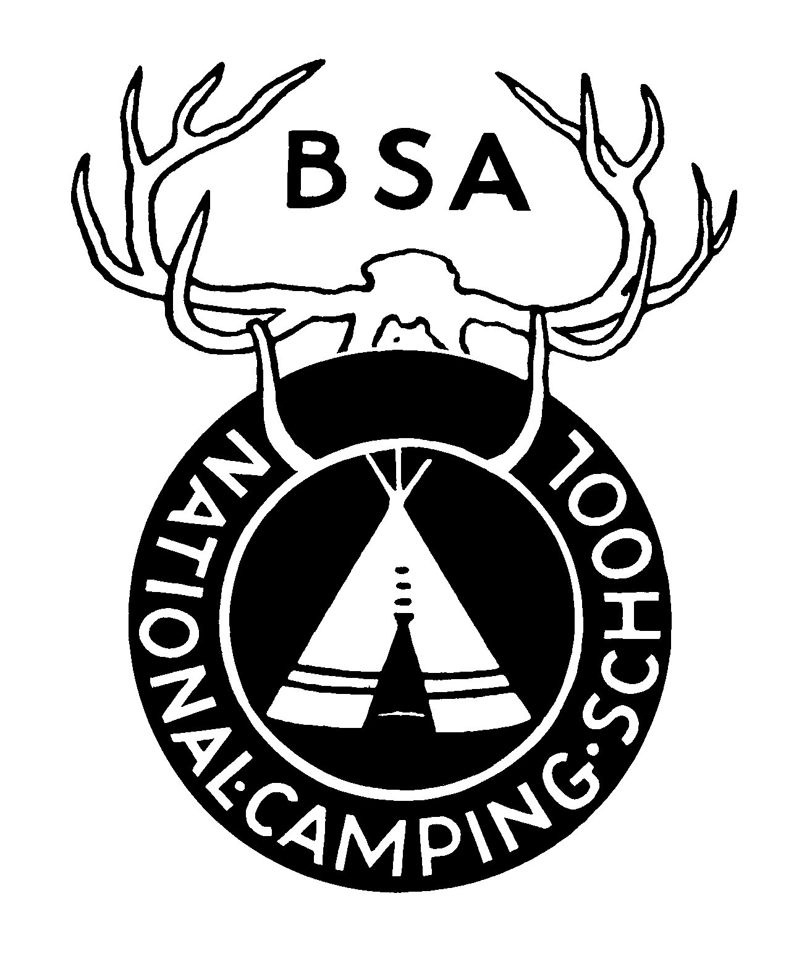

.

**Camp Registration and Fees**

**Registering for Webelos Resident Camp:**

Registration can be done as a den or individually by completing the registration online. Everyone is encouraged to start registering early. For questions about camp or assistance with the registration process please contact Michael DeRuyter at 910-395-1100 ext. 107 or [Michael.DeRuyter@scouting.org](mailto:Michael.DeRuyter@scouting.org).

**Who May Attend:**

All registered Webelos and Arrow of Light Scouts may attend Webelos Resident Camp. Registered leaders and parents may serve as Pack leadership at camp.

## **Leaders in Camp:**

Adults attending may be registered leaders or parents in the Pack. Every scout that attends must always be under the supervision of its own adult leadership. A minimum of two-deep leadership is always required.

**Camp Fees:**

* Camp Fee: $150 per Scout and $50 per adult (Paid in full by June 1)
* Late Fee: $165 per Scout and $65 per adult (Any registrations submitted after June 1)

**Camp Dates:**

July 6-9 (Sunday-Wednesday)

**Camperships:**

Camperships are scholarships given to scouts who need financial assistance to attend camp. Please use the application on the council website to apply for a campership. Be sure to get all applications to the Council Office before May 2. A confirmation letter and notice of the amount of campership will be sent from the Council Office. All approvals will be made after the application deadline.

**Camp Refund Policy:**

Months before Summer Camp opens, extensive planning, purchasing, and staff contractual agreements are all set in place, among other things. Due to these types of commitments, it is not practical to give full refunds. Refunds will only be made in the case of illness, injury, or family emergency when requested for in writing to the Cape Fear Council Service Center.

**All refunds will be assessed a minimum $75 for fixed costs already incurred**.

Please note that we cannot offer refunds for Scouts who leave camp early and under no circumstances may any refunds be carried over to the following summer.

**General Information**

**Medical Forms (required for all Scouts and adults):**

Every Scout and adult must complete an Annual Health and Medical Record prior to camp.   
For Cub Scout Resident Camp, **Parts A & B will be required** for all participants. Every camper must have all parts completed for their medical record. Anyone arriving at camp without the proper medical form and appropriate signatures as stated above will not be allowed to participate in camp programs.

Web Link to BSA medical form:

<https://filestore.scouting.org/filestore/HealthSafety/pdf/680-001_AB.pdf>

**Medical Treatments and Medication:**

An emergency medical technician is on duty at all times and a physician is on call 24 hours a day. Every Scout and adult must have an annual health history form completed prior to camp. All treatments are given at the health lodge except in an emergency. All injuries and illnesses, minor or severe, are to be taken to the health lodge. Serious injuries or illnesses must be reported immediately to the camp director. If a scout becomes sick (cold, flu, virus, etc.), we will ask that they be sent home, to prevent others from becoming sick. The camp medical technician will collect all medications during check-in and administer them appropriately at the health lodge. Exceptions must have prior approval of the medical technician. All youth medications must be accompanied by written permission from a parent or legal guardian. All participants using inhalers and/ or epi-pens must have them on their person at all times. Youth participants must have written permission from their parent or guardian to carry an inhaler and/or epi-pen themselves; otherwise, it must be carried by an adult who must accompany that youth at all times while on camp.

**Buddy System:**

The buddy system should always be used while at Camp. Buddies can be fellow Scouts, a Scout’s parent, or the den. NO ONE should ever go anywhere alone.

**Den Chiefs:**

If a Den Chief is in camp, an adult fee will be charged. Please be aware that the fee charged is for food and insurance; this does not include craft supplies used during the activity sessions. Those materials are for Scouts only. Please note that a Den Chief does not qualify as an adult leader to accompany Scouts to each of their activity areas. A registered Scouts, BSA youth aged 13 years or older can become a Den Chief.

**Check-In:**

Please plan to arrive and start the check-in process begins at 1:00 pm. Please do not plan on arriving before this time. Campers will need to come to the camp office to check-in before going to the campsite. All unpaid fees, Activity Control Forms, and a completed Pack roster must be turned in at this time. Medical forms for all Scouts and adults should be ready for the medical recheck. Each camper including Adults must be present during medical recheck. Swim tags will be issued after completion of medical recheck where your unit will proceed to the waterfront to complete swim checks. A staff guide will be available to assist you with the check-in process. A leaders meeting will be at 7:00pm in the Dining Hall.

**Safety and Security:**

Several measures are used at Camp Bowers to ensure the safety and security of all campers. All the campers and guests must wear wristbands. If a wristband falls off, please come by the Camp Office to receive a new one. The staff members are identified by the Scouts, BSA uniform or staff shirt. If you see anyone suspicious in camp, please report it to the Camp Director immediately.

**Check-Out:**

Before leaving camp, please take time to clean your campsite and the adjoining bathhouse to your campsite. The towing vehicle may be driven to the site to pull a trailer. All campers are requested to check-out by 10:00 am.

**Visitors:**

Please make sure that all visitors sign-in at the Camp Office upon arrival and sign-out upon departure. All vehicles will remain in the parking lot. If a visitor wants to eat in the dining hall a meal ticket can be purchased at the Trading Post for $5.00 per person. We encourage family members to attend any of our campfire programs. We ask that they eat dinner prior to arrival at camp. Campfire visitors are asked to arrive after 7:00 pm.

**Dining Hall and Special Needs:**

Before the morning and evening meal, Packs line up in formation around the flagpole in front of the dining hall. The officer of the day will lead the flag ceremony as appointed by the Program Director. Scouts and leaders should wear their field uniform to the flag lowering. Announcements for the entire camp will occur during assembly. Campers must assist with setting up and cleaning up the tables that they use in the dining hall for each meal. They should show up 15 minutes before the meal to make sure set up is complete. Special dietary needs should be submitted in writing to the Camp Director two weeks **prior** to attending camp. We will do our best to accommodate these needs if substitutions are noted. For specific dietary requirements, some supplements may need to be brought from home.

**Uniform in Camp:**

The official BSA summer uniform is suggested for Scouts and leaders. This uniform will be worn at flag lowering ceremonies, supper, and campfires. During the day Scout shorts and camp T-shirts are appropriate.

**Leader’s Meetings:**

A camp leaders’ meeting will be held on check-in day at 7:00 pm at the dining hall. Please make sure at least **one** leader from each unit is present. This will ensure that your pack has all the necessary information for a safe and fun time at camp.

**Trading Post:**

Visit our Trading Post for cool camp merchandise, entertainment, necessities, ice cream, slushies, sodas, and snacks. Each Scout should be responsible for bringing extra money if he wants something from the Trading Post. Open each day and evening during posted hours.

**Swimming & Boating:**

Any Scout or adult participating in any swimming or boating activity must first take a swim test. Swim tests are given during check-in when your pack arrives at camp. It is recommended that scouts wear aqua shoes during swimming and boating sessions. Swimming and boating are restricted to times listed on the program schedule.

## **Fishing:**

Fishing is available at our lakes for Scouts and leaders. If you want to fish it is necessary to bring fishing poles and bait with you.

**Camp Patch:**

An embroidered patch is awarded to each Scout and leader who has stayed with their scouts for the entire session. Patches will be given at check-out.

**Camp Telephone:**

The camp office phone number is 910-866-4423 and is restricted to camp business and emergency use. In case of an emergency, callers will need to give the Pack number along with the Scout’s name. Please discourage parents from making unnecessary phone calls. Remind them the Scouts are not located near the phone.

**Camp Communication:**

The camp utilizes a messaging system using each leader’s cell phones. This message is in the form of a text message. During check-in, the camp will collect cell phone numbers of leaders who will be staying on camp. These messages will be used for general camp information as well as emergency alerts. Any leaders who “switch-out” need to add the new leader to the communication list with the Camp Director.

**E-mail and Internet:**

For your convenience, we provide wifi access for your laptop or handheld near the administration building at no cost. See the camp director when you arrive for the network access code.

**Camp Mail:**

Mail will run daily at Camp Bowers. All incoming mail will be given out daily to the units.

The camp address is:

**Scout’s Name**

**Pack number**

**Camp Bowers**

**13165 NC Hwy 53 West**

**White Oak, NC 28399**

**Rules and Safety Information**

**Tents:**

There must be sign stating “NO FLAMES IN TENT” on personal tents in the campsite. All camp tents have been labeled as well. Walled tents on a platform with cots are provided in the campsite, but if anyone wishes to provide their own tents, it is also acceptable.

**Campsites/Electricity:**

Campsites at Camp Bowers have electricity, showers, and flushing toilets.

**Firearms and Liquid Fuels:**

Personal firearms and fireworks are strictly prohibited. Liquid fuel lanterns/stoves are restricted to adult use only. They are not allowed in tents under any circumstances.

**Smoking and Alcohol:**

The use of any tobacco product by a youth is prohibited. Adults are prohibited from smoking in any location where they can be observed by youth. The use of alcoholic beverages and/or controlled substances at camp is prohibited.

**Trucks, Trailers, and Campers:**

The beds of a truck or a trailer must never be used for carrying people. Trailer type campers and R/V’s are not allowed in camp. Vehicles are not allowed to stay in the campsite overnight.

**General Cleanliness and Sanitation:**

A Scout is clean. Showers and toilets are available to Scouts and leaders. These facilities must be cleaned by the Scouts and leaders while at camp. It is best to spot clean after each use to prevent a large cleaning time. Trash bags are provided, and regular trash pick-ups will be made. Ask you unit guide to get additional supplies from Headquarters or the Trading Post.

**Scouts Leaving Camp Property:**

Campers are not to leave camp during the camping period without the approval of their leader and the Camp Director or Program Director. In cases of emergency, a senior staff member will accompany the Scout to established medical treatment centers, or approved transportation as may be determined in agreement with the leader. With prior approval of parents and the leader, a Scout may leave camp with a responsible adult, but he must check out and back in with the camp office. Any Scout leaving with their parent must also be checked out at the camp office, regardless of the circumstance. If one parent has court approved custody of a Scout, the camp director must be informed in writing during check-in of any restrictions on leaving camp with anyone other than the court approved guardian or parent.

**Leaders Leaving Camp:**

Leaders who must leave camp for any reason must sign in and out of the Camp Office at the time of departure and return. A check-out sheet is available. Two-deep adult leadership must be always maintained.

**First Aid:**

First aid for injuries is provided by our full-time medic on staff at our Med Lodge.

**Vehicles in Camp:**

All vehicles are to be parked in the camp parking area. Equipment trailers can be towed to and left in the campsite. Towing vehicles must be returned to the designated parking area immediately. **No vehicles will be allowed to stay in campsites.** Only clearly marked camp service vehicles are allowed to travel camp roads. Under no circumstances should passengers ride in the back of pick-up trucks or trailers!

**Bicycles:**

Personal bicycles are allowed at camp. **Helmets are always required with no exceptions**. Riders must be courteous to walkers. **Walkers always have the right of way especially on trails**. After dark, bicycles are not to be ridden and must be walked back to campsites. It is the responsibility of all adult leaders to ensure Scouts are courteous and follow these directions. Remember, the use of a bicycle on camp by an individual is a privilege which if abused will be revoked. **NO electric bikes.**

**Valuables:**

Everyone should provide adequate protection for their valuables. A footlocker with lock is recommended. The Cape Fear Council is not responsible for lost or stolen items. The lost and found will be at the Camp Office. To increase your chance of recovering a lost item, make sure you label name and unit number on personal gear.

**Diversity Policy:**

The Cape Fear Council has a zero tolerance for Scouts or leaders that do not treat other Scouts and leaders by the Scout Oath and Law. Scouts must be on guard to always be aware of actions or behavior which might cause others to be hurt by words or deeds.

Adult Unit Leaders are responsible for making sure that this policy is followed at all Scouting events.

**Emergency Procedures**

 To ensure proper care and protection is provided to our youth and adults, the following emergency procedures are compulsory:

* Atext system will be used to the primary leader of each unit and must always be kept on their person for immediate communications and notifications.
* Emergency procedures will be reviewed at the first leaders meeting along with alternative instructions and options for extreme situations.
* Camp emergencies include tornado watch, tornado warning, severe weather, lost camper, lost bather, or other serious situations as deemed by the Camp Director.
* In the event of an emergency the Camp Director will issue each primary leader an “**EMERGENCY IN THE CAMP**” text page, broadcast the camp emergency notice on the PA and ring the camp emergency bell whereby all youth and adults are required to assemble in the amphitheater without exception and remain until dismissed by the Camp Director.
* Leaders will group their youth and adults and give an accurate accounting when called on.

**What to Bring**

**Personal Equipment:**

Each Scout and leader are responsible for his/her own personal gear. A suggested checklist follows:

1 complete Scout uniform

2 bath towels

4 t-shirts 1 wash cloth

2 pair extra trousers/shorts Shampoo

4 sets of underwear Toothpaste and toothbrush

4 pairs of socks Comb/brush

2 handkerchiefs Soap and soap dish

1 sweater or jacket Fishing pole & tackle box

2 pairs of shoes (no open toe shoes) Flashlight

Scout Handbook Pencil and paper

1 sleeping bag 2 sheets and 2 blankets

1 pillow and case Spending money

Camera Insect repellent lotion

Raincoat or poncho Watch

Sunscreen, hat Camp chair

Swim Trunks Canteen

Prayer Book Aqua Shoes

**DO NOT bring pets, firearms, fireworks, sheath knives, or other electronic games!**

Webelos Resident Camp

Program

**Program overview**

The program is designed for Webelos and Arrow of Light Scouts at Camp Bowers. Scouts and parents can expect a full program from 8:00 am until 9:00 pm each day. Mornings and afternoons will be filled with classes offering chances to earn Adventure awards. There are special programs each evening, such as free swim, free shoot, open boating, and campfires.

**The Staff**

The staff at Camp Bowers is second to none! It is comprised of young men and women with scouting backgrounds who commit their summer to the Scouts. You can expect a high-energy, knowledgeable group of individuals who are dedicated to Camp Bowers and its program.

**Special programs**

There are also several special programs taking place throughout the session, mostly in the evening hours. Brief program descriptions of special program highlights are as follows:

* **Opening & Closing Campfires**: The staff will entertain Scouts and adults alike with an energetic, audience-participation campfire program reflecting the theme of the summer. On your last night with us, your scouts will get the chance to share their talents with the entire Camp.
* **Open Activities**: Each full day will have two hours open that will enable Scouts and adults to enjoy shooting BBs, archery, hiking, swimming, boating, or fishing.
* **Camp Wide S’mores**: After closing campfire, hang out with your pack and the rest of the camp and cook up some s’mores.

**Rainy day program**

Liquid sunshine never washes fun out of the day! In the event of rain or other inclement weather, program will be provided by the staff indoors or under our many shelters throughout Camp. Some programs, like camp craft, can easily be taken inside without modification. Other program areas have special rainy-day backup activities that will keep everyone busy.



Webelos Resident Camp

Schedule

|  |  |  |  |  |  |  |  |  |
| --- | --- | --- | --- | --- | --- | --- | --- | --- |
| **Sunday** | | | | **Tuesday** | | | | |
| **Time** | **Activity** | | **Location** | **Time** | **Activity** | | **Location** | |
| 1:00 - 4:00 PM | Check-In | | Office | 7:00 AM | Reveille/Everyone Up | |  | |
| 4:00 PM | Camp Tour Begins | | From Campsite | 7:50 AM | Morning Flags | | Main Flagpole | |
| 5:45 PM | Evening Flags Retreat | | Main Flagpole | 8:00 AM | Breakfast | | Dining Hall | |
| 6:00 PM | Dinner | | Dining Hall | 9:00-9:50 AM | Activity #1 | |  | |
| 7:00 PM | Den Leaders Meeting | | Office | 10:00 -10:50 AM | Activity #2 | |  | |
| 8:00 PM | Opening Campfire | | Main Flagpole | 11:00-11:50 AM | Free Activities | | | |
| 10:00 PM | Taps/Lights Out | |  | 12:00 PM | Lunch | | Dining Hall | |
|  |  | |  | 1:00 PM | Rest Time | | Campsite | |
|  |  | |  |  | Skit Auditions for Campfire | | Camp Office | |
| **Monday** | | | | 2:00-2:50 PM | Activity #3 | |  | |
| 7:00 AM | Reveille/Everyone Up | | | 3:00-3:50 PM | Activity #4 | |  | |
| 7:50 AM | Morning Flags | Main Flagpole | | 4:00-4:50 PM | Free Activities | | | |
| 8:00 AM | Breakfast | Dining Hall | | 5:45 PM | Evening Flag Retreat | | Main Flagpole | |
| 9:00-9:50 AM | Activity #1 |  | | 6:00 PM | Dinner | | Dining Hall | |
| 10:00-10:50 AM | Activity #2 |  | | 7:00 PM | Vespers Service | | Chapel | |
| 11:00-11:50 AM | Free Activities | | | 8:00 PM | Closing Campfire | |  | |
| 12:00 PM | Lunch | Dining Hall | | 10:00 PM | Taps/Lights Out | |  | |
| 1:00-1:50 PM | Rest Time | Campsite | |  |  | |  | |
| 2:00-2:50 PM | Activity #3 |  | |  |  | |  | |
| 3:00 -3:50 PM | Activity #4 |  | | **Wednesday** | | | | |
| 4:00 - 4:50 PM  5:45 PM | Free Activities  Evening Flags Retreat Main Flagpole | | | 7:00 AM | Reveille/Everyone Up | | | |
| 6:00 PM | Dinner | Dining Hall | | 7:50 AM | | Morning Flags | | Main Flagpole |
| 7:00-8:00 PM | Free Activities |  | | 8:00 AM | | Breakfast | | Dining Hall |
| 10:00 PM | Taps/Lights Out |  | | 8:30 AM | | Closing Retreat | | Main Flagpole |
|  |  |  | | 8:30-9:30 AM | | Check-Out | | Campsites |

Advancement Opportunities

Resident camp is first and foremost about having fun and experiencing new things. That being said, there are advancement opportunities available. Below is a list of the Adventures that are being offered. Paperwork will be given to Leaders at the end of Camp detailing which requirements were covered for each Adventure. **Classes will be done in a two-day time span.**

|  |  |  |  |  |
| --- | --- | --- | --- | --- |
| Location | 9:00-9:50 | 10:00-10:50 | 2:00-2:50 | 3:00-3:50 |
| Eagle Field | Webelos Walkabout | Stronger Faster Higher | Webelos Walkabout | Stronger Faster Higher |
| Handicraft | My Safety | Art Explosion | My Safety | Art Explosion |
| Aquatics | Aquanaut | Paddle Onward | Aquanaut | Paddle Onward |
| Shooting Sports | BB Gun AOL | BB Gun Webelos | Archery AOL | Archery Webelos |
| Ecology | Champions of Nature |  | Champions of Nature |  |
| Scoutcraft | Outdoor Adventurer | Personal Fitness | Outdoor Adventurer | Personal Fitness |
| TTA | First Aid | Chef's Knife | First Aid | Chef's Knife |
| Ecology | Champions of Nature | Into the Wild | Champions of Nature | Into the Woods |
| Aquatics | Paddle Craft | Swimming | Paddle Craft | Swimming |

Adventure Descriptions

Please note that not all requirements will be met for some of the Adventures/ Pins. See descriptions below for details.

**WEBELOS ADVENTURES:**

Archery Webelos: Learn the safety standards and proper use of archery equipment, then spend time improving your target score.

Art Explosion: What do Leonardo, Donatello, Michaelangelo, Raphael, and you have in common? Great art! Explore your artistic side and see what you can create.

Aquanaut: Safety in and around water is a lifelong skill.

BB Gun Webelos: Learn the safety standards and proper use of a BB gun, then spend time improving your target score.

Champions of Nature: Identify and understand how an animal becomes endangered or threatened.

Chef’s Knife: Using a knife safely in the kitchen is a key step in preparing a delicious meal.

My Safety: A Webelo knows the first step in keeping others safe is keeping themselves safe. Learn about a variety of hazards and how to respond to them.

Paddle Onward: Before conquering the high seas, learn the basics on our beautiful lake.

Stronger, Faster, Higher: This class is required for the Webelos Program. An athlete knows that a good training program includes exercises that build strength and endurance. *NOTE: We will not be covering requirements 3, 4, and 5.*

Webelos Walkabout: A hiker knows how to prepare a hike plan before going on a hike.

**ARROW OF LIGHT ADVENTURES:**

Archery: Learn the safety standards and proper use of archery equipment, then spend time improving your target score.

BB Gun: Learn the safety standards and proper use of a BB gun, then spend time improving your target score.

Champions of Nature: Learn about local foods, food production and food waste.

First Aid: From protecting yourself to helping in more serious cases, First Aid is a Scouting staple.

Outdoor Adventure: Plan and review the steps necessary to hold a camp out with your patrol or Troop.

Personal Fitness: Fitness includes everything from nutrition to exercise to medical forms. Learn about it all in this active and engaging class.

Paddle Craft: Boating skills and safety you can take anywhere!

Swimming: Beat the heat and take a plunge in the lake.