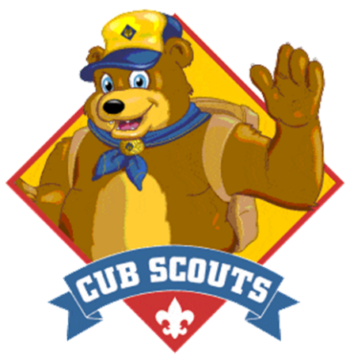
BALOO Training
Fri. Sept. 25 – Sun. Sept. 27

Cost: $30 per participant

No childcare
Includes meals
Optional “BALOO Trained” Shirts
i Sí, Hablamos Español !

At Camp Durant:
4637 Old Carthage Road
Carthage, NC

BALOO is the Cub Scout leader training required for any Cub Scout Pack Camping event or Webelos and AOL den, overnighters. This course is recommended for anyone involved in Cub Scouting.
Basic Adult Leader Outdoor Orientation Training has Two Required Components Both must be completed to qualify as a “BALOO TRAINED” Cub Scout outdoor leader or volunteer.
Part 1 Online ‘BALOO Prerequisite Training v2’ 35min at My.Scouting.Org must be completed prior to the in-person weekend. Part 2 Overnight Camping experience will cover: GPS, aquatics, gear selection, nature & hiking, outdoor ethics, cooking & sanitation, first aid, Cub Scout knife safety, and much, much more!
Check-in 8:00 PM Friday - Course ends 11 AM Sunday. Attendees must have: Safeguarding Youth training & their Annual Health Medical Record parts A+B.
Register Online: scoutingevent.com/421

Online Registration/Refunds by Sept 15th 2026
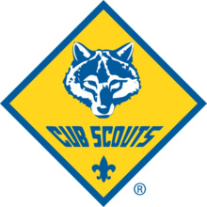
Course Director 910-286-4508 Ezzellmonica@gmail.com
Inform the Course Director of any special needs or dietary restrictions.

