
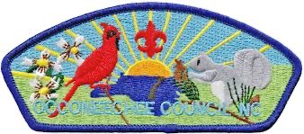

Occoneechee Council
Girls Adventure Camporee

BACK to the BASICS
Camp Campbell, Virginia
May 1,2,3, 2026

Dear Unit Leaders,

We, the Camporee staff, would like to welcome you and your unit to a weekend filled with fellowship and learning through fun and scout skills!

The 2026 Girls Camporee theme of “Back to the Basics” is sure to be one to remember!
Events include competitive food-based events and camp wide events!

Registration is $15 per person if completed on time. Registration opens in March and closes Monday, April 27th. Late registration fees of $20 per person apply on or after April 17th. Registering early helps staff to better budget what can be spent on camporee. Units that register early will have priority on campsite selection.

Come dressed in scout appropriate attire and get ready to have fun!

Please read this Event Guide and be familiar with it before you arrive. The first section covers logistics. The event program guide and schedule are at the end. Camp maps, forms, and other information are also in this guide.

CAMPOREE CONTACT INFORMATION

Adult Advisor: Laura Philpot. ljphilpot@gmail.com
Associate Advisors: Courtney Trujillo, Bill Casola

CAMPOREE ACTIVITIES AND EVENTS
This is a Camp skills and Cooking themed camporee. Scout attire, patrol flags, and campsite decorations are encouraged!

Campwide
- Survival Guide
  - Scouts will use their scouting skills to locate each skill/activity. Stamp your guide and complete the challenge. Challenges range from map reading, canoe course, axe skills, first aid; shelter building; fire safety, etc….
- Open Fire Cooking
  - Come and see how to cook on an open fire. Come by and help with cooking and get a taste of how open fire cooking works.
Note: Equipment is provided by event staff unless otherwise noted.
- Dessert Cook off
  - Does your Troop or patrol have the best dessert in a cast iron skillet or at the end of a stick? Well, we will gladly be the judge of that! All desert styles and cooking methods accepted. After the “taste test” your creations will be shared amongst all competitors. Bring your dessert to the field for everyone to taste. (Units should provide sample cups; table and everyone should bring their own bowl, spoon/fork)

Competition Awards:
Camp wide competitions will have a 1st, 2nd and 3rd place overall winners will be recognized.
Points for overall winners can be earned by:
● Doing well in scored events
● Participating in all Camporee events. (A low score in a scored event gets more points than a skipped event.)
● Presenting a skit, song, cheer, etc. at the campfire. Presentation should be approved on time. ● Wearing Scout uniform and appropriate attire.
● Showing unit/patrol spirit at events and gatherings.

Saturday Night Campfire

All Scouts and Scouters should assemble at the Flagpole in the large activity field at 7:15PM on Saturday Night for the Dessert contest. Immediately after the dessert contest
The Camporee Campfire will start with skits, songs, and other fun stuff. Each unit should be ready to do their favorite skit, song, or cheer. Not sure about what skit to do? The MacScouter’s Big Book of Skits (http://www.macscouter.com/Skits/index.asp) is a great place to start. Units must have their skit or presentation approved (i.e. vetted) by the Campfire Coordinators. Vetting of skits needs to be done by 3:00 PM at the ………. Please, no last-minute changes or entries after skits have been vetted and approved.

Sunday Morning – Scouts Own
We may have a Sunday morning flag raising ceremony and interfaith worship in the large activity field. Units that want to participate should have a Chaplains Aide that is willing and ready to lead a portion of the service.
Cleanup and Departure
Once your site is clean, send two runners to headquarters for departure. A Commissioner will come to your site and give you 2 surveys, one for youth and one for adults. Many improvements to our camporees have come from these surveys. Upon completion of the survey and a brief inspection of the site, patches and ribbons will be given to the unit youth leader and the unit is free to go.
If a unit needs to leave on Saturday or early Sunday, let camporee administration know in advance what time you expect to leave so we can have your patches ready.

Recommended Unit Packing Items for Activities and Campsite (not limited to these items).

  - Mess Kits
  - Portable Tables (some sites do not have tables)
  - Compass
  - Tarps (campsites do not have shelters)
  - Lashing Rope- competitions
  - Troop First Aid Kit
  - Container for vote tickets
  - 1 canned food item
  - Toilet Paper,
  - Trash Bags (This is a Pack in/Pack out camporee)
  - Water Canisters (Water is not at each campsite)

REGISTRATION AND FEES
Advance Registration:
Registration will go live in March using a link found on the district calendar or the event site. Updates may be released as the event approaches, so please be sure to verify that you have the latest version of the guide and check your email for updates.
In addition to the benefit of a discounted fee, advance registration for this Camporee is strongly recommended in order to request a site and have a smoother and faster Friday night check-in. Please correctly indicate the number of people you will be bringing with you so that you can be assigned an appropriately sized campsite. NO FRIDAY NIGHT REGISTRATION for units and please do not bring unregistered adults to the event.

Participation Guidelines
All participants must follow the Scout Oath, Law, Motto, Slogan, Outdoor Code, and the principles of Leave No Trace. The Camporee is open to all Scouts from a registered unit t. Units from other Scouting America districts and councils are also welcome to attend if space is available. However, we need to know in advance which units are planning to attend and how large a contingent they plan to bring. All adult leaders will be expected to volunteer to help with the activities at camp. A sign up sheet will be at check in. The Camporee staff greatly appreciates that a scout is helpful and we look forward to working your units to ensure a safe and fun time at camporee.

Forms Required at Check-In:
All forms must be completed prior to arriving at camp
Not completing forms prior to arrival delays check in. A Scout is courteous.
The Senior Patrol Leader (troops), President (crews), Boatswain (ships), or adult unit leader from each unit checking in on Friday night is responsible for completing and turning in the following forms to the Camporee Registration Staff:
- The On-Site Registration Form: located in appendix B. Emergency contact information for each camper is required.
- Unit swim classification record: located in appendix C
- The unit’s health forms should be presented at check-in. Part A and B are required for short term camps. The unit should keep the forms available and in a secure location. Staff, Adult volunteers, and youth not attending with a unit must present health forms to medical staff for review. (Standard HS-503)
- Copy of SYT certificates for ALL ADULTS

GENERAL ADDITIONAL INFORMATION
Cooking & Campfires
Units are allowed to have campfires and pits for charcoal cooking within their campsites; however, they must be attended at all times while in use and properly put out or banked when not in use. Appropriate fire circles MUST be used. Propane stoves and lanterns are also permitted. Please remember and abide by the Scouting America “NO FLAMES IN TENT” policy.
At Camp Campbell, the Army Corps of Engineers states any tree under three inches may be cut down; other laws may apply to protected species. If larger trees are felled, a fine may be assessed by the Corps of Engineers.

Weather
Weather will be provided. Camporee will be held rain or shine. Be Prepared.
Please check emails for any unforeseen weather or fire related events that may cause cancellation.
Uniforms:
All youth and adult members of Scouting America should be in proper uniform when appropriate. We encourage all scouts to wear their unit activity shirts, scouting shirts, camp tee-shirts or your field uniform.
Meals:
Units are responsible for their Breakfast and Dinner on Saturday and Breakfast on Sunday. Lunch on Saturday will be a group activity in the picnic shelter provided by the camporee staff for all scouts. (MREs - Meals Ready to Eat) Adults and scouts with dietary needs you will need to provide their own food for lunch. (Scouts receive an MRE, if there are enough, adults will be provided an MRE)

Dessert on Saturday will be “Dessert in the round” contest. Each unit will prepare a dessert that can be shared with all the participants (300+). Units will bring a table to the activity field and set up a “booth” where scouts can come by and get a taste of each dessert. Scouts will be able to vote for their 3 favorite desserts. Units will need to provide a container for votes.

Waterfront:
We will have a Scouting America approved swim director to run the beach area.
Unit Leaders should complete the Unit Swim Classification Record in appendix C to turn in at registration. The camporee staff will NOT have time to administer any swim tests at the camporee. Therefore, swim tests must be completed prior to the camporee. Swim tests administered during summer camp last year will suffice for the camporee as long as the swim form is completed..

Community and Campsite Facilities:
Camporee Campers will be camping in designated wilderness campsites. In each of these campsites, there may be some permanent facilities: some picnic tables, a fire ring, a latrine building, and a faucet with running water. Several units will be in each campsite, meaning that units will be in close quarters and will need to all share the permanent facilities in that campsite (no first-come, first serve). Please practice the Scout Law, and be considerate of your neighbors in the campsites! Unless otherwise notified, do not build any fires outside the designated fire rings. A starter roll of Toilet paper will be placed in each campsite privy by Camporee Staff.
Please keep pit toilets clean and neat; Please follow any signs indicating male/female or adult/youth.

Parking
Please arrive in as FEW cars as possible. Parking is limited. If you are bring a trailer please park it off the roads. Parking will be at the campsite, but no driving during the camporee event. Roads are dirt and not state maintained and depending on weather they may be rough to navigate, so leave the Ferrari at home.
Trash & Recycling:
Please be prepared to pack all of your trash out of camp on Sunday. Also there are not convenient recycling collection sites in or near camp, so you will need to take recyclable material back to your hometown.
Camper Security
Make sure all forms are filled out prior to arriving at Camp. Please think of those waiting to be checked in after you. A Scout is courteous.
No youth camper can leave camp without the unit leader first bringing the camper to admin and meeting the person signing the camper out in the presence of an admin staffer. Standard AO-804 Arm Bands will be used throughout the event, any person who is not wearing an armband should be reported to an adult camporee staff member right away. Standard AO-804
Any unauthorized person in camp who may pose a possible threat should be reported to 911 and camporee staff notified right away. Standard AO-804
Per Scouting America requirements, at least two registered adult leaders who are 21 years of age or older are required to attend with each unit, and to be present during the entire Camporee. Units bringing female youth must bring at least one registered adult female who is 21 years of age or older. At least one leader must have current hazardous weather training. All adults (age 18 and up) who are staying overnight must have current Youth Protection Training and must be registered Scouting America members in a position that is allowed to participate in overnight activities.
Medical/First Aid:
- The Camporee will arrange for a medical officer to be on-call at the camp to help with first aid emergencies. The station will be in the HQ building. However, please remember that Day Campers, Units and Unit leaders, NOT the medical officer and NOT the Camporee staff, will be primarily responsible for minor first aid for their participants.
- If any medical care needs arise which requires a visit to a hospital or medical care provider outside of the camp, unit leaders must notify and coordinate such care with Camporee HQ. DO not delay calling 911 if the emergency warrants, HQ must be notified immediately following 911.
- When you call 911 tell them the address is 498 Mill Creek Rd., Clarksville, Virginia
- An AED is stationed in the HQ building.
- If any accident or injury occurs within the camp, Scouts must notify both Camporee HQ and unit leaders, to make sure that the medical needs of any victim are promptly met. Any incident that requires assistance beyond basic Scout-rendered first aid must be reported. Near misses, which are defined as incidents that did not result in injury, illness, or damage, but had the potential to have done so should also be reported.
- In the event that external emergency services (e.g. ambulance) are called, someone should go to the camp front gate to meet and direct the emergency responders to the appropriate area. Camporee HQ will be at the Admin Building.
- Townsville, NC EMS-Fire services.
12729 NC Hwy 39 North
Henderson, NC, 27537
(252) 430-1445
- Clarksville Primary Care Center
61 Burlington Dr,
Clarksville, VA 23927
(434) 374-2773
- Maria Parham Health
566 Ruin Creek Road
Henderson, NC 27536
(252) 438-4143
- Campers’ medical forms must be available to adults authorized to provide camp health care and to adults accompanying minors off-site where emergency health care may be needed.
- Health information is shared only on a need-to-know basis.

DIRECTIONS TO CAMP CAMPBELL AND FRIDAY NIGHT CHECK-IN
- Address: 498 Mill Creek Rd., Clarksville, Va
- Directions to Camp Campbell appear in Appendix E of this Guide. Note: Some GPS and electronic/computer mapping systems suggest traveling on Antioch Church Road to get to Mill Creek Road. Lake levels are often high during the camporee, and this route may be impassable due to flooding. The Epps Fork Road route does not have this problem and is recommended.
- All units, whether or not registered in advance, will go through a check-in process on Friday evening at Camp Campbell. Check-in will take place between 4:00 PM and 9:00 PM. Units will arrive at the camp and be directed to park along the road beneath the power line to the HQ building.
- All Scouts and leaders should try to arrive at the camp at the same time, so that the entire unit can be checked in at one time. People may not hike or drive to campsites until they have completed check-in with camporee administration. All vehicles proceeding beyond the check-in area will require a vehicle pass.
- Anyone arriving outside of the unit arrival must proceed through admin. No exceptions please.
- The unit roster will be collected, and the unit leader can display the medical health form book and then return it to a secure location within the unit.
- Units will be directed directly to the assigned campsite for the weekend by staff after check in and screening.
- Units will have a campsite assigned to them based on availability and their numbers, and then be directed by Camporee staff to their assigned campsite. If a unit is spread out on arriving (that is, several vehicles for the unit which do not all come together), the designated leader of the unit should come first and complete check-in, and people in late arriving vehicles will be directed to the assigned campsite for their unit.
- A welcome packet will be given to the unit’s youth leader with several forms, a campsite inspection sheet, and camporee schedules to distribute to each participant or patrol.
- Upon arrival, each contingent leader must have for each camper (both youth and adult) an up-to-date Scouting America Annual Health and Medical Record form with parts A and B completed.
- All adults volunteers must have SGT updated and current, health forms A and B and registered.

APPENDIX B – ON SITE REGISTRATION FORM- Can Be printed in BLACK PUG
Circle Unit type:  Pack Troop Crew Ship Post | Unit Number: | Circle Unit Youth Gender:  Male Female Both | On-site Unit Leader Name:
Number of Youth Campers: | Number of Adult Campers: | Number of Day Visitors: | Leader Phone:

# | First Name | Last Name | Emergency Contact Name | Emergency Contact Phone | Adult | Camper | Patrol Name
1 |  |  |  |  | Y N | Y N
2 |  |  |  |  | Y N | Y N
3 |  |  |  |  | Y N | Y N
4 |  |  |  |  | Y N | Y N
5 |  |  |  |  | Y N | Y N
6 |  |  |  |  | Y N | Y N
7 |  |  |  |  | Y N | Y N
8 |  |  |  |  | Y N | Y N
9 |  |  |  |  | Y N | Y N
10 |  |  |  |  | Y N | Y N
11 |  |  |  |  | Y N | Y N
12 |  |  |  |  | Y N | Y N
13 |  |  |  |  | Y N | Y N
14 |  |  |  |  | Y N | Y N
15 |  |  |  |  | Y N | Y N
16 |  |  |  |  | Y N | Y N
17 |  |  |  |  | Y N | Y N
18 |  |  |  |  | Y N | Y N
19 |  |  |  |  | Y N | Y N
20 |  |  |  |  | Y N | Y N

APPENDIX B – ON SITE REGISTRATION FORM (Continued)
Circle Unit type:  Pack Troop Crew Ship Post | Unit Number: | Circle Unit Youth Gender:  Male Female Both | On-site Unit Leader Name:
Number of Youth Campers: | Number of Adult Campers: | Number of Day Visitors: | Leader Phone:

# | First Name | Last Name | Emergency Contact Name | Emergency Contact Phone | Adult | Camper | Patrol Name
1 |  |  |  |  | Y N | Y N
2 |  |  |  |  | Y N | Y N
3 |  |  |  |  | Y N | Y N
4 |  |  |  |  | Y N | Y N
5 |  |  |  |  | Y N | Y N
6 |  |  |  |  | Y N | Y N
7 |  |  |  |  | Y N | Y N
8 |  |  |  |  | Y N | Y N
9 |  |  |  |  | Y N | Y N
10 |  |  |  |  | Y N | Y N
11 |  |  |  |  | Y N | Y N
12 |  |  |  |  | Y N | Y N
13 |  |  |  |  | Y N | Y N
14 |  |  |  |  | Y N | Y N
15 |  |  |  |  | Y N | Y N
16 |  |  |  |  | Y N | Y N
17 |  |  |  |  | Y N | Y N
18 |  |  |  |  | Y N | Y N
19 |  |  |  |  | Y N | Y N
20 |  |  |  |  | Y N | Y N

APPENDIX C – UNIT SWIM CLASSIFICATION RECORD
https://filestore.scouting.org/filestore/outdoor%20program/aquatics/pdf/430-122.pdf

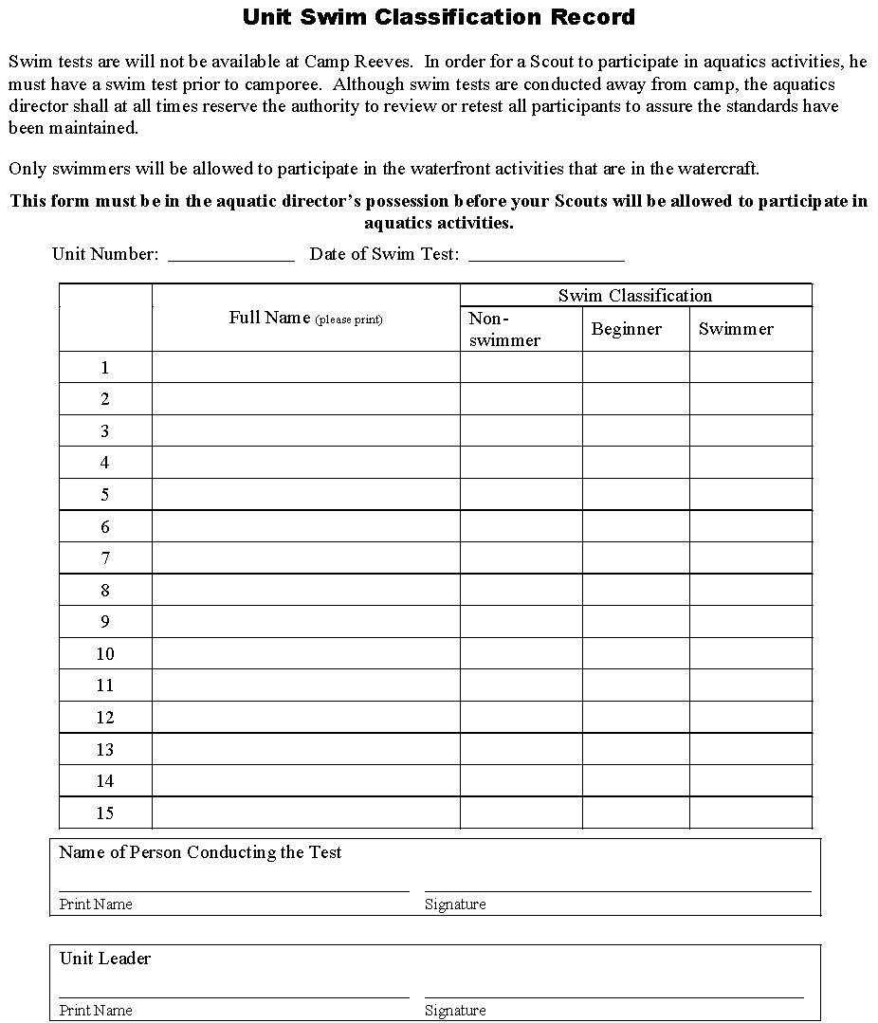

APPENDIX E – MAPS AND DIRECTIONS TO CAMP CAMPBELL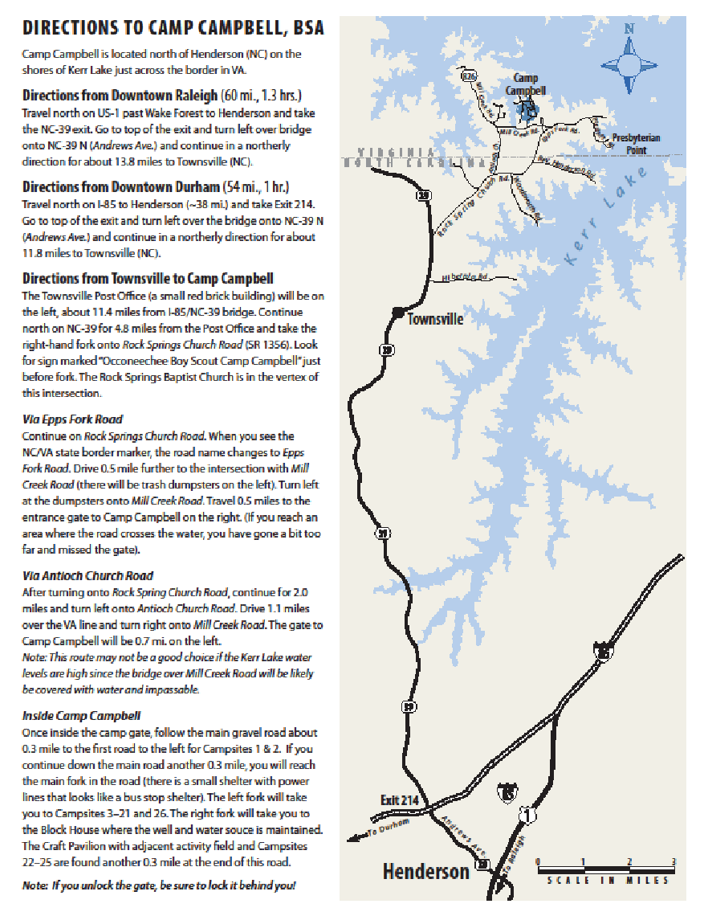:

APPENDIX F - MAP OF CAMP CAMPBELL
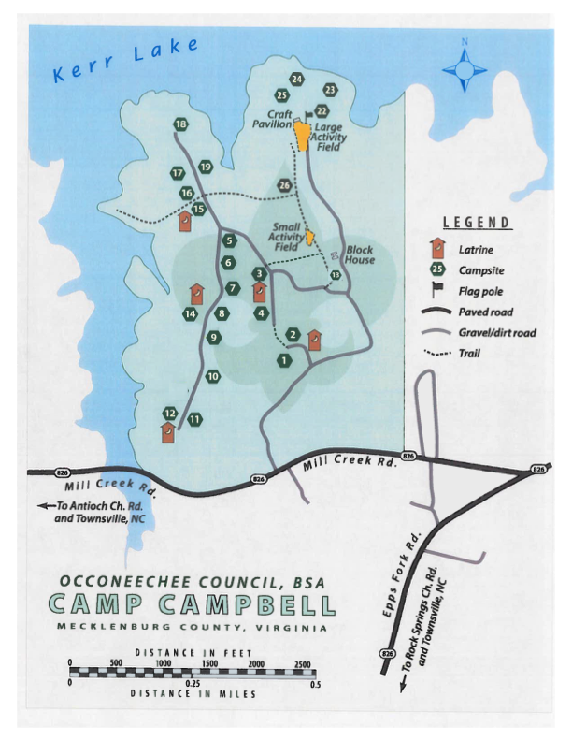

APPENDIX I - CAMPOREE PROGRAM PLAN
Friday Evening Camporee Activities – May 1st
4 – 9 PM | Unit Check-In, Campsite Assignment, and Campsite Set Up
9:30 PM | Leader Meeting and Cracker Barrel for Unit Leaders and Senior Patrol Leaders – Admin Building.(HQ)
11:00 PM | Taps / Quiet Time
Saturday Daytime Camporee Activities – May 2nd
6:30 AM | Reveille
6:30 – 8 AM | Breakfast, Cleanup and Campsite Preparation (at your camp site).
8:30 AM | Saturday Morning Flag Raising and Assembly (Large activity field)
9 AM – 11:45 AM | Saturday Daytime Camporee Activities – Morning Sessions
12:00 - 1:30 PM | Lunch (at the shelter- bring your mess kit).
1:30 - 4:30 PM | Saturday Daytime Camporee Activities – Afternoon Sessions
1 - 3:00 PM | Vetting of Skits (Admin) Bring skit on time to earn extra patrol points!
4:30 - 7:00 PM | Dinner prep, Dinner, and Cleanup (at your campsite)
7:15 PM | Dessert Contest- (Bring to Field)
7:45 PM - Until? | Flag Retreat at Flagpole and Campfire/Awards Presentation  All units should bring their unit flag and take it from Flag Retreat to Campfire (Campfire directly follows retreat.)
11:00 PM | Taps / Quiet Time
Sunday Morning – May 3rd
7:00 AM | Reveille
7:00 – 8:30 AM | Breakfast, Cleanup and Campsite Preparation
9:00 AM | Optional Interfaith Worship Service at the Activity field (Chaplain aides report at 8)
9:00 AM – 11 AM | Cleanup Campsites, Report to admin for a campsite inspection and check-out.

