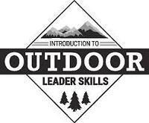 | LEADER TRAINING  IOLS  Introduction to Outdoor  Leader Skills  Sponsored by:  Eno River/Cardinal Districts | 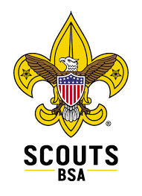

Wednesday, November 12th, 2025 7:00-8:30 pm (Zoom)
Friday-Sunday, November 14th-16th, 2025
Union Grove UMC, 6407 Union Grove Church Rd., Hillsborough, NC 27278

7-8:30 pm Wednesday, November 12th - Mandatory Zoom Meeting
5:30 pm Friday, November 14th - Registration/Campsite Selection Opens
6:30 pm Friday, November 14th - Training Starts
11:30 am Sunday, November 16th - Training Ends

Required Training for: SCOUTMASTERS & ASSISTANTS
Recommended for: VENTURING and SEA SCOUT leaders & ASSISTANTS

Trained leaders provide better programs for the young men and women they serve in their troops and crews. This is a required training course for all Scoutmasters & Assistants. Though not required, this is strongly encouraged for all Crew Advisors & Assistants.

In this course, you will learn the Tenderfoot through 1st Class outdoor skills required to instruct your Scouts and lead safe & fun outdoor programs. Topics include: Campsite Selection, Backpacking & Hiking Techniques, Knots & Lashings, Woods Tools, Fire Building, Map & Compass Use, Plant & Animal Identification, First Aid, and lots more.

$50.00 — Includes meals (Friday cracker barrel, Saturday breakfast/lunch/dinner/cracker barrel, & Sunday breakfast), course materials and a 2-night camping experience.
Refunds may be made, through close of Registration.

Prerequisite: Scouters must have completed Youth Protection Training as well as the position specific course for their position. Both are available at my.scouting.org.

Eno River Course Director: Cynthia Abell-Brown, ScouterCAB@gmail.com, 919-946-8060
Cardinal District Course Director: Marty Ross, Martyross22@gmail.com, (919) 699-5788
Cardinal District Course Director: Larry Williams, lmwiliams415@gmail.com, (919) 608-5178
Please inform any of the Course Directors of any special needs or dietary restrictions

Registration closes November 1st, or when course is full
Register Here:

