Leatherstocking Council Susquehanna Headwaters District
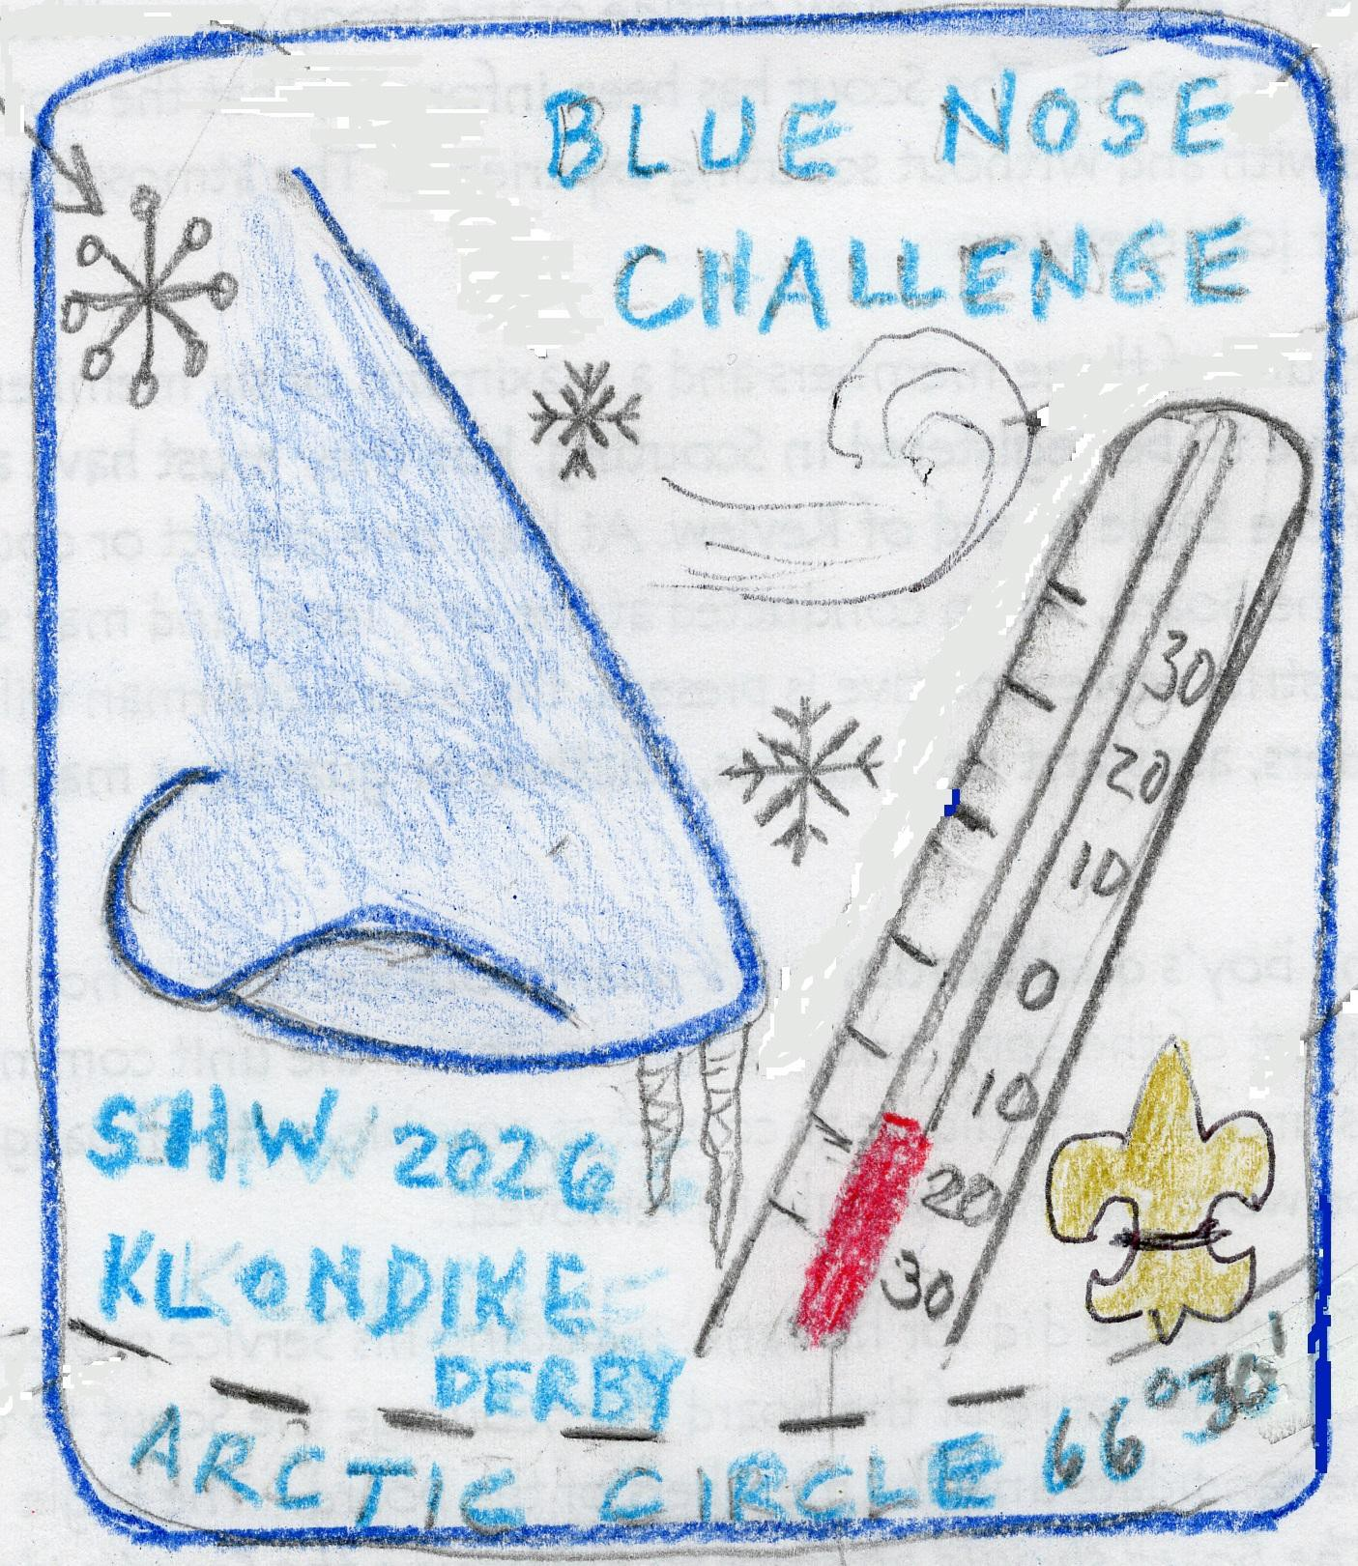
Klondike Derby February 7, 2026
Blue Nose Challenge Klondike Derby

Location: Unadilla Rod & Gun Club, 566 Butternut Road, Unadilla, NY 13849

Klondike Derby: open to all Scouts BSA and Arrow of Light: Arrow of Light scouts are not permitted to be in patrols/teams with Troops and must register under Klondike Derby not Gold Nugget Derby
Gold Nugget Derby: Open to all cub scouts

Date & Time: The derby is being held on Saturday February 7, 2026 8-9:00 am: registration at the clubhouse. Scoutmaster and SPL only. 9:00 am opening ceremony at the large pavilion
9:15 am events begin 12-12:45pm lunch 3:30pm events end
4:00 pm closing ceremony/awards

10 am-2:00 pm Cub Scouts

Fees: The cost for this event is $20 per Scout BSA/Arrow of Light (if participating in Klondike Derby), $10 Cub Scout (Gold Nugget Derby) if paid & registered by January 25, 2024. The fee includes patches, unit awards and hot drinks. Payments will not be accepted at registration.

Volunteers Needed: Each troop/pack must provide 1 volunteer per team entered for the day or points will be deducted. Names are required at registration

Registration: Please register online at leatherstockingcouncil.org before January 25 2026

Sled: All troops should have a Klondike Derby Sled - suggestions below From ScoutDocs.ca http://scoutdocs.ca/Klondike/Klondike_sled_plans.php From Boys Life http://media.scouting.org/boyslife/workshop/sledplans.pdf From Scouters.us http://www.scouters.us/sled.html
21 Sled Concepts http://www.inquiry.net/outdoor/winter/gear/sleds/
Lots of concepts (all over the place) http://pack239novi.tripod.com/Klondike/Sled_design.pdf

Facilities:
• Two outside restrooms will be provided. Please do not go into the clubhouse for restrooms
• One large community bonfire on the pavilion grounds. We will try to have wood available for mayors to have individual fires at the stations -but this is not guaranteed.
• Please carry a trash bag and follow Leave No Trace etiquette. There is a dumpster for trash near the clubhouse parking area.

Safety: The road between the two sides of the event stations is a public road. Please use extreme caution when crossing, even though we will have caution signs posted.
The pond is off limits. The ice thickness is unknown, and we don’t want to have any wet scouts. No flammable liquids are to be used for any events.
Knives used by scouts must follow BSA rules of folding knives that fit in the palm of your hand.

We have planned 16 events to test the patrol’s knowledge, skills, and teamwork abilities.
Events are subject to change. The number of volunteers will determine the number of events being offered.

Please email potential judges name and contact information to Jennifer Regelski-Rotman at onion197525@gmail.com

Patrol Equipment to bring:
Klondike sled
Pencil & paper in a gallon ziploc bag Heavy-duty bag for gold!
First aid supplies including a heavy blanket Two- six-foot-long staves
Whistle
Fire starting material from nature (no Char Cloth) flint & steel
Pocket knife Compass, calculator 6' x 8' tarp
2 gallons of water in plastic jugs Natural water purification materials:
Hand held GPS Device - with knowledge of how to use it Lunch for each scout - (only 45-minute lunch period) Water Bottle for each scout
Trash bag (leave no trace)
Each scout and leader brings their own mug!!
Proper boots and attire for the weather is a must! No sneakers Extra gloves and socks
Safety Glasses
6 pieces of 1/4 " Rope 10-12' in length for tying knots and lashings Small item with patrol name on it for Geocache

Klondike Derby Roster
Please complete in advance and submit to Jennifer at onion197525@gmail.com

Troop/Pack # (circle one) Patrol #1 Name
1:
2:
3:
4:
5:
6:

Patrol #2 Name 1:
2:
3:
4:
5:
6:

Required: Volunteer Name:
Phone # Email

