

Leader's Guide

Palmyra-Macedon Aqueduct County Park
Palmyra, NY 14427

CANAL QUEST:
HIKE and PADDLE
Fall Camporee
September 25th-27th 2026

Waters Edge Fall Camporee 2026

This event is a Canoeing, hiking, and camping event that takes place at the Palmyra-Macedon Aqueduct Park. Units can choose to either hike or canoe/kayak in the morning session, or the afternoon session. The agenda is more relaxed than the Canal Quest Camporee we had here in 2024. Units can participate at their leisure and enjoy a nice weekend on the canal. We will have Canoe’s, Kayaks and PFD’s available, we will be reaching out as units register to see if they are supplying their own boats or if they need to borrow one so we can make sure we have enough. There is more information below on the BSA Swimmer Classification, the map of the area, registration cost, and more!

General Erie Canal Trailmaps can be found here->
https://www.eriecanal.org/maps.html
https://nycanalmap.com/
https://www.ptny.org/cycletheeriecanal/planatrip/trailmap

COST & REGISTRATION

Price includes patch and covers scout station supplies.
Scout Base- $10
Adult Base- $0 FREE! Well, we are expecting help so that’s really the cost.

Payable directly to Council via blackpug ->
https://scoutingevent.com/397-WEFallCamporee26

All Scouts BSA Troops and Crews are welcome.

Registration deadline: September 18, 2026.

Valid BSA Swimmer Classification form from within the last 12 months for participants who want to canoe in the canal. ->
https://www.scouting.org/wp-content/uploads/2022/03/Swim-Classificaiton-record-430-122.pdf
Units are responsible for bringing all swim check paperwork with them and ensuring that all participants who paddle canoes have completed a Swim Check or are appropriately partnered with a swimmer classified Adult. Paddling canoes is not a requirement but an option.

Units will be responsible for providing all their own meals. Troops may charge extra to cover their own food and menu items.

TROOP ROSTERS
Leaders: Please have a copy of your Troop roster of attendees available at check-in.

BSA HEALTH FORMS
Parts A & B Here.

CHECK IN

Check in will start at 6:00pm and run until about 7:30pm. Please try to arrive by Troop; try to minimize individual Scout arrivals.

Use this location for directions and as the entrance (https://maps.app.goo.gl/ZXqELyo3h2Dx2WLD8 ) to the Park.

All troops must send a representative for check in to turn in rosters. Documentation will be provided at camporee cracker barrel.

Any late arrivals will have to coordinate with other troops for space to setup.
Parking will be limited—please car-pool if possible. Troop trailers will be able to park near the camping area in the far east side of the park but cannot block the roadway. All other vehicles can enter to drop off people and gear but must park in the main lot to the west side of the park or in additional spots off the park road.

All scouts are expected to participate respectfully in the all the Camporee activities and events. Scout Spirit is expected at ALL times.

Note that we will not have exclusive access to the park. The public will have access to the site while we are there. Keep trailers, gear and valuables locked up when not in use.

There will be NO ALCOHOL, FIREARMS, FIREWORKS, SLINGSHOTS, SHEATH KNIVES. Please discourage use of cell phones and other electronics.

IMPORTANT EVENT INFORMATION

Waters Edge District Camporee is a designated Scouting event. As with every BSA event, certain rules and regulations must be followed to ensure everyone's safety and positive participation.
Code of conduct: All Scouts, leaders & parents at this event will follow the Scout Oath and Law.
Safe Scouting: The Guide to Safe Scouting will be the benchmark by which all Scouting activities will be conducted. Any questions regarding safe Scout rules and principles will be directed to the District Executive.
Youth Protection: All registered Scout leaders are required to have current youth protection training. Make sure that all unit leadership in attendance is compliant.
Two deep leadership, when interacting with Scouts in camp and during activities.
Outdoor Code: We are fortunate to be allowed to use this county Park for this event. We will practice the Outdoor Code and the Leave No Trace Principles in all areas.
Meals: Units are responsible for providing meals for their attendees.
These should include Friday evening cracker barrel
Saturday Breakfast, Lunch and Dinner.
Sunday Breakfast.
Pay attention to the daily schedule for appropriate meal prep and clean up in the times allotted.
Water: There is NO water source in the camping area so we encourage you to bring all of what you need.
Toilets: There are vault toilets in the area for all to use.
Garbage: The park is Carry In Carry Out.
Safety: There exist a number of hazards at the Palmyra Macedon Aqueduct County Park and along the Erie Canal, both natural and man-made. Please respect these areas and stay safe.
LOCK 29: Phone: 315-597-4691 (Krista will be the weekend manager)

FIRST AID

- Primary First Aid support and supplies will be provided by each unit and unit leaders.
- Each unit should have a first aid kit at their site. Please report any significant injuries to your unit Medical Officer.
- In case of emergency dial 911 or the Palmyra town police at 315 597 9211.
- Each person attending the event will need to provide a current BSA Health Form Parts A & B to their unit leader. These need not be turned in but must be available. There are no exceptions.
- SAFETY: Each unit must have at least one stand-by vehicle in the parking area for use if transport home is needed.
- Each unit is responsible for medical transportation for any minor injuries; all emergency issues will go to 911.

CAMPFIRES AND STOVES

No ground fires are permitted. Bring elevated fire pits that will not damage the underlying grass if you wish to have a fire.

Cooking stoves (e.g. propane) are recommended.

WHAT TO BRING

Troops are responsible for bringing all Troop Gear needed for a weekend Campout.
Scouts are responsible for themselves; gear, clothing, and BEING PREPARED! See attached information on what to bring for the rafting trip.

Troop Class Bs for Opening Ceremony and Participation throughout the day. We are representing scouting out in the public.

Each scout should also have:
Day pack
Personal First Aid Kit
Drinking Bottles / bladder for hydration
Rain gear; Dress appropriately for the weather
Snacks as appropriate

Registration Questions: Will Gales, Field Director, William.gales@scouting.org

SITE MAP
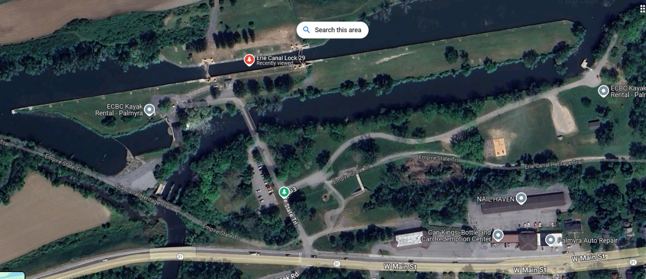
UNIT CAMPING AREAS
Opening
Addl Parking
TROOP TRAILERS
Main Parking

Canal

Canal Trail

Entrance

MAPS

All printed course maps will be handed out to units at the cracker barrel Friday night or Saturday morning at the opening. Maps will mark stations, approx. distances and contact information. Patrols will need a minimum of 2 adults to accompany them on all courses in compliance with 2 -deep leadership and safety considerations.

Below are the public routes created on gaiagps.com. These should be available to anyone with the link.

Canal Quest Hike Route-

https://www.gaiagps.com/map/?loc=13.8/-77.2418/43.0649&pubLink=RcxHdg789XkJdmWBuHWMwDtp&trackId=0a97634c-cd69-4807-8e73-9a99ebf9d3aa

Canal Quest Canoe Route-

https://www.gaiagps.com/map/?loc=13.8/-77.2418/43.0649&pubLink=DfepYKyAUj6kR5TLK1BBt7s2&trackId=3f533676-81cc-4f12-bcd3-c5aedc2f7543

Patrol Register
Fill out one sheet for each patrol from your unit and provide at check in.

TROOP #:
PATROL NAME :
Scout Member Names:
Adult Member Names (at least 2 needed for each patrol):

Requirements that could be completed

Hike (5 mi, est 2h) | Canoe (5-10mi, est 3h)
SCOUT 1a,c,e | SECOND CLASS 5c-d
SCOUT 2c | SECOND CLASS 6d-e
SCOUT 3a | FIRST CLASS 3b-c
SCOUT 4a | FIRST CLASS 5d
TENDERFOOT 3d | FIRST CLASS 6b,c,d
TENDERFOOT 5c-d | FIRST CLASS 7f

For those who wish to canoe in the canal, 2 to 3 scouts can be in a canoe and they must be full BSA Swimmer classification with a current test (within 1 year). Alternatively, a scout who is a beginner or non-swimmer can paddle a canoe with a full Swimmer adult in the boat. Only 2 boats (min 4 scouts) for a patrol need to paddle from the starting station to the next station. Buddy boats must stay together. Others in a patrol can hike (or bike) along the canal if they do not wish to paddle but want to follow along with the boats. We will also need a few Safe Swim Defense and Safety Afloat trained adults to manage and monitor the canoes.
SCHEDULE

Friday 6pm - 730pm Arrival Check in. Troops set up their Camps

930pm Cracker Barrel @ T110 site
(please send 1 adult leader and 1 youth leader)

Saturday 7am Reveille and Breakfast within Troops

815-830am Opening at Location near aqueduct bridge

830am-9am Safety briefing

9am- 1130am Morning Courses

Scouts must be back in camp no later than noon.

12-1pm Lunch in Troop sites

130-430pm Afternoon Courses

Scouts must be back in camp no later than 5pm.

5-7pm Troop dinners

7-10pm Troop campfires and/or evening activities

No ground fires. Must use raised firepits that will not damage grass.

10pm Lights Out

Sunday 730am Reveille and Breakfast within Troops

9am Units take down camp and clean up sites

11am Troop departures no later than this time

