CUB SCOUT

ADVENTURE CAMP

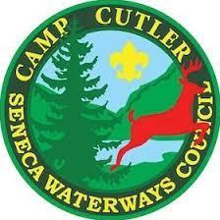

PARENT GUIDE

TABLE OF CONTENTS
Mission Statement 3
Contacts 3
Welcome 4
General Information 5-7
Medical 8
Food Services 9
What to Pack 10
Villages 11
Check In 12
Aquatics 13
In Camp 14-17
Check Out 18
Camp Policies and Emergency Procedures 19-24
Map 25
Schedule 26
Rank Based Electives 27
Open Program Activities 28
Theme 29
House Cup 30

MISSION STATEMENT
It is the mission of Scouting America to prepare young people to make ethical choices over their lifetimes by instilling in them the values of the Scout Oath and Law.

It is the mission of the Seneca Waterways Council summer camping program to provide each Scout with an outdoor experience through which they have opportunities to: be challenged; work toward advancement; be active with their troop, patrol and others; achieve while learning; develop as a person; enjoy the Outdoors; and have fun.

CONTACTS

Seneca Waterways Council
P:585-244-4210 F:585-241-8552
2320 Brighton-Henrietta Town Line Road, Rochester, NY 14623

CSAC Camp Director: Sara Hardy, 585-857-8126
csac-director@senecawaterways.org

Director of Support Services: Tracy Jones, 585.244.4210 x 8543
tracyg.jones@scouting.org

Scout Executive: Jonathan Widmark, 585-241-8554
jonathan.widmark@scouting.org

J. Warren Cutler Scout Reservation
Before Camp:
Attn: Camp Cutler
Seneca Waterways Council, BSA J. 2320 Brighton-Henrietta TL Rd.

Phone: 585-241-8547
Fax: 585-244-8552
Rochester, NY 14623
During Camp:
Attn: Camp Director
J. Warren Cutler Scout Reservation
7131 Gulick Road

Phone: 585-374-8656
Naples, NY 14512

Welcome to Cub Scout Camp!

Dear Leaders & Parents,
Thank you for choosing Cub Scout Adventure Camp at Camp Cutler as your Cub Scout’s summer destination! With the 2026 camp season fast approaching—less than 100 days away!—our team is eager to welcome you to a magical new adventure: “The Wizarding School.”
This summer, Scouts will step into a world of imagination and discovery, where creativity, courage, and curiosity come to life through themed activities, hands-on learning, and plenty of camp fun. Our dedicated staff can’t wait to guide your Cub Scouts through enchanted challenges, spellbinding adventures, and unforgettable moments under the stars.
This guide is designed to provide leaders and parents with all the key information you’ll need for camp in 2026—from check-in and schedules to program highlights, packing lists, health and safety notes, and more. While we’ve included as much detail as possible, there’s always more to explore! If you have any questions or ideas, please don’t hesitate to reach out. We always value your input and collaboration. For additional updates, visit www.senecawaterways.org/outdoors.
Thank you for joining your child on this journey. Scouting thrives because of dedicated leaders and parents like you who help make the magic happen. On behalf of the entire 2026 CSAC staff, thank you for choosing Camp Cutler—we look forward to sharing a summer filled with wonder, laughter, and adventure as we open the gates to The Wizarding School!
Sara Hardy
Camp Director
csac-director@senecawaterways.org
585-857-8126

GENERAL INFORMATION
2026 Cub Scout Adventure Camp Season

Session 1: July 5 - July 7
Session 2: July 9 - July 11
Session 3: July 12 - July 14
Session 4: July 16 - July 18
Session 5: July 19 - July 21
Session 6: July 23 - July 25
Session 7: July 26 - July 28
Session 8: July 30 - August 1
Session 9: August 2 - August 4

2026 CSAC Camp Fees

Camper Fee Schedule
- Camper Deposits must be paid in full by March 27, 2026
- Early Bird Fee must be paid in full by April 24, 2026
- Scouts who missed Early Bird deadline must have fees paid in full by June 30, 2026
- Youth who have joined scouting in the Spring (Feb-June) are Eligible for early bird rates. Be sure to select "New Scout in Spring"
Rates
- Regular Rate Sessions 1,3,5,7,9 - $290 Sessions 2,4,6,8 - $300
- Early Bird Rate Sessions 1,3,5,7,9 - $265 Sessions 2,4,6,8 - $275
- Adult Rate $75
Sibling discounts - Have more than one child attending camp? Receive a $25 discount! Requests for sibling discounts must be submitted to camping@senecawaterways.org before final payments are due in order to apply.

Reservations
Packs register for camp through the online registration portal. Please note that villages are shared spaces, and your Pack may be housed alongside families from other Packs. In some cases, camp management may need to adjust accommodations as needed.
Not attending with your Pack? No problem—you can register independently and still enjoy camp with your Scout(s)!
Refund Policy
There are situations in which a campers’ fee may be refunded, either in whole or in part to the unit. Please note that refund checks will not be written to individual families, they will be written to the Pack.

Full Refund
The balance of a campers’ fee may be refunded up until two weeks prior to the start of your week at camp for the following reasons if accompanied by appropriate documentation:
- Medical issue regarding the camper
- Extreme family emergencies

Partial Refunds:
Partial refunds of $50 per camper may be issued to the unit for reasons outside of those listed above, provided the request is made at least two weeks prior to the start of your scheduled camp session. After this deadline, refunds cannot be granted, as expenses such as food and program supplies are purchased based on your unit’s projected attendance.
All refund requests must be submitted in writing no later than two weeks before your camp session to be considered. Requests can be mailed to Seneca Waterways Council, 2320 Brighton-Henrietta Town Line Road, Rochester, NY 14623, or emailed to camping@senecawaterways.org.
Leadership
Each Pack must have at least one adult leader age 21 or older for every four Cub Scouts attending camp. The New York State Department of Health requires Seneca Waterways Council to maintain records of all adult leaders’ qualifications while at camp. In addition, all adults attending camp—including camp staff—must undergo a sex offender registry check prior to arrival.
All adult leaders are required to bring proof of current Safeguarding Youth Training (SYT) to camp. Every adult in attendance must complete SYT before arriving. Training can be completed online at https://my.scouting.org/.
IMPORTANT - This includes any/all adults, parents, or visitors who are staying overnight in camp. Adults without SYT will not be allowed to remain on the property.

Out of Council Unit Requirements:
SYT & Registration - Out-of-council units attending a Seneca Waterways Council summer program must provide a current copy of their official unit roster, including all registered youth and adults. This roster can be printed from my.scouting.org or obtained through your local Scout Service Center.
All adults attending camp must be listed on the roster and marked as having completed Safeguarding Youth Training. Rosters must be submitted to the Camp Director at csac-director@senecawaterways.org at least one week prior to your unit’s arrival. Please note that any youth not listed on the roster will not be permitted to remain at camp.
Accommodating Special Needs
The staff of Cub Scout Adventure Camp are dedicated to ensuring all Scouts can fully participate in every aspect of the camp experience. Meeting individual needs may involve adjustments to facilities, staffing, or program delivery.
Accommodations such as special menus, accessible campsites, and other supports can be arranged for Scouts and leaders with physical or learning disabilities, medical conditions, dietary needs, religious practices, or other considerations. Unit leaders are encouraged to contact the Camp Director well in advance to discuss any specific needs within their Pack so appropriate arrangements can be made.

MEDICAL
Required Medical Forms: Each camper must have a current BSA Annual Medical Form filled out completely. Parts A & B1, B2 of the form are required for ALL youth and adults. Form B2 MUST be filled out and signed by a physician for any campers who require prescription medication. An updated immunization record must be provided for ALL campers. The Youth Medication Permission Form MUST be filled out for ALL YOUTH with a physician’s signature. ALL medications must be turned in to the Health Director upon check in.

Medical Services: Camp Cutler is equipped with a health lodge staffed by a qualified health officer, with a non-resident physician available on call. Nearby hospital facilities are accessible if additional medical care is needed.
If the health officer determines that a Scout or leader requires care beyond what can be provided at camp, the individual may be sent home for further medical attention.
Medications: All medications must be turned in to the Health Director upon arrival at camp, and will be stored in the health lodge. This includes prescription medications as well as over the counter medications.

CPAP Machines: More and more adult leaders are using CPAP machines. Camp Cutler offers areas in each site for power cords to support individuals needing to power a machine. Please contact the Camp Director prior to arrival so we can make appropriate accommodations.

FOOD SERVICES

Food Service: Cub Scout Adventure Camp provides an outstanding Dining Hall experience for all campers and leaders. At J. Warren Cutler Scout Reservation, our qualified food service team prepares high-quality meals designed to keep everyone fueled for a full day of adventure.
Campers enjoy three meals each day, starting with dinner on the first day of their session and concluding with dinner on the third day. All menus are reviewed by a licensed dietitian to ensure well-balanced, nutritious meals that meet the needs of growing Scouts.
Dietary Needs: If Scouts or adults have special dietary needs, please submit a Camp Food Accommodation Form (available online) at least two weeks prior to your pack’s arrival. All requests should be sent to cutler-food@senecawaterways.org.
Please note that requests made at the time of arrival may not be able to be accommodated. Our goal is to make your camp experience enjoyable for everyone, so we encourage you to communicate any dietary needs as early as possible.
***All meals will be served in the dining hall this summer.

WHAT TO PACK

Recommended Packing List:
Uniform Class A Shirt*
Swimsuit & goggles
Poncho or Raincoat
Personal Hygiene Items**
Pants/Slacks/Shorts
Underwear & Socks
Pajamas
Flashlight/Headlamp
Towels
Water Bottle
Sweater or Jacket
Mosquito Repellent
Sunscreen
Closed Toed Walking Shoes (for walking around camp) (2 Pairs)***
Crocs/Swim Shoes (1 pair) (for the beach/pool)
Small Backpack/ Day pack
Spending Money forTrading Post
Sleeping Bag & Pillow
Whittling Chip
BSA Med Forms

*The uniform is highly recommended, but no Cub Scout is denied attendance because they do not own a uniform

**Adult and youth have separate shower facilities so please plan accordingly

***NO OPEN TOED SHOES WILL BE PERMITTED EXCEPT ON THE POOL DECK AND BEACH.

Optional Items:
Mosquito Netting
Binoculars
Matches (adults only)
Cub Scout Knife
Camera
Watch
Sports Equipment For Free Time
Fishing Pole and Tackle Box
Lawn Chairs
Stuffie friend

DO NOT BRING:
Open Toed Shoes
Bikes/Scooters
Alcoholic Beverages
Pets
Fireworks
Weapons
Aerosol Cans

VILLAGES

About Our Villages
Cub Scout Adventure Camp features five unique villages, each with its own fun theme and atmosphere: Mountain Scout, Medieval Castle, Pioneer Fort, Viking Longhouse, and High Seas. Each village offers a welcoming home base where Scouts stay, build friendships, and take part in daily activities, all while being immersed in an exciting adventure setting that brings the spirit of camp to life.

Sleeping Accommodations
Separate accommodations are provided for youth males, youth females, adult males, and adult females. Youth may not share accommodations with other youth who have an age difference of two years or more.

Special accommodations may be available upon request. Please contact the Camp Director at least two weeks prior to your arrival to discuss needs such as parents needing to sleep closer to their children or access to electricity for medical devices (such as CPAP machines).

Food Storage
Campers are welcome to bring snacks to enjoy throughout the day. However, food is not permitted in sleeping quarters—unless you’d like a visit from some furry friends—so please use designated storage areas. For Castle, Fort, and High Seas, food should be stored in the Village Kitchen, while Viking and Mountain Scout should use the Dining Hall Kitchen.
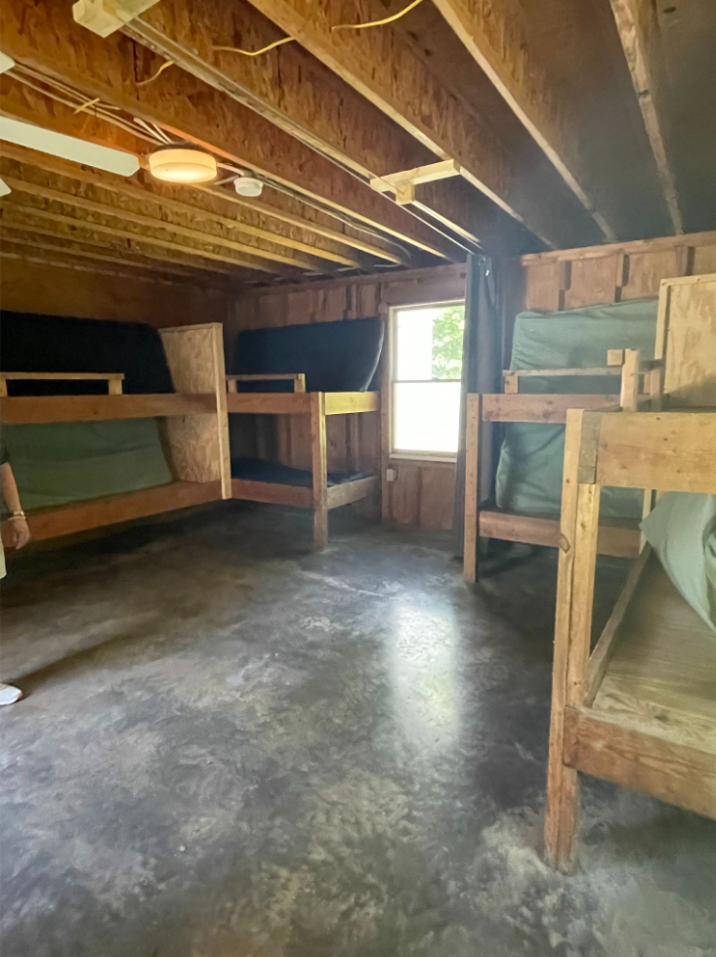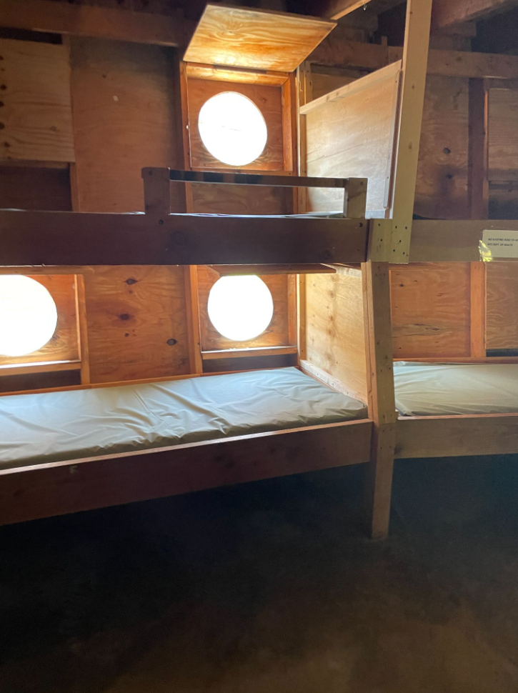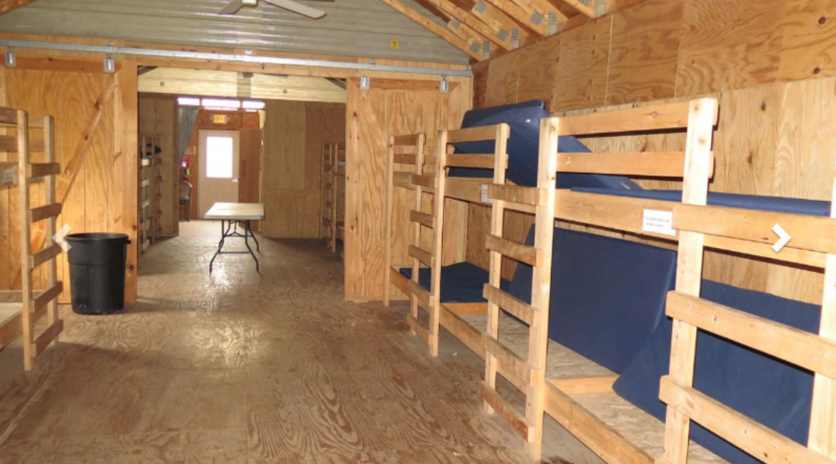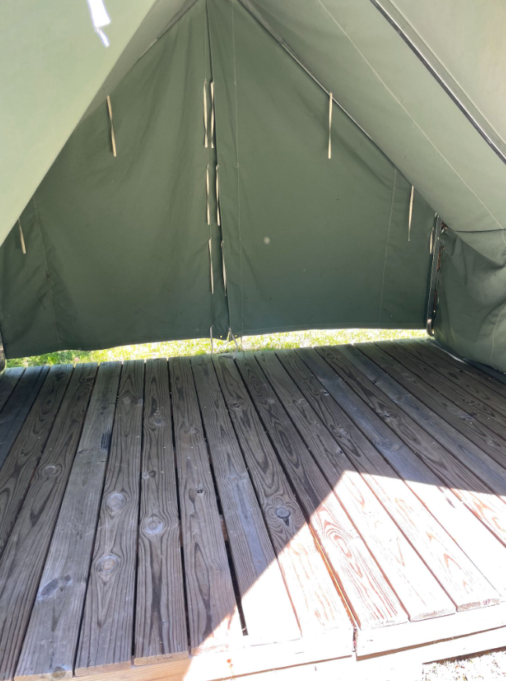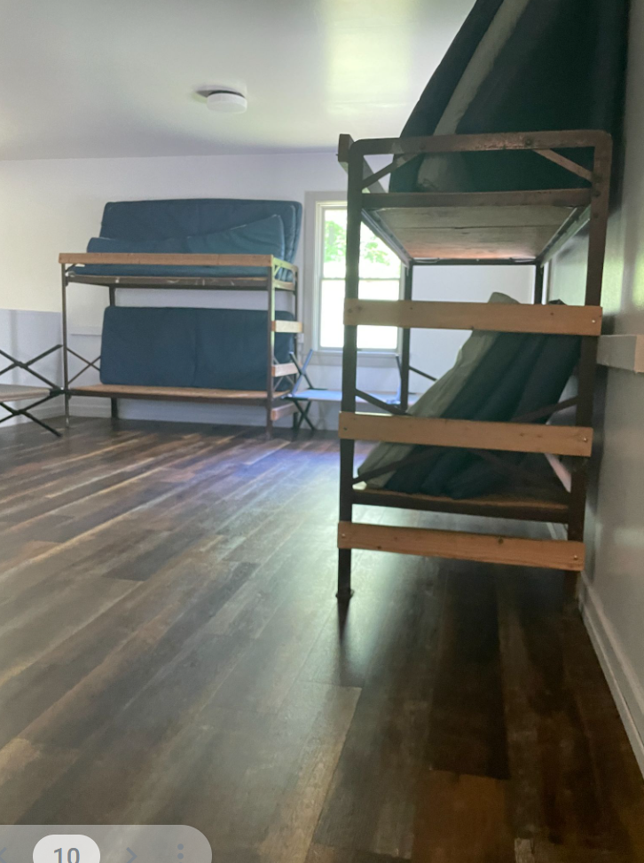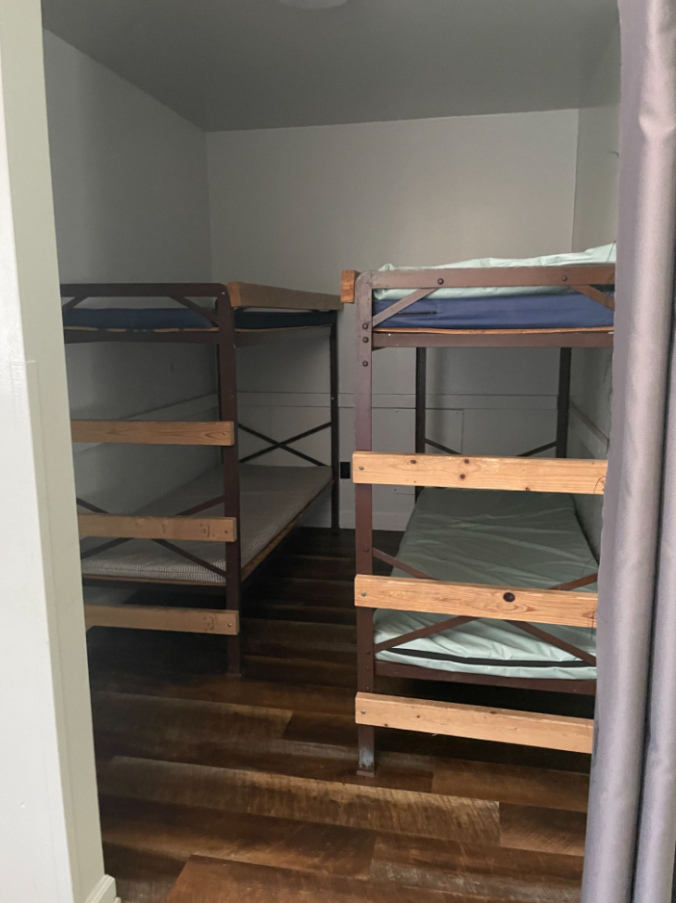

CHECK IN

Arrival Time
There will be three one-hour check in blocks, beginning at 11:00 AM. These will be based on villages. If any campers arrive before their designated time, they will be asked to wait until everyone from the prior slot has finished checking in. We hope that by staggering the check in process, it will alleviate wait times.

11:00 AM Mountain Scout and Medieval Castle
12:00 PM Pioneer Fort and Viking Longhouse
1:00 PM High Seas

*If your pack is split between two or more villages for the same session, please reach out to the Camp Director for further guidance on check in times.

Upon Arrival
Upon arrival, please check in with the parking attendant before being directed to your designated parking area. After parking, unload your gear and place it in the location assigned to your Village under the pavillion.
Be sure to have a backpack or tote bag readily accessible containing your medical forms, any medications, and your swim gear (along with your swim classification form if completing a test prior to camp). You will carry these items with you.
All other gear will be transported to your Village by camp staff and will be waiting for you upon arrival. Please remember to clearly label all personal belongings.
Health Screening
You may proceed to the Welcome Pavilion (located adjacent to the lower parking lot) with your daypack containing the items detailed above. At the Pavilion you will meet our Health Director and complete your Medical Check-In. During Medical Check-In please be prepared to turn in your completed Medical Forms and all medications.

Late Arrivals
If you know someone in your pack will be arriving late please let the Camp Director know upon check in. If arriving after 2:00 PM, please head directly to the Health Lodge to check in with the Health Director. After checking in, you will be allowed to unload your car at your village, and will need to promptly move your vehicle back to the lower parking lot.
AQUATICS

Swim Checks
Once you have completed the Medical Check-In, grab your backpack (now containing only your swim gear) and proceed to the Dining Hall to receive buddy tags and enter the shower house to get ready for the pool and a swim ability check.

Please remind all adults in your group that they need to take the swim test with the youth. Your Pack may choose to do their Swim Test prior to your arrival at camp as part of a Pack or Den activity this spring or early summer (see Swim Classification Test information on pages 10-11).

During swim checks, you will be given basic information such as aquatics rules and how to use the Buddy System. This check will allow the staff to determine who can use the rowboats, canoes, and sections of the pool. If your pack has done a pre-camp swim check, bring it to the Aquatics Director for review. Pre checks can be submitted only with the BSA Swim Classification Record form with a copy of the credentials of the test administrator. Pre checks will not be approved without these credentials!

Swimming Band Classifications:
- Swimmer’s Test/Blue Band - Jump feet first into deep end, level off, begin swimming. Swim 75 yards in a strong manner, then swim 25 yards using resting backstroke. Float on your back for one minute.
- Beginner’s Test/Red Band - Jump feet first into deep end, level off, begin swimming. Swim 50 feet on the surface.
- Non-Swimmer/White Band - anyone unable to complete a swimmer or beginner test.
Pool:
- Shallow End -
  - Red or Blue Band swimmers
- Deep End -
  - Blue band swimmers only
Boating:
- Row Boat -
  - White or red band adult or youth WITH blue band ADULT
  - Any blue band swimmer
- Canoe and Corcl -
  - Blue band youth/adult
IN CAMP

Identification
Each camper, adult leader, and visitor is required to wear a camp-issued wristband at all times while in camp. Campers and leaders staying in camp will receive their wristbands at the pool deck upon arrival. Visitors will be issued a wristband when they check in.
Anyone not wearing a wristband will be stopped and asked about their purpose in camp to ensure the safety and security of all participants. If your wristband is lost or damaged, please see a member of the aquatics staff to receive a replacement.
Leaders
A Scout Leaders meeting will be conducted in the Dining Hall in the evening on your first day. Please ensure that your unit is represented. We will preview the session and address any concerns as well as an introduction to key staff.

Scout Uniforms at Camp
The official Scout Field Uniform consists of the official shirt, belt, shorts, and socks. This uniform is recommended to be worn each day for dinner, as well as for Scouts Own Service. It is also appropriate for opening and closing campfires. The content of all clothing and hats should be consistent with the principles of Scouting America.

Trading Post
A full-service Trading Post is available at camp, offering a wide variety of items Scouts will love. Regular business hours are posted at the Trading Post, though it is typically closed during meals, rank activities, and camp-wide campfires.
Camp Cutler’s Trading Post is open most of the day and carries everything from camping supplies and Camp T-shirts to craft kits, books, snacks, ice cream, slushies, drinks, and more. For your convenience, cash, credit cards, and checks are all accepted.
Campsite Equipment
Camp Cutler features five different village sites where Cub Scouts will stay during their time at camp. Each site is equipped with appropriate sleeping accommodations, as well as picnic tables, a bulletin board, and nearby bathroom facilities.
It is the responsibility of all campers and leaders to help keep these facilities clean and in good condition. Please ensure that no foreign materials are placed in bathroom facilities (including feminine hygiene products).
Everyone is expected to use camp equipment properly and treat it with care. Units may be charged for the repair or replacement of property damaged due to misuse. If any accidental damage occurs, please notify the camp office as soon as possible.
Tent Care
In order to maintain the quality and durability of our tents, please follow the guidelines below:
● Do not put clothes hangers over ridgepoles; it causes tears and leaks (Hang a clothesline or improvise a method that will not damage tents).
● Do not put nails in tents poles or platforms.
● Aerosol sprays damage waterproofing and are not permitted in camp.
● No flames of any kind are allowed in tents (battery-powered flashlights and lamps should be used).
● Tent platforms may not be moved.
● Please notify the Camp Office if a tent is leaking or has a hole in it.
● Do not use any duct tape to make any repairs to the tents. The glue on duct tape makes it harder to repair a tent properly and much more effort has to go into fixing the tent properly.

Volunteering at Camp
It takes a significant amount of me to maintain and improve the properties of Camp Cutler. We are fortunate to have volunteers who are willing to take time while attending camp to help improve camp. Skilled maintenance, general labor and upkeep, and major improvements are all needed. Carpenters, electricians, plumbers, equipment operators, and many more, are all needed to help camp prepare for your arrival. If you are a skilled tradesman or you would like to help around camp, please contact the camp ranger Peter Heiderich at 585-364-5770 or Peter.Heiderich@scouting.org .

Telephone Usage
You can reach the Camp Business Office 585-374-8656. Please use this telephone number for business and emergency calls only. Individuals will be summoned to the phone only in cases of emergency. WiFi is available for the convenience of leaders attending camp.

Cell Phones & Other Electronic Devices
Staff members will not tolerate the use of cell phones, MP3 players or other electronics by Scouts in program areas. Any further policies for electronic devices are the purview of the unit leadership in consultation with parents. Seneca Waterways will not be responsible for the lost or damaged electronics.

Safeguarding Youth at Camp
Cubmasters and Pack Leaders should review Safeguarding Youth guidelines with all adults who will be serving as leaders in camp. All adults attending camp MUST be SYT trained.

The following barriers to abuse are used at camp to ensure the safety of our youth campers. We expect adult leaders to follow these guidelines at all times:
- Two deep leadership is required at all times.
- No one-on-one contact: Personal conferences must take place in plain view of others.
- Separate accommodations: Youth Scouts may not share a tent with an adult unless the adult is a parent. Male and female leaders may not share a tent unless they are married.
- Separate bathroom facilities: Indoor village restrooms are for adults only. Outdoor village restrooms located in High Seas, Pioneer Fort and Medieval Castle are for youth only. Bathrooms located at the Dining Hall are clearly marked based on age and gender and must be used accordingly.
- No secret organizations are recognized by Scouting America: All aspects of the Scouting programs are open to observation by parents and leaders.
- Constructive discipline: Discipline should be constructive and reflect Scouting’s values. Corporal punishment is never permitted.
- Hazing prohibited: Physical hazing and initiations of any type are prohibited and may not be included as part of any Scouting activity.
- Junior leader training and supervision: Adult leaders must monitor and guide the leadership techniques used by junior leaders to ensure that Scouting America policies are followed.

Child Abuse
If at any time you suspect a Scout has been mistreated, neglected, or physically or emotionally abused, notify the Camp Director immediately. If the Camp Director is not available, report the situation to the Program Director, Business Manager, or Scout Executive. Do not investigate any situations that may occur. Keep information confidential and share only with the appropriate authorities.

Visitors in Camp
Visitors are welcome in camp, as long as they have been approved by the Camp Director. Visitors must sign-in at the camp office immediately upon their arrival in camp. If a visitor plans on staying for any meals, they must purchase a meal ticket at the Camp Office before going to the Dining Hall. The Cost of each meal is $8.00 (Breakfast, Lunch or Dinner) .

Early Release of Campers
There may be reasons that Scouts need to leave before the end of their camp session. If a Scout needs to leave camp for any reason during the session, they must have documented permission from their parent/guardian that attends with them before they will be released. This permission is usually provided on the BSA Annual Health Form, but can also be provided in writing to the Camp Director. Upon arrival, an adult taking a camper out of camp must fill out an Early Release Verification form and obtain signature of the unit leader as well as permission of the Camp Director or designee before the youth will be released. This is in lines with the Youth Protection policies of the BSA as well as NYS Department of Health requirements.

Wildlife Encounters
It is recognized that in a summer camp facility there can be encounters with a variety of wildlife. Staff, leaders, and all campers should adhere to the following procedures. All wildlife that might be encountered (in campsites, program areas, or on the road/trails) should be avoided. Campers should be removed from the area until the animal leaves or the Ranger dispatches the animal. If an animal is acting strange (aggressive or friendly), alert camp leadership immediately. In most cases if people leave the wild animal alone, it will leave them alone. This includes dead, dying and live animals. No one should pick up or touch a dead animal. In the event of a wild animal bite or scratch, notify the Health Lodge immediately. This is especially important when raccoons, skunks, and bats are involved. Some general policies for avoiding adverse interactions with wildlife:
● Keep a clean campsite
● Keep food and smellables out of your tent
● At night lock food and smellables up tight
● Never approach or follow wild animals
● Do not feed wild animals
● Do not mistake a passive animal as a sign of safety
● Never tease or attempt to pick up wildlife
● Leave young animals alone; a protective mother is usually nearby
● Notify Camp Ranger or Director of strange animal behavior
● Never act aggressively toward wild animals

CHECK OUT

Leaving Camp Checklist
- Reconcile bills with the Camp Director
- Ensure your Village is clean and in better condition than you found it
- Return a camp evaluation form to the office
- Retrieve medications from the Health Lodge
- Make a reservation for summer 2027

Loading Cars
Only two vehicles at a time are permitted to park in each village to load gear when departing camp on the third day. Once gear is loaded, cars must be moved back to the lower parking lot for the duration of camp. If departing prior to the third day, permission must be obtained from the Camp Director to load vehicles at the village sites.

Camp Dismissal
Camp program is offered through the end of our closing campfire. We encourage all campers to stay for the entirety of their session. If departing prior to dinner on the third day, all campers leaving property must sign out at the Camp Office. If departing after dinner on the third day, no official checkout is needed.

Procedures for the Release of Minors from Camp
All participants must sign out at the Camp Office. The following steps have been established to protect the child.
1) If a parent or legal guardian wishes to pick up their child during camp, they must inform their pack leader prior to the pickup. The parent or legal guardian must take their child to the Camp Office to sign out.
2) If a person other than a parent or legal guardian wishes to pick up a child during camp, the following procedures must be followed:
- Inform your pack leader prior to arriving to camp
- Add the adult’s name and contact information on the “Authorized Pick Up” section of the BSA Medical Form
- The pack leader, child, and person picking up the child must sign out at the Camp Office.
- Fill out a Camper Release Verification Form needs to be completed before the child is released. Proper identification must be furnished.
- Sign out at the Camp Office before leaving camp property.

CAMP POLICIES AND EMERGENCY PROCEDURES

Smoking policy
It is the responsibility of the BSA to protect the health and safety of the Scouts in our program. It is the policy of the BSA and New York State law that leaders should not use tobacco products in any form in the presence of youth members. Extreme care should be exercised to provide a smoke-free environment for all Scouting participants.

To that end:
- No smoking will be allowed in any structure owned by Seneca Waterways Council.
- No smoking will be allowed in tents on Seneca Waterways Council property.
- Smoking will be prohibited near the entrances/exits of council owned structures.
- All Scouting functions will be conducted on a smoke-free basis.
- Smokers will go to the designated area to smoke, which is restricted to the lower parking lot.

Prohibited Items in Camp
The following items are prohibited in camp. There is a zero tolerance policy regarding these items. Scouts and units who are found in possession of these items may be sent home, and possibly turned into local authorities.
● Alcohol
● Drugs
● Fireworks
● No liquid fuels are allowed on council property.
● No fixed blade knives are allowed.
● No personal Shoong Sports equipment

Bullying in Camp
The Scout Oath and Law are expected to be followed throughout your entire visit at camp. Camp Cutler has a NO tolerance policy for bullying. Bullying is grounds for immediate dismissal from camp at the discretion of the Camp Director. Any form of verbal abuse, physical abuse, or threats will result in immediate dismissal from camp; authorities may be contacted at the Camp Director’s discretion. Further information on behavioral guidance will be provided in the Camp Parent’s Guide.

Motor Vehicles and Parking
Parking is restricted to the lower parking lot. For safety and to comply with BSA National Policy, campsites and program areas are NOT designated parking lots. Handicapped and persons with disabilities may be granted special consideration. Only those vehicles authorized by the Health Director will be permitted to park in the campsites (Special permits will be issued by the Health Director). Please drive slowly and carefully at all times. The camp speed limit is 10 mph. Only authorized vehicles may drive through the main area of camp - most vehicles should travel only to the main parking lot. Per BSA Policy, Under no circumstances are Scouts or leaders to ride in the back of a vehicle pick-up truck. Any vehicles parked in an unauthorized area will be asked to move their vehicle immediately.

Pets
No pets, except service animals, are allowed in camp. Pets can pose a safety hazard to some campers. Therefore, in keeping with BSA policy, no pets are allowed in camp. This includes extended stay or daily visits. Even if a pet is well behaved, issues can happen. This policy is in place for the safety of all parties involved. Please inform your parents and visitors of this.

Storms & Lightning
Bring rain gear - be prepared! In the event of precipitation, camp-wide activities will proceed as normal and the staff will make appropriate changes if necessary. In the case of a severe weather situation, Scouts will be moved to a safe structure and given further instructions from the staff.

General Safety Rules
● Staves (walking sticks) may only be used in the manner for which they were intended.
● Stoves and lanterns are allowed in camp. However, they are only to be operated by the unit’s leaders. Lanterns may not be inside of any tents. Fuel must be stored in a secure location.
● Scouts or leaders should not enter another unit’s campsite unless granted permission.
● Bare feet are not allowed in camp with the exception of the waterfront and Shower houses.
● Fires are to be built in designated areas only. Do not cut live or dead standing trees unless it is part of an approved conservation project.
● Shooting ranges are closed at all times unless the proper personnel are staffing it and permission to enter has been granted.
● Driving off the main roads is not permitted unless the Reservation Director, Camp Ranger, or Health Officer has granted permission to do so.
● Everyone must conform to the health and safety regulations of the BSA and the New York State Health Department.

After Lights Out Emergency Procedure
- For a medical emergency, use the village phone and dial 40 to reach the Health Director
- For any other type of emergency, dial 21 to reach the Camp Director Sara Hardy.

Daytime Emergency Procedure
- For a medical emergency, locate a staff member with a radio and ask them to radio the Health Director
- For any other type of emergency, have the nearest staff member radio the Camp Director Sara Hardy

Procedures for Intrusion of Unauthorized Persons
The following procedures have been established for the safety of the campers. It is important that everyone, campers, leaders and staff work together to ensure camp safety.
1) If an unauthorized person is suspected, please notify the closest Program Area Director or staff member. The staff member will direct them to sign in at the Camp Office.
2) If the individual resists this directive, the Camp Director will immediately question the person as to their purpose in camp.
3) If the person flees camp, the Camp Director will file the designated report regarding unauthorized persons.
4) If the Camp Director determines it is necessary to account for all campers, leaders, and staff, the siren will be sounded.
5) The Scout Executive will immediately be notified of the situation. The Scout Executive will determine if it is necessary to notify the County Sheriff’s Department.

When the Emergency Alarm Sounds
When an emergency alarm sounds, all campers and adult leaders are to go to the parade field at the Dining Hall using the buddy system. At the Dining hall Village directors will take roll call and report to the Camp Director. Camp Director and Ranger staff will determine the next course of action. Campers will be able to resume activity when the all clear has been given.

Missing Persons If a person is believed to be missing, the following steps should be taken.
1. The nearest staff member should be notified immediately
2. The camp office, Camp Director and Ranger staff will immediately be informed,
- All information about the last whereabouts will be gathered, where the person was last seen, what they were wearing, who they were with, and attitude.
- An effort will be made to locate the missing person.
3. If the individual cannot be initially located, the emergency alarm will be sounded.
- All staff are to close their Villages and program areas and report to the Parade field with all campers.
- The Aquatics staff will remain at the lakefront and pool and conduct lost swimmer/boater procedures.
- Village directors will take roll call and report to the Camp director.
4. Camp Director and Ranger initiates the Campsite search procedure. Buddy teams of staff will be assigned to search areas thoroughly starting at the center of camp and working to the perimeters. All campers will remain at the parade field until further instructions are given.

Lost Swimmer / Boater
Same procedures are followed as Missing Camper with additions below
1. All buddy tags and boats are accounted for.
2. Health Officer is dispatched to the pool/waterfront.
3. Aquatics director runs lost swimmer search until swimmer/boater is accounted for
4. A concurrent land search will be conducted by the camp management team.

Flooding
In the event of heavy rains, flash flooding is possible in gullies, ravines, and lower levels on the lakefront. Should heavy rains occur, all trails, bridges, roads, culverts, and low-lying areas would be closed until they are inspected. If they are safe, they may be used. All unsafe areas will be roped off. Areas of special consideration include the lakefront, High Seas, Castle pods, Lake outflow, any ravines, any road culverts, and all leach fields.

Earthquakes
If an earthquake should occur, the most important factor to remember is not to panic. If you are in a building, stand next to the walls. Stay away from windows and outside doors. If you are outdoors, you should stay there, keeping clear of any overhead lines, trees, structures or anything that may fall.

Electrical storms
To prevent injury due to electrocution or falling debris caused by lightning, the following steps should be followed.
1. All persons are to remain clear of tall metallic structures such as flagpoles, antennas, power lines, fencing, and lightning arrestor rods. Tall trees should also be avoided.
2. All electrical devices should be shut off and unplugged.
3. All program areas will be closed.
4. If a severe thunderstorm occurs, you should seek shelter in the dining hall, or other permanent structure. Campers should move to shelter as a unit with adult supervision. The Dining Hall is lightning protected.
5. Remember to stay low and take cover.

High Winds / Tornado
High winds cause danger from falling timber, downed electrical lines, and windborne objects. In the event of a High Winds Warning, all scouts will assemble in the dining hall. All doors will be closed, stay away from windows. In the event of a tornado warning, all scouts will assemble at the dining hall. Scouts will be directed to huddle under tables next to walls.

High Heat / High Humidity
1. Stress water at meals. Carry a water bottle, limit bug juice and pop
2. All program areas have water and shade available
3. Cool down periods at every program area are provided
4. Village Directors and area directors monitor campers. If any camper is feeling or looking ill they are sent to the health office.
5. The Health Office is air conditioned and used if necessary for a cool down period.
6. If no improvement is noticed after cool down attempts, an ambulance is called.

Chemical Spills
In the event of a major chemical spill staff will report the accident to the Camp Director. An assessment will be made with the Camp Ranger and all necessary action will be taken. The Camp Director will contact the Ontario County Sheriff by 911 and NYDEC at 266-2466. All details will be given to the Sheriff or a response from the local fire company or Hazmat team. The fire alarm will be sounded and staff will be given appropriate instructions. Campers and leaders will assemble at the parade field or appropriate area within a safe distance from the spill. If necessary, evacuation procedures will be implemented.

Fire Safety Plan
Campsite fire plan requirements:
1. Each Village has a hose and fire tools in the latrine with an Indian pump.
2. Each Village has multiple ABC fire extinguishers.
3. The tools and extinguishers are used only for very small fires.
4. Inform Villager director.
5. Villager director will inform Camp Director and they will inform Ranger staff
6. The Village director will lead campers to the Dining hall and conduct roll call to ensure all are present.

In case of an uncontrolled fire in camp, follow these steps:
1. Immediately alert the staff. The emergency alarm will then be sounded.
2. Naples Fire Department will be called by dialing 911
3. All staff and campers assemble at the Dining hall
4. The staff will be given instructions as they arrive at the parade field by Ranger staff.
5. Fire fighting teams will be assembled only if deemed appropriate by Ranger staff.
6. Everyone is to stay clear of the roads, as the fire fighting trucks will be using the camp roads.
7. Camp wide fire drills are done each session.

If a fire should occur in your campsite, follow these steps:
1. Immediately alert the staff. The alarm will be sounded.
2. Clear everyone away from the fire. Do not risk injury in order to fight the fire.
3. The staff will arrive to fight the fire if determined by Ranger staff.
4. The fire dept. will be alerted if the fire cannot be easily controlled.
Be sure to use your Village Fireguard Plan.

Evacuation Plan
If at any time while camp is in session it is deemed necessary to evacuate the camp, follow these steps.
1. The emergency alarm will be sounded.
2. The Camp Director will conduct a leaders meeting detailing evacuation plans.
3. The Camp Director shall be in charge of the evacuation. Area Directors will serve as assistants.
4. Parents will be asked to drive campers home.
5. The Camp Director and Ranger will remain behind to secure the camp.

MAP

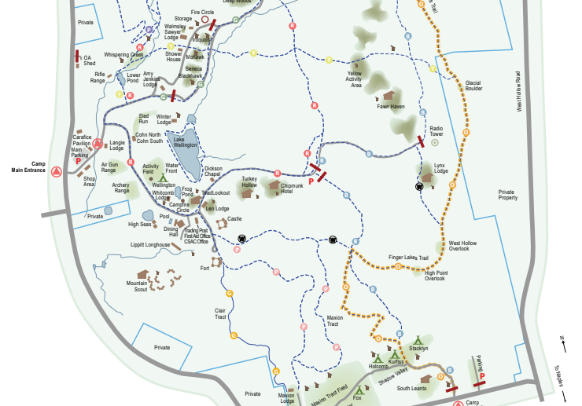

SCHEDULE
Time | Sunday/Thursday | Time | Monday/Friday | Time | Tuesday/Saturday
 |  | 6:30am - 7:00am | Polar Bear Swim | 6:30am - 7:00am | Polar Bear Swim
 |  | 7:45am | Flags | 7:45am | Flags
 |  | 8:00am - 8:45am | Breakfast | 8:00am - 8:45am | Breakfast
 |  | 9:00am - 10:00am | Rank Activity | 9:00am - 10:00am | Rank Activity
 |  | 10:05am - 11:05am | Rank Activity | 10:05am - 11:05am | Rank Activity
11:00 am-12 pm | Check-In Blocks | 11:10am - 12:00pm | Village Time | 11:10am - 12:00pm | Village Time
12pm to 1 pm
12pm to 1 pm | Check-In Blocks | 12:15pm - 1:00pm | Parade Field and Lunch | 12:15pm - 1:00pm | Parade Field and Lunch
1 pm - 2pm
1 pm - 2pm | Check-In Blocks | 1:00pm - 2:00pm | Siesta | 1:00pm - 2:00pm | Siesta
2pm - 2:30pm | Extra Time | 2:05pm - 3:05pm | Rank Activity | 2:05pm - 3:05pm | Rank Activity
2:40pm - 3:30pm | Block 1
2:40pm - 3:30pm | Block 1 | 3:15pm - 4:10pm | Open Program | 3:15pm - 4:10pm | Open Program
3:40pm - 4:30pm | Block 2
3:40pm - 4:30pm | Block 2 | 4:20pm - 5:15pm | Open Program | 4:20pm - 5:15pm | Open Program
4:40pm - 5:30pm | Block 3
4:40pm - 5:30pm | Block 3 | 5:30pm | Flags | 5:30pm | Flags
5:45pm | Flags | 5:45pm - 6:30pm | Dinner | 5:45pm - 6:30pm | Dinner
6:00pm - 7:00pm | Dinner
6:00pm - 7:00pm | Dinner | 6:45pm - 7:45pm | Open Program | 6:30pm - 7:00pm | Campfire
7:15pm - 7:45pm | Scouts Own Service | 6:45pm - 7:45pm | Open Program | 7:15pm | Camp Dismissed
8:00pm | Opening Campfire | 8:00pm - 9:00pm | Village Time and Campfire
9:15 pm | Cubmaster/Leader Mtg | 8:00pm - 9:00pm | Village Time and Campfire
10:00pm | Lights Out | 10:00pm | Lights Out

RANK BASED ELECTIVES

Rank Based Schedule |  | Tiger | Wolf | Bear | Webelos | AOL
Day 2 | 9:00am - 10:00am | Archery | Finding Your Way @ High Seas Deck | Hike - Balancing Bears @ Dining Hall | Earth Rocks @ Nature Lodge | Hike - Into the Woods @ Nature Lodge
Day 2 | 10:05am - 11:05am | Tigers in the Water @ Pool OR Tiger-iffic! @ Lower Sports Pavilion | Archery | A Bear Goes Fishing | Hike- Tech on the Trail @ Nature Lodge | Hike - Into the Woods @ Nature Lodge
Day 2 | 2:05pm - 3:05pm | Sky is the Limit @ Nature Lodge | Paws for Water @ Pool OR Paws of Skill @ Lower Sports Field | Whittling @ Fort | Chefs Knife @ Dining Hall | Fishing
Day 3 | 9:00am - 10:00am | Hike- Champions For Nature @ Nature Lodge | Digging in the Past @ Parade Field | Salmon Run @ Pool OR Baloo the Builder @ Nature Lodge | Catch the Big One Fishing | BB Gun
Day 3 | 10:05am - 11:05am | Fish On | Hike - Spirit of the Water | Forensics @ Nature Lodge | BB Gun | Swimming OR Into the Wild @ Mountain Scout Village
Day 3 | 2:05pm - 3:05pm | Curiosity, Intrigue, and Magical Mysteries @ Castle Courtyard | A Wolf Goes Fishing | BB Gun | Aquanaut @ Pool OR Build It @ Nature Lodge | Mud Run @ Mountain Scout Village

OPEN PROGRAM ACTIVITIES
THIS PAGE IS UNDER CONSTRUCTION!!!!

Please note that the open program schedule is still being finalized and will be determined based on staffing. We are working hard to ensure we offer a variety of fun and engaging activities for all participants. As we get closer to camp, we will provide a more detailed schedule. Thank you for your understanding and patience as we make sure everything is in place for an exciting camp experience!

Open Programs:
Boating
Sponge Wars
Archery
Shooting Sports
Sports
Bouldering
Swimming
Nature/STEAM
Gaga
Quidditch

THEME
Get ready for a summer full of magic, mystery, and adventure—Cub Scout Adventure Camp 2026 is transforming into a Wizarding School! This year, Scouts will step into a world of spells, potions, and enchanted challenges as they join their village “houses,” earn points for the House Cup, and experience camp like never before. Grab your robes and prepare for an unforgettable journey at Camp Cutler!



HOUSE CUP
What it is
The House Cup is a camp-wide competition where each village (house) works together to earn points throughout their session. Scouts and leaders can earn points by showing great Scout spirit, participating in activities, winning competitions, demonstrating teamwork, and following camp expectations. At the end of the session, the village with the most points is awarded the House Cup, earning a ribbon to take home to display on their Pack flag.

Point System
Scout Spirit (daily) up to +50 points
Campfire Participation +25 points
Clean Campsite / Village Inspection up to +25 points
First Village to Flags (each meal) +25 points
All Scouts Present at Flags (per village) +10 points
Meal Chant Winner (each meal) +20 points
Dining Hall Behavior (each meal) up to +15 points
Lunch Competition Winner (daily) +30 points
Winning Organized Competitions +25–50 points
Participation in Open Program Activities +10 points per activity
Random Acts of Kindness +10–25 points
Helping Another Village +20 points
Outstanding Leadership (youth or adult) +15 points
Staff Recognition (“Caught Being Awesome”) +10 points

