CUB SCOUT
ADVENTURE CAMP 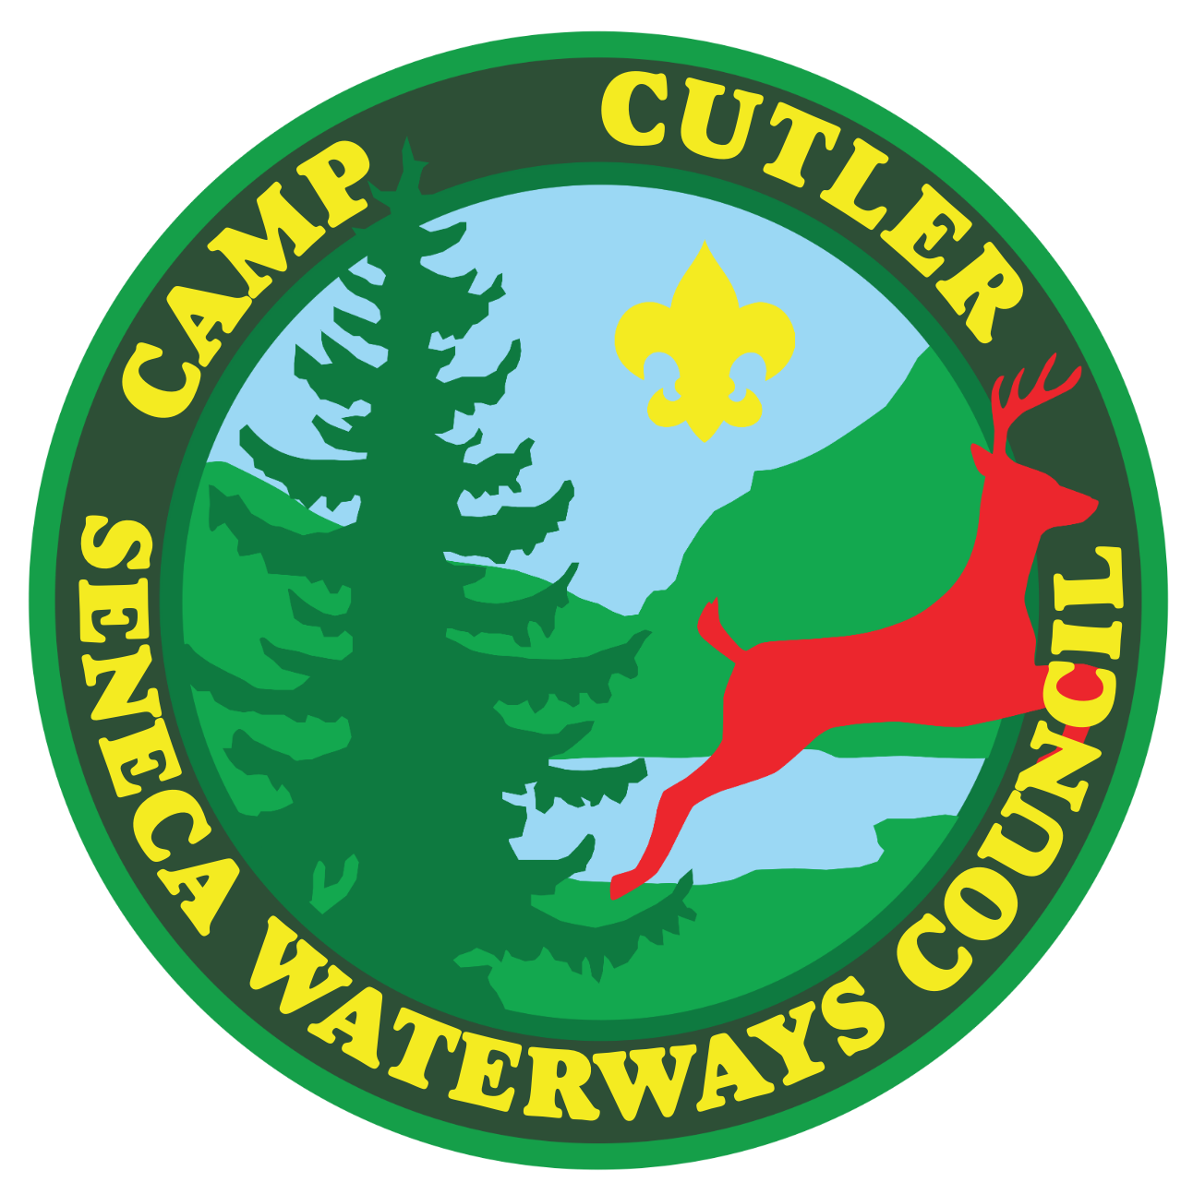
KICKOFF GUIDE

TABLE OF CONTENTS

MISSION STATEMENT
CONTACTS
FOREWORD
GENERAL INFORMATION PREPARING FOR CAMP SCHEDULE
RANK BASED ELECTIVES
OPEN PROGRAM ACTIVITIES
AOL WEEK
CIT PROGRAM
CAMP STEWARDSHIP

MISSION STATEMENT
It is the mission of Scouting America to prepare young people to make ethical choices over their lifetimes by instilling in them the values of the Scout Oath and Law.
It is the mission of the Seneca Waterways Council summer camping program to provide each Scout with an outdoor experience through which they have opportunities to: be challenged; work toward advancement; be active with their troop, patrol and others; achieve while learning; develop as a person; enjoy the Outdoors; and have fun.
CONTACTS

Seneca Waterways Council
P:585-244-4210 F:585-241-8552
2320 Brighton-Henrietta Town Line Road, Rochester, NY 14623

CSAC Camp Director: Sara Hardy, 585-857-8126
csac-director@senecawaterways.org

Director of Support Services: Tracy Jones, 585.244.4210 x 8543
tracyg.jones@scouting.org

Scout Executive: Jonathan Widmark, 585-241-8554
jonathan.widmark@scouting.org
J. Warren Cutler Scout Reservation
Before Camp:
Attn: Camp Cutler
Seneca Waterways Council, BSA J. 2320 Brighton-Henriea TL Rd. Rochester, NY 14623
Phone: 585-241-8547

During Camp:
Attn: Camp Director
J. Warren Cutler Scout Reservation 7131 Gulick Road
Naples, NY 14512
Phone: 585-374-8656

FOREWORD
We’re thrilled to be preparing for another magical summer at Cub Scout Adventure Camp!
Our incredible 2026 camp staff is coming together to bring the world of The Wizarding School to life—creating an unforgettable experience filled with imagination, discovery, and adventure for every Cub Scout who joins us.
This Kickoff Guide offers a first look at what’s ahead for the 2026 season and serves as your go-to resource for early planning and preparation. It includes key information to help you and your Scouts get ready for camp, with a more detailed and in-depth version coming soon—especially designed to support first-time leaders and parents.
In the meantime, if you have any questions, ideas, or suggestions, we’d love to hear from you! Communication and collaboration are what make our camp community so special. For additional updates and resources, please visit www.senecawaterways.org/outdoors.
On behalf of the entire 2026 Camp Cutler staff, thank you for choosing Cub Scout Adventure Camp. We can’t wait to share a summer full of fun, friendship, and adventure as we open the gates to The Wizarding School!
Sara Hardy
Camp Director
csac-director@senecawaterways.org
585-857-8126

GENERAL INFORMATION
2026 Cub Scout Adventure Camp Season
Session 1: July 5 - July 7
Session 2: July 9 - July 11
Session 3: July 12 - July 14
Session 4: July 16 - July 18
Session 5: July 19 - July 21
Session 6: July 23 - July 25
Session 7: July 26 - July 28
Session 8: July 30 - August 1
Session 9: August 2 - August 4
2026 CSAC Camp Fees
Camper Fee Schedule
● Camper Deposits must be paid in full by March 27, 2026
● Early Bird Fee must be paid in full by April 24, 2026
● Scouts who missed Early Bird deadline must have fees paid in full by June 30, 2026
● Youth who have joined scouting in the Spring (Feb-June) are Eligible for early bird rates. Be sure to select "New Scout in Spring"
Rates
- Regular Rate: Sessions 1,3,5,7,9 - $290 Sessions 2,4,6,8 - $300
- Early Bird Rate: Sessions 1,3,5,7,9 - $265 Sessions 2,4,6,8 - $275
- Adult Rate $75
Sibling discounts - Have more than one child attending camp? Receive a $25 discount! Requests for sibling discounts must be submitted to csac-director@senecawaterways.org before final payments are due in order to apply.

Reservations
Packs can make reservations through the camp’s online registration portal. Please note that packs will likely share village space with families from other packs, unless your pack reserves and pays for all the spots in a village. Any remaining spaces will be available for other packs or families to reserve.
Can’t attend with your pack? No problem! You can still make a separate reservation for you and your scout(s)!
Refund Policy
There are situations in which a campers’ fee may be refunded, either in whole or in part to the unit. Please note that refund checks will not be written to individual families, they will be written to the Pack.
Full Refund
The balance of a campers’ fee may be refunded up until two weeks prior to the start of your week at camp for the following reasons if accompanied by appropriate documentation:
● Medical issue regarding the camper
● Extreme family emergencies
Partial Refunds:
Partial refunds of $50 per camper may be refunded to the unit for reasons other than the above, up until two weeks prior to the start of your week at camp. Please be aware that Seneca Waterways Council cannot provide any refunds after this timeframe as certain expenditures have been made (e.g. food and program-related items) based upon the unit’s projected attendance. Requests for refunds must be made in writing no later than two weeks prior to the start of your week at camp in order to be considered. Please submit requests to the Seneca Waterways Council, 2320 Brighton-Henrietta TL Rd, Rochester, NY 14623 or email: camping@senecawaterways.org .
Camperships
The Seneca Waterways Council believes that all Scouts should be able to attend summer resident camp, regardless of their financial situation. Campership funds are available from the council to assist local Scouts who may have difficulty affording the full camp fee. Applications are now submitted online at
hps://senecawaterways.org/campership-information/ . Questions about the online application can be made at the Council Service Center (585-244-4210).
Deadline for Campership Application submissions is March 1, 2026

PREPARING FOR CAMP

Leadership
All Packs must have at least one adult leader over the age of 21 for every four cubs in camp. The New York State Department of Health requires Seneca Waterways Council to maintain records at camp of the qualifications of all adult leaders. NYS DOH also requires that we submit all adults attending camp and adult camp staff to a sex offender registry check prior to their arrival at camp.
All leaders must bring with them verification that they have completed youth protection training. All adults in camp must have completed Safeguarding Youth Training prior to attending camp. Safeguarding Youth Training can be taken in a class format through your district or council or can be taken online by visiting hps://my.scouting.org/.
IMPORTANT - This includes any/all adults, parents, or visitors who are staying overnight in camp. Adults without SYT will not be allowed to remain on the property.
Out of Council Unit Requirements:
SYT & Registration - Out of Council Units, who are attending a Seneca Waterways Council summer program, must provide a copy of the unit's official roster including both adult and youth registrants. The roster can be printed from my.scouting.org or obtained from your Scout Service Center. All adults attending camp should be on the roster and be marked as Safeguarding Youth trained. Rosters should be submitted to the Camp Director at csac-director@senecawaterways.org at least one week ahead of the unit’s arrival at camp. Youth Members not on the roster will not be able to remain on property.
Required Medical Forms
Each camper must have a current BSA Annual Medical Form and fill out all other medical paperwork under the “Summer Camp Medical Forms” tab on the Camp Cutler camp registration page online. Parts A & B of the form are required for all youth and adults. All forms must be signed by a doctor and filled out completely (including month & year of inoculations). All participants, youth & adults must have had a physical in the past year. Youth who take medication must have the Youth Medication Permission Form with a physician’s signature on file. Please be sure to submit a copy of each individual’s medical form, not the originals.

Accommodating Special Needs
The staff of Cub Scout Adventure Camp is committed to fully including all Scouts in all aspects of the summer camp program. Often, meeting the needs of all campers requires minor adaptations of our facilities, staffing, and instructional plans. Special menus, accessible campsites,and other provisions can be made for Scouts or leaders because of physical disabilities, learning disabilities, diagnosed psychological or social difficulties, severe medical conditions, particular dietary requirements, religious practices, or other special needs. Unit leaders should contact the Reservation Director well in advance to outline the specific needs of Scouts and leaders in their pack.
Food Service
Cub Scout Adventure Camp offers an amazing Dining Hall experience for our campers. J. Warren Cutler Scout Reservation employs qualified food service personnel to provide high quality food for all campers and leaders. Three meals per day are provided, beginning with dinner on day one of your session and ending with dinner on day three of your session. A licensed dietitian has reviewed the menus for balanced nutrition.
Dietary Needs: If Scouts or leaders have special dietary needs, notification must be made through the Camp Food Accommodation form (found online) two weeks prior to your pack’s arrival. Send all requests to cutler-food@senecawaterways.org. Requests made at the time of arrival may not be accommodated. We want your stay at camp to be enjoyable; please communicate your needs as soon as possible.
Check in: Check-in will be scheduled in one-hour time blocks based on the village you will be staying in, with check-in beginning at 11:00 AM. Please make every effort to arrive during the designated time block for your village. If you're unable to arrive within this window, please contact the camp director at csac-director@senecawaterways.org so we can make alternate arrangements.
If your pack is attending the same session but splitting between villages, please coordinate with the camp director to arrange the best time for your arrival.
Swim Checks
Immediately after check-in, you will head to the pool deck for your swim check. During this check, you'll receive important information, including aquatics rules and how to properly use the Buddy System. The staff will assess swimming abilities to determine who can use the rowboats, canoes, and specific areas of the pool.
If your pack has completed a pre-camp swim check, please submit the BSA Swim Classification Record form along with the credentials of the test administrator to the Aquatics Director for review. Pre-checks will only be approved if these credentials are provided. Without them, pre-checks cannot be accepted!

Medical Services: Camp Cutler has a well-equipped health lodge staffed with a qualified health director. A non-resident doctor is on call. Hospital facilities are close to the camp, should additional medical attention be required. If the camp health officer determines that a Scout or leader requires advanced medical attention or care, the individual may be sent home for health reasons.
CPAP Machines: An increasing number of adult leaders are using CPAP machines, and Camp Cutler provides power cord access in High Seas, Viking, Pioneer Fort, and Medieval Castle for those who need to power their machines. Please contact the camp office upon arrival for assistance.
If you're staying in Mountain Scout or a tent, we recommend bringing a battery pack to power your CPAP machine. Camp Cutler has a limited number of battery packs available for loan, but all requests must be submitted at least two weeks prior to your stay to ensure availability.
Youth Protection at Camp
Cubmasters should review youth protection guidelines with all adults who will be serving as leaders in camp. The following barriers to abuse within Scouting are used at camp to ensure the safety of our youth campers. We expect adult leaders to follow these guidelines at all times:
● Two deep leadership is required at all times.
● No one-on-one contact: Personal conferences must take place in plain view of others. ● Separate accommodations: Youth Scouts may not share a tent with an adult unless the adult is a parent. Male and female leaders may not share a tent unless they are married.
● No secret organizations are recognized by Scouting America: All aspects of the Scouting programs are open to observation by parents and leaders. ● Constructive discipline: Discipline should be constructive and reflect Scouting’s values. Corporal punishment is never permitted.
● Hazing prohibited: Physical hazing and initiations of any type are prohibited and may not be included as part of any Scouting activity.
● Junior leader training and supervision: Adult leaders must monitor and guide the leadership techniques used by junior leaders to ensure that Scouting America policies are followed.
Child Abuse
If at any time you suspect a Scout has been mistreated, neglected, or physically or emotionally abused, notify the Camp Director immediately. If the Camp Director is not available, report the situation to the Program Director, Business Manager, or Scout Executive. Do not investigate any situations that may occur. Keep information confidential and share only with the appropriate authorities.

SCHEDULE

Time | Sunday/Thursday | Time | Monday/Friday | Time | Tuesday/Saturday
 |  | 6:30am - 7:00am | Polar Bear Swim | 6:30am - 7:00am | Polar Bear Swim
 |  | 7:45am | Flags | 7:45am | Flags
 |  | 8:00am - 8:45am | Breakfast | 8:00am - 8:45am | Breakfast
 |  | 9:00am - 10:00am | Rank Activity | 9:00am - 10:00am | Rank Activity
 |  | 10:05am - 11:05am | Rank Activity | 10:05am - 11:05am | Rank Activity
11:00am - 12:00 pm | Check-In Blocks | 11:10am - 12:00pm | Village Time | 11:10am - 12:00pm | Village Time
12:00pm - 1:00 pm | Check-In Blocks | 12:15pm - 1:00pm | Parade Field and Lunch | 12:15pm - 1:00pm | Parade Field and Lunch
1:00pm - 2:00pm | Check-In Blocks | 1:00pm - 2:00pm | Siesta | 1:00pm - 2:00pm | Siesta
2:00pm - 2:30pm | Extra Time | 2:05pm - 3:05pm | Rank Activity | 2:05pm - 3:05pm | Rank Activity
2:40pm - 3:30pm | Block 1
2:40pm - 3:30pm | Block 1 | 3:15pm - 4:10pm | Open Program | 3:15pm - 4:10pm | Open Program
3:40pm - 4:30pm | Block 2
3:40pm - 4:30pm | Block 2 | 4:20pm - 5:15pm | Open Program | 4:20pm - 5:15pm | Open Program
4:40pm - 5:30pm | Block 3
4:40pm - 5:30pm | Block 3 | 5:30pm | Flags | 5:30pm | Flags
5:45pm | Flags | 5:45pm - 6:30pm | Dinner | 5:45pm - 6:30pm | Dinner
6:00pm - 7:00pm | Dinner
6:00pm - 7:00pm | Dinner | 6:45pm - 7:45pm | Open Program | 6:30pm - 7:00pm | Campfire
7:15pm - 7:45pm | Scouts Own Service | 6:45pm - 7:45pm | Open Program | 7:15pm | Camp Dismissed
8:00pm | Opening Campfire | 8:00pm - 9:00pm | Village Time and Campfire
9:15pm | Cubmaster/Leader Mtg
10:00pm | Lights Out | 10:00pm | Lights Out

RANK BASED ELECTIVES
The Cub Scout program was updated in 2024 with exciting new adventures at every rank level—including brand-new elective adventures! In response, Cub Scout Adventure Camp (CSAC) developed a refreshed curriculum that incorporates many of these new opportunities.
Based on feedback from parents and unit leaders, we are making a few adjustments to certain electives to better align with time constraints and the interests of our Scouts. Updated information will be shared prior to camp, outlining which electives each rank will have the opportunity to explore during their CSAC session.
Each session is action-packed, featuring six dedicated program blocks focused on rank-level activities. That means Scouts can complete up to six elective adventures in just three days at Cub Scout Adventure Camp!
OPEN PROGRAM ACTIVITIES
We will once again offer open program blocks, giving Scouts the opportunity to choose which activities they’d like to participate in. Options may include swimming, boating, archery, a gaga tournament, a science fair, and much more!
To ensure a quality experience and manage capacity for certain activities, open programs will continue to require sign-ups. Sign-ups will be completed on an individual basis, not by pack. We are currently in the process of redeveloping our sign-up system and will share additional details prior to camp.
AOL WEEK
Cub Scout Adventure Camp offers a special experience for Arrow of Light Scouts through AOL Week—a unique “camp within a camp” designed specifically for ranking AOLs. This program spans two sessions, instead of the standard three-day format, providing an extended and immersive adventure.
AOL Week will take place during Sessions Six and Seven, July 23–28, and will feature two outposts, campfire cooking, a base camp at Mountain Scout, and double the fun as Scouts take on new challenges and experiences.
Please note that participation in AOL Week requires:
- Attendance of a parent or responsible adult
- A completed Part C medical form, in addition to standard Parts A, B1, and B2
- A tent suitable for camping away from the Mountain Scout village for multiple nights
CIT PROGRAM
In 2024, Cub Scout Adventure Camp proudly relaunched our Counselor-in-Training (CIT) Program! This program is designed for 14- and 15-year-olds who are not yet eligible for camp staff positions but are eager to build leadership skills and gain hands-on experience working at camp.
The CIT program is a two-week commitment, with participants attending either Sessions 1–4 or Sessions 5–8. During their session, CITs remain on site, with the exception of the staff off-day from Tuesday at 9:00 PM through Thursday at 9:00 AM.
Throughout the program, CITs have the opportunity to observe, practice, and help teach across ten different program areas at CSAC. This experience allows them to learn new skills while developing confidence by assisting and mentoring younger Scouts.
CAMP STEWARDSHIP
BEHAVIORAL POLICY
The Scout Oath and Law are expected to be followed throughout your entire visit at camp. Camp Cutler has a NO tolerance policy for bullying. Bullying is grounds for immediate dismissal from camp at the discretion of the Camp Director. Any form of verbal abuse, physical abuse, or threats will result in immediate dismissal from camp; authorities may be contacted at the Camp Director’s discretion.
Good stewardship
Camp Cutler is a year-round camping facility maintained by the Seneca Waterways Council, Scouting America. The Camp Ranger, Council Camping Committee, and volunteers work to maintain and improve the facilities. The continued existence and improvement of the summer camp program is dependent on the care of our camp facilities. Scouts and adults must be good stewards of the facilities of Camp Cutler so they may remain for others to enjoy them in future years.
The Scout Oath and Law are expected to be followed throughout your entire visit at camp. Camp Cutler has a NO tolerance policy for bullying. Bullying is grounds for immediate dismissal from camp at the discretion of the Camp Director. Any form of verbal abuse, physical abuse, or threats will result in immediate dismissal from camp; authorities may be contacted at the Camp Director’s discretion.

