Questions? Contact CSAC Director:
Sara.Hardy@scouting.org
(585) 241-8522
Eagle Flight 2026
COST
Only $650 per Scout if paid by April 10. A $100 deposit must be submitted with application. This deposit is applied to the total Eagle Flight fee.
First Pre-Camp Meeting is February 5, 2026 at the Council office

For More Information and to Register for Eagle Flight…
Check out our website

https://scoutingevent.com/397-EF2026
August 8 – 14, 2026
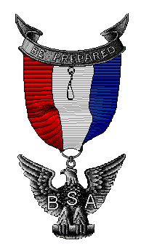
Participants must be at least 14 years old and First Class by the first day of Eagle Flight Week.
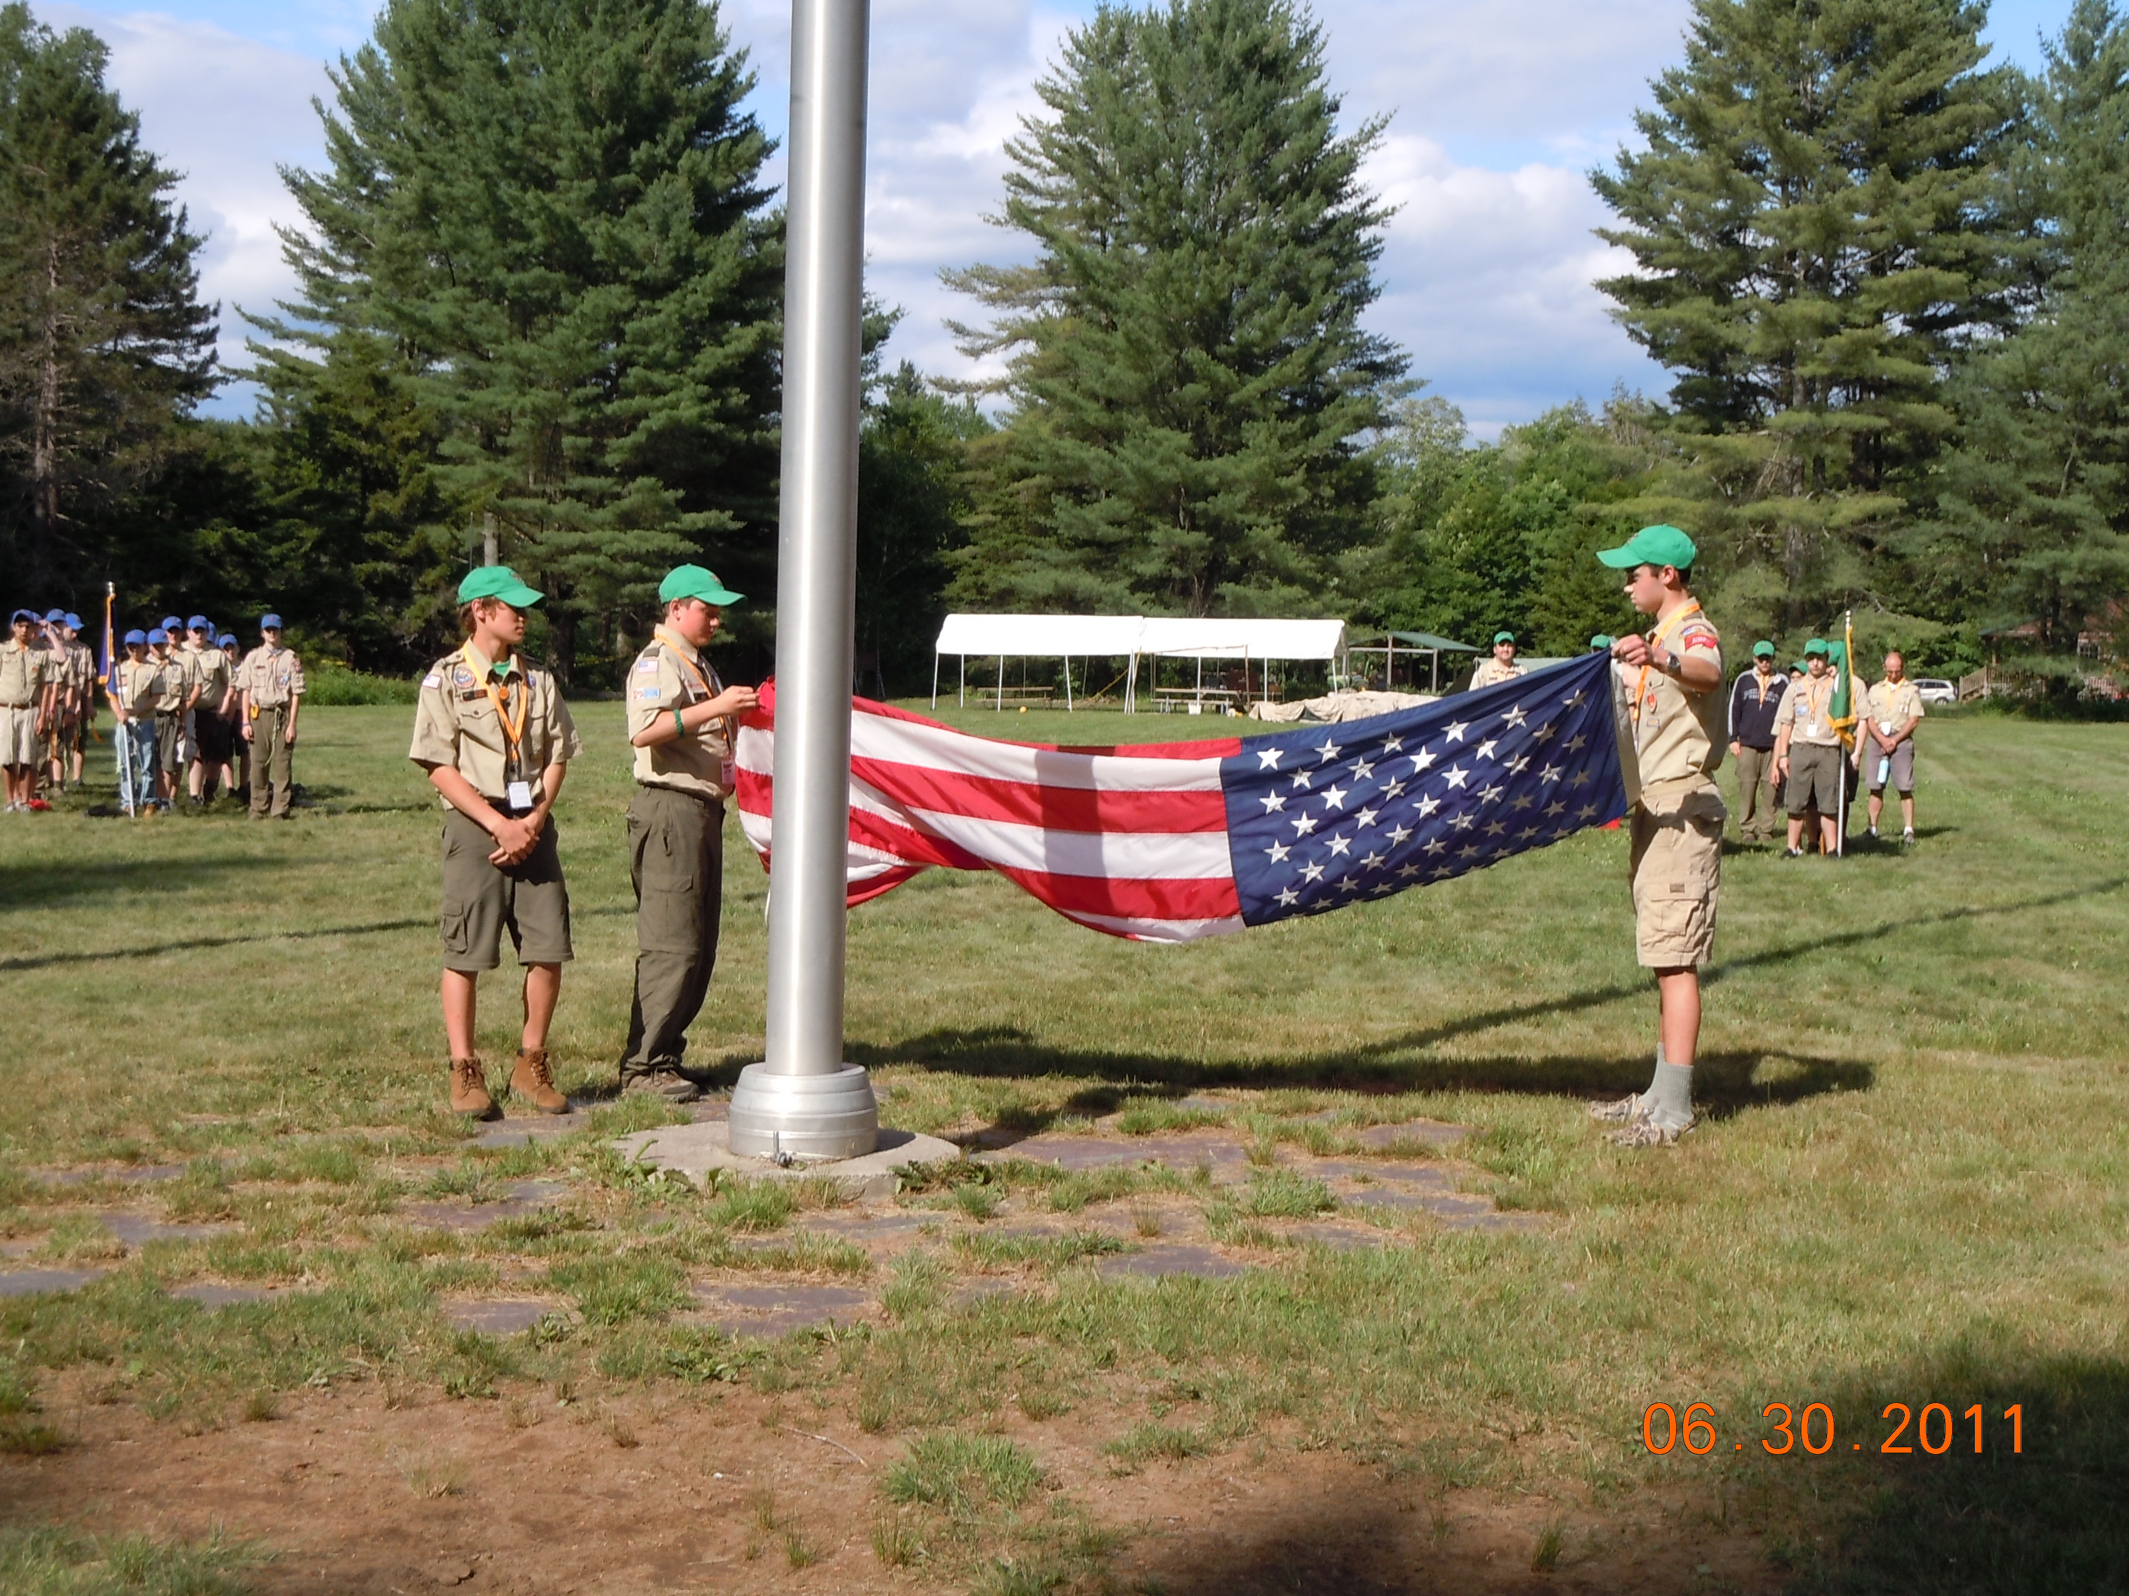
Eagle Flight is specifically designed for the older Scouts to give them the opportunity to work on the merit badges they need to finish their Eagle Rank requirements.
This highly structured program offers more than 40 merit badges along with many exciting non-merit badge programs and activities specifically designed for Eagle Candidates.
Join fellow Eagle Candidates for this very special one week event sponsored by the Seneca Waterways Council at the J. Warren Cutler Scout Reservation.

For information on open positions or to submit your resume, please visit our Web site at: www.lucernepublishing.com

Why Eagle Flight?
- Limited to the first 51 applicants.

- Be part of an elite group of scouts dedicated to becoming Eagle Scouts.

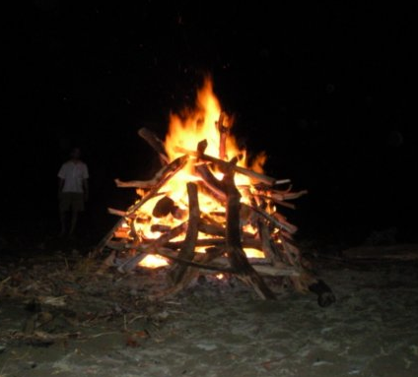

EAGLE CANDIDATES
• The 2026 Eagle Flight is celebrating its sixteenth year. It offers the only such program in the Northeast and gets better every year.
• During our first 15 years we served over 740 Scouts, most of whom have gone on to earn their Eagle Rank.
• Some of these scouts have come back to serve as staff and the JASM Corp

MERIT BADGE PROGRAM
- Experienced adult merit badge counselors teach and review requirements using their own skills and exhibits.
- Over 40 different Merit Badges are offered.
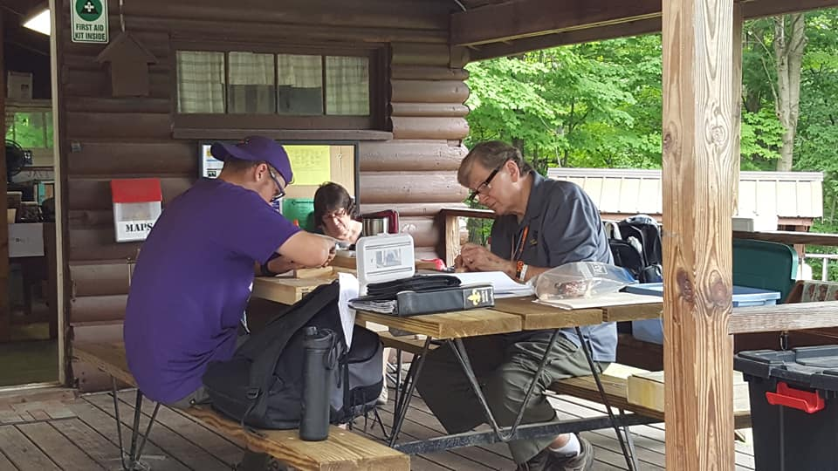
- Candidates earn an average of eight merit badges each.
- We offer all Eagle required merit badges and over 20 non-Eagle required merit badges.
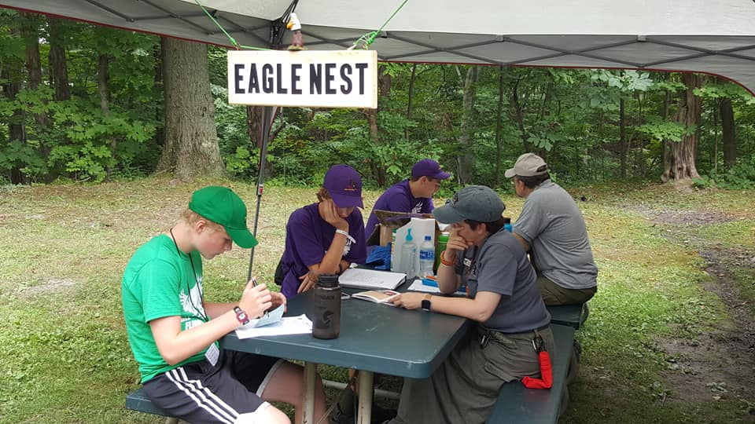

HIGH Fun ACTIVITIES
- Including fun nights, Scout Jeopardy, Scout Skill competitions, and much more.
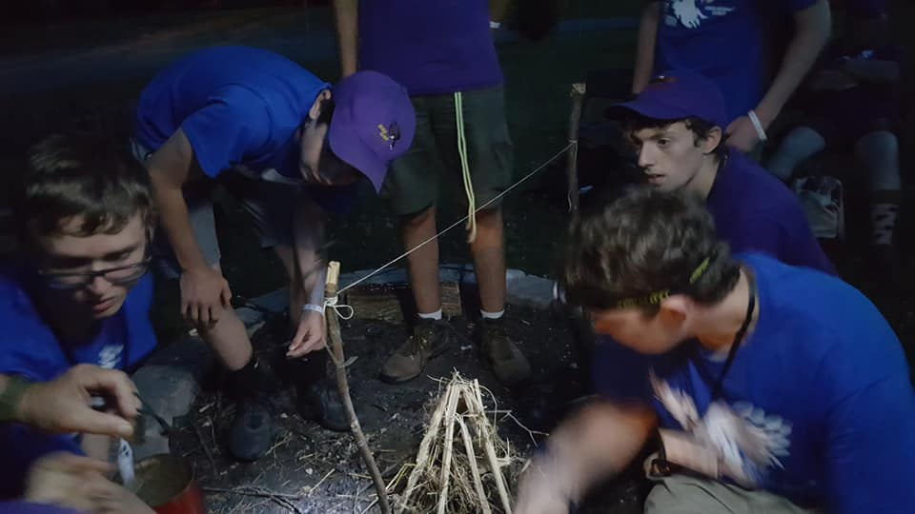

- Eagle Candidates compete for the highly coveted Honor Troop award. Points are awarded through competitions, camp inspections, uniform inspections, Troop spirit, etc.
- Eagle Flight ends with a special honors ceremony for the Eagle Candidates to celebrate each Scout’s accomplishments. This special event is open to all family members to attend.
