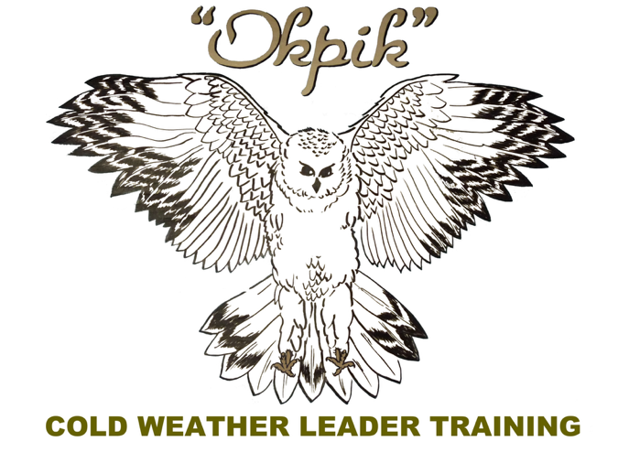
COLD WEATHER PACKING LIST

Note: A final packing list will be sent out before the course with any changes needed due to the forecast weather conditions.

Bring the following for Okpik

- Warm personal clothing.
- Long underwear, socks, shirts, and sweaters (synthetic or wool that wicks!)
- Fleece or wool pants (plus shell) or 2 pair pants, 1 that fits over the other if possible). No blue jeans or cotton pants.
- Waterproof winter coat or shell.
- Insulated waterproof boots.
- Winter hat, and mittens or gloves (wool or fleece, waterproof shell).
- Face mask or neck gaiter that you can pull up over your nose.
- Sunglasses.
- Any personal items you normally use including medication.
- BSA Medical Form (Parts A & B. If you came for Okpik as well, you should have parts A,B, and C)

Additional items for Okpikattavik

- Sleeping bag, pillow and ground pads.*
- Tent, bivvy, hammock, tarps.*
- Pulk or lightweight sled with tarp & rope.*
- Cook gear and stove.*
- Plastic mess kit.* (You do not want metal in wintertime!!!)
- 2 1 Liter Water Bottles (Nalgene recommended, optionally a 500 mL bottle to keep inside your coat)

*Starred Items: Contact us in advance if you need to borrow any gear you don’t have. We’ll do our best to accommodate you!

Email: okpik@senecawaterways.org

Revised: December 2025, Jeremy Wyatt

