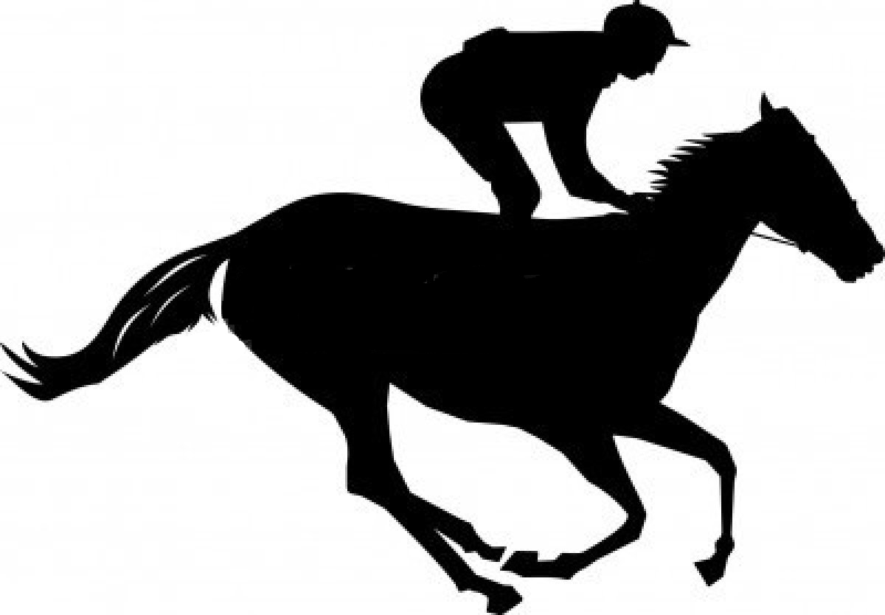
232025 Council Service Territory 10
This Photo by Unknown Author is licensed under CC BY-NC
KEY COUNCIL Leadership Conference
October 24-25 Holiday Inn Saratoga Springs
Glens Falls NY

Race to Membership Growth

Please forward this information to all key leaders in your Council, Districts and on your Executive Board
Each council is encouraged to have a full team of council / district leaders and board members participate (All functions):
Council Key 3 & Executive VP District Key 3
Council Membership/Marketing Leads District Membership/ Marketing Volunteers
Council Commissioner Staff District Commissioners
Council Professionals District Executives
Executive Board Members District Finance Committee
Council Finance Committee District Committee Volunteers
Council Program Leads District Program Leads
…and all other Council and District level volunteers!
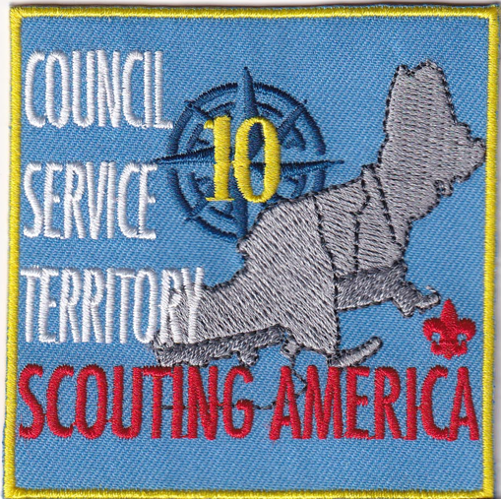
Highlights of the Conference:
Friday, October 24 – Holiday Inn Saratoga Springs
  - 3:00-5:00 Council Key-3's
  - 4:00 Hotel Check-in
  - 5:00-6:00 Conference Check In & Opening Reception
  - 6:00-8:00 Dinner and Keynote Speaker – Dan Kiel
Saturday, October 25 @ Holiday Inn Saratoga Springs
- 7:45 – 8:50 Breakfast – Keynote Speaker – Roger Krone Chief Scout Executive, Scouting America
- 9:00 – 9:50 Breakout Session 1
- 10:00 – 10:50 Breakout Session 2
- 11:00 – 11:50 Breakout Session 3
- 12:00 – 1:20 Lunch
- 1:30 – 2:20 Breakout Session 4
- 2:30 – 3:20 Breakout Session 5
- 3:30 – 4:20 Breakout Session 6

Dress for the Day is Scout Uniform (if you have one), otherwise business casual

Sessions and Registration Information are listed on the following page

- Sessions
- Risk Management – Council Structure of Safety and Safeguarding
- Building a Culture of Safety – S.A.F.E and Safeguarding
- Safeguarding Youth – Barriers to Abuse, S.A.F.E.Guarding Youth training; MESH
- Commissioners - Leading the Way for Commissioner Service
- Commissioners and Membership working together to increase our Impact on Membership Growth
- Commissioners - Breaking Down Communication Barriers for Commissioners
- Program - Promoting Camping Opportunities
- Program - Council Program Activities - Bringing on Inspiring Creative Activities
- Program – Program and Customer Service
- Program – Older Youth Programs
- Alumni - Uncover a Buried Treasure - Digging up Valuable Alumni to Bring Valuable Benefits to your Council
- Marketing - Scout the Story: Building Digital Narratives That Grow Membership and Increase Participation
- Marketing - Scouting’s Best Classroom: Designing an Annual University of Scouting Program
- Fundraising and Finance - Best Methods for Friends of Scouting in Councils with Program Fees
- Fundraising and Finance - Restarting Your Endowment Again
- Fundraising and Finance - Endowment Management
- Fundraising and Finance - Council Finances Roundtable
- Fundraising and Finance - Camp Operating and Capital Budgets
- Leadership and Governance - Building Effective and Diverse Executive and Advisory Boards that Showcase Scouting to the Community
- Leadership and Governance - Property Stewardship and Effective Utilization
- Membership/Program/Training - Why Are Scouts Leaving
- Membership – Recruiting and Retaining Adults for Volunteer Leadership
- Membership – Building Scouting America Brand Awareness Before We Recruit
- Membership – Expanding the Search for Charter Partners
- Membership – Recruiting Youth - Strategies – “The Menu” and “The Power of 3”
- Scout Executives ONLY
- Council Presidents and Chairs ONLY
Conference Registration - $125 Conference fee
Here is the Link for registration: https://scoutingevent.com/397-KeyCouncilConference2025
Be sure to select your classes/sessions using the red Update Information button after entering your demographic information.
Class registration is open until October 15.

Please make your hotel reservation before the deadline.

Room Reservations are Required by October 3, 2025
Holiday Inn Saratoga Springs – 232 Broadway; Saratoga Springs NY 12866
Phone: 1-518-584-4550
Holiday Inn Booking Link - Boy Scouts of America
There are King, Queen, or Double Queen Rooms available at a rate of $219 + 13% Tax.
For reservations: Everyone is responsible for making their own reservations. They may do so by calling (518) 584-4550 or 1-855-592-8367 or by using a hotel provided booking link with the Group Code BSA.

