Seneca Waterways Council Pinewood Derby Rules for 2024
These are the Official Rules for the Seneca Waterways Council, District, and preferably Pack Pinewood Derby Races for 2024. By standardizing the Rules, the intent is to create a fair environment for all participants while eliminating Rule differences between Districts and Packs which could lead to participants not being allowed to race at District and Council Races. Please note the importance of knowing these Rules as changes have been made to minimize the inspection issues that have been encountered in the past. All Scouts will be held to these Rules without exception and not knowing them is not an excuse for not following them. All participants will be held to these Rules in the spirit of consistency for all Scouts. Please direct all questions about PWD rules to pinewood-derby@senecawaterways.org

General Rules

- Race cars must be constructed during the 2023-2024 Scouting Year from the parts within the Official BSA Kit Part # 17006 other than the specific parts that may be substituted as described below. Extremely fast cars can be built from the Official BSA Kit. Preparation and setup are the most important aspects of all speed gains. The Scout should be the primary car builder with only minimal adult supervision/assistance as required for advice, cutting, shaping, etc. as needed based upon the Scout’s age and ability. Purchased cars will be disqualified. http://www.scoutstuff.org/bsa/crafts/pinewood-derby/vehicle/official-pinewood-derby-car-kit.html
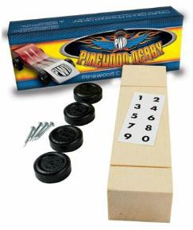
- There will be an Inspection prior to all Council, District, and preferably Pack Races. The car needs to be lubricated prior to Inspection. There is a specially designated area for this usually within the Rework Area. Once the car has passed Inspection, the car will be impounded and may not be touched by Scout or Adult. If a car fails Inspection and time allows, you will be provided the opportunity to choose between adjusting the car to fit within the Rules or racing it “as is” without the ability to win speed related awards (Trophies) or advance to District/Council Championships.

Dimensions and Configuration
- Wheel Base: Any - utilizing the existing axle slots is not required
- Length: 7 inches or less and the wheels, weights, decals, etc… must not extend beyond the 7 inches
- Height: 5 inches or less
- Width: 2 3/4 inches or less from outside wheel edges (axle heads). 1 3/4 inches or more between inside wheel edges.
- Bottom Clearance: 3/8 inches or greater ( If placing weights under the car, make sure it meets this clearance parameter. If not, weights will need to be removed to meet clearance requirements.)
- Weight: Less than or equal to 5.004 oz. (141.70 grams) on a 1/100th accuracy scale (Please design the car so adjustments can be made on race day as not all scales are the same and only the official inspection scale will be used .
- No portion of the car shall extend past the starting peg
- Quick Start Front Ends ARE PERMITTED for 2024 Below is an example of an acceptable Quick Start Front End:
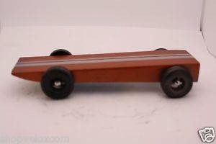
Quick Start Front End

- “U” and “V” Shaped front ends with or without a cheater bar are not permitted. Below is an example of a “U” shaped front end with a cheater bar:
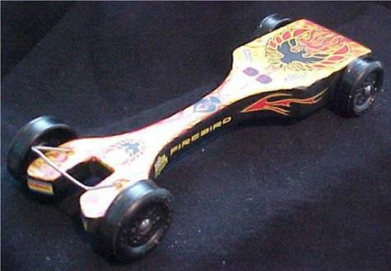
NOT PERMITTED!
- The front of the car is to be and at least 1/2 inch wide where the car will make contact with the starting peg. Pointy nose cars such as Carrots, Arrows, Pencils, Rockets, etc… ARE NOT PERMITTED as the cars are difficult to stage and can create timing issues. Below are two examples of these types of cars.
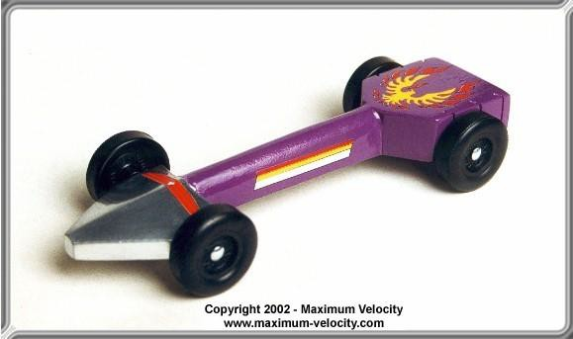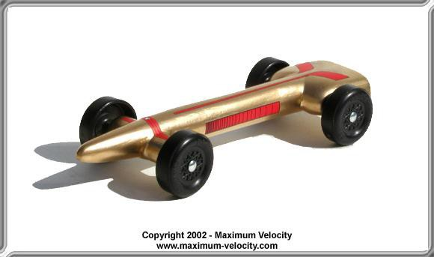
NOT PERMITTED!

The Length, Height, Widths, and Bottom Clearance will be verified using the Maximum Velocity Inspection Gauge. The car must pass this Gauge to be able to race. It can be purchased directly from Maximum Velocity following the Link below. ***IT IS STRONGLY ADVISED THAT PACKS USE THIS GAUGE AS WELL TO ENSURE CONSISTENCY AT ALL RACING LEVELS ***

http://www.maximum-velocity.com/gauge.htm
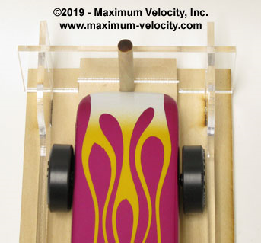
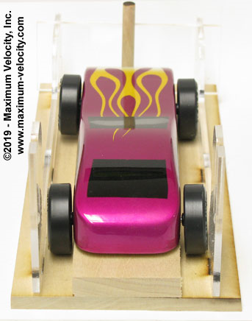
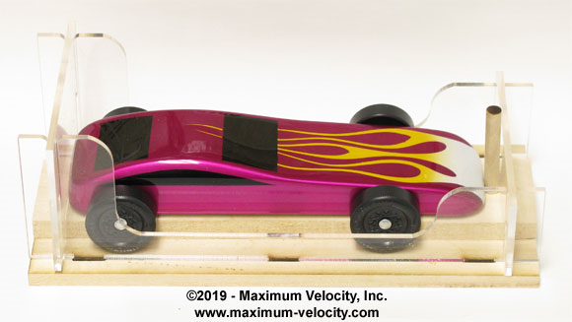
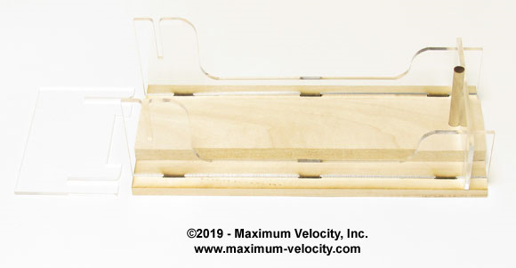

Warning: The Blocks are usually over 7 inches in length by around an 1/8 inch. Please make sure that you verify the length removing material if necessary. Paint, Decals, Weights, and Wheel location can all affect the overall length of the Car so please account for this in the design of the Car.

Warning: If weights are placed on the bottom of the car they need to be recessed into the car body otherwise there is the potential to fail the Bottom Clearance requirement of greater than 3/8 inches.
The Block is allowed to be substituted provided it meets the dimensions above. Any wood is permissible. BSA, Revell, Pinecar, Maximum Velocity, etc… precut, unfinished blocks are allowed.
http://www.scoutstuff.org/bsa/crafts/pinewood-derby/vehicle/kit-pwd-wedge-pre-cut.html

Wheels
- 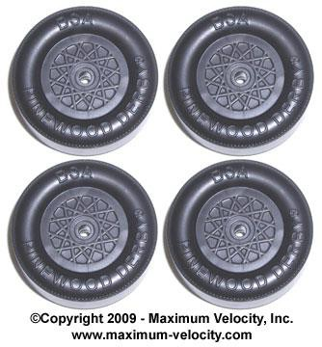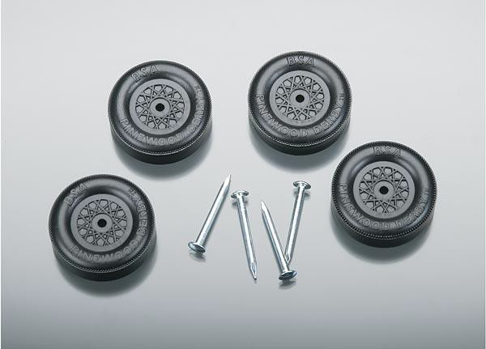Any BSA Wheels which includes Official Licensed Revell BSA Wheels are permitted including colored wheels. PineCar, Maximum Velocity, Awana, Royal Ranger, etc… Wheels are not permitted. Mold Matched Wheels are permitted!
The Official BSA Wheels are on the Left. The Revell BSA Wheels and Axles are on the Right. They look very similar in appearance, but there are subtle differences between them with the Official BSA Wheels being the better quality ones.
- Wheel Outside Diameter (OD) maybe turned, sanded, and/or polished provided the Wheel Diameter is greater than 1.180”. This will be verified using the Maximum Velocity Wheel Gauge shown below. This tool is not sold at the National Scout Shop, but It can be purchased directly from Maximum Velocity following the Link below. ***IT IS STRONGLY ADVISED THAT PACKS USE THIS GAUGE AS WELL TO ENSURE CONSISTENCY AT ALL RACING
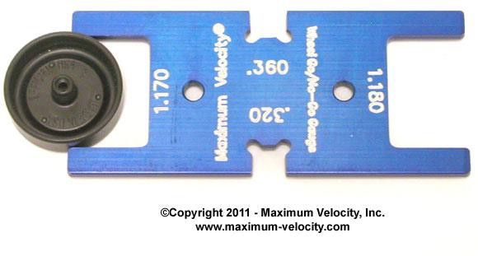
LEVELS ***
http://www.maximum-velocity.com
This side of the Gage will be used

Warning: It is almost impossible to turn and/or sand the Wheel OD without it going undersize which will fail the Wheel Gauge. Please refrain from attempting to do this.

- The wheels may not be modified in the following fashion which includes, but not limited to: reshaping, rounding, tapering, beveling, “H” tread, “V” tread, “C” tread, dishing, weight reducing, etc…. Below are some examples:
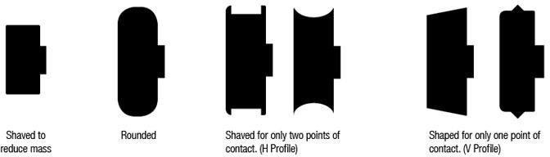

- The tread width may not be less than .360”. This will be verified using the Maximum Velocity Wheel Gauge shown below. It can be purchased directly from Maximum Velocity following the Link below.***IT IS STRONGLY ADVISED THAT PACKS USE THIS GAUGE AS WELL TO ENSURE CONSISTENCY AT ALL RACING LEVELS ***
http://www.maximum-velocity.com/7530.htm
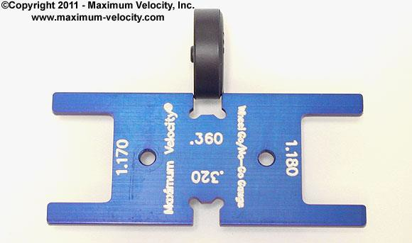
This side of the Gage will be used
- All lettering inside & out must be visible and intact.
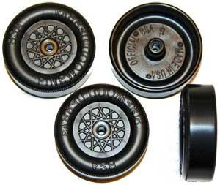
Lettering
- Dimples/Fluting must be present.
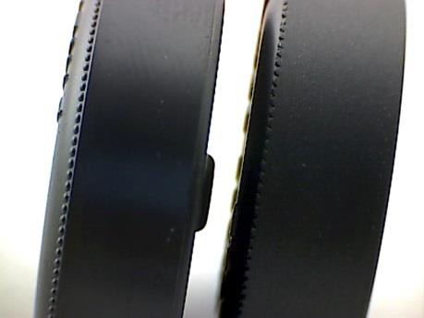
NO !!
YES!
Dimples/Fluting

- There must be 4 wheels and axles on the car that meet all Rules. The wheels are to be mounted directly across from each other. A minimum of 3 wheels must be touching the track at all times. The raised wheel is to be install the same as the other 3 wheels.
- Wheels must not be mounted in the reverse orientation
- No wheel covers, air shields, or wheel weights permitted as this inhibits the ability to inspect the Wheel IDs
- No rotation or spin altering devices
- No wheel bearings, washers, hub caps, bushings, shims, or axle guards
- Fenders are permissible to make Police Cars, Stock Cars, Busses, Fire Trucks, etc… and must meet the overall dimensions above. Aerodynamic Fenders are not permitted. Below is an example of Aerodynamic Fenders:
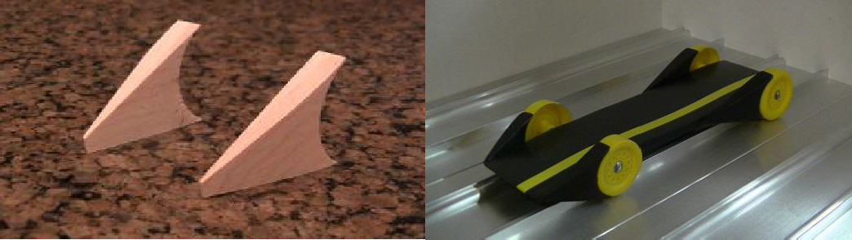

Warning: Wheel or Wheels may be asked to be pulled by the Inspector if it is believed the ID has been modified for further inspection. Please be aware of this if you are planning on gluing your axel. Wheels that fail the Gauge and/or any of the inspection criteria will need to be replaced to Race. Wheels will not be provided for replacement at the District and Council Races so please plan accordingly if you are trying to push the interpretation of the Rules. Inspectors have the final say as to the legality of your car’s wheels.

Axles
  - Any Removable, Bare Metal, “Nail Type” Axle with a Nail Head. A Nail Point is not required.
  - No full width solid axles
  - No springs or suspension allowed (the axles in the block are the only suspension)
  - No electro-graphite coated axles

Lubrication
  - Acceptable “Dry” Lubricants allowed are Powdered Graphite, Moly, Teflon, “plastic safe” aerosol spray, etc….
Warning: Any visible signs of residual wetness on the wheels and/or axles at Inspection will disqualify the car to protect the tracks. Excessive graphite will need to be removed before a car will be allowed to race in order to help keep the track clean for all racers.

Additional Prohibited Items/Modifications
  - No glass or fragile parts that may break
  - No sharp objects especially on the bottom of the car
  - No wet paint or glue – the car should be completely dry at Inspection
  - No Propellants
  - No Mercury, liquid, or other moving material
RULES FOR ADVANCEMENT TO DISTRICT AND COUNCIL RACES

Advancement from Pack Race to District Race
      - Top 2 finishers in each class (rank) will automatically qualify for their respective District Race
      - 3rd and 4th place finishers for each class (rank) will be designated as the 1st and 2nd alternates
      - All cars that are eligible to run at their respective District Races (i.e. places 1-4) ARE TO BE IMPOUNDED FOLLOWING THE COMPLETION OF THE PACK'S RACE.
        - Pack leaders are responsible for the collection and impounding of their Pack's eligible cars as well as making the Scout's car available to them on the day of their District Race.
    - Advancement from District Race to Council Race
      - Top 2 finishers in each class (rank) will automatically qualify for the Council Race
      - 3rd and 4th place finishers for each class (rank) will be designated as the 1st and 2nd alternates
      - All cars that are eligible to run at the Council Race (i.e., places 1-4) WILL BE IMPOUNDED FOLLOWING THE COMPLETION OF THE DISTRICT RACE
        - Cars will be collected / impounded by a District or Council Staff member.
        - Scouts cars will be available to them by Council Race staff upon check-in at Council Race
    - Notes Regarding Impounding
      - ALL cars will still need to pass inspection prior to racing in both District and Council Races
      - Scouts will be allowed to add a rule accepted lubricant to their cars prior to the race
      - Cars sustaining any damage in a race will be given an opportunity to repair that damage prior to the car being impounded
      - All cars impounded for the District Races and Council Race will utilize the PWD Car Impound Form which can be found on the last page of the rules.
        - It is STRONGLY recommended that individual Pack’s utilize this form to ensure consistency.
      - If a Scout qualifies to advance to the next round but cannot attend, then their car may be returned to them once they have verified they will not be advancing to the next level.

The decision to impound cars between races has been implemented to help ensure the fairest possible experience for the Scouts. Unfortunately, there have been incidents where Scouts have run / attempted to run, a different car than they ran in their Pack and/or District Race. The expectation is that the Scout races the car that was built for the current year’s Pack Race, at all subsequent races the Scout may qualify for.

2023 - 2024 PINEWOOD DERBY RULE SUMMARY SHEET

[*** This sheet is not a complete listing of all 2023 - 2024 rules and is
intended only as a general guide in the building of your car. ***]

- Wheelbase: Any - utilizing the existing axle slots is not required
- Length: 7 inches or less and the wheels, weights, decals, etc… must not extend beyond the 7 inches
- Height: 5 inches or less
- Width: 2 3/4 inches or less from outside wheel edges (axle heads). 1 3/4 inches or more between inside wheel edges.
- Bottom Clearance: 3/8 inches or greater. Keep this in mind if placing weights on the bottom of the car!!!
- Weight: Less than or equal to 5.004 oz. (141.70 grams) on a 1/100th accuracy scale
- Front of car at least ½ inch wide / No portion of the car shall extend past the starting peg
- Quick Start Front Ends ARE PERMITTED for 2024
- Wheels
  - Diameter NO LESS than 1.180 inches
  - Tread Width NO LESS than 0.360
    - As measured using Maximum Velocity Wheel Gauge
- There must be 4 wheels and axles on the car that meet all Rules.
  - The wheels are to be mounted directly across from each other.
  - A minimum of 3 wheels must touch the track at all times.
  - The raised wheel is to be installed the same as the other 3 wheels.

