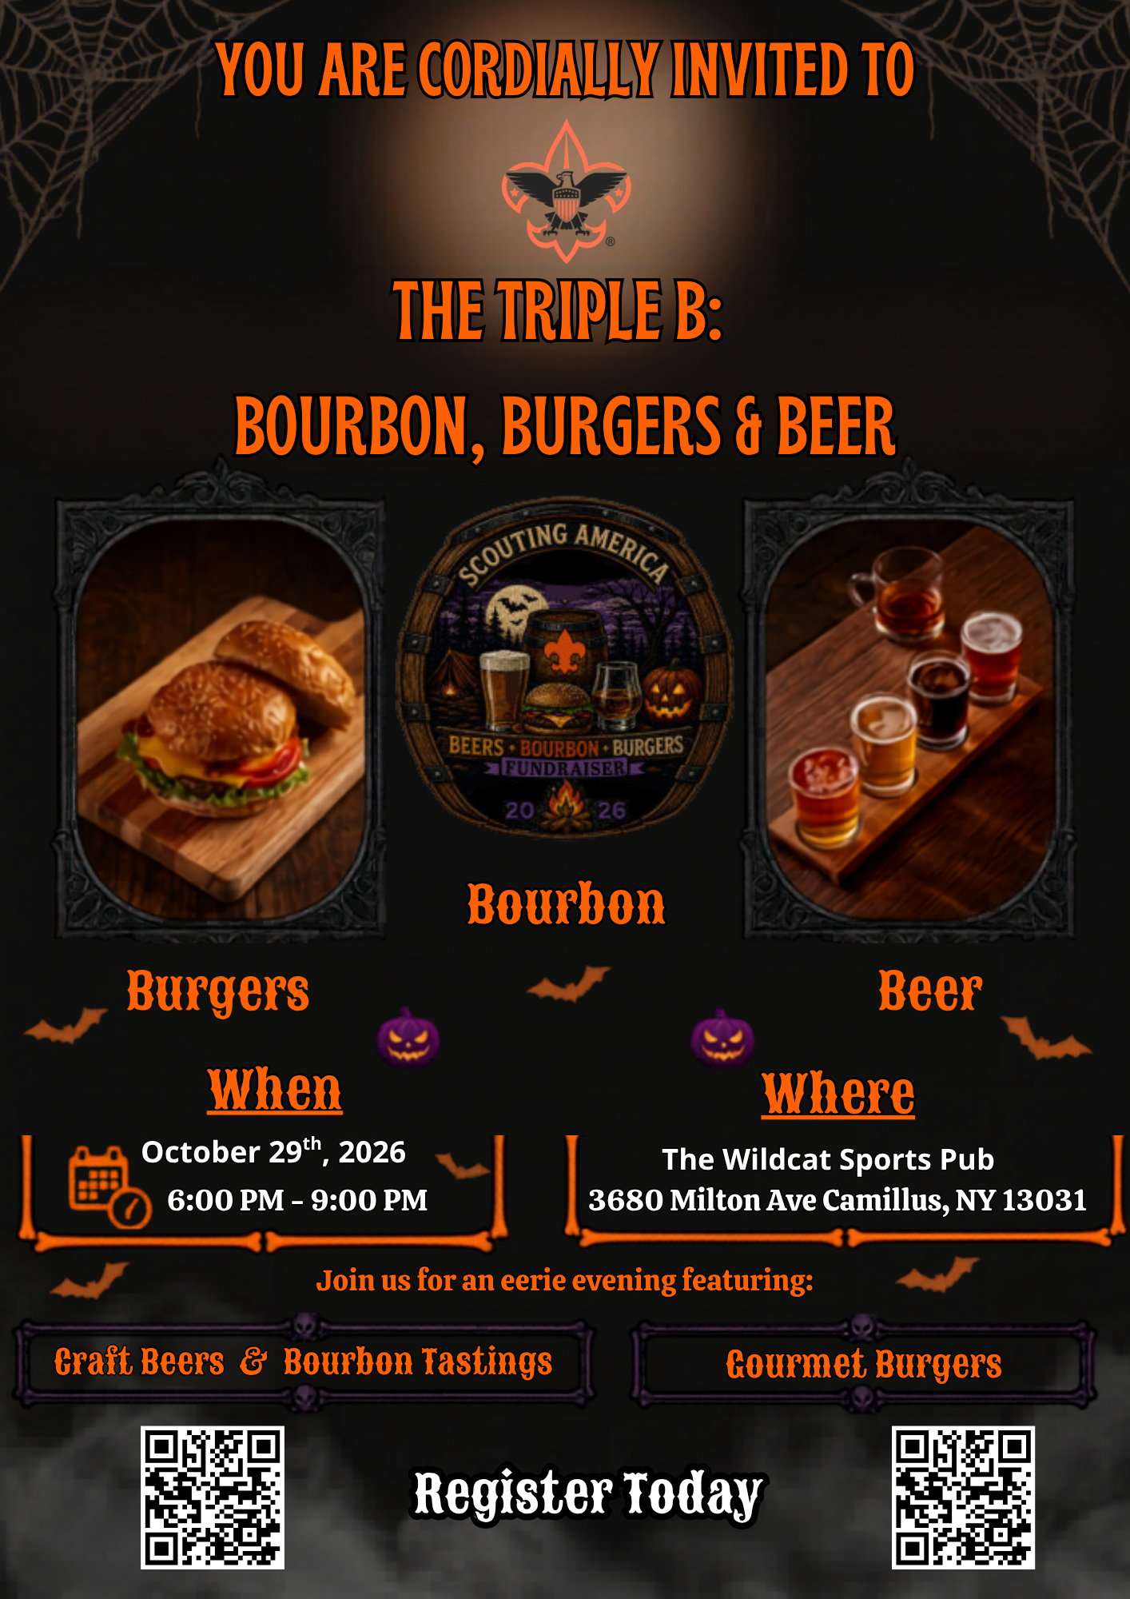

Presenting  Sponsor  $1,500  Event Signage throughout Venue  Speech recognition during event  Recognition in all event social media content  Tickets to the Event (4)  *Receives Rock’s Glass, Bourbon Barrel Coaster, Bottle opener, Cigar | Food and Beverage  Sponsor  $1,000  Sponsor our Food and Beverages of the evening  Event Signage throughout Venue  Speech recognition during event  Recognition in all event social media content  Tickets to the Event (4)  *Receives Rock’s Glass, Bourbon Barrel Coaster, Bottle opener | Souvenir  Sponsor  $750  Sponsor our Commemorative Souvenir Bourbon Barrel Patch  Event Signage throughout Venue  Speech recognition  Recognition in all event social media content  Tickets to the Event (2)  *Receives Rock’s Glass, Bourbon Barrel Coaster, Bottle opener, Cigar
Rocks Glass  Sponsor  $1000  Event Signage throughout Venue  Speech recognition during event  Recognition in all event social media content  Tickets to the Event (2)  *Receives Rock’s Glass, Bourbon Barrel Coaster, Cigar  SOLD | Pint Glass  Sponsor  $750  Event Signage throughout Venue  Speech recognition during event  Recognition in all event social media content  Tickets to the Event (2)  *Receives Rock’s Glass, Bourbon Barrel Coaster, Cigar | Cigar  Sponsor  $250  Event Signage throughout Venue  Speech recognition during event  Recognition in all event social media content  Ticket to Event (1)  *Receives Bourbon Barrel Coaster, Cigar
Corporate Sponsorship Package Options
Name: ________________________ Package Title: _____________________________
Please make check payable to: Scouting America – Longhouse Council Contact: John Romero @ 315-463-0201 ext. 114 or John.romero@scouting.org
Donation Request Form
Triple B: Beer, Bourbon & Burgers

Business Name: ___________________________
Contact Name: ____________________________
Phone: _________________________________
Email: _________________________________

We Would Like to Sponsor/Donate:
☐ $250
☐ $500
☐ $750
☐ $1000
☐ Gift Basket Items: ________
☐ Gift Certificate: _________

Approximate Retail Value (FMV): $_______________
Donation Available By: ___________________

