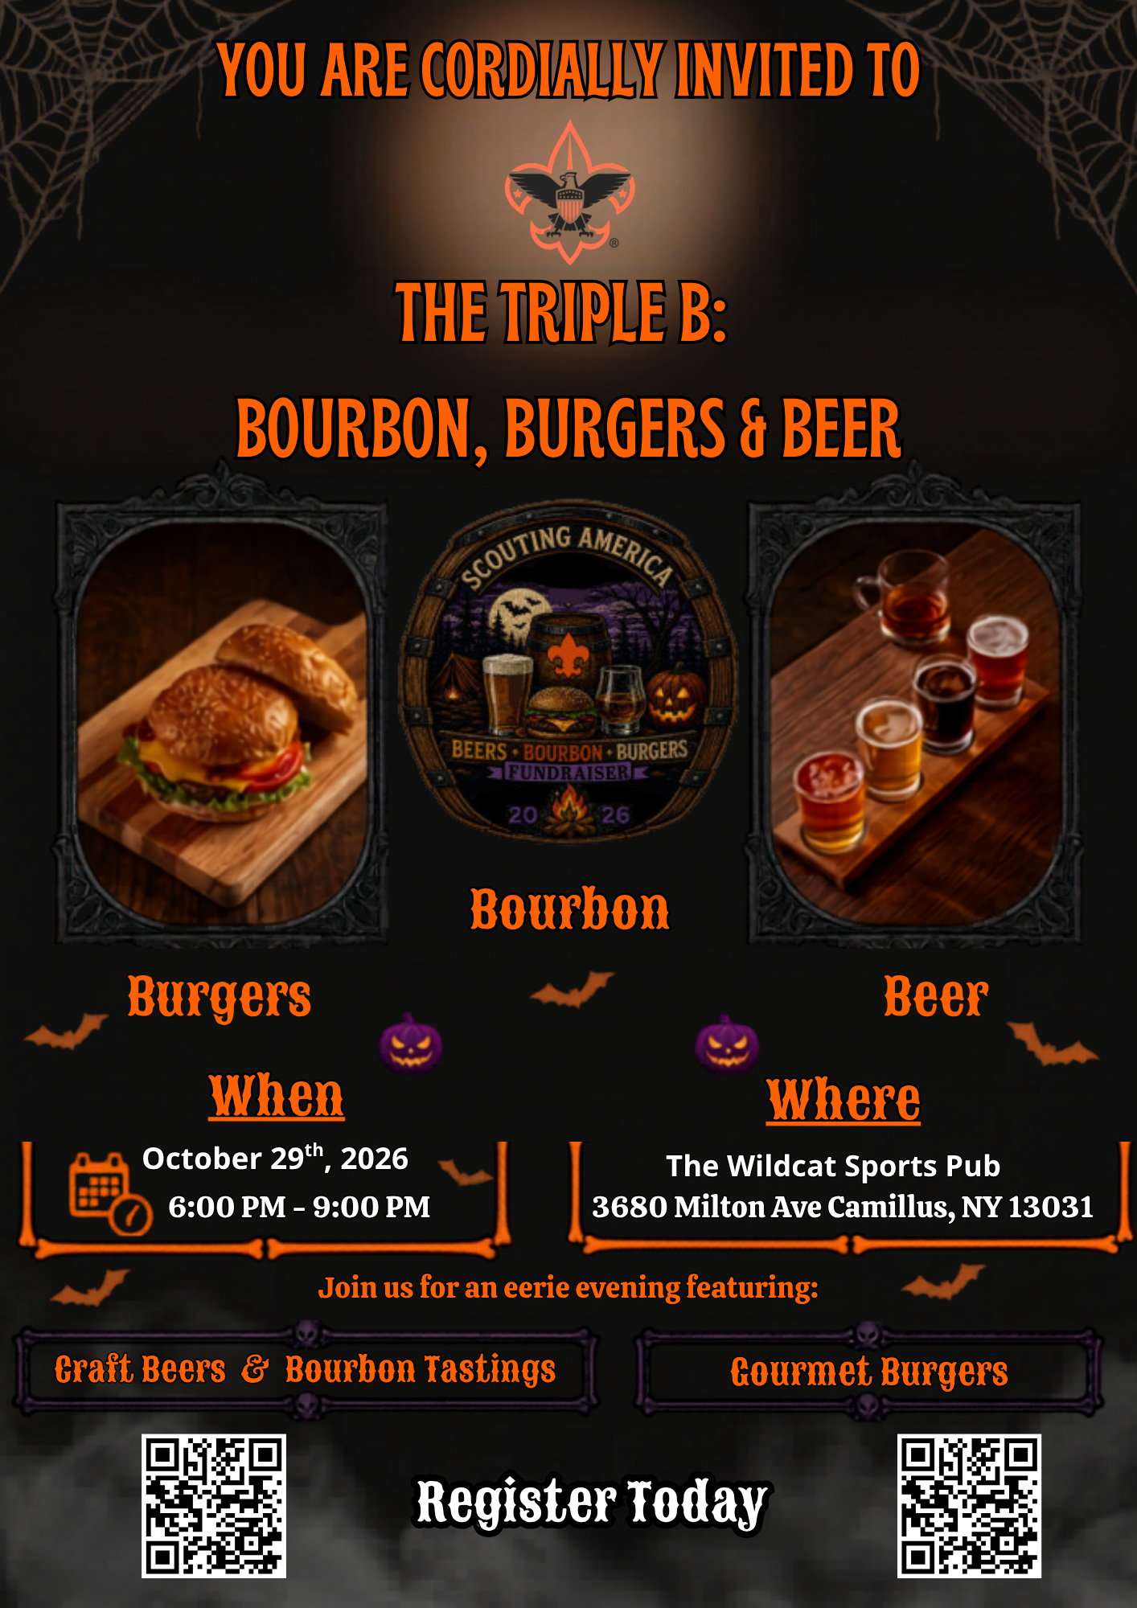

$1000 | Monster Mash  Tier-4: Premium Sponsor  Includes admission for 6 souls’  Logo Display throughout Venue  Social Media Recognition  Speech Recognition During Event  (1) Select Whiskey  Each Guest will receive:  *Rocks Glass, Pint Glass, Bourbon Barrel Coaster, Bottle Opener  Included with Package Purchase | $750 | Zombie Zoo  Tier-3: Signature Sponsor  SPONSOR OUR SOUVENIR COASTERS  Includes admission for 6 souls’  Logo Display throughout Venue  Social Media Recognition  Speech Recognition During Event  Each Guest will receive:  *Rocks Glass, Pint Glass, Bourbon Barrel Coaster, Bottle Opener  Included with Package Purchase
$500 | Bad Moon Rising  Tier-2: Select Sponsor  SPONSOR OUR MEAL FOR THE EVENING  Includes admission for 4 souls’  Logo Display throughout Venue  Social Media Recognition  Speech Recognition During Event  Each Guest will receive:  *Rocks Glass, Pint Glass, Bourbon Barrel Coaster, Bottle Opener  Included with Package Purchase | $200 | Devil or Angel  Tier-1: Sponsor  SPONSOR OUR BEVERAGES FOR THE EVENING  Includes admission for a Couple of Souls’ (2)  Logo Display throughout Venue  Social Media Recognition  Speech Recognition During Event  Each Guest will receive:  *Rocks Glass, Pint Glass, Bourbon Barrel Coaster, Bottle Opener  Included with Package Purchase
$100 | I Married A Witch  Includes admission for a couple of souls’ (2)  Bourbon Barrel Coaster  -  Rocks Glass  -  Bottle Opener | $60 | Dead Man’s Party  Includes admission for 1 soul  Bourbon Barrel Coaster  -  Rocks Glass
Presenting Sponsor | $1500
Name: ________________________ Package Title: _________________________
Please make check payable to: Scouting America – Longhouse Council Contact: John Romero @ 315-463-0201 ext. 114 or John.romero@scouting.org

