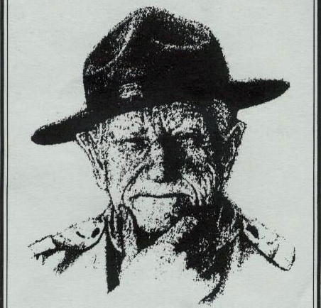 2025 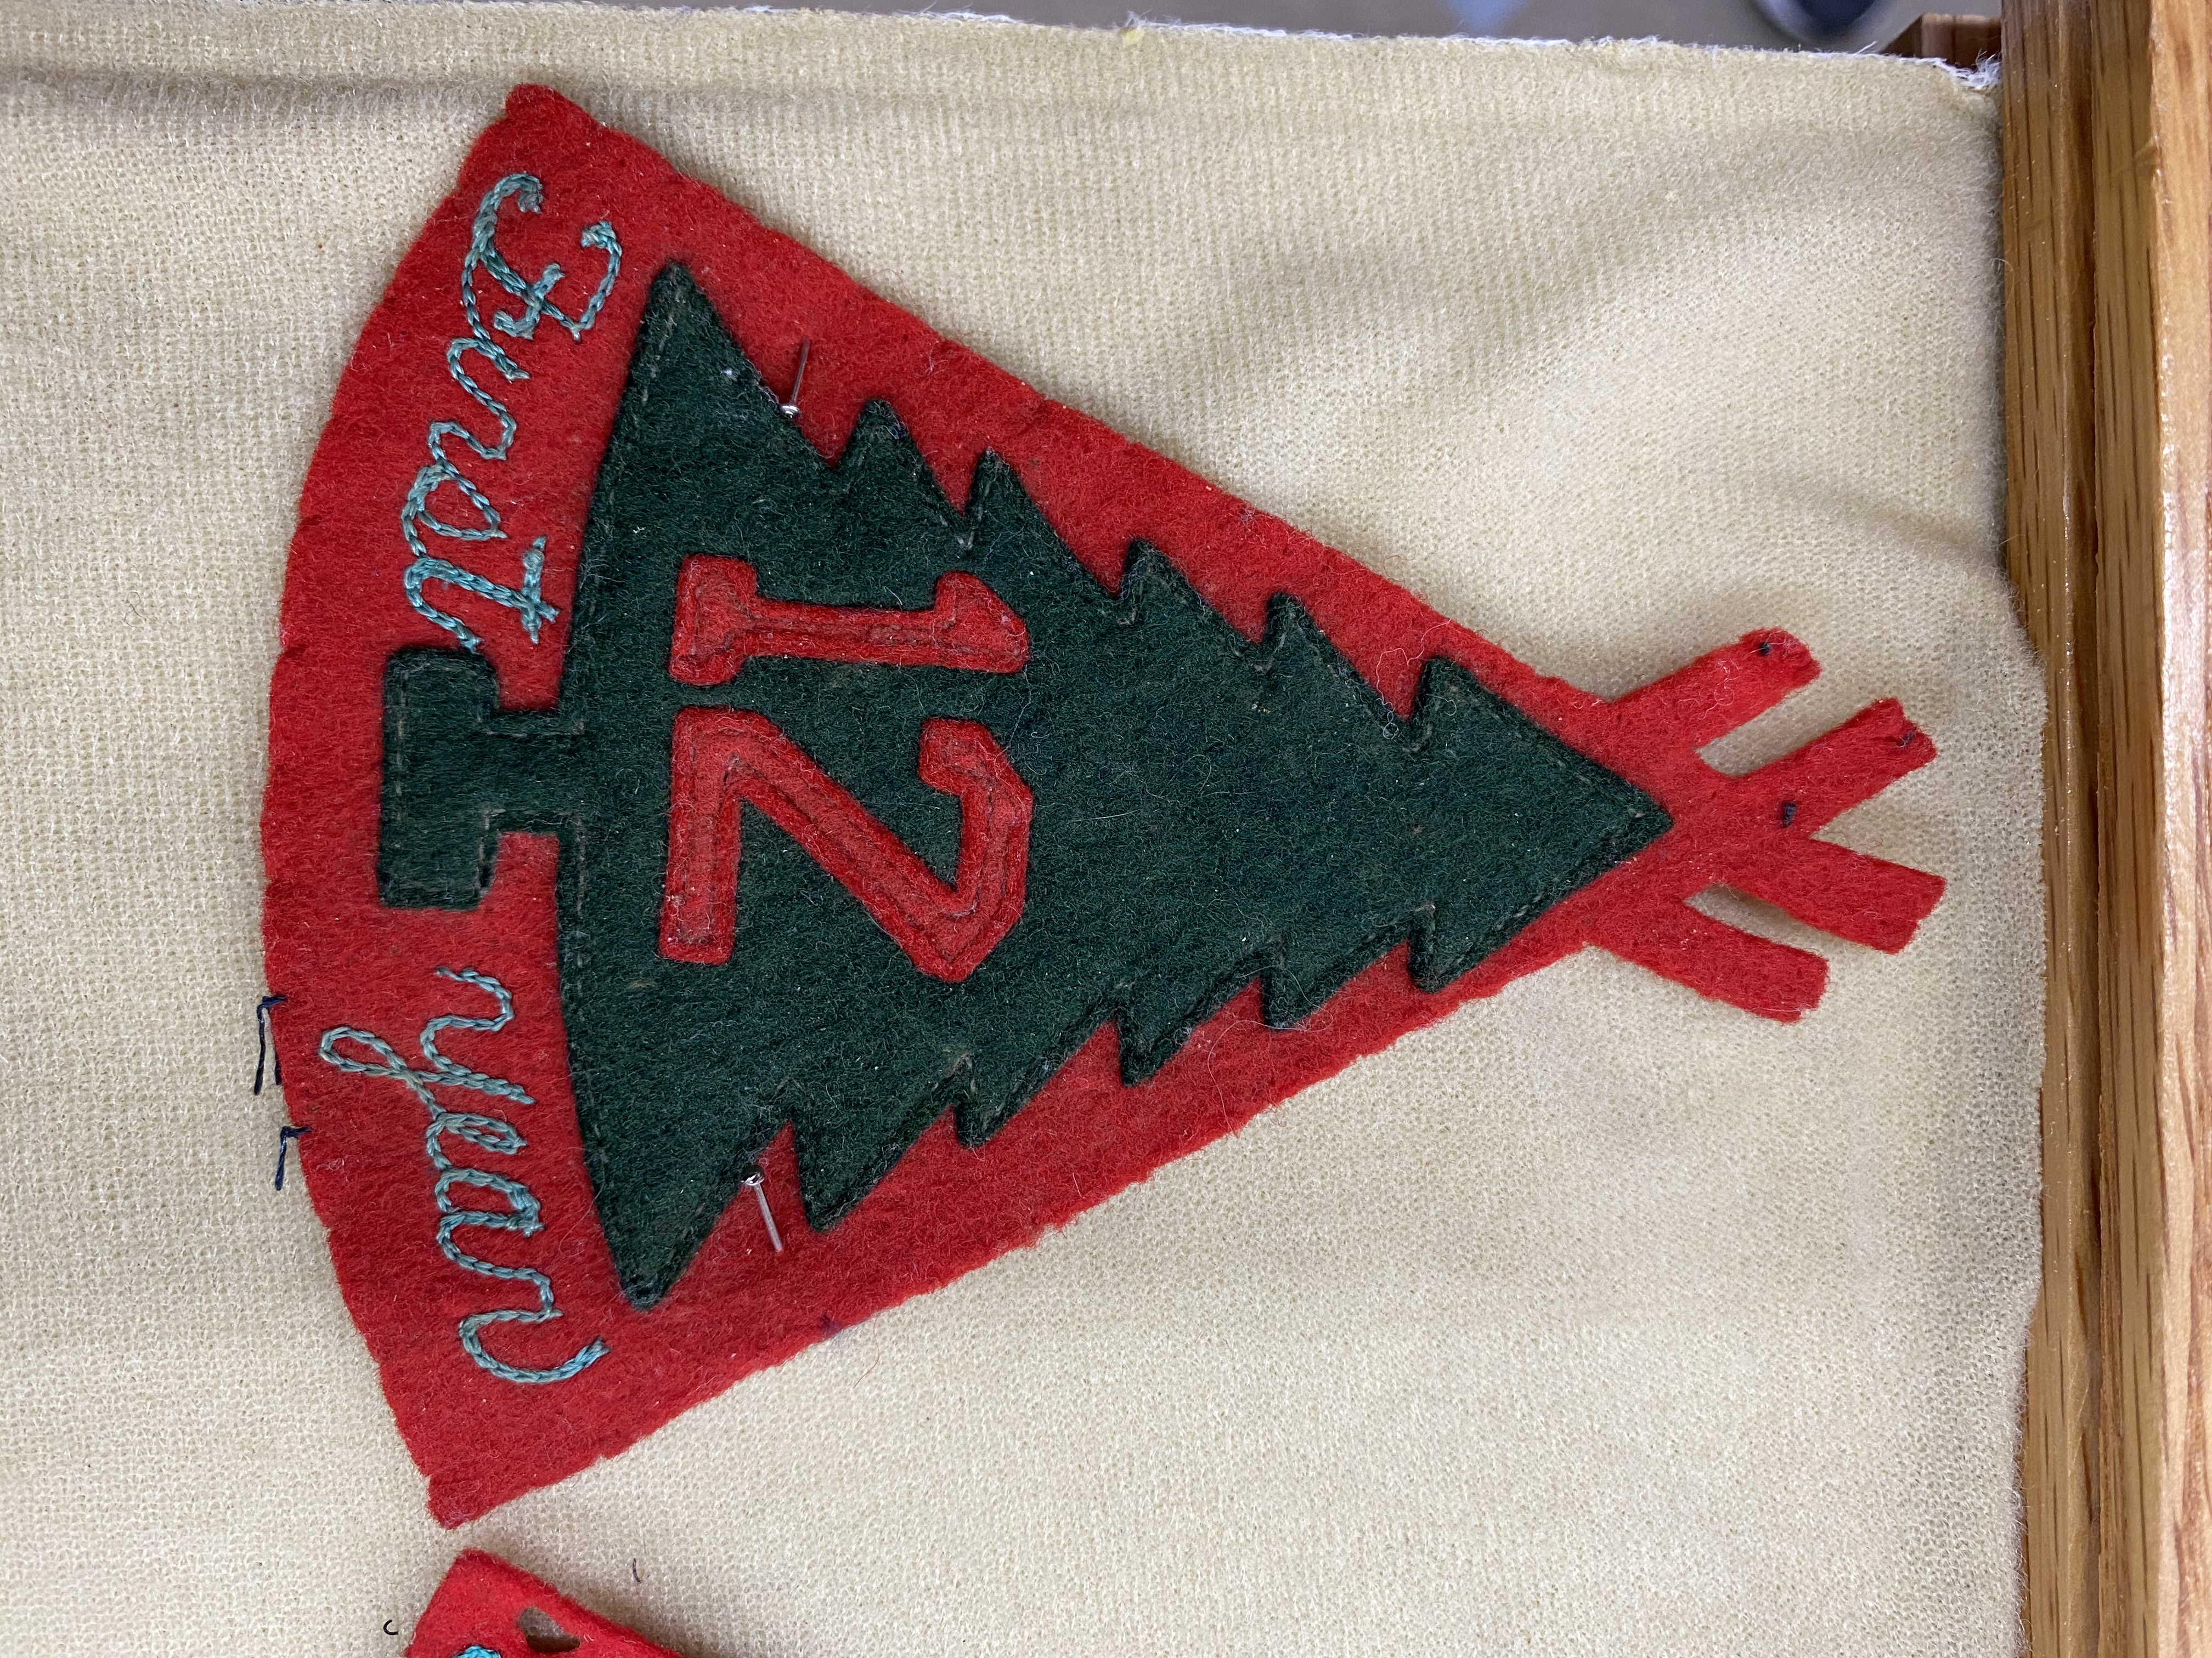
Camp Woodland
Boy Scout Trade-O-Ree

Who: All Scouts, Leaders – or Boy Scout Memorabilia collectors
What: Boy Scout items for sale and trade – multiple dealers
By: William Hillcourt Scout Museum
When: Friday, June 13th (3-10 PM) & Saturday, June 14th (9AM –3PM)
Where: Camp Woodland (in Owens Hall), Constantia, NY

Details: Admission is free
Every Scout will get a FREE bag of patches for attending!
For more information contact Steve Austin
saustincsp@gmail.com

