2022 Turning Point District
Klondike Derby
Leader’s Guide

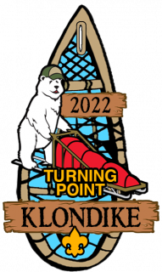

February 12, 2022
Camp Wakpominee

LEADERS’ GUIDE TABLE OF CONTENTS
Introduction 3
Honoring the History 3
General Notice for Event 4
Schedule 4
Covid-19 Policy Changes 5
Registration 5
Fee Schedule 5
Unit Information 6
Troops and Patrols 6
Equipment to Bring 6
Clothing 7
ZOOM Leader Meeting 7
Golden Skillet 8
Policies 8
General Rules 8
Sled Rules 8
Health 9
Covid-19 Rules 9
COLD WEATHER 10
Appendix 11
Snow Snake 11
Klondike Sled 12
Golden Skillet 13
Registration Form 14
Contact Information 15

Honoring the History
Klondike Heritage: In August 1896, prospectors discovered gold in the remote Klondike region of Canada's Yukon Territory. In July 1897, the S.S. Portland arrived in Seattle, Washington, with more than a ton of Klondike gold on board. This event touched off the great KLONDIKE GOLD RUSH as thousands of people who dreamed of becoming wealthy began booking passage on steamers heading north from Seattle and other West Coast ports TO THE YUKON. Upon arriving at the northern end of the Inside Passage, however, these adventure-bound stampeders found no easy route leading to the still distant Klondike region. Their progress was slow as each prospector made repeated trips over the rugged trail through the bitter cold. Imagine pulling a sled loaded with three to six hundred pounds of supplies over a stretch of ice up a steep grade, strewn with boulders and logs, then crossing over a river bed on a couple of trees laid side by side, and you get a picture of their labors. Facing 60-mile-an-hour winds in 65- degree-below-zero weather, the prospectors had to ascend the Chilkoot Pass -- 1,000 feet straight up. With a steady stream of stampeders lining the path each day, it took forty trips to get a ton of supplies up the mountain. Those who survived the mountain then faced a treacherous passage by boat to the town of Dawson near the gold fields.
Since 1949, Boy Scout Troops have been participating in Klondike Derbies as a way to honor this historic time. Scouts pull a sled loaded with supplies from station to station and compete in various scout skill-based events.

This Year’s Klondike
The 2022 Klondike Derby will be modified to reflect COVID-19 pandemic guidelines. All participants will be expected to fill out and bring a health attestation form with them to the event. All participants will be required to have their temperature taken. All participants will wear face masks at all times during the event.
We will not be holding the traditional morning assembly to launch troops on their way, or the afternoon gathering to announce winners. We will not be using the Dining Hall as a warming station.
After check in, sled teams will report directly to their starting station. Once they complete the event at that station they will depart for the next station as directed by the Klondike event leader on site. There will be no “jumping around”. Participants are urged to use their cars to warm Scouts if required. A First Aid station will be available as needed.

Winners will be announced online by email.

Sled teams/Patrols should be limited to about 8 Scouts with no more than two adult leaders accompanying the sled to reduce density on location.

General Notice for Event
There will be no late registration for this in person event.

Each troop will be assigned to a starting site and they will follow a specific order to complete each station.

The COVID-19 From needs to be completed by a parent of any scout and it needs to be done before leaving for camp.

The Klondike Derby will consist of ten event stations:

1. Tomahawk Throw
2. Knots & Lashings
3. Fire Boiling
4. Ice Rescue
5. Snow Snake
6. Sled Race
7. Log Cutting
8. First Aid
9. Kim’s Game
10. Snow Ball Throw

Schedule
7:30 to 8:45 | Check In Begins
9:00 | Morning Session Begins
9:00 to 12:00 | Morning Session
12:00 to 1:00 | Lunch and Golden Skillet
1:00 | Afternoon Session Begins
1:00 to 4:00 | Afternoon Session
4:00 | Afternoon Session Ends

Covid-19 Policy Changes
The Turning Point District Klondike Derby has changed in order to comply with the BSA and NYS Department of Health social distancing and public health requirements. These include, but are not limited to, reducing the number of Scouts and Scouters at event stations, eliminating indoor gathering spaces except in the case of emergency, staggering the arrival times of Scouts, reducing the number of events to avoid crowding and eliminating the need for a routine warming shelter.
- There will be no lunch event to avoid congregating and to allow the event to proceed more quickly than in normal years. Scouts will be encouraged to bring and eat snacks as needed.
- Troops will be asked to limit the number of vehicles in the parking lot when possible.

- Scouters will be asked to use unit vehicles as a warming station for Scouts when necessary.
- Winners will not be announced on the day of the event. Scores will be tabulated and winners will be announced following the event.
- Klondike patches and troop ribbons will be distributed at check in.

These are the COVID Policies as of today, and subject to change as we get more guidance from New York State and BSA as we get closer to the Klondike.

Registration
Unit registration is extremely important, with a deadline of February 4th. Registering early for the derby will help ensure that adequate arrangements are in place. Troops must register Scouts and Scouters ahead of time and pay ahead of time. No walk-in payments will be accepted. Troops will have medical forms on hand but those will remain with the troops.

The Dining Hall will be used as Klondike headquarters, check in will be in the pavilion by the Dining Hall. No Scouts or Scouters will enter the camp offices or headquarters except in the case of an emergency.

Fee Schedule
Klondike payments should be made online. The fee includes a patch for each paid participant, insurance, and other anticipated costs for this event.

$15.00 per Scout and Adult Leader

Unit Information

Troops and Patrols
The Patrol is the basic Unit of Scouting, and a Klondike Derby is the perfect place to reinforce the Patrol Method. It is also a perfect place to reinforce the following:

- An Opportunity for youth leadership
- Testing basic Scout Skills
- Promote teamwork and team building
- Demonstrate Scout spirit
- Create and Environment to have fun

Equipment to Bring
Scouts will be asked to bring equipment to be able to participate in events:
- Sled and Snow Snake
- Patrol First Aid Kit
- 4 poles (capable of being a stretcher and knot tying)
- Small tarp
- 2 40-ft ropes (1/4” or thicker)
- 8 ropes (10 Ft approx. for Knot Tying)
- Small shovel
- Gallon of Water
- Patrol Flag
- Trash Bag
- Flint and steel, hot spark or friction fire starter, matches
- Kindling and fuel to make small fire
- Pencil and Paper
- Scout Handbook

Staffing

Each participating troop is asked to supply at least two volunteers to assist with staffing for the day. These volunteers may be older scouts, parents, or adult leaders. (Adults must have YPT) Judges as well as support staff will be needed. CONTACT John VanMarkwyk at 404 723 6655 to discuss who will be volunteering for the day. Volunteers don’t need to be adults but need to be at least an older youth that is knowledgeable in the scout skills and relate well to younger scouts. Since multiple patrols may be evaluated each period at each site, multiple judges will be needed at each event station. Event packages will be e-mailed to volunteers prior to the Klondike to allow for adequate preparation. Volunteers who are overseeing events should report to the pavilion by the Dining Hall at 7:30 on Saturday morning for final instructions.

Clothing
Adult Leaders should inspect all Scouts for appropriate cold weather clothing and proper footwear. The best protection in winter weather is common sense. Scouts should be instructed to dress in layers. Avoid working up a sweat and keep themselves comfortable by removing or adding layers of clothing as needed. Avoid cotton clothing. Blue Jeans or cotton sweat pants should not be worn on the Klondike Trail. Wool, silk and polypropylene are the better materials for winter camping. Scouts should wear non-cotton long underwear. i.e. smart-tech / under armor.

Please see the proper outdoor gear section discussed later in this event guide.
Each scout should have the following in a day pack.
1-liter water bottle full
1 pair of extra gloves
1 pair extra socks – Not Cotton
1 extra hat

ZOOM Leader Meeting
On Thursday, February 10th, there will be a leader meeting for Scoutmasters/Advisors and Senior Patrol Leaders/Presidents or their proxies. Units will receive pertinent information for the events as well as information on any updates or changes made since the final Leaders Guide was published. Unit youth leaders and adult leaders must attend in order to participate. The meeting will be via ZOOM.

Golden Skillet Award

The Golden Skillet Competition is an optional event that can be completed during Lunch. This contest does not contribute to the score of the Klondike Derby. This event is scored and judged as a separate award. See the “Golden Skillet” Guidelines in the Appendix.

Policies

General Rules
The following rules need to be read or explained to your units prior to the Klondike. Please make sure parents and scouts are aware of these rules.

● The Scout Law is the main rule of all Boy Scout Events.
● The Buddy System is to be used during the entirety of the event.
● The use of the Event Facilities is a privilege - be respectful of property facilities.
● All Vehicles must be parked in designated parking areas - vehicles not parked in a properly designated parking spot will be required to move or may be towed at owner's expense. A limited number of 4-wheel drive and off-road vehicles will be used inside the Camp to support the Derby events.
● Patrol Flags and other patrol spirit methods are encouraged during the entirety of the event.
● Scouts are not to mingle with other units or event areas until it is clear and have been invited into the area.
● No scout may leave the event unless such departure is arranged with the Unit Leader and the Klondike Key Staff notified and youth is signed out.
● As at any Scout Event, no illegal drugs, alcohol, firearms or weapons may be on the premises at any time. Possession of any aforementioned item is grounds for immediate dismissal from the event.

Sled Rules
No commercially manufactured sleds are permitted. This means that items such as plastic sleds, toboggans, wheelbarrows or commercially manufactured wagons will not be allowed to compete. In the interest of tradition, sleds should ideally be fashioned to look like a traditional Alaskan dog sled. A harness for pulling the sled should be attached to the front of the sled. Ideally, loops should extend from a single main trunk rope. The sled may be constructed of any materials (wood, PVC, fiberglass, aluminum, etc.). Wheels are allowed if the patrol feels that it is necessary. Removable wheels would be ideal. Keeping in mind if there is snow, wheels will slow the sled in a race.

Health
Troop leaders must have a filled in copy of the Covid Symptom waiver form for each Scout and leader at the event. Temperature of each Scout should be done prior to arriving to camp and certifying that no Scouts have a temperature in excess of 100 degrees Fahrenheit. No Scout who has a high temperature or symptoms of COVID-19 may remain at camp. Troop leaders must have a BSA Health Form for each Scout and Adult participating in the Klondike and certify this at check in. The BSA Health Forms will remain with the unit. Health personnel will be on site.

Covid-19 Rules
1) Twin Rivers Council and Turning Point District will be following all CDC COVID-19 rules, guidelines and regulations.

2) Scouts and Scouters will wear CDC compliant masks at all times while in camp. Scarves and fleece gators do not comply with CDC guidelines, however these may be worn OVER (in addition to) a CDC appropriate mask.

3) Scouts and Scouters will practice social distancing and avoid close contact with non-troop
members or others not on their sled team.

4) Scouts and Scouters will all fill out health attestation forms prior to departing from home and those will be deposited with the District Staff at the event. BSA health forms will be brought to camp and kept by unit leaders.

5) Scouts and Scouters will undergo a temperature check before arriving at camp.

6) Warming opportunities will be limited to an emergency first aid location and Scout
leader vehicles. There will be no regular warming sites to discourage congregating.

7) Cabins and buildings will be closed to Klondike Derby participants unless a cabin has already been rented by a troop/pack.

8) To limit the number of people in camp, Troops are limited to two adult leaders per entered sled team.

These are the COVID Policies as of today, and subject to change as we get more guidance from New York State and BSA as we get closer to the Klondike.

COLD WEATHER
1. When you wear a hat, your feet stay warmer. Fact: 70% of heat loss from the body is through the head.
2. Waterproof your boots with a waterproofing spray before your camping trip.
3. Always bring at least one extra pair of wool socks for emergencies.
4. If you are cold or get wet, talk to your leaders. Don’t wait until you are numb or until the early morning hours. Learn what hypothermia is before going winter camping and learn to prevent it.
5. Eat lots of fat, complex carbs, and protein (i.e., meats, pasta, bacon, sausage, fruits and veggies, butter, nuts, peanut butter, cheese, salami). Sweets will not sustain you.
6. DRINK LOTS of water to avoid dehydration. Warm drinks can keep you warm. Energy Drinks are the opposite of helpful.
7. Be prepared: • Dress Warm • Keep Warm – Feet, Head and Hands • Sleep Warm • Eat and Drink Warm

Think Warm: Keep a Positive Mental Attitude! Keeping warm is the most important part of cold weather camping. Use the C-O-L-D method to assure staying warm.
C – CLEAN Since insulation is only effective when heat is trapped by dead air spaces, keep your insulating layers clean and fluffy. Dirt, grime, and perspiration can mat down those air spaces and reduce the warmth of a garment.
O – OVERHEATING Avoid overheating by adjusting the layers of your clothing to meet the outside temperature and the exertions of your activities. Excessive sweating can dampen your garments and cause chilling later on.
L – LOOSE LAYERS A steady flow of warm blood is essential to keep all parts of your body heated. Wear several loosely fitting layers of clothing and footgear that will allow maximum insulation without impeding your circulation.
D – DRY Damp clothing and skin can cause your body to cool quickly, possibly leading to frostbite and hypothermia. Keep dry by avoiding cotton clothes that absorb moisture. Always brush away snow that is on your clothes before you enter a heated area. Keep the clothing around your neck loosened so that body heat and moisture can escape instead of soaking several layers of clothing.

Appendix

Snow Snake
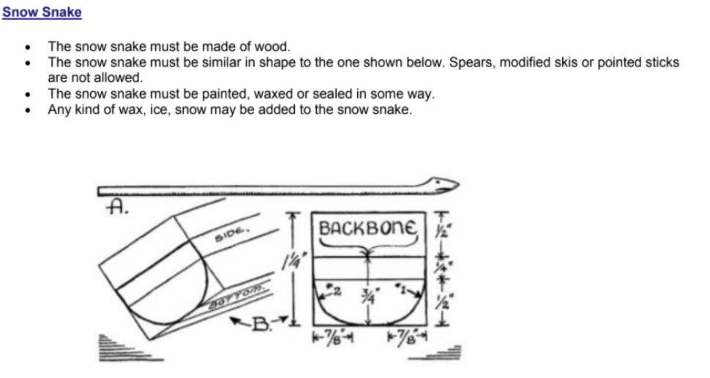
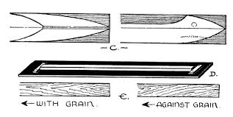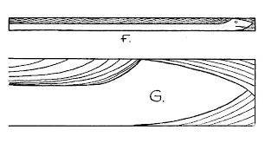

Klondike Sled
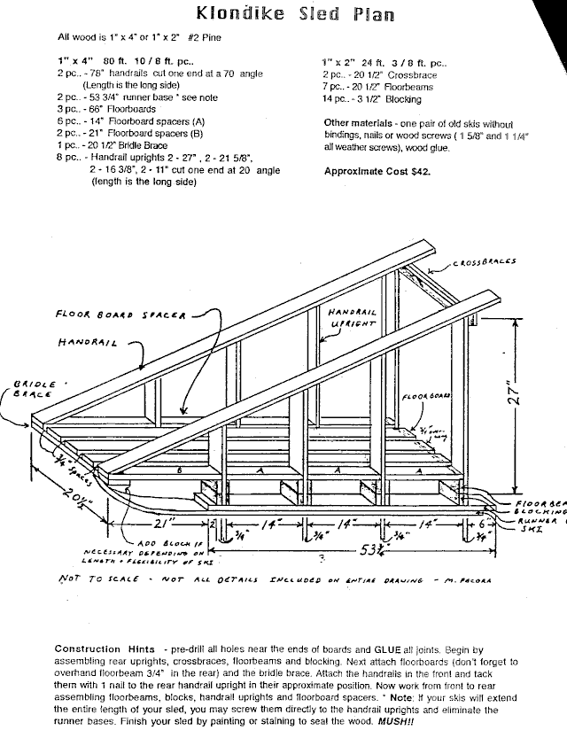

GOLDEN SKILLET RULES
TEAM – The patrol will compete as a team.
SAFETY – Safety is paramount above all else (fire safety, food safety, knife safety, etc.). Any violation of Scouting’s safety standards will result in an automatic disqualification.
FOOD – There will be 5 main ingredients that must be used for your meal (see scoring). The ingredient list will be announced Wednesday night prior to the Klondike. Patrols may use oils, spices, herbs, seasonings in addition to these 5 items.
COOKING – Cooking will be done on a portable trail stove or open fire. If open fire is used, it must be properly put out by 1:00 pm. Ingredients can be prepped ahead of time but all cooking must be done at the Klondike.
EQUIPMENT – The patrol must transport anything and everything that they need with their sled. Stoves, food, coolers, etc.
TIME – The lunch break starts at 12:00 PM. The meal must be ready for judging by 12:50 PM at the latest. Patrols must be cleaned up and “no trace” left by 1:00 PM.
HYGIENE – All patrol members must have clean and sanitized hands. To enter the food for judging all proper hygiene and food safety rules must be followed.
SCORING – Scoring will be based on taste (10 points) and use of ingredients (5 points). One point will be subtracted from use of ingredients if a market basket item cannot be identified in the meal. If additional ingredients are used that distract from the main 5, taste points will be deducted.

2022 Klondike Derby Check–in Form
Submit completed form 8 to 8:45 AM, Saturday, February 12th, at the Pavilion by the Dining Hall
If adjustments are needed, adult should return to the Pavilion between 10 and 11:30.
4-digit Troop #: _________________________ Adult Leader #1 _______________________
Community ____________________________ Cell phone # __________________________
District ________________________________ Adult Leader #2 ________________________
Cell phone # ___________________________
#Registered Scouts: _________ Total Fee ($15/participant): _____________
#Registered Adults: __________
#Total Participants: __________ Balance Due: __________

Troop Roster of Participants
Patrol _____________________________
_____________________ Rank _______ _____________________ Rank _______ _____________________ Rank _______ _____________________ Rank _______ _____________________ Rank _______ _____________________ Rank _______ _____________________ Rank _______ _____________________ Rank _______

Patrol______________________________
_____________________ Rank _______ _____________________ Rank _______ _____________________ Rank _______ _____________________ Rank _______ _____________________ Rank _______ _____________________ Rank _______ _____________________ Rank _______ _____________________ Rank _______

Volunteer Staff _____________________ Contact ____________________
Volunteer Staff _____________________ Contact ____________________
Volunteer Staff _____________________ Contact ____________________
Volunteer Staff _____________________ Contact ____________________

Contact
Our mission is to provide a fun and exciting weekend for all Scouts and Adult Leaders. Should you have any questions, please contact one of the main contacts.
We are looking forward to seeing you at the 2022 Turning Point District Klondike Derby.

Yours in Scouting,
Your 2022 Klondike Derby Staff

Klondike Derby Lead
John VanMarkwyk
Cell 404 723 6655
Email: johnvanmarkwyk@gmail.com
Troop 4016 Scoutmaster
Ron Tremper
Cell: 518 469 3095
Email: Trepmron@hotmail.com
Assistant Council Commissioner
Frank Mihalek
Cell: 518 461 5567
E Mail: wakpominee@gmail.com
District Commissioner Select
Chet Szymnanski
Cell 917 273 5443
Email: cszymanski1@gmail.com
Special Thanks to 4016 Saratoga Springs for Sponsoring this Year’s Klondike, Ranger Dan for preparing Camp Wakpominee for the Klondike, all the Klondike Volunteers that help made this Event a success and Quin Ciccolella for his Leader’s Guide Expertise.

