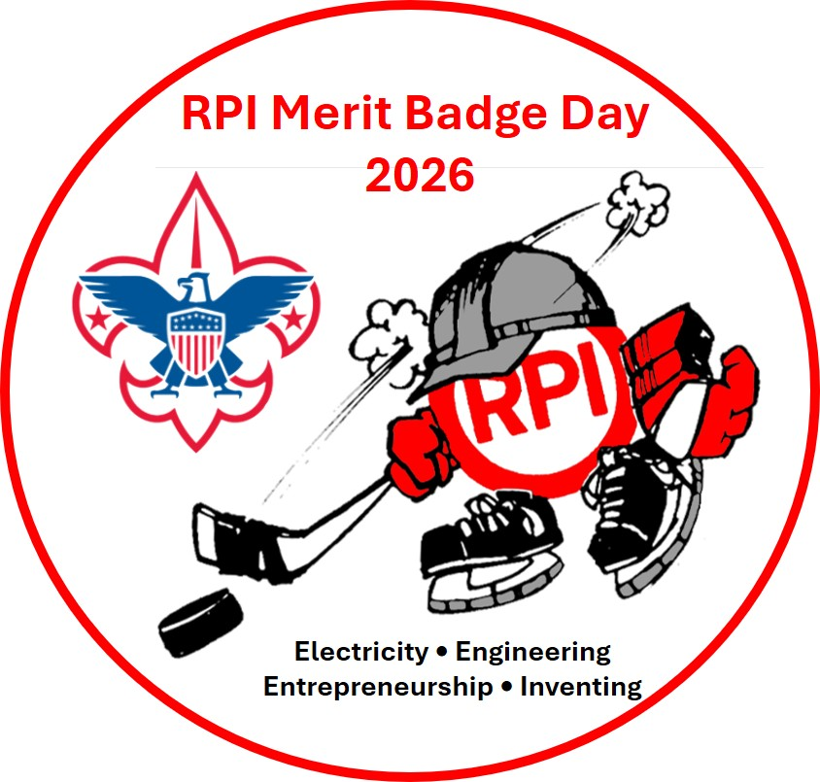

Merit Badge Day at RPI – Parent Guide
Center for Biotechnology and Interdisciplinary Studies
Rensselaer Polytechnic Institute
1623 15th Street
Troy, NY 12180

Saturday December 5, 2026
9:00 a.m. – 2:00 p.m.

Important Items to Note Purpose of the Merit Badge College (the “MBC”): The intent of this program is to supplement your scout’s merit badge work with counselor volunteers from RPI. Specifically, the MBC seeks to provide your scout an opportunity to meet with highly qualified professionals to learn and foster the development of lifelong interests, particularly for career-oriented merit badges.
Disclaimer: Earning a merit badge at the MBC is NOT guaranteed. No requirements will be “excused”; none will be "gifted". Your scout MUST participate. Completion of assigned pre-requisites (“Pre-Reqs”, i.e. merit badge requirements that cannot be completed during the MBC) is essential to complete the merit badge.
For scouts who are disappointed that they did not finish a merit badge at the MBC, please let them know that there is nothing wrong with partially completing a merit badge; your scout can finish the merit badge up until they are 18 years old.
Code of Conduct: The Scout Oath and Scout Law apply at all times. If your scout’s merit badge counselor determines that your scout is disruptive to a merit badge class, your scout may be asked to leave. No refunds will be given.
The Twin Rivers Council and the MBC participants are guests of RPI. Please leave it better than how you found it. Scouts should NOT be roaming the hallways. Please be respectful to both the MBC staff and its counselors; they are volunteering their time to support your scout’s advancement.
Prior to Arrival: To maximize their learning, your Scout should complete the following:
- Secure the merit badge pamphlet(s) for your scout’s class(es) and then… …have your Scout read the pamphlet(s)!!
- Complete the pre-requisite requirements (refer to the Merit Badge PreReq list)
- Print the merit badge workbook from this site (BEFORE the MBC: http://usscouts.org/mb/worksheets/list.asp) and complete the specified prerequisites.
- Before printing, please confirm they have been updated, if applicable for any 2026 requirement updates ( https://www.scouting.org/skills/merit-badges/all/)

Recording of Merit Badge Advancement: All advancement will be processed through Scoutbook. Prior to the MBC, please have your scout’s Unit Leader “Start Another Merit Badge” for your scout in Scoutbook, provide the “initial unit leader signature” and proceed to “Invite Counselor” for the identified merit badge counselor in the “Merit Badge Counselor Info” form. If your scout’s unit does not use Scoutbook, please feel free to bring a cardstock blue card that is signed by your scout’s Unit Leader. Cardstock blue cards will NOT be provided at the MBC
Items for your Scout to Bring to the MBC:
Class A uniform – Scouts MUST be in their Class A uniform
Snack from home Water bottle / something to drink
Brown Bag lunch (if not purchasing the lunch option)
Pen/pencil
USScouts.org Merit Badge Worksheets with the completed pre-requisites for their class(es)
Draw string bag or backpack to hold the above items
Cell Phones:
Scouts may bring them BUT: It must be set to silent/vibrate during class
A Scout is Courteous – unless instructed by the merit badge counselor for your scout to use their phone, your scout may NOT call/text/browse/play games/etc. during a class
Merit Badge Class Sessions:
Check in starts at 08:00 Morning (AM)
Classes begin at 9:00 am
A one hour lunch session will take place at noon – 1 pm, during this time lab tours will be made available in working biomedical engineering labs within the RPI center
Classes will re-convene from lunch at 1:00 pm for a final one-hour session
Dismissal is at 2:00 pm
Pricing:
Credit / Debit Card = $20.00 (w/ lunch) or $10.00 (w/ out lunch)
Lunch Option- Lunch will be available to preorder at time of registration. It will be a boxed lunch from Subway (includes sandwich or salad option, chips and cookie). If your scout does not preorder lunch they must bring a bag lunch as there will be no food available to purchase on site
Where does my Scout report upon arrival, and how do we park?
Please have your scout report to the center atrium in the Center for Biotechnology and Interdisciplinary Studies (CBIS) at RPI: packet, patch, as well as lunch ticket (if this was purchased with the scout’s registration). See the attached map with suggested parking locations and event registration site.

