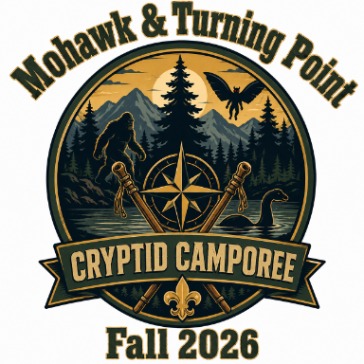
For generations, strange creatures have been reported throughout the forests, mountains, swamps, and lakes of North America. Scouts have been assembled by the Twin Rivers Cryptid Research Agency (TRCRA) to investigate reports of mysterious creatures appearing throughout the reservation. Patrols will travel between investigation stations, gathering evidence, learning outdoor skills, and solving the mystery of which cryptid has recently appeared in camp.
Patrols earn Evidence Tokens at each station. At the conclusion of the camporee, patrols present their findings and identify the cryptid responsible for the disturbances.
Camp Motto:
"Seek the Evidence. Master the Skills. Discover the Legend." 🏕️🔍👣🦶🌲

Cryptid Quest Camporee Stations
- The Mothman Warning – Archery
- The Beast of SlyPond Road Hunt – Rifle Shooting
- The Chupacabra Ranch – BB Gun Range (AOL/Crossovers)
- The Jersey Devil's Forest – Tomahawk Throwing
- Bigfoot Expedition – Orienteering
- Surviving a Sasquatch Encounter – First Aid
- Monster Hunter Field Kitchen – Cooking
- Tracking the Unknown – Nature / Plant & Animal Identification
- Thunderbird Peak – COPE & Climbing
- The Creature Crime Scene – Cryptid CSI Investigation
- The Wendigo Winter Survival – Fire Building
- The Hidebehind Lumber Camp – Knife & Ax Work
- The Hunt for Champ – Knots & Lashings
- Mothman Emergency Network – Signals & Codes
- Lost in the Cryptid Zone – Emergency Shelter Building

Camp wide Events
- The Great Cryptid Hunt – Camp wide Investigation Challenge
- Cryptid Summit Campfire Program – Patrol Evidence Presentation
- Cryptid Research Base Inspection – Campsite Inspection
- Cryptid Trivia Challenge – Bonus Event
- Scoutmaster's Mystery Challenge – Bonus Event
- Commissioner's Cryptid Challenge – Bonus Event
- Patrol Spirit Competition – Scout Spirit Award
- Cryptid Costume / Patrol Identity Contest (Optional)
- Cryptid Trading Post Challenge (Optional Patrol Activity)

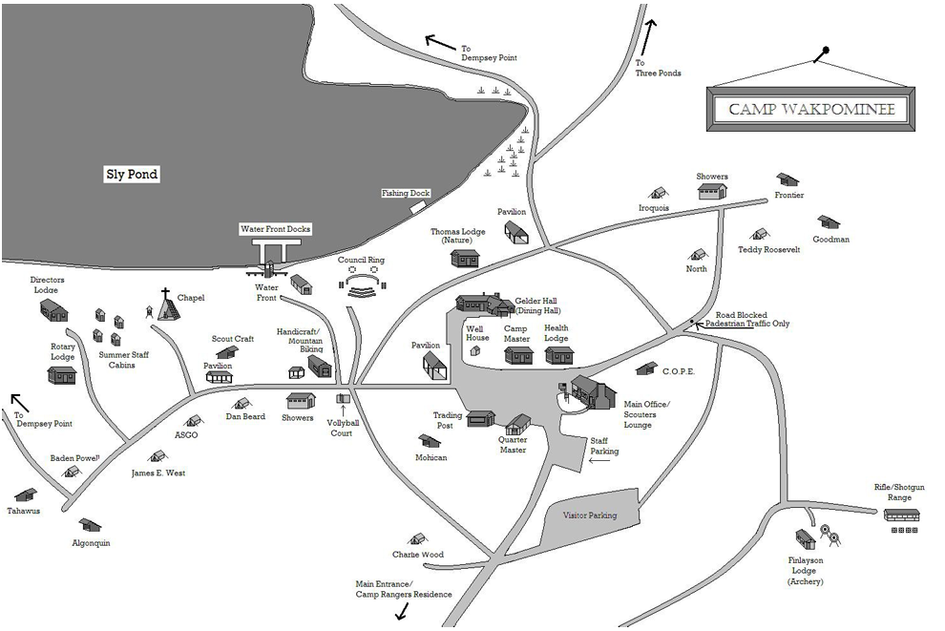

Camp wide Awards
Best Investigators | Master Tracker | Wilderness Survival Team | Marksman Patrol | Cryptid Champions
Highest CSI score | Highest Orienteering/Nature combined score | Highest Fire, Shelter, and First Aid score | Highest combined Archery, Rifle OR BB, and Tomahawk score | Overall Camporee Champion Patrol

Cub Scout Cryptid Camporee

Cub Scout Cryptid Camporee Advancement Matrix
Camporee Station | Arrow of Light
Archery (Mothman) | Archery Adventure*
BB Range (Chupacabra) | BB Gun Adventure*
Orienteering (Bigfoot Expedition) | Outdoor Adventurer
First Aid (Sasquatch Encounter) | First Aid
Cooking (Monster Hunter Kitchen) | Outdoor Adventurer
Nature Identification | Into the Wild / Into the Woods
CSI Investigation | High Tech Outdoors
Fire Building | Outdoor Adventurer
Knife Safety | Knife Safety
Knots & Lashings | Outdoor Adventurer
Signals & Codes | High Tech Outdoors
Emergency Shelter | Outdoor Adventurer
Climbing / COPE | Outdoor Adventurer

AOL/Crossover Documentation Form for Station Leaders - EXAMPLE
Each participant will receive a completion sheet in their welcome packet upon arrival.

Scout Name: _____________________

Pack: _____________________

Rank: _____________________
Station | AOL Requirement | Completed | Stamp
Sasquatch First Aid  AOL – First Aid Adventure | Demonstrated treatment of cuts and scrapes | □
Sasquatch First Aid  AOL – First Aid Adventure | Identified emergency response procedures | □
Sasquatch First Aid  AOL – First Aid Adventure | Explained when to call 911 | □
Sasquatch First Aid  AOL – First Aid Adventure | Met Adventure requirement | □

Station Leader Signature: ___________________

Camporee Advancement Passport
Each AOL/Crossover receives a "Cryptid Investigator Passport."
Stations provide:
- Stamp
- Sticker
- Signature
Passport Sections:
- Mothman Archery
- Chupacabra Range
- Bigfoot Expedition
- Sasquatch First Aid
- Thunderbird Climb
- Champ Investigation
- Wendigo Survival Fire
- Hidebehind Woodcraft
- Jersey Devil Throwing
- Cryptid CSI Lab

At checkout, the advancement coordinator for participants collects passports and generates a report for unit leaders showing:
- Adventure
- Requirement completed
- Station attended
- Instructor verification

Scouts BSA Cryptid Quest Camporee

Rank Advancement Opportunities & Documentation Guide: Scout, Tenderfoot, Second and First Class.
Important: Unit leaders retain final authority for advancement signoffs.
Station | Scout Rank | Tenderfoot | Second Class | First Class
Archery (Mothman) | Safety discussion | Safe handling and range behavior | Shooting sports participation | Shooting sports participation
Rifle (Beast of Sly Pond Road) | Safety discussion | Safe handling and range behavior | Shooting sports participation | Shooting sports participation
BB Range (Chupacabra) | Safety discussion | Safe handling and range behavior | Shooting sports participation | Shooting sports participation
Tomahawk (Jersey Devil) | Totin' Chip concepts | Tool safety review | Woods tools discussion | Woods tools discussion
Bigfoot Orienteering | Basic map symbols | Map and compass introduction | Navigation requirements | Orienteering requirements
Sasquatch First Aid | Basic first aid knowledge | Tenderfoot first aid skills | Second Class first aid skills | First Class first aid skills
Monster Hunter Cooking | Patrol method introduction | Outdoor meal planning | Cooking requirements | Advanced cooking requirements
Nature Investigation | Outdoor Code | Plant and animal identification | Nature identification | Conservation awareness
Thunderbird Climbing | Teamwork discussion | Physical fitness participation | Challenge activity | Challenge activity
Cryptid CSI | Observation skills | Emergency response discussion | Problem-solving skills | Leadership/problem-solving
Wendigo Fire building | Fire safety | Fire building skills | Fire lays and safety | Fire building proficiency
Hidebehind Woods Tools | Knife safety | Woods tools requirements | Woods tools review | Woods tools proficiency
Champ Knots & Lashings | Basic knots | Tenderfoot knot requirements | Lashings and advanced knots | Advanced lashings
Mothman Signals | Patrol communication | Basic signaling | Navigation communication | Leadership communication
Emergency Shelter | Outdoor preparedness | Shelter building | Wilderness skills | Advanced shelter construction

SCOUT ADVANCEMENT PASSPORT
Each Scout receives a Cryptid Investigator Advancement Passport.
At each station, leaders record:

Scout Information
Name: ___________________
Troop: ___________________
Rank: ___________________

1. BIGFOOT EXPEDITION ORIENTEERING

Scout Rank
- Explain the Outdoor Code.
- Demonstrate basic map awareness.

Tenderfoot
- Demonstrate understanding of a map.
- Identify map symbols.
- Discuss route planning.

Second Class
- Orient a map.
- Use a compass.
- Complete a navigation course.

First Class
- Use map and compass together.
- Navigate multiple checkpoints.

Documentation Form
Scout Name: __________________
Skill | Completed
Identified map symbols | □
Oriented map correctly | □
Used compass bearings | □
Completed course | □
Instructor Initials _______

Cryptid Quest Camporee Patrol Scorecard
Patrol Name: _______________________________
Troop: _______________________________
Patrol Leader: _______________________________
Number of Scouts: ___________

Scoring System
Each station is scored out of 100 points:
Category | Points
Skill Demonstration | 40
Teamwork | 20
Problem Solving | 15
Scout Spirit | 15
Patrol Presentation | 10
Total | 100

Patrol Station Scorecard
Station | Skill (40) | Teamwork (20) | Problem Solving (15) | Spirit (15) | Presentation (10) | Total (100) | Judge Initials
1. Mothman Archery
2. Beast of Sly Pond Road Rifle
3. Chupacabra BB Range
4. Jersey Devil Tomahawk
5. Bigfoot Expedition Orienteering
6. Sasquatch First Aid
7. Monster Hunter Cooking
8. Nature Investigation
9. Thunderbird Climbing
10. Cryptid CSI Investigation
11. Wendigo Fire Building
12. Hidebehind Woods Tools
13. Champ Knots & Lashings
14. Mothman Signals & Codes
15. Emergency Shelter Building

Special Event Scoring

Camp wide Cryptid Investigation

Evidence Collection Challenge
Category | Points Possible | Score
Evidence Collected | 25
Evidence Organization | 25
Investigation Notes | 25
Final Theory | 25
Total | 100
Judge Initials: __________

Patrol Campsite Inspection
Category | Points
Gateway | 20
Patrol Flag | 10
Camp Gadget | 20
Cleanliness | 20
Fire Safety | 15
Scout Spirit | 15
Total | 100
Inspector Initials: __________

Campfire Participation
Category | Points
Patrol Yell | 20
Skit | 30
Song | 20
Scout Spirit | 30
Total | 100
Judge Initials: __________

Bonus Challenges
Bonus Event | Points Earned
Mystery Footprint Identification | _____ / 25
Cryptid Trivia Challenge | _____ / 25
Best Patrol Cheer | _____ / 25
Best Patrol Flag | _____ / 25
Scoutmaster Challenge | _____ / 50
Commissioner Challenge | _____ / 50

Schedule: Tentative

Friday October 9th, 2026
Start time | End Time | Activity | Location | Who
600pm | 800pm | Check-in | Frost Center | All Attendees
600pm | 800pm | Camp Setup | Assigned Campsites | All Attendees
800pm | 900pm | Swag order pickup | Dining Hall | Prepaid orders
915pm | 945pm | SPL Meeting | Dining Hall | SM & SPL
1100pm | overnight | Lights out | Assigned Campsites | All Attendees

Saturday October 10th, 2026
Start time | End Time | Activity | Location | Who
630am | 630am | Reville
630am | 730am | Breakfast | Assigned Campsites | All Attendees
730am | 800am | Flags & Announcements | Flag Poles | All Attendees
800am | 12Noon | Stations by Troop Assigned Schedule | All Activity Areas (Map will be provided w station locations) | All Youth attendees
12Noon | 100pm | Lunch | Assigned Campsites | All Attendees
100pm | 630pm | Stations by Troop Assigned Schedule | All Activity Areas (Map will be provided w station locations) | All Youth Attendees
630pm | 730pm | Camp wide Dinner | Gelder Hall Dining | Ticketholders
730pm | 830pm | Free Time
830pm | 1000pm | Campfire | Council Ring | All Attendees
1000pm | 1100pm | Free Time | Assigned Campsites | All Attendees
1100pm | overnight | Lights out | Assigned Campsites | All Attendees

Sunday October 11th, 2026
Start time | End Time | Activity | Location | Who
630am | 630am | Reville
630am | 730am | Breakfast | Assigned Campsites | All Attendees
730am | 800am | Flags & Announcements | Flag Poles | All Attendees
800am | 1000am | Camp Checkout w/staff signing off on campsites | Each campsite | All Attendees
1030 | - | Camp Closed | - | -

